Week 29

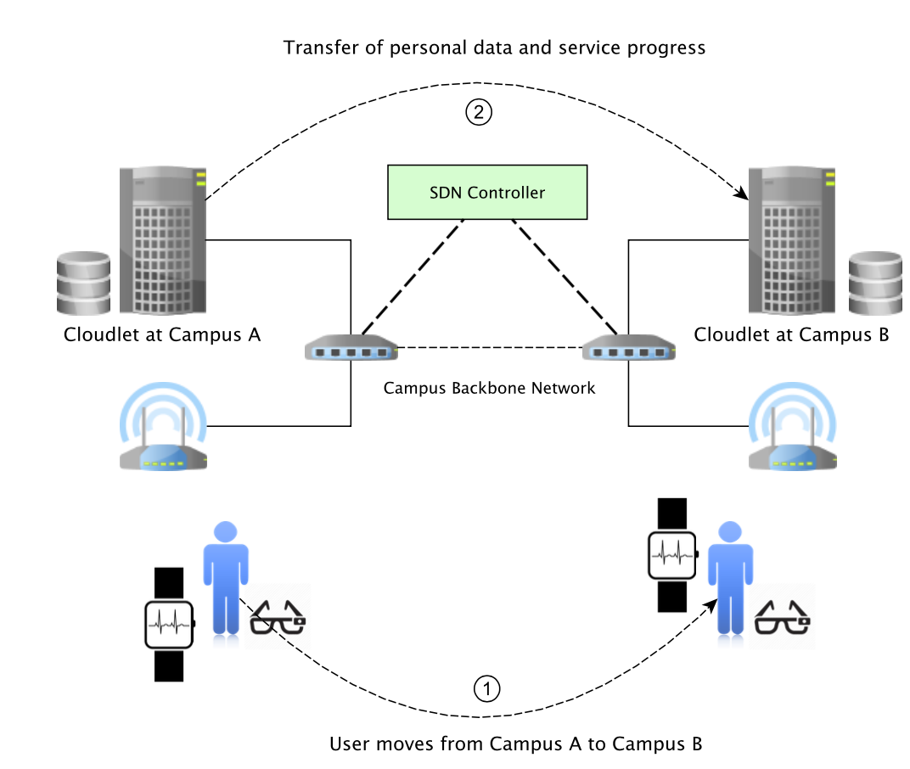

fig 1.user moves from campus A to campus B

Considering a campus-based scenario, students of a university with more than one campus probably have to visit each of the campuses in a day or even in a shorter period. In such an environment, the mobility and handover scenarios are inevitable. Figure 1 highlights a possible handover scenario between the campuses. After the user generates a service request at Campus A, it may visit the other campus before the Cloudlet at the former location completes the execution of the procedures. During this change in location, it may disconnect from the network and establish a new connection at the recent position.

For this case, the SDN controller can track the changes and acquire the recently assigned IP address for the user. Since the controller is aware that the user is in the same network with a Cloudlet but its latest request is forwarded to another one, it may trigger a handover at the application layer for handling the subsequent requests more effectively. When the decision is taken, the source and destination servers are informed. The former Cloudlet initializes the process of transferring the service code that is to be executed, the recent memory state and the personal database. At this step, the SDN controller has the responsibility of adjusting the data transfer. The important point to note is that the handover process should not deteriorate the performance and user experience. Therefore, the controller should determine the most feasible path between the two Cloudlets that is able to minimize the duration of data transfer. By sending OFPMP_PORT_STATS messages, which is defined by OpenFlow, to the switches, the controller can determine the least loaded links and paths Lastly, the flow rules that define the path are installed on the nodes and the data transfer is progressed. If the same user requests for the same service at Campus B in the future, the overall delay is minimized because it can get the service from the nearest Cloudlet.

By hiding all the operational tasks from the user and remove the burden of locating the service from the user application, the service-centric model implemented at the edge is helpful for maximizing the user experience. Deployment of SDN-enabled switches and implementation of northbound applications with an SDN controller may enable these functionalities without modifying or reshaping the entire network infrastructure and protocol stack.