**EE 232E**

**Graphs and Network Flows**

Homework 1 Report

Pingyuan Yue: 504737715

Ke Xu: 604761427

Yuanyi Ding: 404773978

4/17/2017

Table of Contents

**1. Introduction 3**

**2. Dataset and Problem Statement 3**

**3. Creates a Random Graph by Simulating Its Evolution 3**

**4. Forest Fire Model 4**

**5. Conclusion 4**

# Introduction

# Dataset and Problem Statement

# Creates a Random Graph by Simulating Its Evolution

1. By definition, a preferential attachment process is any of a class of processes in which some quantity, typically some form of wealth or credit, is distributed among a number of individuals or objects according to how much they already have, so that those who are already wealthy receive more than those who are not.

In this problem, we created a random graph with 1000 nodes by simulating its evolution. A new vertex is added and creates a number of links to old vertices and the probability that an old vertex is cited depends on its in-degree. We can simply simulate the evolution of the graph by calling the sample_pa_age function in igraph library.

g <- sample_pa_age(1000, pa.exp=1, aging.exp=-1, aging.bin=1000, directed=FALSE)

The degree distribution of the graph is shown as follows:

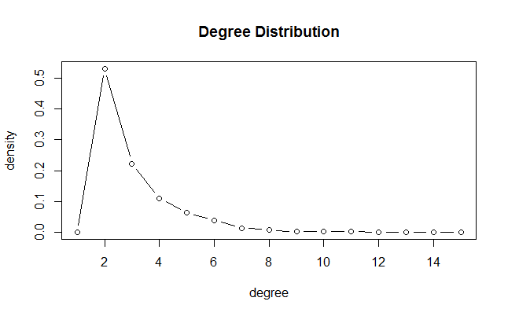

1. Use fast greedy method to find the community structure. We can find that the number of communities of this graph is around 32. The modularity is 0.93597. The structure of the graph is shown below:

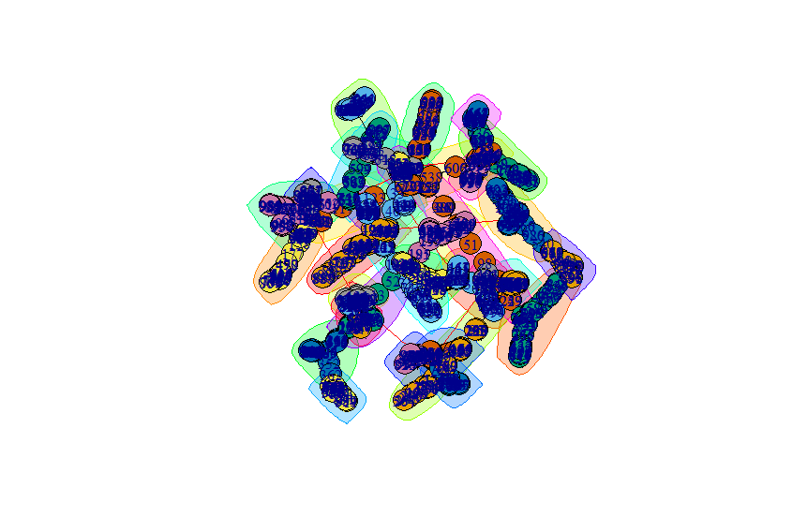

# Forest Fire Model

1. In this problem, we generate a forest fire model by using forest.fire.game function. The forward burning probability is set to be 0.37, and the backward burning probability is set to be 0.32/0.37 = 0.86. Both in-degree distribution and out-degree distribution of the graph are shown below. It could be concluded that both degree decrease quite fast.

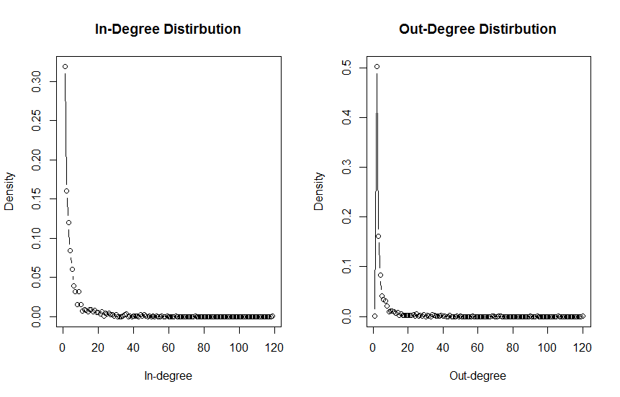

1. We generate the graph for 50 times and calculate the average diameter which is around: 10.56.
2. In this problem, the structure of the graph is calculated using spinglass method, since fast greedy method is only applicable to undirected graph. The number of communities is around 24 and the modularity of the graph is calculated to be 0.47009. The structure of the graph is shown below:

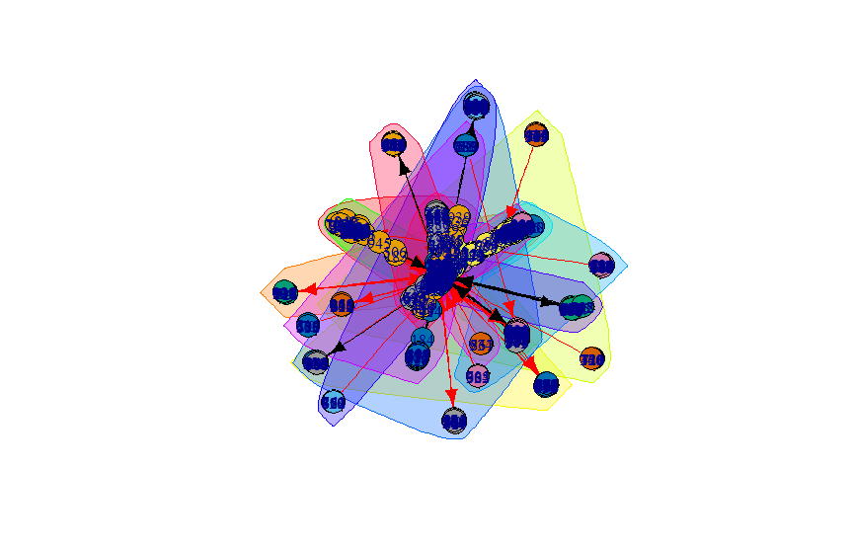

# Conclusion

In this assignment, we learn the basic knowledge of several graph theories and models and get familiar with igraph library and R language programming. The main challenges in this assignment is to figure out the meaning of different models (e.g. fat-tailed distribution, preferential attachment, forest fire) find the correct method to generate different models.