# Random walk on random networks

**Part (a):**

Just like what we did in homework 1, we simply created the random network using the following commands:

p<-0.01

n<-1000

g<-sample_gnp(n, p, directed = FALSE, loops = FALSE)

**Part (b):**

We utilized the function RandomWalker (netrw) to simulate random walk on the graph with 1000 nodes. The following 2 graphs shows average distance and standard deviation of graph with 1000 nodes:

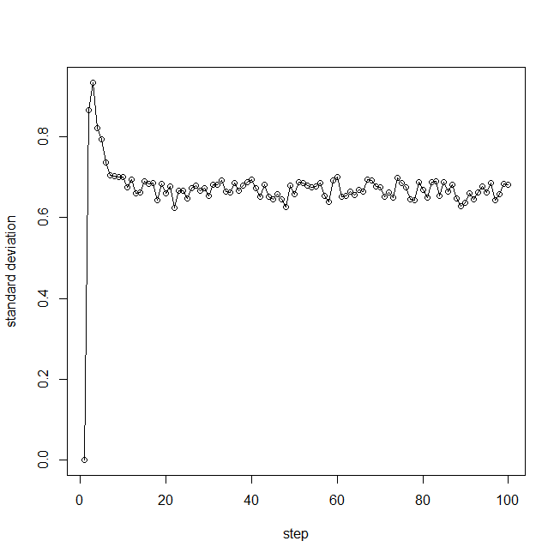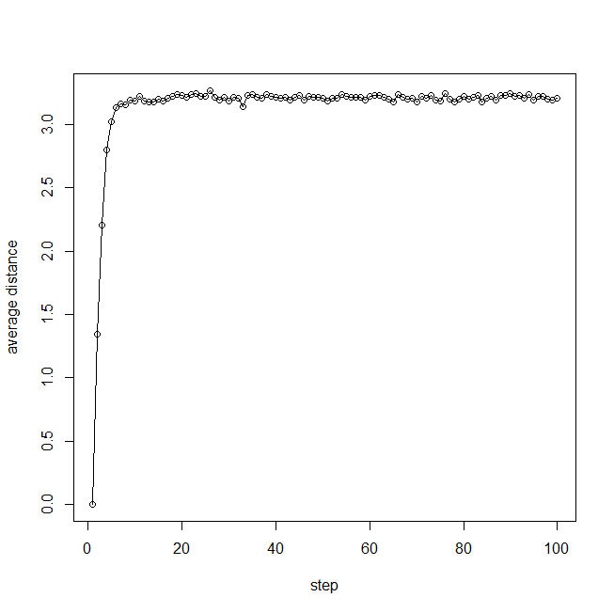

Figrue1.1: average distance and standard deviation of graph with 1000 nodes

**Part (c):**

The result in (b) is not the same as the random work in the d-dimensional space. The reason of it is that in the d-dimensional space, the distance could be negative, which means it could have cancellation between positive and negative distance that causes the average distance to be 0. While the random graph we created has no negative distance, so the average distance is around positive 3. As a result, the result is different from a random walker in d dimensional.

**Part (d):**

We just repeated the process for random networks with 100 and 10000 nodes.

The following 4 graphs shows average distance and standard deviation of graph with 100 and 10000 nodes:

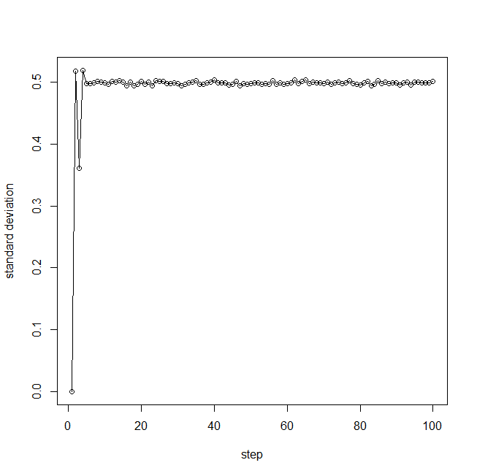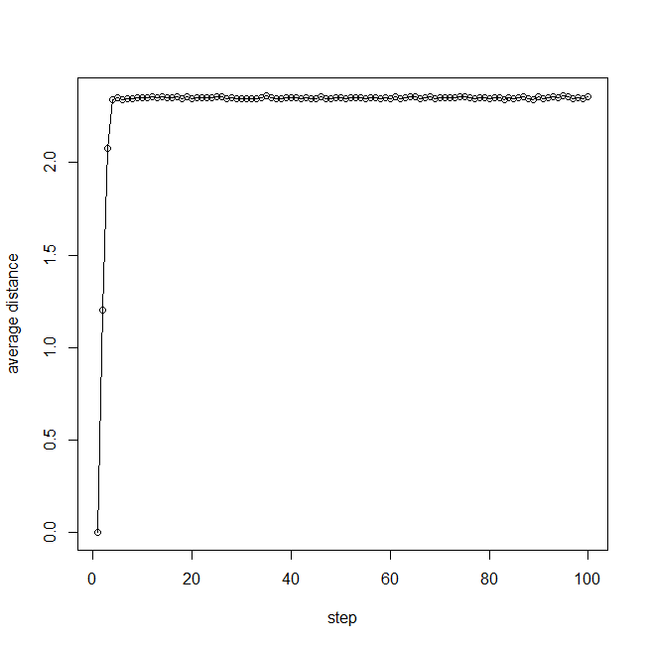

Figrue1.2: average distance and standard deviation of graph with 10000 nodes

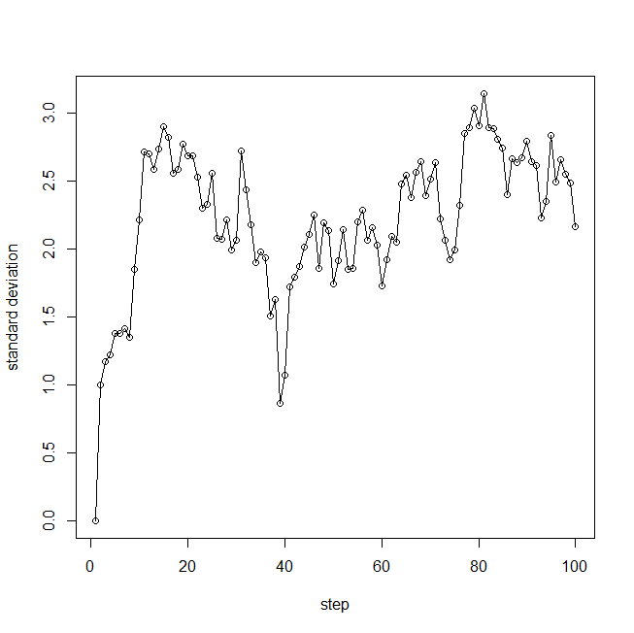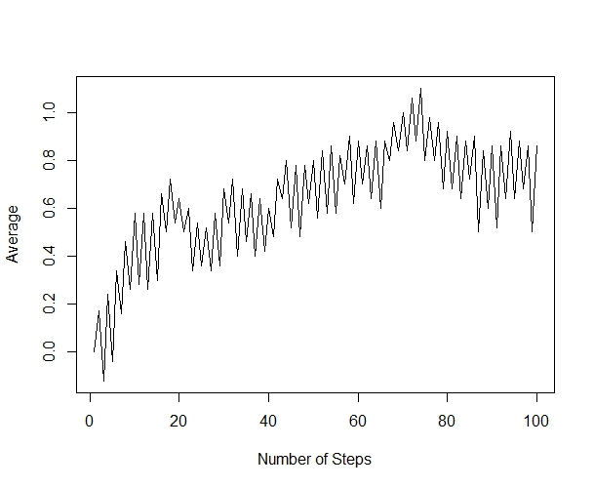

Figrue1.3: average distance and standard deviation of graph with 100 nodes

Also the diameters of graphs with 100, 1000 and 10000 nodes are 10,6,3 respectively. It can be obviously seen from figures above that for the graph with 100 nodes the distribution converge slowly or even cannot converge if we do not set the start node fixed. The smaller the diameter is, the ave and std converge more quickly and turn out to have smaller fluctuation. Also since the average distance of graphs with 100, 1000 and 10000 nodes are 0.6, 2.8, 3.2 respectively, we can say that generally, the graph with larger diameter will have larger average distance.

**Part (e):**

Firstly, the number of total steps of the random walk is set to 100.

Then the following figure shows the comparison between the degree distribution of the graph and the degree distribution of the nodes reached at the end of the random walk on the graph.

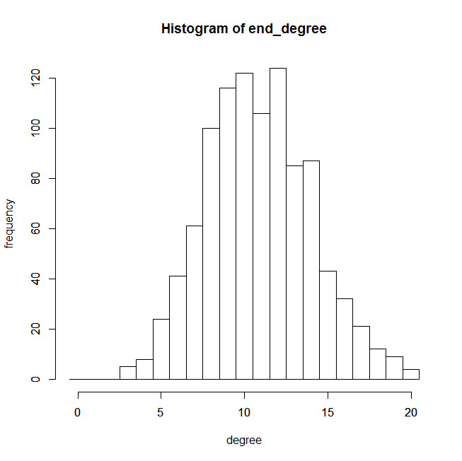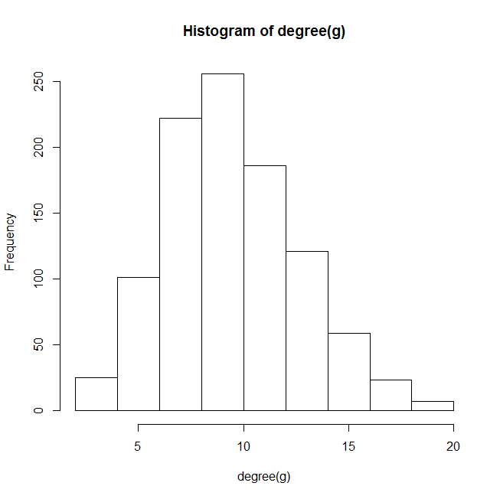

Figure 1.4 Comparison between two degree distributions

Running several times to get several figures, we could see that after a certain large number of steps of random walk, the two degree distributions are similar to each other.

# Create a Network with Fat-tailed Distribution

**Part (a):**

Just like what we did in problem 1 part a, we simply created the fat-tailed network using the following commands:

n<-1000

g <- barabasi.game(n, power = -3, directed = FALSE)

**Part (b):**

We utilized the function RandomWalker (netrw) to simulate random walk on the fat-tailed graph with 1000 nodes. The following 2 graphs shows average distance and standard deviation of graph with 1000 nodes:

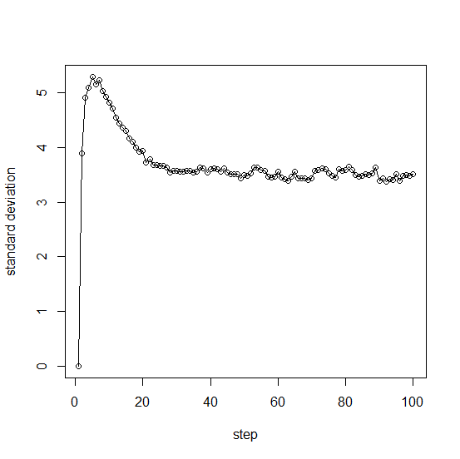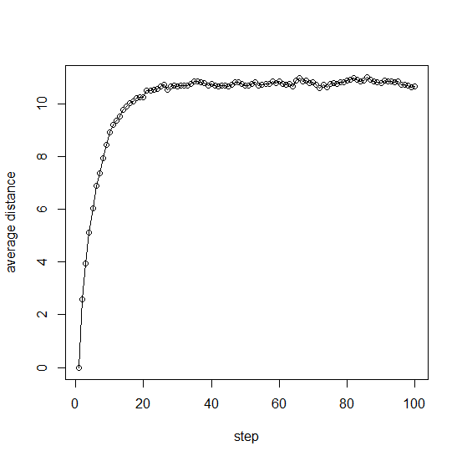

Figrue2.1: average distance and standard deviation of graph with 1000 nodes

**Part (c):**

The result in (b) is not the same as the random work in the d-dimensional space. The reason of it is that in the d-dimensional space, the distance could be negative, which means it could have cancellation between positive and negative distance that causes the average distance to be 0. While the random graph we created has no negative distance, so the average distance is around positive 11. As a result, the result is different from a random walker in d dimensional.

**Part (d):**

We just repeated the process for fat-tailed networks with 100 and 10000 nodes.

The following 4 graphs shows average distance and standard deviation of graph with 100 and 10000 nodes:

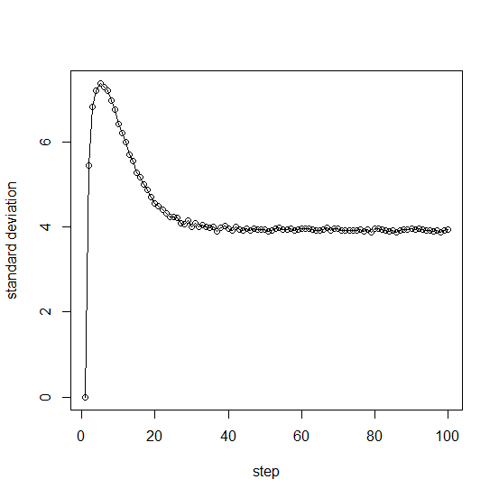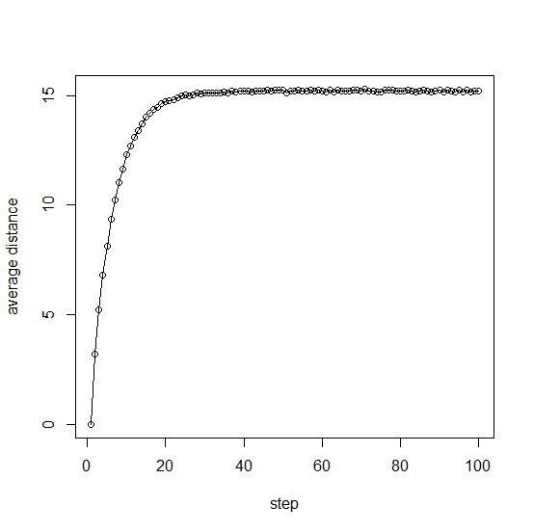

Figrue2.2: average distance and standard deviation of graph with 10000 nodes

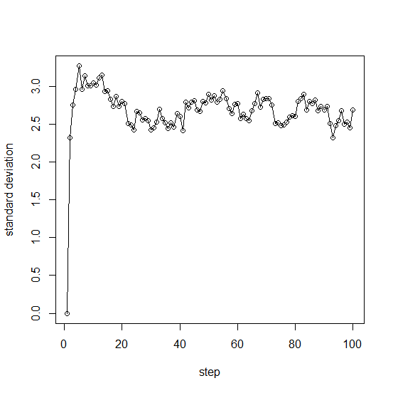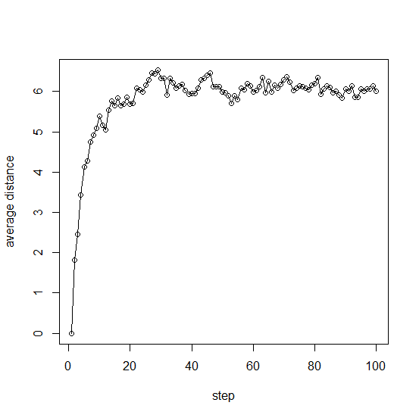

Figrue2.3: average distance and standard deviation of graph with 100 nodes

Also the diameters of graphs with 100, 1000 and 10000 nodes are 15,24,33 respectively. Since the average distance of graphs with 100, 1000 and 10000 nodes are 6, 11, 15 respectively, we can say that generally, the graph with larger diameter will have larger average distance.

**Part (e):**

Firstly, the number of total steps of the random walk is set to 100.

Then the following figure shows the comparison between the degree distribution of the graph and the degree distribution of the nodes reached at the end of the random walk on the graph.

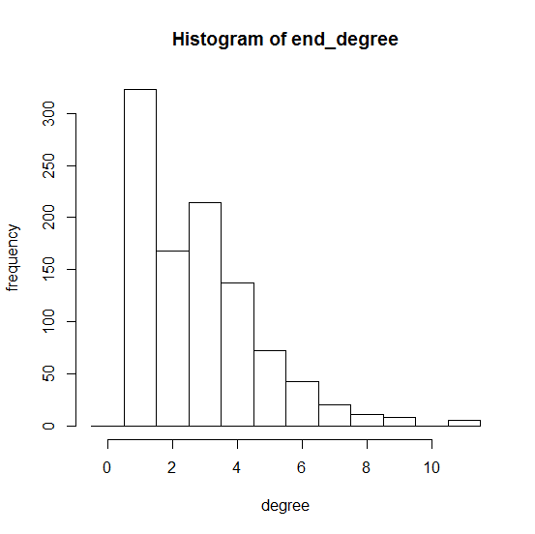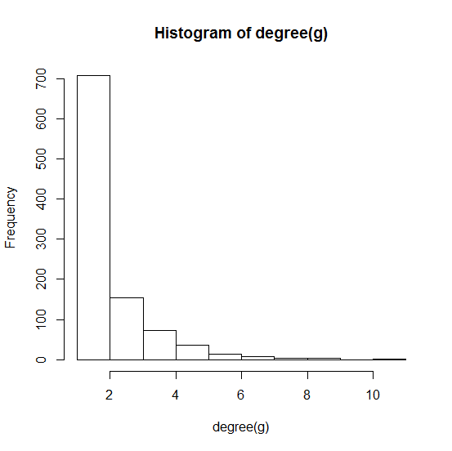

Figure 2.4 Comparison between two degree distributions

Running several times to get several figures, we could see that after a certain large number of steps of random walk, the two degree distributions are similar to each other.