DETAILED REPORT OF BINARY ANALYSES

Pinheiro R.B.P., Felix G.M.F., and Lewinsohn T.M.

February 2022

Table of Contents

# 1. Dataset

Binary networks formed by four kinds of species interaction, comprising almost all the networks analyzed by:

1. J. Bascompte, P. Jordano, C. J. Melian, J. M. Olesen, The nested assembly of plant-animal mutualistic networks. Proc. Natl. Acad. Sci. 100, 9383–9387 (2003).
2. P. Jordano, J. Bascompte, J. M. Olesen, Invariant properties in coevolutionary networks of plant-animal interactions. Ecol. Lett. 6, 69–81 (2003).
3. J. M. Olesen, J. Bascompte, Y. L. Dupont, P. Jordano, The modularity of pollination networks. Proc. Natl. Acad. Sci. 104, 19891–19896 (2007).
4. M. A. Fortuna, et al., Nestedness versus modularity in ecological networks: two sides of the same coin? J. Anim. Ecol. 79, 811–817 (2010).
5. E. Thebault, C. Fontaine, Stability of ecological communities and the architecture of mutualistic and trophic networks. Science (80-. ). 329, 853–856 (2010).

## [1] "Networks in the dataset: 142"

|  |  |  |  |  |
| --- | --- | --- | --- | --- |
| ID | Interaction | Reference | rows | cols |
| TP-001 | disp | Beehler 1983 | 31 | 9 |
| TP-002 | disp | Sorensen 1981 | 7 | 6 |
| TP-003 | disp | Frost 1980 | 16 | 10 |
| TP-004 | disp | GuitiÃ¡n 1983 | 12 | 7 |
| TP-005 | disp | Galetti 1996 | 7 | 18 |
| TP-006 | disp | Galetti 1996 | 35 | 29 |
| TP-007 | disp | Kantak 1981 | 5 | 27 |
| TP-008 | disp | Snow 1988 | 11 | 14 |
| TP-009 | disp | Tutin 1997 | 19 | 8 |
| TP-010 | disp | Noma 1997 | 15 | 8 |
| TP-011 | disp | Wheelwright 1984 | 169 | 40 |
| TP-012 | disp | Crome 1975 | 71 | 7 |
| TP-013 | disp | Snow 1971 | 50 | 14 |
| TP-014 | disp | Jordano unpub | 25 | 33 |
| TP-015 | disp | Jordano 1985 | 16 | 17 |
| TP-016 | disp | Herrera 1984 | 14 | 10 |
| TP-017 | pollin | Arroyo 1982 | 98 | 87 |
| TP-018 | pollin | Arroyo 1982 | 62 | 43 |
| TP-019 | pollin | Arroyo 1982 | 28 | 41 |
| TP-020 | pollin | Elberling 1999 | 118 | 23 |
| TP-021 | pollin | Olesen 2008 | 76 | 31 |
| TP-022 | pollin | Olesen 2002 | 13 | 14 |
| TP-023 | pollin | Herrera 1988 | 179 | 26 |
| TP-024 | pollin | Hocking 1968 | 86 | 29 |
| TP-025 | pollin | Inoue 1990 | 840 | 112 |
| TP-026 | pollin | Inouye 1988 | 91 | 41 |
| TP-027 | pollin | Kakutani 1990 | 314 | 113 |
| TP-028 | pollin | Kato 1996 | 187 | 64 |
| TP-029 | pollin | Kato 1990 | 679 | 91 |
| TP-030 | pollin | Kato 1993 | 356 | 90 |
| TP-031 | pollin | Kevan 1970 | 115 | 32 |
| TP-032 | pollin | McMullen 1993 | 54 | 105 |
| TP-033 | pollin | Mosquin 1967 | 18 | 11 |
| TP-034 | pollin | Montero 2005 | 82 | 28 |
| TP-035 | pollin | Olesen & Forfarg unpubl | 55 | 29 |
| TP-036 | pollin | Montero 2005 | 42 | 8 |
| TP-037 | pollin | Montero 2005 | 40 | 10 |
| TP-038 | pollin | Olesen 2002 | 12 | 10 |
| TP-039 | pollin | Percival 1974 | 36 | 61 |
| TP-040 | pollin | Petanidou 1991 | 666 | 131 |
| TP-041 | pollin | Primack 1983 | 60 | 18 |
| TP-042 | pollin | Primack 1983 | 138 | 41 |
| TP-043 | pollin | Primack 1983 | 118 | 49 |
| TP-044 | pollin | Ramirez 1989 | 49 | 48 |
| TP-045 | pollin | Schemske 1978 | 33 | 7 |
| TP-046 | disp | Baird 1980 | 21 | 7 |
| TP-047 | disp | Lambert 1989 | 25 | 61 |
| TP-048 | disp | Jordano unpub | 18 | 28 |
| TP-053 | disp | Jordano 1993 | 11 | 6 |
| TP-056 | disp | Silva 2002 | 207 | 110 |
| TP-071 | pollin | Kato 2000 | 678 | 91 |
| TP-072 | pollin | Gonzalez Alvaro 2004 | 46 | 477 |
| TP-073 | pollin | Yamazaki 2003 | 99 | 294 |
| TP-074 | pollin | Clements 1923 | 275 | 96 |
| TP-075 | pollin | Dupont 2009 | 30 | 236 |
| TP-076 | pollin | Bek 2006 | 37 | 225 |
| TP-077 | pollin | Dupont 2009 | 19 | 186 |
| TP-079 | pollin | VÃ¡zquez 2002 | 90 | 14 |
| TP-080 | pollin | Medan 2002 | 72 | 23 |
| TP-081 | pollin | Ingversen 2006 | 36 | 61 |
| TP-082 | pollin | Stald 2003 | 51 | 17 |
| TP-083 | pollin | Medan 2002 | 45 | 21 |
| TP-084 | pollin | Helenurm 1987 | 102 | 12 |
| TP-085 | pollin | Memmott 1999 | 79 | 25 |
| TP-086 | pollin | Ingversen 2006 | 44 | 31 |
| TP-087 | pollin | Bundgaard 2003 | 44 | 16 |
| TP-088 | pollin | Witt 1998 | 39 | 15 |
| TP-089 | pollin | Dupont 2003 | 38 | 11 |
| TP-090 | pollin | Stald 2003 | 35 | 14 |
| TP-091 | pollin | Lundgren 2005 | 26 | 17 |
| TP-092 | pollin | Philipp 2006 | 12 | 6 |
| TP-093 | disp | Jordano unpub | 12 | 4 |
| TP-094 | disp | Jordano unpub | 21 | 6 |
| TP-095 | pollin | Montero 2005 | 105 | 39 |
| TP-096 | paras | Alania 1964 | 20 | 15 |
| TP-097 | paras | Arthur 1976 | 29 | 7 |
| TP-098 | paras | Mikulin 1959 | 26 | 19 |
| TP-099 | paras | Vershinina 1967 | 17 | 28 |
| TP-100 | paras | deMoraes 2003 | 10 | 16 |
| TP-101 | paras | Linsdale 1956 | 22 | 19 |
| TP-102 | paras | Davis 2002 | 17 | 9 |
| TP-103 | paras | Elshanskaya 1972 | 18 | 8 |
| TP-104 | paras | Leong 1981 | 40 | 10 |
| TP-105 | paras | Burdelova 1996 | 22 | 15 |
| TP-106 | paras | Mikulin 1959 | 37 | 22 |
| TP-107 | paras | Morozkina 1971 | 25 | 8 |
| TP-108 | paras | Allred 1968 | 29 | 14 |
| TP-109 | paras | Syrvacheva 1964 | 21 | 13 |
| TP-110 | paras | Koshkin 1966 | 22 | 9 |
| TP-111 | paras | Leonov 1958 | 12 | 8 |
| TP-112 | paras | Reshetnikova 1959 | 19 | 17 |
| TP-113 | paras | Arai 1983 | 51 | 14 |
| TP-114 | paras | Vasiliev 1966 | 21 | 9 |
| TP-115 | paras | Labunets 1967 | 44 | 21 |
| TP-116 | paras | Popova 1968 | 31 | 18 |
| TP-117 | paras | Krasnov 1997 | 11 | 13 |
| TP-118 | paras | Morlan 1955 | 34 | 29 |
| TP-119 | paras | Yudin 1976 | 16 | 15 |
| TP-120 | paras | Shwartz 1958 | 35 | 16 |
| TP-121 | paras | Violovich 1969 | 34 | 27 |
| TP-122 | paras | Sineltschikov 1956 | 53 | 17 |
| TP-123 | paras | Vasiliev 1966 | 14 | 16 |
| TP-124 | paras | Bangham 1955 | 97 | 33 |
| TP-125 | paras | Pauller 1966 | 13 | 9 |
| TP-126 | paras | Stanko 2002 | 22 | 17 |
| TP-127 | paras | Chinniah 1978 | 25 | 6 |
| TP-128 | paras | Kunitsky 1962 | 23 | 13 |
| TP-129 | paras | Mikulin 1958 | 35 | 23 |
| TP-130 | paras | Zagniborodova 1960 | 42 | 18 |
| TP-131 | paras | Letov 1966 | 28 | 13 |
| TP-132 | paras | Kozlovskaya 1958 | 21 | 9 |
| TP-133 | paras | Nazarova 1981 | 35 | 29 |
| TP-134 | paras | Emelyanova 1967 | 29 | 15 |
| TP-135 | pollin | Motten 1986 | 44 | 13 |
| TP-136 | pollin | Ramirez 1992 | 53 | 28 |
| TP-137 | pollin | Robertson 1928 | 1427 | 454 |
| TP-138 | pollin | Small 1976 | 34 | 13 |
| TP-139 | pollin | Ollerton 2003 | 56 | 9 |
| TP-140 | pollin | Smith-Ramirez 2005 | 128 | 26 |
| TP-141 | herbiv | Basset 1996 | 32 | 10 |
| TP-142 | herbiv | Dawah 1995 | 17 | 10 |
| TP-143 | herbiv | Dyer 2002 | 443 | 293 |
| TP-144 | herbiv | Henneman 2001 | 23 | 22 |
| TP-145 | herbiv | Henneman 2001 | 25 | 26 |
| TP-146 | herbiv | Janzen 1980 | 110 | 98 |
| TP-147 | herbiv | Janzen 2005 | 301 | 776 |
| TP-148 | herbiv | Joern 1979 | 22 | 53 |
| TP-149 | herbiv | Joern 1979 | 21 | 53 |
| TP-150 | herbiv | Lewis 2002 | 93 | 71 |
| TP-151 | herbiv | Loye 1992 | 35 | 42 |
| TP-152 | herbiv | Memmott 1994 | 87 | 50 |
| TP-153 | herbiv | Muller 1999 | 25 | 26 |
| TP-154 | herbiv | Nakagawa 2003 | 29 | 20 |
| TP-155 | herbiv | Nakagawa 2003 | 36 | 13 |
| TP-156 | herbiv | Novotny 2005 | 29 | 29 |
| TP-157 | herbiv | Prado 2004 | 34 | 81 |
| TP-158 | herbiv | Tavakilian 1997 | 352 | 300 |
| TP-159 | herbiv | Tscharntke 2001 | 16 | 10 |
| TP-160 | herbiv | Ueckert 1971 | 14 | 43 |
| TP-161 | herbiv | Bluthgen 2006 | 14 | 38 |
| TP-162 | herbiv | Coley 2006 | 95 | 40 |
| TP-163 | herbiv | Cuevas-Reyes 2007 | 29 | 29 |

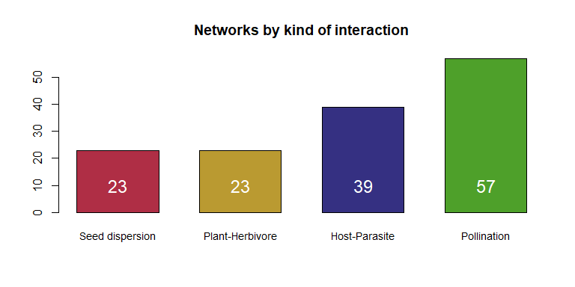

## Warnings (matrix loadings)

## [1] "TP-027 was not binary"  
## [1] "TP-099 had 1 empty columns"  
## [1] "TP-108 had 1 empty columns"  
## [1] "TP-111 had 1 empty columns"  
## [1] "TP-113 had 1 empty columns"  
## [1] "TP-121 had 1 empty columns"  
## [1] "TP-126 had 2 empty columns"  
## [1] "TP-128 had 1 empty columns"  
## [1] "TP-133 had 1 empty columns"  
## [1] "TP-001 was not binary"  
## [1] "TP-072 was not binary"

# 2. Overall nestedness vs. Modularity

Binary nestedness: we applied the NODF index (Almeida-Neto et al. 2008).

Binary modularity: we calculated Barber’s modularity index (Barber 2007) using the LPA and the DIRT LPA algorithms (Beckett 2016).

For too large networks (> 600 species), it was computational impracticable to apply the DIRT LPA algorithm, so we applied the faster, although a bit less effective, LPA.

## List of large binary networks (>600 species)

|  |  |  |  |  |
| --- | --- | --- | --- | --- |
| ID | Interaction | Reference | rows | cols |
| TP-025 | pollin | Inoue 1990 | 840 | 112 |
| TP-029 | pollin | Kato 1990 | 679 | 91 |
| TP-040 | pollin | Petanidou 1991 | 666 | 131 |
| TP-071 | pollin | Kato 2000 | 678 | 91 |
| TP-137 | pollin | Robertson 1928 | 1427 | 454 |
| TP-143 | herbiv | Dyer 2002 | 443 | 293 |
| TP-147 | herbiv | Janzen 2005 | 301 | 776 |
| TP-158 | herbiv | Tavakilian 1997 | 352 | 300 |

## Plot and correlation test

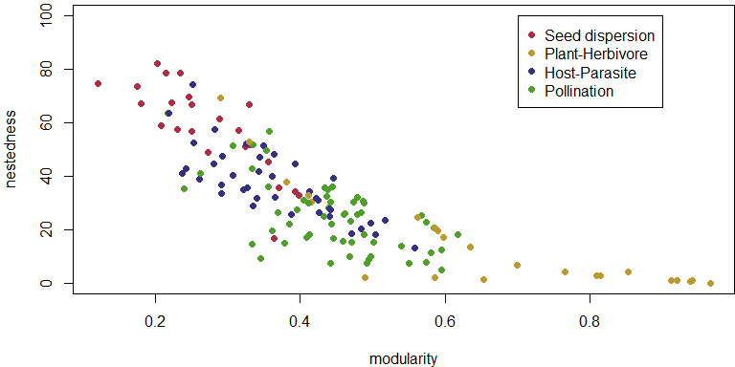

Testing the correlation between modularity and nestedness:

## Warning in cor.test.default(TABLE_RESULTS$modularity, TABLE_RESULTS$NODF, :  
## Cannot compute exact p-value with ties

##   
## Spearman's rank correlation rho  
##   
## data: TABLE_RESULTS$modularity and TABLE_RESULTS$NODF  
## S = 9e+05, p-value <2e-16  
## alternative hypothesis: true rho is not equal to 0  
## sample estimates:  
## rho   
## -0.867

# 3. Correlations and comparisons

## 3.1. Connectance:

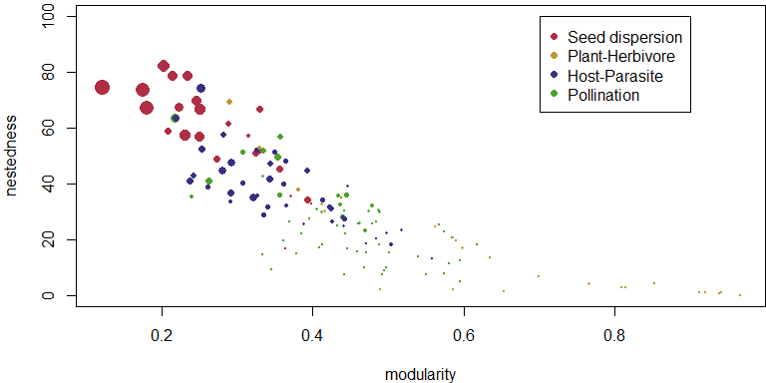

Correlation between modularity and connectance:

## Warning in cor.test.default(TABLE_RESULTS$modularity,  
## TABLE_RESULTS$connectance, : Cannot compute exact p-value with ties

##   
## Spearman's rank correlation rho  
##   
## data: TABLE_RESULTS$modularity and TABLE_RESULTS$connectance  
## S = 9e+05, p-value <2e-16  
## alternative hypothesis: true rho is not equal to 0  
## sample estimates:  
## rho   
## -0.81

Correlation between nestedness and connectance:

## Warning in cor.test.default(TABLE_RESULTS$NODF, TABLE_RESULTS$connectance, :  
## Cannot compute exact p-value with ties

##   
## Spearman's rank correlation rho  
##   
## data: TABLE_RESULTS$NODF and TABLE_RESULTS$connectance  
## S = 42655, p-value <2e-16  
## alternative hypothesis: true rho is not equal to 0  
## sample estimates:  
## rho   
## 0.911

## 3.2. Network size:

Size was log transformed (size = log(number of species))

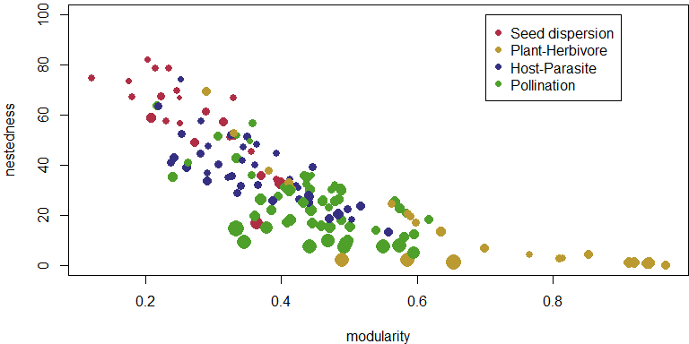

Correlation between size and connectance:

## Warning in cor.test.default((X$rows + X$cols), TABLE_RESULTS$connectance, :  
## Cannot compute exact p-value with ties

##   
## Spearman's rank correlation rho  
##   
## data: (X$rows + X$cols) and TABLE_RESULTS$connectance  
## S = 9e+05, p-value <2e-16  
## alternative hypothesis: true rho is not equal to 0  
## sample estimates:  
## rho   
## -0.831

## 3.3. Nestedness vs. kind of interaction

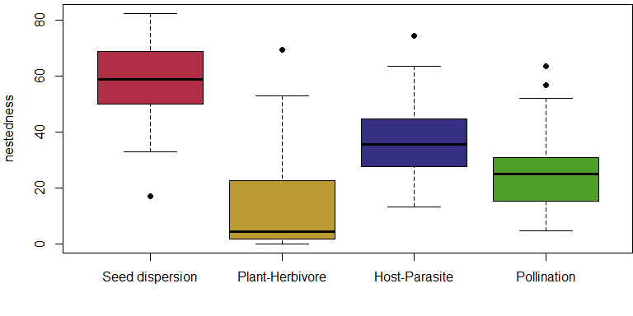

## 3.4. Modularity vs. kind of interaction

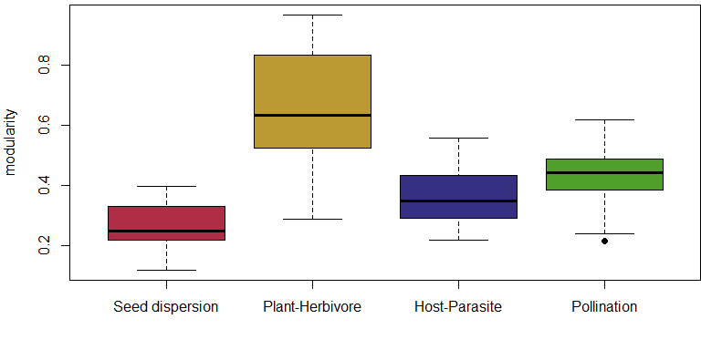

# 4. Distortions on null model connectance

We used a null model that forces the randomized matrix to keep the dimensions. It is based on the method developed by Vázquez (2007). However, because of conserving the dimensions, null models are not able to conserve connectance when the number of interactions divided by network size (linkage density) is lower than 1.

Here, to illustrate this problem, we built null models for all networks, regardless of linkage density. Then, we divided the average connectance in the null matrices by the connectance in the observed matrix.

Notice that, in networks with linkage density lower than 1, connectance in the null matrices is often higher than in the observed matrix. This problems never occur for matrices with linkage density equal or higher than 1.

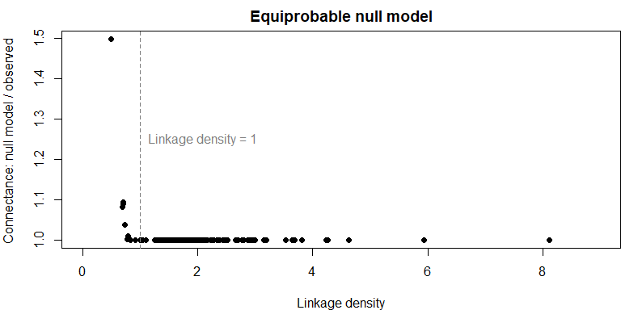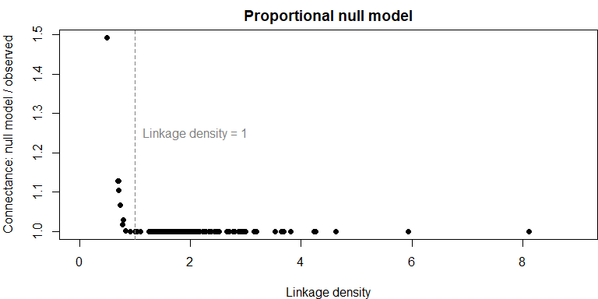

## 4.1. Networks with linkage density < 1

This is the list of networks in our dataset with likage density lower than 1.

|  |  |  |  |  |
| --- | --- | --- | --- | --- |
| ID | Interaction | Reference | rows | cols |
| TP-142 | herbiv | Dawah 1995 | 17 | 10 |
| TP-146 | herbiv | Janzen 1980 | 110 | 98 |
| TP-150 | herbiv | Lewis 2002 | 93 | 71 |
| TP-152 | herbiv | Memmott 1994 | 87 | 50 |
| TP-153 | herbiv | Muller 1999 | 25 | 26 |
| TP-156 | herbiv | Novotny 2005 | 29 | 29 |
| TP-159 | herbiv | Tscharntke 2001 | 16 | 10 |
| TP-162 | herbiv | Coley 2006 | 95 | 40 |
| TP-163 | herbiv | Cuevas-Reyes 2007 | 29 | 29 |

Notice that these networks correspond to the 9 networks with higher modularity:

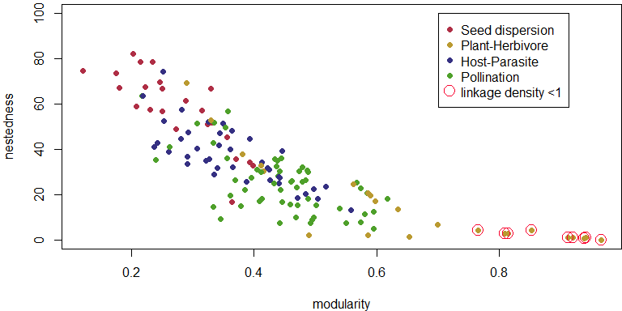

# 5. Modularity and nestedness significance

For these analysis we only included networks with linkage density equal or higher to 1.

Null models in our study are composed of 105 randomized matrices each. This is not a very high number of matrices, but for computational limitations it was impracticable to produce larger null models. We analyzed a large number of real networks (binary: 142, weighted: 68), some of which including a very large number of species (max= 1881 species).

## [1] "Number of remaining networks: 133"

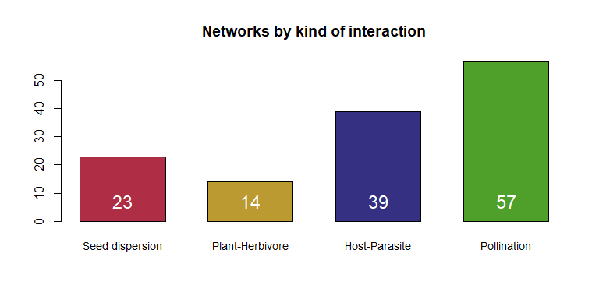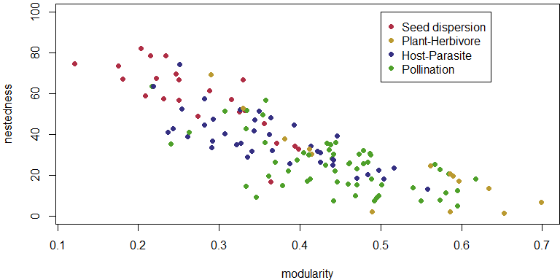

## 5.1. Significantly nested

Nestedness significance was assessed through comparisons with the equiprobable null model.

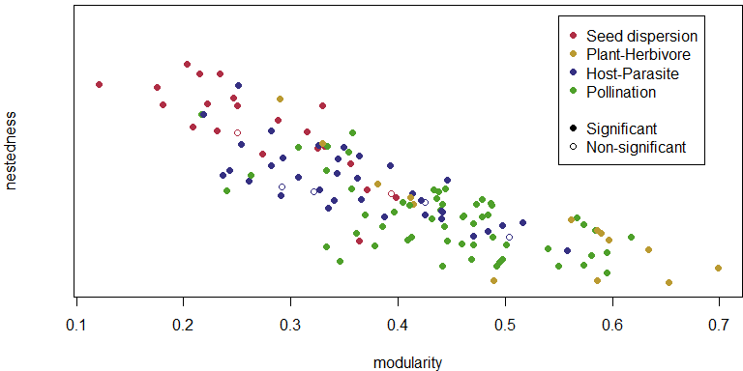

## [1] "Number of significantly nested networks: 127"

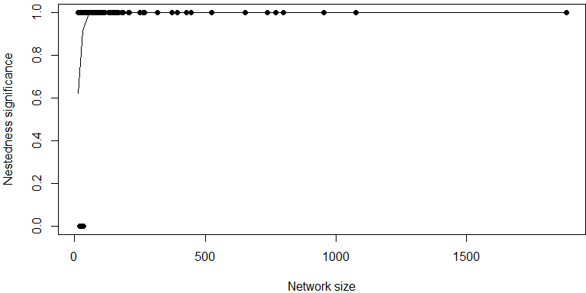

All the networks with more than 34 species were significantly nested.

## 5.2. Significantly modular

Modularity significance was assessed through comparisons with the proportional null model.

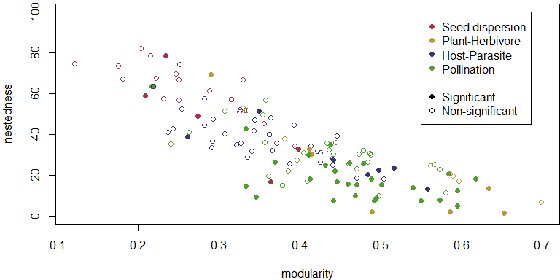

## [1] "Number of significantly modular networks: 48"

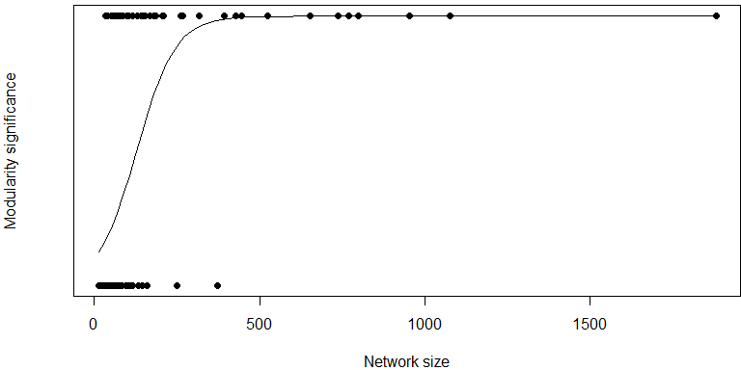

Almost all the networks (except from two) with more than 160 species were significantly modular.

# 6. Nestedness SM and DM

For significant modular networks we calculated nestedness between species belonging to the same module (NSM) and nestedness between species in different modules (NDM) (Flores et al. 2013, Pinheiro et al. 2019, Felix et al. 2022).

## [1] "Modular networks: 48"

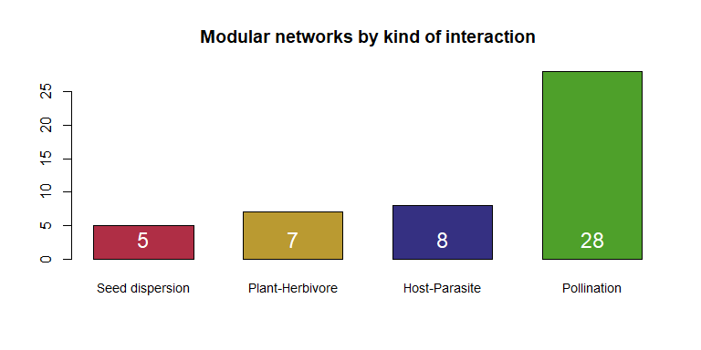

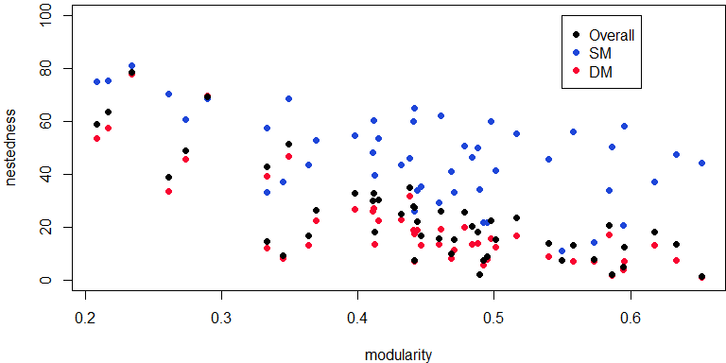

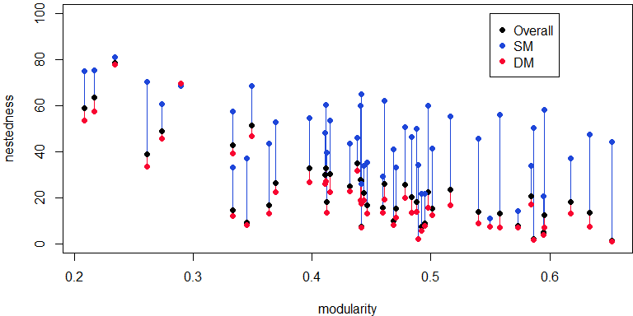

I applied local regressions (R function loess), very smoothly, to see the general trend of NODF, NODFSM and NODFDM, with increasing modularity.

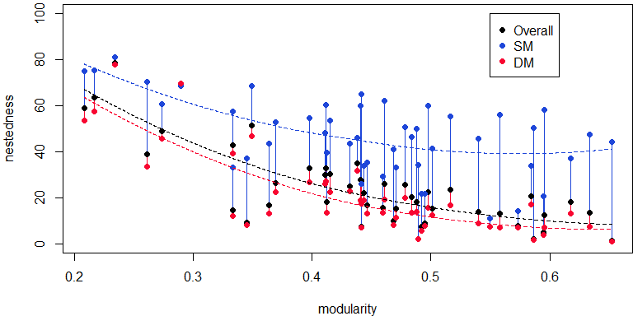

# 7. Significance of nestedness SM

We used restricted null models (models that conserve the modular structure on the networks) to test NSM significance.

Brackets represent 95% of values in the null model.

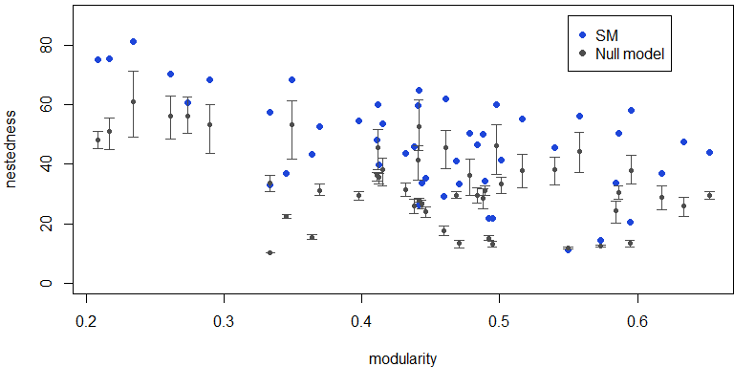

Only a few modular networks do not present significant nestedness SM (red arrows).

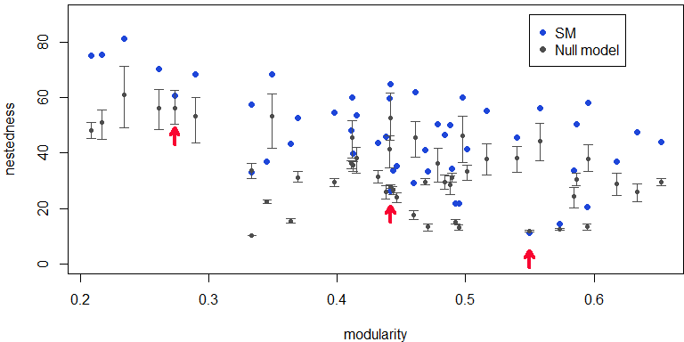

# 8. Network topologies

Significance tests:

Equiprobable null model for NO significance.

Proportional null model for modularity significance.

Equiprobable restricted null model for NSM significance.

Topologies:

Nested network: non-significant modularity and significant NO

Pure modular network: significant modularity and non-significant NSM

Compound topology: singnificant modularity and significant NSM

Unstructured: non significant NO and non significant modularity

|  |  |
| --- | --- |
| topology | Number of networks |
| compound | 45 |
| nested | 79 |
| pure modular | 3 |
| unstructured | 6 |

## 8.1. Topology vs. kind of interaction

|  |  |  |  |  |
| --- | --- | --- | --- | --- |
|  | seed dispersal | plant-herbivore | host-parasite | pollination |
| nested | 16 | 7 | 27 | 29 |
| unstructured | 2 | 0 | 4 | 0 |
| compound | 4 | 7 | 8 | 26 |
| pure modular | 1 | 0 | 0 | 2 |
| linkage density <1 | 0 | 9 | 0 | 0 |

# 9. References

D. P. Vázquez, et al., Species abundance and asymmetric interaction strength in ecological networks. Oikos 116, 1120–1127 (2007).

M. Almeida-Neto, P. Guimarães, P. R. Guimarães, R. D. Loyola, W. Ulrich, A consistent metric for nestedness analysis in ecological systems: reconciling concept and measurement. Oikos 117, 1227–1239 (2008).

C. O. Flores, S. Valverde, J. S. Weitz, Multi-scale structure and geographic drivers of cross-infection within marine bacteria and phages. ISME J. 7, 520–532 (2013).

S. J. Beckett, Improved community detection in weighted bipartite networks. R. Soc. Open Sci. 3, 140536 (2016).

R. B. P. Pinheiro, G. M. F. Felix, C. F. Dormann, M. A. R. Mello, A new model explaining the origin of different topologies in interaction networks. Ecology 100, 1–30 (2019).

G. M. Felix, R. B. P. Pinheiro, R. Poulin, B. R. Krasnov, M. A. R. Mello, The compound topology of host–parasite networks is explained by the integrative hypothesis of specialization. Oikos 2022 (2022).