DETAILED REPORT OF WEIGHTED ANALYSES

Pinheiro R.B.P., Felix G.M.F., and Lewinsohn T.M.

February 2022

Table of Contents

# 1. Dataset

We searched for weighted versions of the networks included in the binary dataset (see Appendix S1) in two online databases: the Web-of-life (<http://www.web-of-life.es/>) and the Interaction Web Database (<http://www.ecologia.ib.usp.br/iwdb/>), and in a pool of weighted host-parasite networks (Hadfield et al., 2009) directly provided by Boris Krasnov.

## [1] "CODES: set1W"

|  |  |  |  |  |  |
| --- | --- | --- | --- | --- | --- |
| ID | Interaction | References | rows | cols | connectance |
| TP-001 | disp | Beehler 1983 | 31 | 9 | 0.427 |
| TP-002 | disp | Sorensen 1981 | 14 | 11 | 0.299 |
| TP-003 | disp | Frost 1980 | 16 | 10 | 0.688 |
| TP-005 | disp | Galetti 1996 | 7 | 18 | 0.302 |
| TP-006 | disp | Galetti 1996 | 35 | 29 | 0.144 |
| TP-008 | disp | Snow 1988 | 19 | 29 | 0.383 |
| TP-010 | disp | Noma 1997 | 15 | 8 | 0.317 |
| TP-013 | disp | Snow 1971 | 50 | 14 | 0.334 |
| TP-014 | disp | Jordano unpub | 25 | 33 | 0.182 |
| TP-020 | pollin | Elberling 1999 | 118 | 23 | 0.088 |
| TP-025 | pollin | Inoue 1990 | 883 | 114 | 0.019 |
| TP-026 | pollin | Inouye 1988 | 85 | 40 | 0.078 |
| TP-027 | pollin | Kakutani 1990 | 318 | 113 | 0.022 |
| TP-028 | pollin | Kato 1996 | 195 | 64 | 0.035 |
| TP-029 | pollin | Kato 1990 | 678 | 89 | 0.020 |
| TP-030 | pollin | Kato 1993 | 365 | 91 | 0.026 |
| TP-033 | pollin | Mosquin 1967 | 18 | 11 | 0.192 |
| TP-038 | pollin | Olesen 2002 | 12 | 10 | 0.250 |
| TP-045 | pollin | Schemske 1978 | 32 | 7 | 0.263 |
| TP-046 | disp | Baird 1980 | 21 | 7 | 0.340 |
| TP-079 | pollin | VÃ¡zquez 2002 | 90 | 14 | 0.130 |
| TP-081 | pollin | Ingversen 2006 | 29 | 43 | 0.091 |
| TP-084 | pollin | Helenurm 1987 | 102 | 12 | 0.136 |
| TP-085 | pollin | Memmott 1999 | 79 | 25 | 0.151 |
| TP-086 | pollin | Ingversen 2006 | 43 | 31 | 0.109 |
| TP-091 | pollin | Lundgren 2005 | 26 | 17 | 0.143 |
| TP-096 | paras | Alania 1964 | 20 | 15 | 0.247 |
| TP-097 | paras | Arthur 1976 | 29 | 7 | 0.384 |
| TP-098 | paras | Mikulin 1959 | 26 | 19 | 0.217 |
| TP-099 | paras | Vershinina 1967 | 17 | 29 | 0.191 |
| TP-100 | paras | deMoraes 2003 | 10 | 16 | 0.238 |
| TP-101 | paras | Linsdale 1956 | 22 | 19 | 0.230 |
| TP-102 | paras | Davis 2002 | 17 | 9 | 0.268 |
| TP-103 | paras | Elshanskaya 1972 | 18 | 9 | 0.278 |
| TP-104 | paras | Leong 1981 | 40 | 10 | 0.228 |
| TP-105 | paras | Burdelova 1996 | 22 | 15 | 0.303 |
| TP-106 | paras | Mikulin 1959 | 37 | 22 | 0.130 |
| TP-107 | paras | Morozkina 1971 | 25 | 8 | 0.340 |
| TP-108 | paras | Allred 1968 | 29 | 14 | 0.155 |
| TP-109 | paras | Syrvacheva 1964 | 21 | 13 | 0.293 |
| TP-110 | paras | Koshkin 1966 | 22 | 9 | 0.303 |
| TP-111 | paras | Leonov 1958 | 12 | 8 | 0.406 |
| TP-112 | paras | Reshetnikova 1959 | 19 | 17 | 0.232 |
| TP-113 | paras | Arai 1983 | 51 | 14 | 0.160 |
| TP-114 | paras | Vasiliev 1966 | 21 | 10 | 0.219 |
| TP-115 | paras | Labunets 1967 | 44 | 21 | 0.150 |
| TP-116 | paras | Popova 1968 | 31 | 18 | 0.201 |
| TP-117 | paras | Krasnov 1997 | 13 | 13 | 0.219 |
| TP-118 | paras | Morlan 1955 | 34 | 29 | 0.109 |
| TP-119 | paras | Yudin 1976 | 16 | 15 | 0.225 |
| TP-120 | paras | Shwartz 1958 | 35 | 16 | 0.146 |
| TP-121 | paras | Violovich 1969 | 34 | 27 | 0.195 |
| TP-122 | paras | Sineltschikov 1956 | 53 | 17 | 0.175 |
| TP-123 | paras | Vasiliev 1966 | 14 | 16 | 0.170 |
| TP-124 | paras | Bangham 1955 | 97 | 33 | 0.099 |
| TP-125 | paras | Pauller 1966 | 13 | 10 | 0.262 |
| TP-126 | paras | Stanko 2002 | 22 | 19 | 0.230 |
| TP-127 | paras | Chinniah 1978 | 25 | 6 | 0.353 |
| TP-128 | paras | Kunitsky 1962 | 23 | 13 | 0.204 |
| TP-129 | paras | Mikulin 1958 | 35 | 23 | 0.108 |
| TP-130 | paras | Zagniborodova 1960 | 42 | 18 | 0.290 |
| TP-131 | paras | Letov 1966 | 28 | 13 | 0.327 |
| TP-132 | paras | Kozlovskaya 1958 | 21 | 9 | 0.360 |
| TP-133 | paras | Nazarova 1981 | 35 | 29 | 0.239 |
| TP-134 | paras | Emelyanova 1967 | 29 | 15 | 0.320 |
| TP-135 | pollin | Motten 1986 | 44 | 13 | 0.250 |
| TP-138 | pollin | Small 1976 | 34 | 13 | 0.319 |
| TP-139 | pollin | Ollerton 2003 | 56 | 9 | 0.204 |

## [1] "Weighted networks in the dataset: 68"

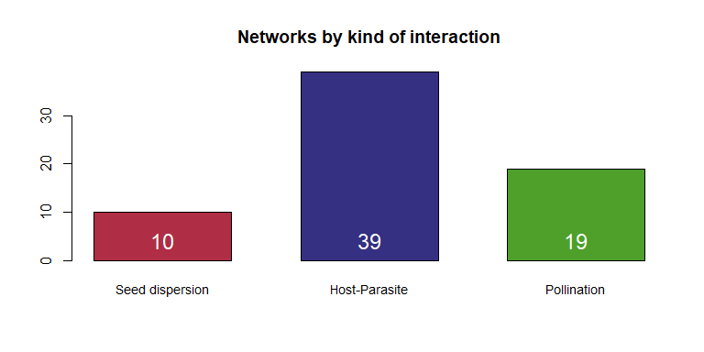

## 1.1. Warnings (matrix loadings)

Warnings for missing rows and columns in the weighted matrix.

Inconsistencies for the number of rows and columns between the binary and weighted matrices.

Inconsistencies within 2 decimal places for connectance.

## [1] "weighted TP-002 had 1 empty columns"  
## [1] "TP-002 Rows in binary matrix: 7 Rows in weighted matrix: 14"  
## [1] "TP-002 Cols in binary matrix: 6 Cols in weighted matrix: 11"  
## [1] "TP-002 Connectance in binary matrix: 0.52 Connectance in weighted matrix: 0.3"  
## [1] "weighted TP-008 had 1 empty rows"  
## [1] "weighted TP-008 had 6 empty columns"  
## [1] "TP-008 Rows in binary matrix: 11 Rows in weighted matrix: 19"  
## [1] "TP-008 Cols in binary matrix: 14 Cols in weighted matrix: 29"  
## [1] "TP-008 Connectance in binary matrix: 0.31 Connectance in weighted matrix: 0.38"  
## [1] "TP-014 Connectance in binary matrix: 0.19 Connectance in weighted matrix: 0.18"  
## [1] "TP-025 Rows in binary matrix: 840 Rows in weighted matrix: 883"  
## [1] "TP-025 Cols in binary matrix: 112 Cols in weighted matrix: 114"  
## [1] "TP-026 Rows in binary matrix: 91 Rows in weighted matrix: 85"  
## [1] "TP-026 Cols in binary matrix: 41 Cols in weighted matrix: 40"  
## [1] "TP-027 Rows in binary matrix: 314 Rows in weighted matrix: 318"  
## [1] "TP-028 Rows in binary matrix: 187 Rows in weighted matrix: 195"  
## [1] "TP-028 Connectance in binary matrix: 0.04 Connectance in weighted matrix: 0.03"  
## [1] "weighted TP-029 had 1 empty rows"  
## [1] "weighted TP-029 had 2 empty columns"  
## [1] "TP-029 Rows in binary matrix: 679 Rows in weighted matrix: 678"  
## [1] "TP-029 Cols in binary matrix: 91 Cols in weighted matrix: 89"  
## [1] "TP-030 Rows in binary matrix: 356 Rows in weighted matrix: 365"  
## [1] "TP-030 Cols in binary matrix: 90 Cols in weighted matrix: 91"  
## [1] "TP-045 Rows in binary matrix: 33 Rows in weighted matrix: 32"  
## [1] "TP-045 Connectance in binary matrix: 0.28 Connectance in weighted matrix: 0.26"  
## [1] "TP-081 Rows in binary matrix: 36 Rows in weighted matrix: 29"  
## [1] "TP-081 Cols in binary matrix: 61 Cols in weighted matrix: 43"  
## [1] "TP-081 Connectance in binary matrix: 0.08 Connectance in weighted matrix: 0.09"  
## [1] "TP-086 Rows in binary matrix: 44 Rows in weighted matrix: 43"  
## [1] "TP-099 Cols in binary matrix: 28 Cols in weighted matrix: 29"  
## [1] "TP-099 Connectance in binary matrix: 0.2 Connectance in weighted matrix: 0.19"  
## [1] "TP-103 Cols in binary matrix: 8 Cols in weighted matrix: 9"  
## [1] "TP-103 Connectance in binary matrix: 0.3 Connectance in weighted matrix: 0.28"  
## [1] "weighted TP-108 had 1 empty rows"  
## [1] "weighted TP-111 had 1 empty rows"  
## [1] "weighted TP-113 had 1 empty rows"  
## [1] "TP-114 Cols in binary matrix: 9 Cols in weighted matrix: 10"  
## [1] "TP-114 Connectance in binary matrix: 0.23 Connectance in weighted matrix: 0.22"  
## [1] "TP-117 Rows in binary matrix: 11 Rows in weighted matrix: 13"  
## [1] "TP-117 Connectance in binary matrix: 0.24 Connectance in weighted matrix: 0.22"  
## [1] "weighted TP-121 had 1 empty rows"  
## [1] "TP-125 Cols in binary matrix: 9 Cols in weighted matrix: 10"  
## [1] "TP-125 Connectance in binary matrix: 0.28 Connectance in weighted matrix: 0.26"  
## [1] "TP-126 Cols in binary matrix: 17 Cols in weighted matrix: 19"  
## [1] "TP-126 Connectance in binary matrix: 0.25 Connectance in weighted matrix: 0.23"  
## [1] "weighted TP-128 had 1 empty rows"  
## [1] "weighted TP-133 had 1 empty rows"

Networks with non integer cell values ( = host-endoparasite networks with prevalence) were rounded to 1 decimal place and then multiplied by 10.

## [1] "TP-097 has non integer values"  
## [1] "TP-097 rounded with 1 decimal place and multiplied by 10"  
## [1] "Values < 0.1 converted to 0.1 before this procedure"  
## [1] "TP-099 has non integer values"  
## [1] "TP-099 rounded with 1 decimal place and multiplied by 10"  
## [1] "Values < 0.1 converted to 0.1 before this procedure"  
## [1] "TP-104 has non integer values"  
## [1] "TP-104 rounded with 1 decimal place and multiplied by 10"  
## [1] "Values < 0.1 converted to 0.1 before this procedure"  
## [1] "TP-113 has non integer values"  
## [1] "TP-113 rounded with 1 decimal place and multiplied by 10"  
## [1] "Values < 0.1 converted to 0.1 before this procedure"  
## [1] "TP-122 has non integer values"  
## [1] "TP-122 rounded with 1 decimal place and multiplied by 10"  
## [1] "Values < 0.1 converted to 0.1 before this procedure"  
## [1] "TP-124 has non integer values"  
## [1] "TP-124 rounded with 1 decimal place and multiplied by 10"  
## [1] "Values < 0.1 converted to 0.1 before this procedure"

# 2. Binary vs. weighted indices (nestedness and modularity)

## 2.1. Correlation between binary nestedness (NODF) and weighted nestedness (WNODA):

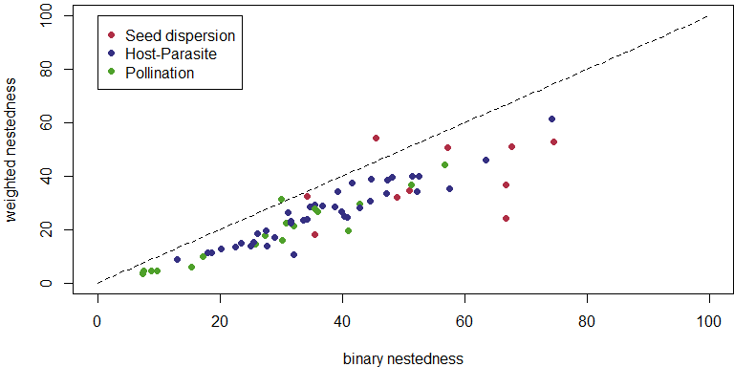

##   
## Spearman's rank correlation rho  
##   
## data: TABLE_RESULTS$WNODA and BIN_TABLE_RESULTS$NODF  
## S = 4584, p-value <2e-16  
## alternative hypothesis: true rho is not equal to 0  
## sample estimates:  
## rho   
## 0.913

The dashed line represents equal values of weighted and binary nestedness. Most of the points (66 out of 68) are bellow the line, which means that networks are more nested in their binary than in their weighted structures.

The correlation between binary and weighted nestedness is very high.

## 2.2. Correlation between binary and weighted modularity:

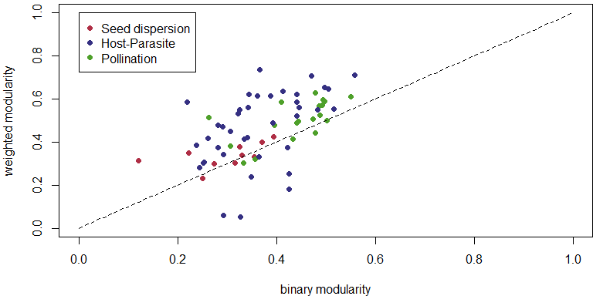

##   
## Spearman's rank correlation rho  
##   
## data: TABLE_RESULTS$modularity and BIN_TABLE_RESULTS$modularity  
## S = 21542, p-value = 2e-07  
## alternative hypothesis: true rho is not equal to 0  
## sample estimates:  
## rho   
## 0.589

The dashed line represents equal values of weighted and binary modularity. Most of the points (53 out of 68) are above the line, which means that networks are more modular in their weighted than in their binary structures.

# 3. Nestedness vs. Modularity

Weighted nestedness: we applied the WNODA index (Pinheiro et al. 2019).

Weighted modularity: we calculated Barber’s modularity index (Barber 2007) using the LPA and the DIRT LPA algorithms (Beckett 2016).

For too large networks (> 600 species), it was computational impracticable to apply the DIRT LPA algorithm, so we applied the faster, although a bit less effective, LPA.

|  |  |  |  |  |
| --- | --- | --- | --- | --- |
| ID | Interaction | References | rows | cols |
| TP-025 | pollin | Inoue 1990 | 883 | 114 |
| TP-029 | pollin | Kato 1990 | 678 | 89 |

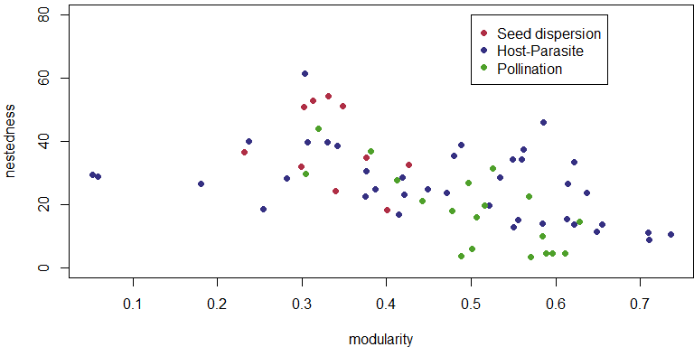

Testing the correlation between modularity and nestedness:

##   
## Spearman's rank correlation rho  
##   
## data: TABLE_RESULTS$WNODA and TABLE_RESULTS$modularity  
## S = 83820, p-value = 1e-07  
## alternative hypothesis: true rho is not equal to 0  
## sample estimates:  
## rho   
## -0.6

# 4. Correlations and comparisons

## 4.1. Connectance:

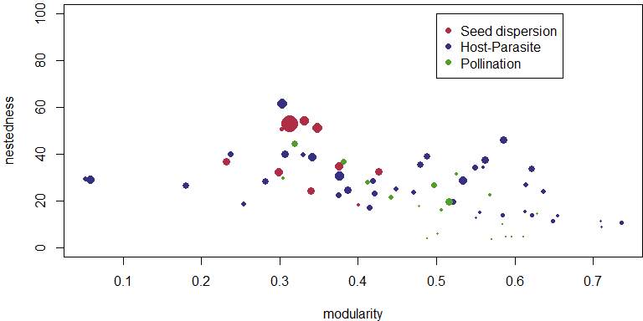

Correlation between modularity and connectance:

## Warning in cor.test.default(TABLE_RESULTS$modularity,  
## TABLE_RESULTS$connectance, : Cannot compute exact p-value with ties

##   
## Spearman's rank correlation rho  
##   
## data: TABLE_RESULTS$modularity and TABLE_RESULTS$connectance  
## S = 80923, p-value = 2e-06  
## alternative hypothesis: true rho is not equal to 0  
## sample estimates:  
## rho   
## -0.545

Correlation between nestedness and connectance:

## Warning in cor.test.default(TABLE_RESULTS$WNODA, TABLE_RESULTS$connectance, :  
## Cannot compute exact p-value with ties

##   
## Spearman's rank correlation rho  
##   
## data: TABLE_RESULTS$WNODA and TABLE_RESULTS$connectance  
## S = 11778, p-value = 9e-15  
## alternative hypothesis: true rho is not equal to 0  
## sample estimates:  
## rho   
## 0.775

## 4.2. Network size:

Size was log transformed (size = log(number of species))

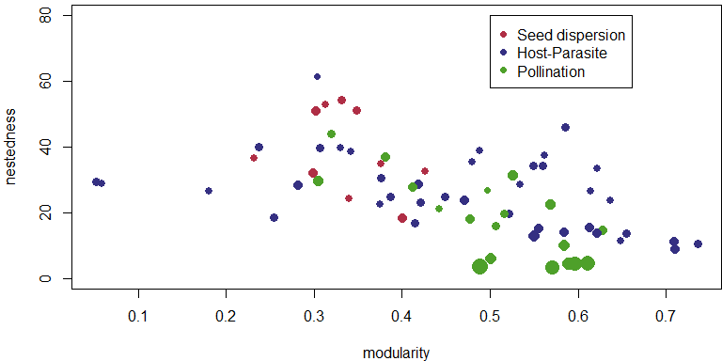

## 4.3. Nestedness vs. kind of interaction

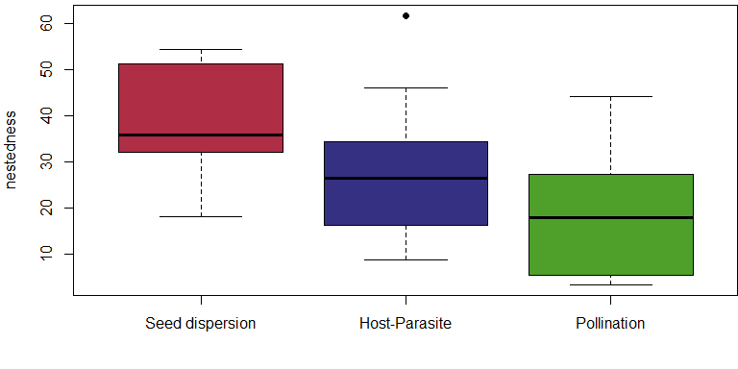

## 4.4. Modularity vs. kind of interaction

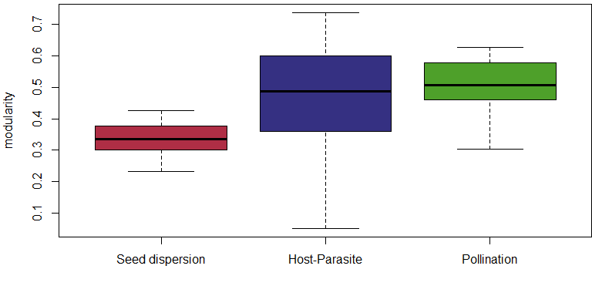

# 5. Modularity and nestedness significance

Null models in our study are composed of 105 randomized matrices each. This is not a very high number of matrices, but for computational limitations it was impracticable to produce larger null models. We analyzed a large number of real networks (binary: 142, weighted: 68), some of which including a very large number of species (max= 1881 species).

All weighted networks have link density higher than 1.

## 5.1. Significantly nested

Nestedness significance was assessed through comparisons with the equiprobable null model.

## [1] "Networks with significant nestedness: 15"

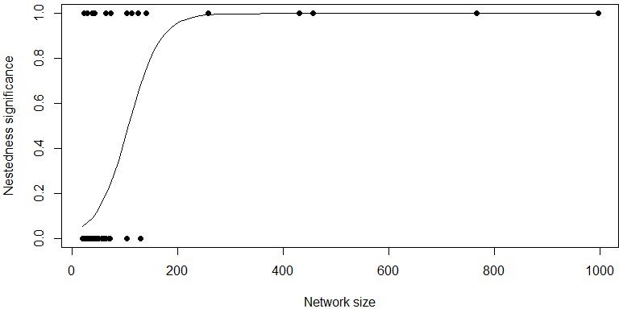

## 5.2. Significantly modular

Modularity significance was assessed through comparisons with the proportional null model.

## [1] "Networks with significant modularity: 67"

# 6. Nestedness SM and DM

For significant modular networks we calculated nestedness between species belonging to the same module (NSM) and nestedness between species in different modules (NDM) (Flores et al. 2013, Pinheiro et al. 2019, Felix et al. 2022).

## [1] "Modular networks: 67"

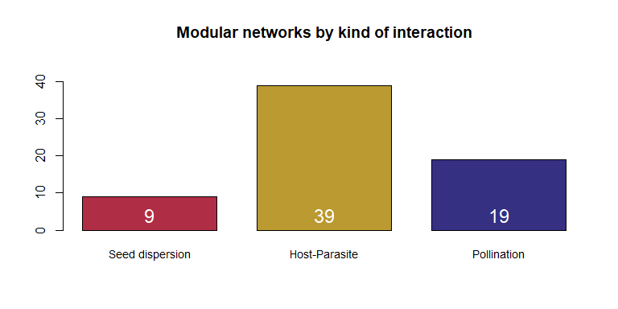

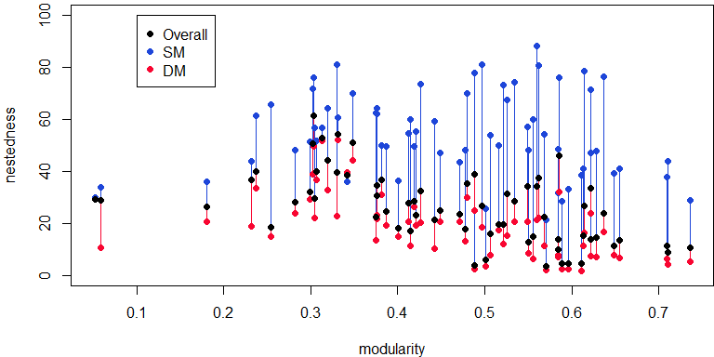

I applied local regressions (R function loess), very smoothly, to see the general trend of NODFO, NODFSM and NODFDM, with increasing modularity.

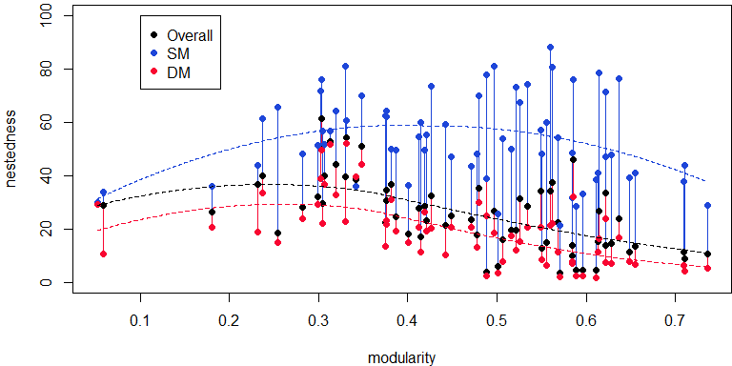

# 7. Significance of nestedness SM

We used restricted null models (models that conserve the modular structure on the networks) to test NSM significance.

## [1] "Networks with significant nestedness SM: 48"

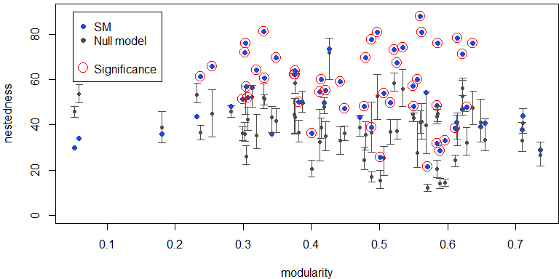

# 8. Network topologies

Significance tests:

Equiprobable null model for NO significance.

Proportional null model for modularity significance.

Equiprobable restricted null model for NSM significance.

Topologies:

Nested network: non-significant modularity and significant NO

Pure modular network: significant modularity and non-significant NSM

Compound topology: singnificant modularity and significant NSM

Unstructured: non significant NO and non significant modularity

|  |  |
| --- | --- |
| topology | Number of networks |
| nested | 1 |
| pure modular | 19 |
| compound | 48 |

## 8.1. Topology vs. kind of interaction

|  |  |  |  |
| --- | --- | --- | --- |
|  | seed dispersal | host-parasite | pollination |
| nested | 1 | 0 | 0 |
| pure modular | 3 | 15 | 1 |
| compound | 6 | 24 | 18 |

# 9. References

C. O. Flores, S. Valverde, J. S. Weitz, Multi-scale structure and geographic drivers of cross-infection within marine bacteria and phages. ISME J. 7, 520–532 (2013).

J. D. Hadfield, B. R. Krasnov, R. Poulin, S. Nakagawa, A Tale of Two Phylogenies: Comparative Analyses of Ecological Interactions. Am. Nat. 183, 174–187 (2014).

S. J. Beckett, Improved community detection in weighted bipartite networks. R. Soc. Open Sci. 3, 140536 (2016).

R. B. P. Pinheiro, G. M. F. Felix, C. F. Dormann, M. A. R. Mello, A new model explaining the origin of different topologies in interaction networks. Ecology 100, 1–30 (2019).

G. M. Felix, R. B. P. Pinheiro, R. Poulin, B. R. Krasnov, M. A. R. Mello, The compound topology of host–parasite networks is explained by the integrative hypothesis of specialization. Oikos 2022 (2022).