Data Science Project

1. Clustering skin cancer images
https://www.kaggle.com/kmader/skin-cancer-mnistham10000 select=HAM10000_images_part_2 (MNIST1000)

http://www.cs.rug.nl/~imaging/databases/melanoma_naevi/ (datasetWeb)

The dataset was splitted into folders that coresponds to the skin cancer type: HAM10000: Actinic keratoses and intraepithelial carcinoma / Bowen's disease (akiec), basal cell carcinoma (bcc), benign keratosis-like lesions (solar lentigines / seborrheic keratoses and lichen-planus like keratoses, bkl), dermatofibroma (df), melanoma (mel), melanocytic nevi (nv) and vascular lesions (angiomas, angiokeratomas, pyogenic granulomas and hemorrhage, vasc). Dataset PH2: Melanoma(mel), nevus(nv)

The initial goal for the project was to use the DIP-VAE autoencoder for merged skin cancer images and create latent features for further analysis such as clustering, regression and random forest walk.
After gathering the data and creating a csv data with labels (image name, kind of skin cancer) we ran the AIX360 code using google colabs and goolge drive to generate our model on our data. After many tres, we have generated only some pictures that go thru the deep convolutional network and crashes due to the error : FileNotFoundError: [Errno 2] No such file or directory: '/content/drive/My Drive/Dataset_skin_cancer/.DS_Store'. We did not find any hint in the internet for this issue. We assume that the code was written especially for iOS systems that use DS_Store directory to gather logs and other information about files that are needed to create the model. The DIPVAE algorithms seems to be a closed algorithm that is not adjustable for other images. Another problem that we faced was the computational limitation of google colabs that showed errors due to slow connection between the drive and computational unit. We have drop the project.

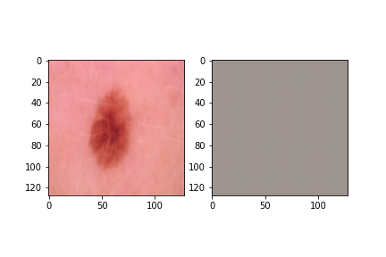
Figure demonstrates a skin lesion after epoch1
2. Modeling parlament votes of two german cities – Frankfurt and Dresden

2.1 Clustering
We aimed to create clusters to answer the question if the cities parts are similar to each other due to voting on parties. For example: Is Frankfurt Innenstadt voting similar to Dresden Innenstadt?
We performed k-means clustering but after the application, we decided that the information we got is not helping to answer this question. Using k-means we are forced to set the number of clusters but we do not know any grouping of our data. This leads us to agglomerative clustering, where the algorithm decides which data in the data frame is similar due to euclidian distance and creates own clusters.

2.1.1 Data Preprocessing

We faced the problem that our downloaded data had german characters and was not encoded in UTF-8. To outpass the problem we used a paramenter "encoding=" in panda.read_csv() method while opening the .csv data. The file "Dresden2017Prozente.csv" had also % characters that were removed. Another problem was that some of the columns and rows had a different data structure. The preprocessing data package helped to unify the values to floats. The clustering algorithms take as input only numpy arrays. After using numpy.arrays(our_dataframe) we got NA instead of 0, so we used another numpy method.

2.1.2 Agglomerative clustering results
The agglomerative clusteriring plot was generated with “agglomerative_clustering.ipynb”

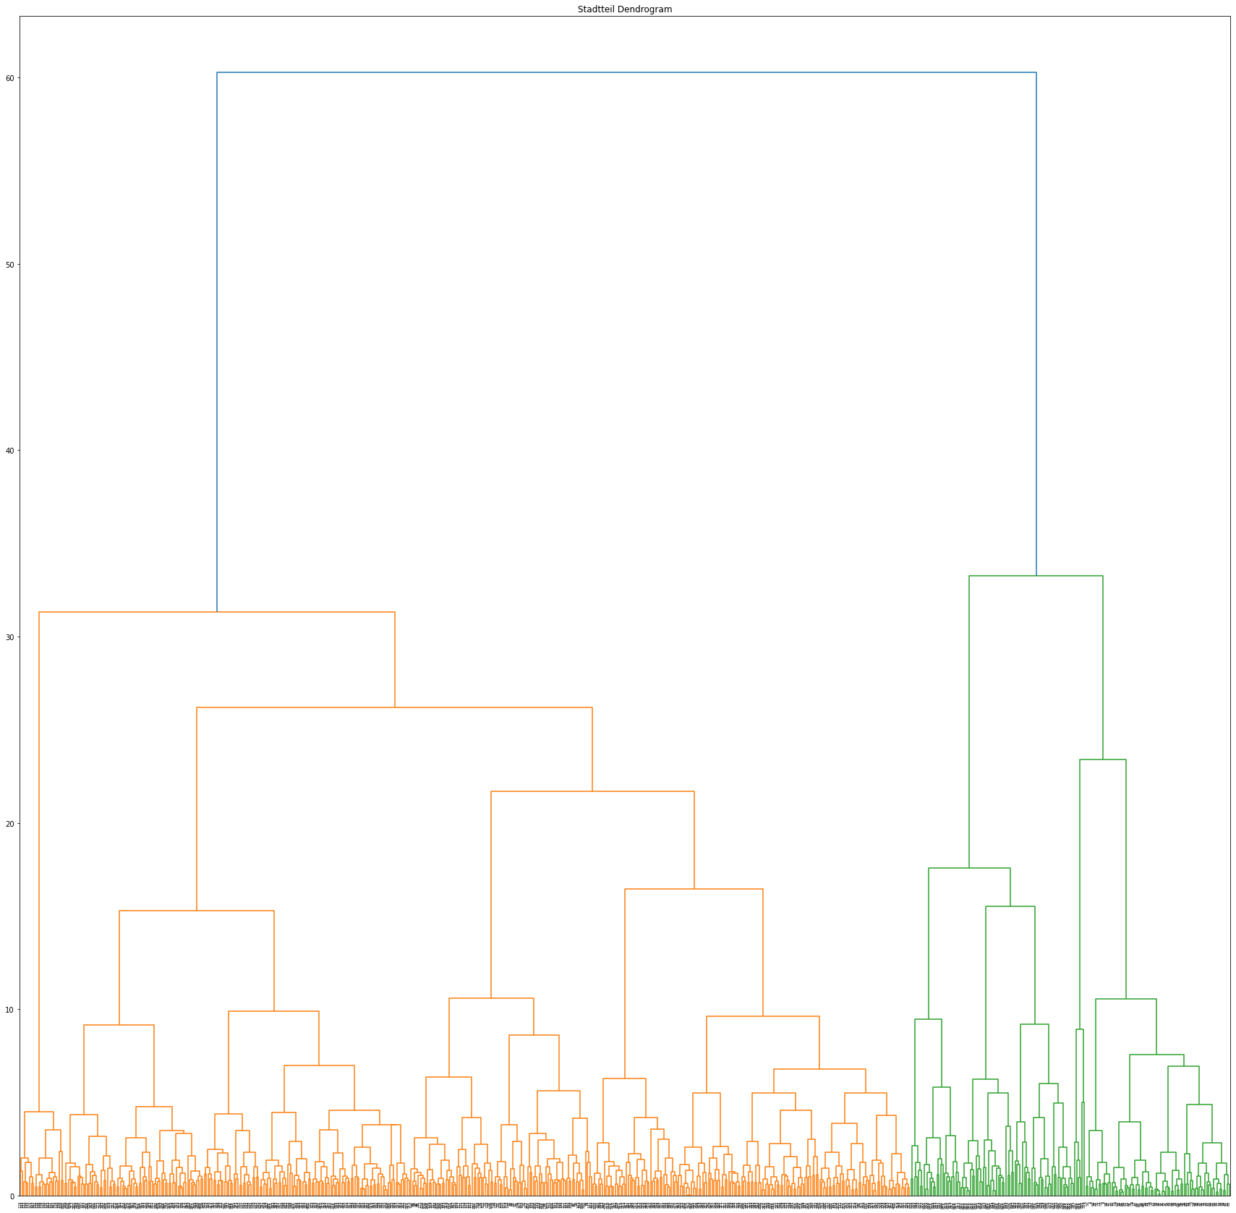

2.1.3 Discussion
As observed in the plot we have generated two big clusters that divide into smaller ones. What we found out is that for each city and city part the clusters are created first. For example city: Dresden, city part 9: Tolkewitz is paired with Dresden, city part: 11: Prohlis. It makes sense because the average voting for each party was very similar. Both districts had an average of 25% partial voting for CDU. We observe also that district 5 Muenchen pairs directly to district 504 Cotta Dresden because the votes are fairly similar to each other. Such connections between cities are rare for small clusters. The principle is that city parts of one city pair together first. This leads us to the assumption that those cities vote differently. Furthermore, the two big clusters indicate that Dresden as city votes more similar to Hamburg then to Muenchen.

