It is the index page.

It lets user to decide which type of data he want to insert/check/change.

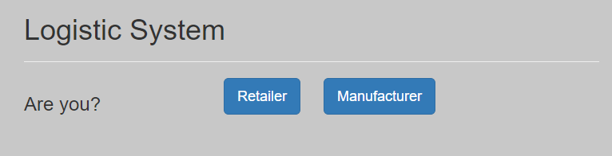

If user chooses retailer in index page,

he can insert retailer data by choosing retailer_data.csv file.

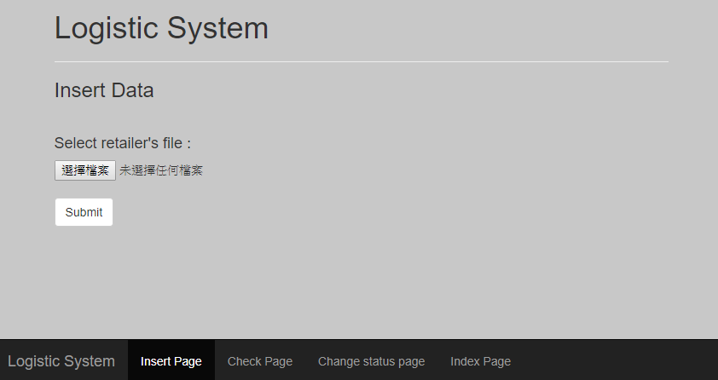

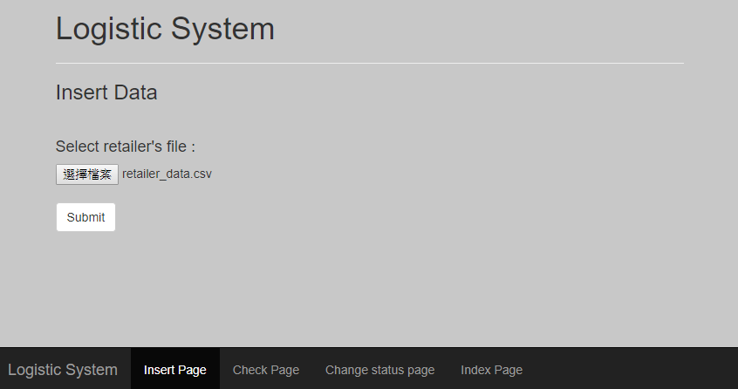

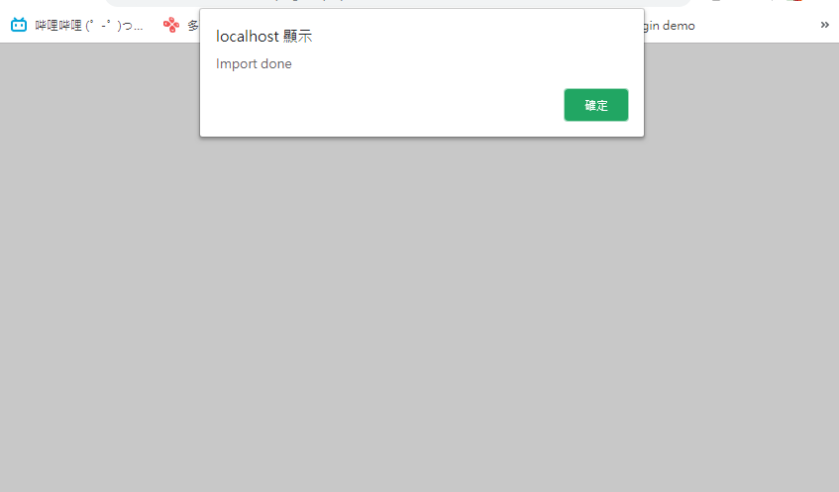

User can view the retailer data by entering the tracking number (bill number).

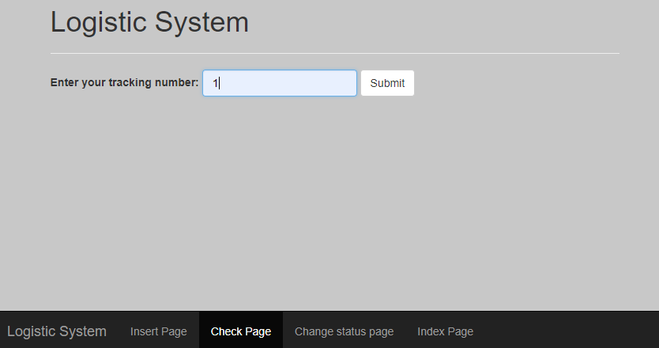

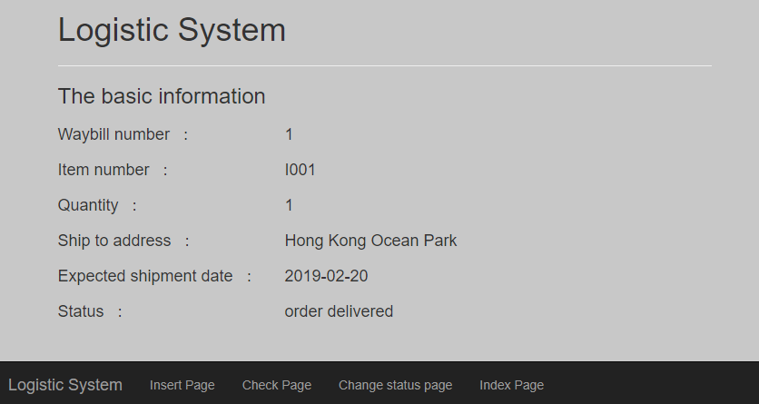

User can change the retailer bill status by entering the tracking number (bill number).

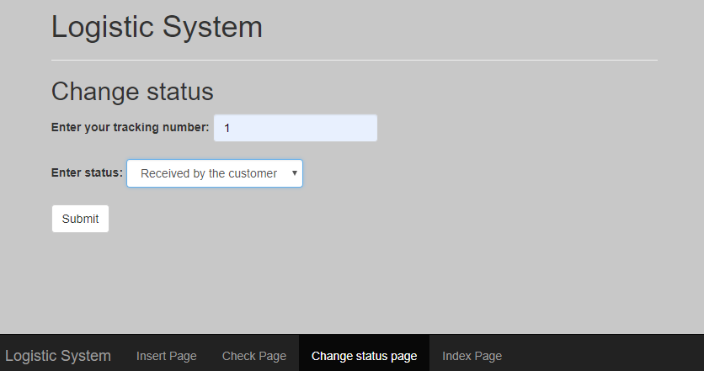

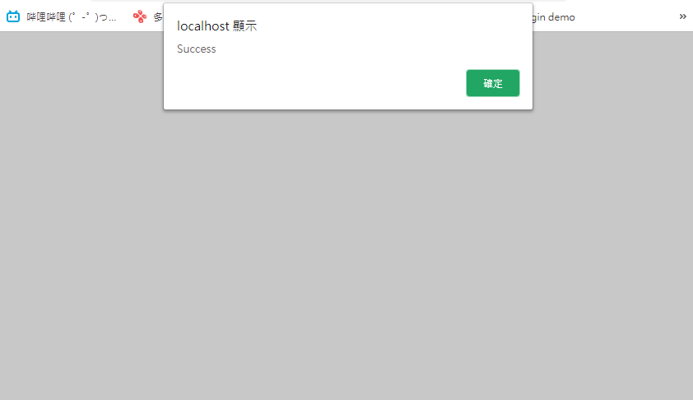

If user chooses manufacture in index page.

He can insert manufacturer data by choosing manufacturer_data.csv file

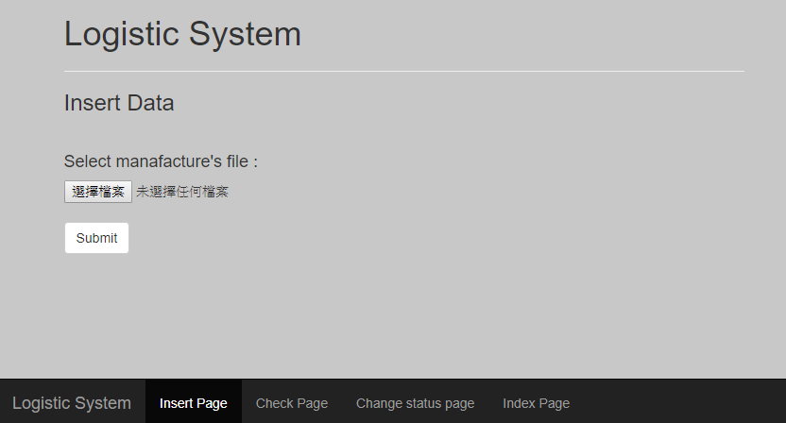

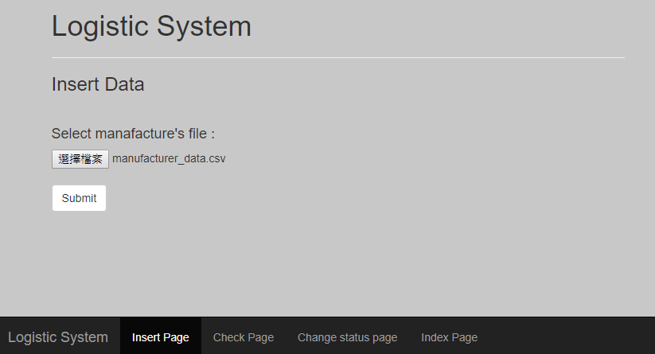

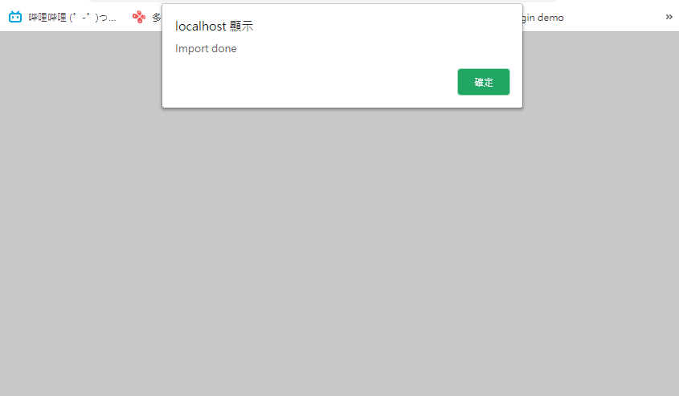

User can view the manufacturer data by entering the tracking number (bill number)

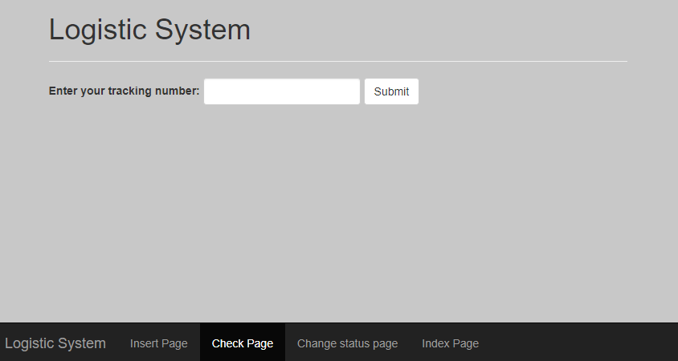

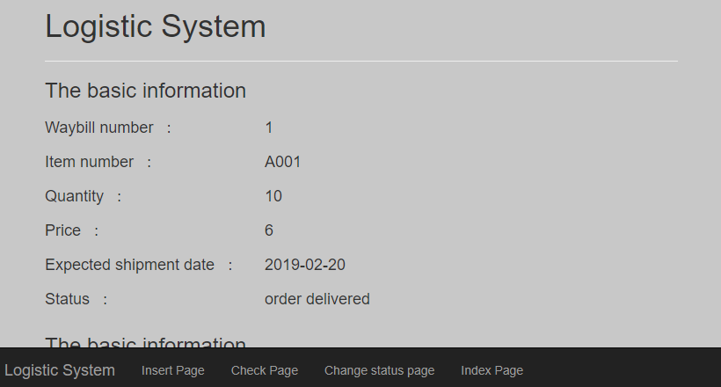

User can change the manufacturer bill status by entering the tracking number (bill number)

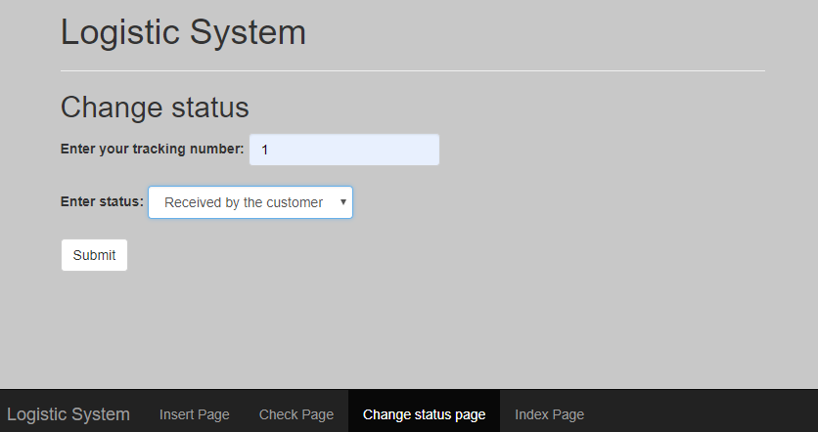

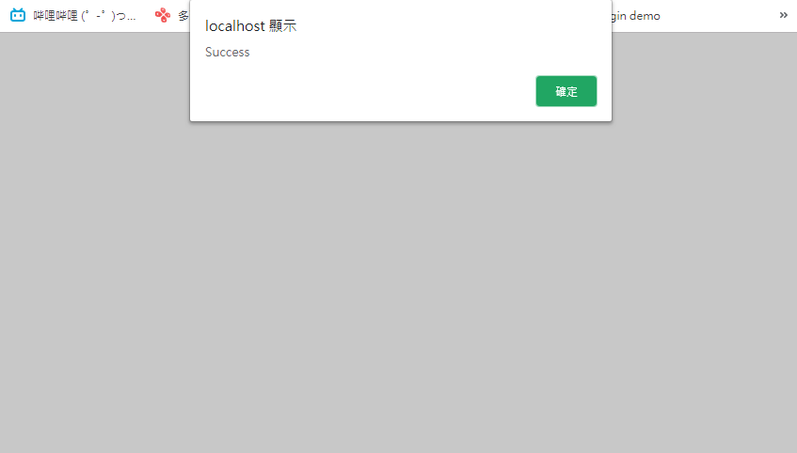

Here is the sample data of manufacturer and retailer.

manufacturer_order

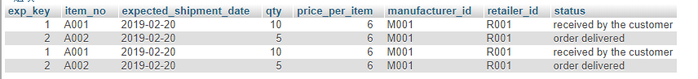

retailer_order



Here is the data interface layout.

