1. What is software? What is software engineering?

Software is a set of data, instructions and programs that are used to run computer and execute a specific task. Software engineering is a branch of computer science that deal with design, development, testing and maintenance of a software. Software engineers design software solutions.

1. Explain types of software.

System Software: Software which are already installed in user’s system are in build softwares.

Eg. Notepad,calculator

Application Software: Softwares which are created by software engineers to perform a specific task or a set of tasks for user.

Eg.Microsoft Office,office suits,graphic softwares

Driver Software: Driver Software is a part of system softwares. It is a type of software which enables user to perform specific task using devices attached to the system.

Eg.Audio driver,video driver,Game Controllers

Middleware Software:It is at the middle of both softwares system software and application softwares.

Eg. Database,application server

Programming software: The type of software allows programmer to write,test,debug code.

Eg.Sublime,VS Code,Turbo C

1. What is SDLC? Explain each phase of SDLC

SDLC stands for Software Development Life Cycle. It is a systematic process of developing a software from the scratch.This methodology creates a high quality software within time and budget. It involves 6 specific tasks.

1)Requirement Gathering

2)Analysis

3)Designing

4) Developing/Coding

5) Testing

6) Maintening

1)Requirement Gathering: Collecting required information from the client as well as other resources.Generally it demands a question that what is required to build.It involves planning part,too.

2)Analysis:After gathering requirements deciding on how to fulfil such requirements to create a software. Basically analyzing the requirements such as new modules to create,integrating modules,adding new features and functionalities to a new module or the same module.

3)Designing: This is basically designing part. Designing means how the product will look. It involves the front end designing too.

4)Developing:It is basically developing the software. It is performed by developers. This is the implementation part.Developers implements the idea they discovered during the Analysis phase.

5)Testing:Once the coding is completed it is time for testing . Testing is performed to check if there is any bug in the software or not. Testing is performed by Quality Analyst’ team.

6)Maintenance: Once the software is out from testing , it is then deployed. After deployment maintenance phase comes in action.Just in case some bugs are there, to resolve client queries, to implement new changes maintenance phase is required.On the other side the team monitors overall system performance, security and user experience.

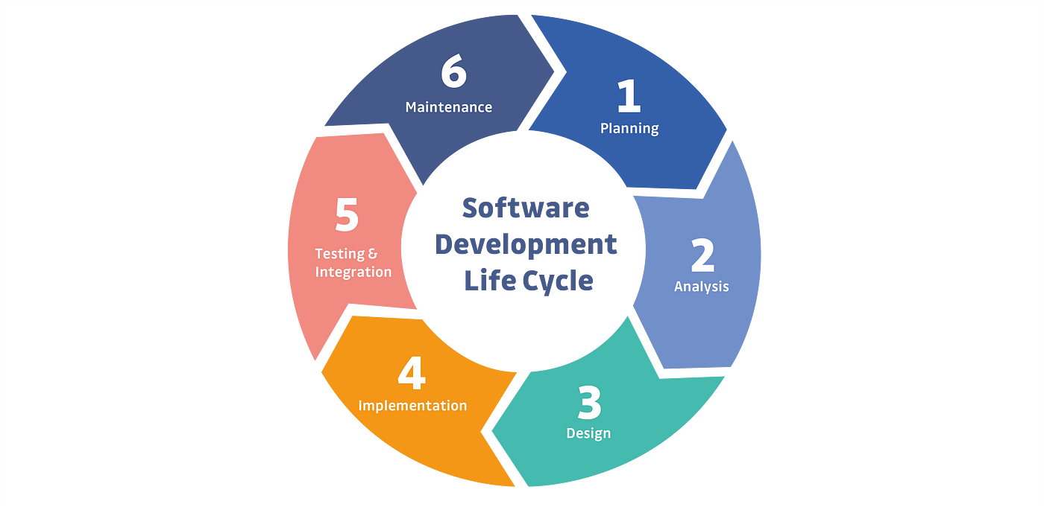

1. What is DFD ? Create a DFD diagram on flipkart.

DFD stands for Data Flow Diagram.It is basically a graphical representation of the data flow to be understood by technical and non technical user.It is generally performed during Analysis phase of a Software Development Life Cycle.It represents flow of data within information system.

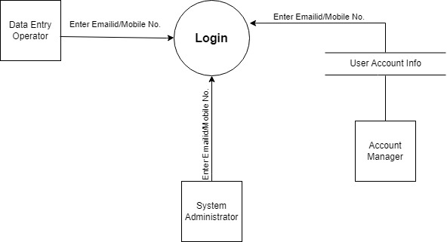

DFD-Login-01

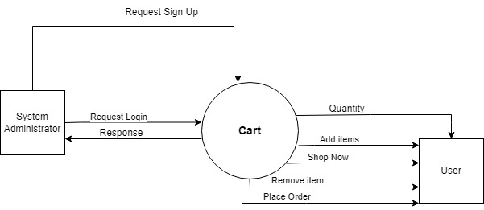

DFD-Cart-02

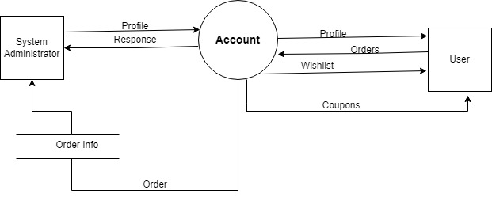

DFD-Account-03

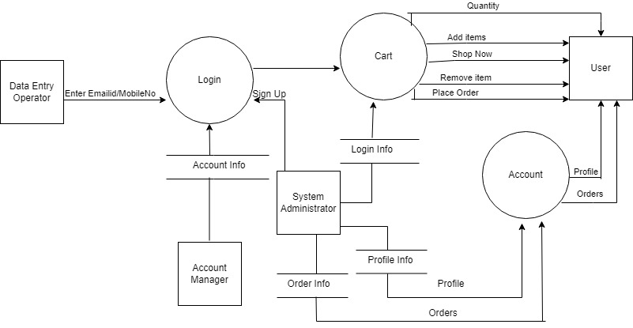

DFD-Flipkart-04

1. What is Flowchart? Create a flow chart to make addition of two numbers.

Flowchart represents a workflow or process. It can also be called as diagrammatic representation of algorithm or a step by step approach to solving a task.

Below is a flowchart to make addition of two numbers.

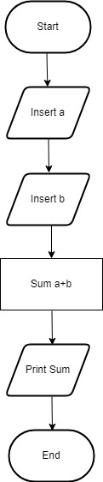

1. What is Use case diagram? Create a use case on bill payment on paytm.

It is basically a user’s possible interaction with a system. It is a unique functionality of a system which is accomplished by a user. Use case diagram captures core functionalities of a system and interacts with actors. Below is a use case representation of paytm.

