**Q1. What is the concept of a metaclass?**

**Ans: Metaclass in python is a class of a class that defines how a class behaves . A class is itself a instance of meta class, and any instance of class in python is an instance of type metaclass . E.g., type of int, str, float, list , tuple and many more is of metaclass type.**

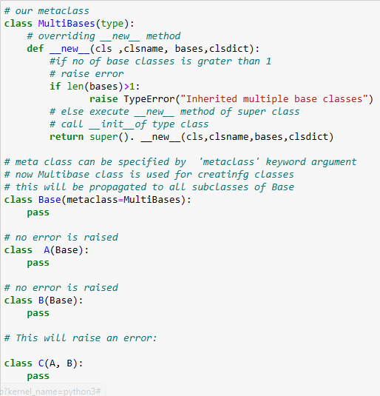

**Q2. What is the best way to declare a class's metaclass?**

Ans: A way to declare a class metaclass is by using **metaclass** keyword in class definition.

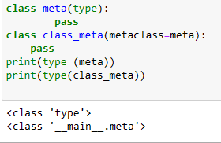

**Q3. How do class decorators overlap with metaclasses for handling classes?**

Ans: Anything you can do with a class decorator , you can of course do with a custom metaclasses (just apply the functionality of the “decorator function” , i.e., the one that takes a class object and modifies, in the course of the metaclass’s __new__ or __init__ that make the class object

**Q4. How do class decorators overlap with metaclasses for handling instances?**

Ans: Anything you can do with a class decorator , you can of course do with a custom metaclass (just apply the functionality of the “decorator function” , i.e., the one that takes a class object and modifies it, in the course of the metaclass’s **__new__** or **__init__** that make the class object!)