**Q1. Is an assignment operator like += only for show? Is it possible that it would lead to faster results at the runtime?**

Ans: A=A+1 evaluates to finding A , adding 1 to it. Then storing the value again in variable A . This expression makes python to look for memory holder of ‘a’ twice. But A+1 simply means value of A is to incremented by 1,As memory address has to be identified once, += leads to faster operation.

**Q2. What is the smallest number of statements you'd have to write in most programming languages to replace the Python expression a, b = a + b, a?**

**Ans:** Minimum number of lines required to write above code in languages other python will be 4, two for assigning initial values for variables a and b, and two for reassignment i.e., a= a +b and b=a.

**Q3. In Python, what is the most effective way to set a list of 100 integers to 0?**

**Ans: The Most effective way to set a list of 100 integers to 0 in python is by using repition operator (*) or by using list comprehension.**

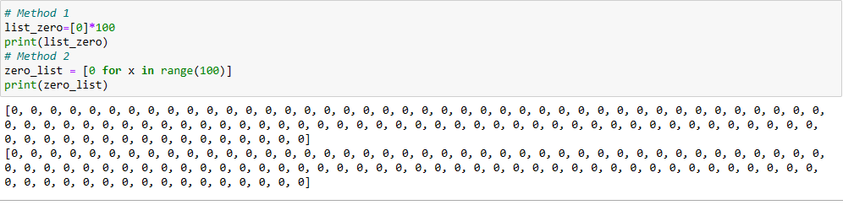

**Q4. What is the most effective way to initialise a list of 99 integers that repeats the sequence 1, 2, 3? S If necessary, show step-by-step instructions on how to accomplish this.**

**Ans:**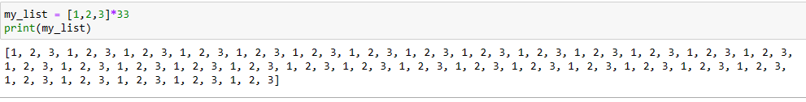

**Q5. If you're using IDLE to run a Python application, explain how to print a multidimensional list as efficiently?**

**Ans:**

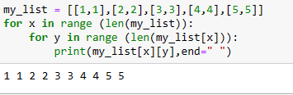

**Q6. Is it possible to use list comprehension with a string? If so, how can you go about doing it?**

Ans**:** List comprehension with string is possible

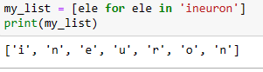

**Q7. From the command line, how do you get support with a user-written Python programme? Is this possible from inside IDLE?**

**Ans: Get support with a user –written python programme:** start a command prompt(window or terminal window (Linux/Mac). If the current working directory is the same as the location in which you saved the file , you can simply specify the filename as a command-line argument to the python interpreter.

**Get support with a user-written python program from IDLE:** you can also create script files and run them in IDLE. From the shell window menu, select **File → New File.** That should open an additional editing window. Type in the code to be execute , From the menu in the window. Type in the code to be executed . From the menu in that window, **Select File → Save** or **File →Save** **As** and save the file to desk . Then **select Run →Run Module** . The output should appear back in the interpreter

**Q8. Functions are said to be “first-class objects” in Python but not in most other languages, such as C++ or Java. What can you do in Python with a function (callable object) that you can't do in C or C++?**

**Ans**: The task which can be performed with the function in python are:

* A function is an instance of the object type.
* You can store the function in a variable.
* You can pass the function as a parameter to another function.
* You can return the function from a function.
* You can store them in data structures such as hash tables , lists

**Q9. How do you distinguish between a wrapper, a wrapped feature, and a decorator?**

**Ans: Wrappers around the functions are known as a decorators.**

**Q10. If a function is a generator function, what does it return?**

Ans: Generator functions are a special kind of function that return a **lazy iterator** . These are objects that you can loop over like a list . However , unlike lists, lazy iterators do not store their contents in memory

**Q11. What is the one improvement that must be made to a function in order for it to become a generator function in the Python language?**

**Ans:** Generator is a written as normal function but uses **Yield** keyword to return values instead or **return** keyword

**Q12. Identify at least one benefit of generators.**

**Ans: return** statement sends a specified value back to its caller whereas **yield** statement can produce a sequence of values. We should use generator when we want to iterate over a sequence, but don’t want to store the entire sequence in memory