**1.What are the two values of the Boolean data type? How do you write them?**

Ans: there are true and false

**2. What are the three different types of Boolean operators?**

Ans: the three different types of Boolean operators are: AND,OR, and NOT

**3. Make a list of each Boolean operator's truth tables (i.e. every possible combination of Boolean values for the operator and what it evaluate ).**

**Ans: AND operator: OR operator:**

**A B OUTPUT A B OUTPUT**

0 0 0 0 0 0

0 1 0 0 1 1

1 0 0 1 0 1

1 1 1 1 1 1

**4. What are the values of the following expressions?**

(5 > 4) and (3 == 5) = False

not (5 > 4) =False

(5 > 4) or (3 == 5) = True

not ((5 > 4) or (3 == 5)) =False

(True and True) and (True == False) =False

(not False) or (not True) =True

**5. What are the six comparison operators?**

**Ans: ==**(Equal to), **>**(greater than), **<**(less than)**, >**=(grater than or equal to), **<=**(less than or equal to), **<>**(not equal to)

**6. How do you tell the difference between the equal to and assignment operators?Describe a condition and when you would use one.**

**Ans:** == is the equal operator to operator that compares the values and evaluates to a Boolean,while = is the assignment operator that stores a value in a veriable.

A Condition is an expression used in a flow control statement that evaluates to a Boolean value.

**7. Identify the three blocks in this code:**

**spam = 0**

**if spam == 10:**

**print('eggs')**

**if spam > 5:**

**print('bacon')**

**else:**

**print('ham')**

**print('spam')**

**ans:**The three blocks are everything inside the if statement and the lines print(‘bacon’) and print(‘ham’).

Print(‘eggs’)

If spam >5:

Print(‘bacon’)

else:

print(‘ham’)

print(‘spam’)

**8. Write code that prints Hello if 1 is stored in spam, prints Howdy if 2 is stored in spam, and prints Greetings! if anything else is stored in spam.**

**Ans:** 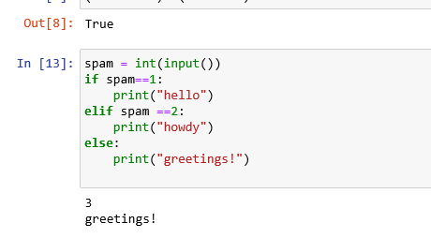

**9.If your programme is stuck in an endless loop, what keys you’ll press?**

**Ans:** press ctrl-c to stop a program stuck in an infinite loop

**10. How can you tell the difference between break and continue?**

**Ans:** Break statement is used to skip the iterations of a loop if some condition is satisfied.e.g; 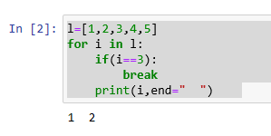

Whereas,continue is like a jump point which ignores current iteration and then continue from the next iteration in a loop.e.g;

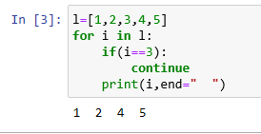

**11. In a for loop, what is the difference between range(10), range(0, 10), and range(0, 10, 1)?**

**Ans**: basically there is no difference between the 3 given range function output values.

range function in python accepts 3 parameters start,stop, and step.

**Start** is optional.when not provided,it defaults to 0.

**Stop** is mandatory.range will generate numbers up to but not including the value of stop.

**Step** is optional.when not provided,its defaults to 1

So,this is how range (0,10,1) works.

0 would be the starting point of your range. 1 would be the step,and valid numbers in the range would be more than 0,less than 10 with a gap of 1 values.

As a output you will get

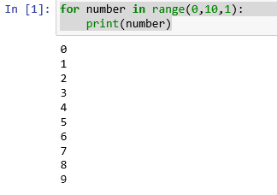

This is how range(0,10) works

Here step is muted but by default it 1 ,so the output you will get

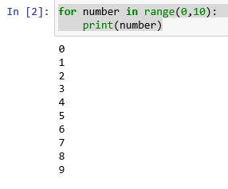

This is how range (10) works

Here start is not mention and default its 0 ansd step by default to 1, so the output is

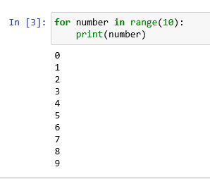

**12. Write a short program that prints the numbers 1 to 10 using a for loop. Then write an equivalent program that prints the numbers 1 to 10 using a while loop**.

ans: **while loop:**

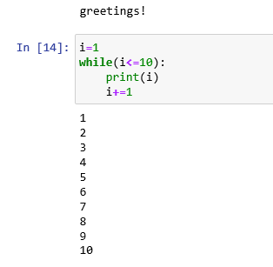

**13. If you had a function named bacon() inside a module named spam, how would you call it after importing spam?**

**Ans:** The function can be call with spam.bacon()