**1. What exactly is []?**

**Ans:** The empty list value, which is a list value that contains no items.

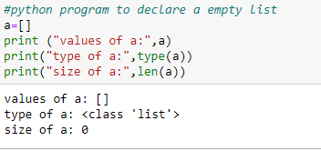

**2. In a list of values stored in a variable called spam, how would you assign the value 'hello' as the third value? (Assume [2, 4, 6, 8, 10] are in spam.)**

Ans: spam[2] =’hello’ (lists follows zero based indexing)

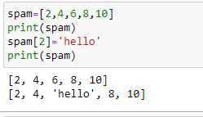

**Let's pretend the spam includes the list ['a', 'b', 'c', 'd'] for the next three queries.**

**3. What is the value of spam[int(int('3' * 2) / 11)]?**

Ans: The value is ’d’ (‘3’*2 is the string ‘33’,which is passed to int() before being devided by 11.This eventually evaluate to 3,spam[3] is equal to d.)

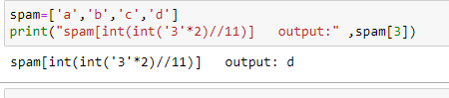

**4. What is the value of spam[-1]?**

Ans: The value is ’d’ (list support negative indexing ,and negative indexing start from last item of the list)

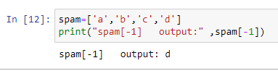

**5. What is the value of spam[:2]?**

Ans: The value is [‘a’,’b’] (return all the elements in the list spam from 0 to 2 excluding 2)

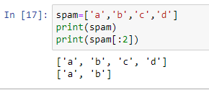

**Let's pretend bacon has the list [3.14, 'cat,' 11, 'cat,' True] for the next three questions.**

**6. What is the value of bacon.index('cat')?**

**Ans:** The value is 1(as indexing start from zero ,so it’s returns the index of first occurrence of ‘cat’)

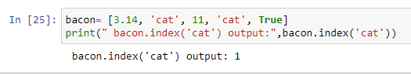

**7. How does bacon.append(99) change the look of the list value in bacon?**

**Ans:** The append method adds new elements to the end of the list

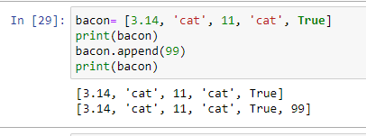

**8. How does bacon.remove('cat') change the look of the list in bacon?**

**Ans:**The remove method remove the first occurrence of the list (as here ‘cat ‘ is used two times so it’s remove the first ‘cat’ veriable)

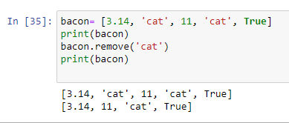

**9. What are the list concatenation and list replication operators?**

**Ans:** The operator for list concatenation is +, while the operator for replication is *.

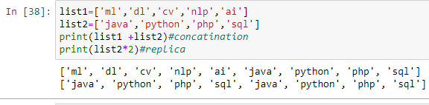

**10. What is difference between the list methods append() and insert()?**

**Ans:** While append() will add values only to the end of a list, insert() can add them anywhere in the list.

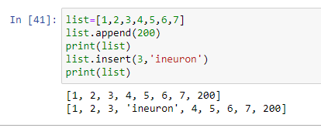

**11. What are the two methods for removing items from a list?**

Ans:There are two methods for removing items from a list .One is by index that use del statement and the other way to do it by element useing remove() method.

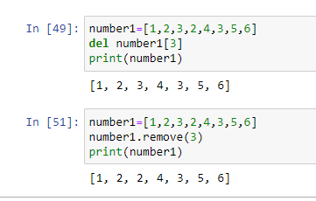

**12. Describe how list values and string values are identical.**

**Ans:**

**13. What's the difference between tuples and lists?**

**Ans:** list is mutable while tuples are immutable,this means tuples cannot be changed while the lists can be modified.tuples are more memory efficient than the lists.Also ,tuples are represented using parentheses (),while list use the square brackets [].

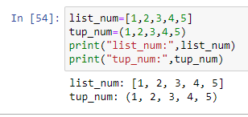

**14. How do you type a tuple value that only contains the integer 42?**

**Ans**:(42,)(The trailing comma is mandatory.otherwise its considered as aint by python interpreter)

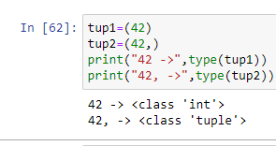

**15. How do you get a list value's tuple form? How do you get a tuple value's list form?**

**Ans:**The tuple() and list() function,respectively are used to covert alist to tuple and vice versa

**16. Variables that "contain" list values are not necessarily lists themselves. Instead, what do they contain?**

**Ans:**They contain references to list values.

**17. How do you distinguish between copy.copy() and copy.deepcopy()?**

**Ans:** A shallow copy constructs a new compound object and then(to the extend possible)inserts references into it to the objectsfound in the original.

A deep copy constructs a new compound object and then,recursively,inserts copies into it of the objects found in the original.