**1. What are escape characters, and how do you use them?**

**Ans:**escape characters represent characters in string values that would otherwise be difficult or impossible to type into code.

**2. What do the escape characters n and t stand for?**

**Ans:** \n is a new line;\t is a tab

**3. What is the way to include backslash characters in a string?**

**Ans:** The \\ escape character will represent a backslash character.

**4. The string "Howl's Moving Castle" is a correct value. Why isn't the single quote character in the word Howl's not escaped a problem?**

**Ans:**T he single quote in HOWl’s has no problem because you have used double quotes to mark the beginning and end of the string.

**5. How do you write a string of newlines if you don't want to use the n character?**

Ans: by using \n at the end of our string.

**6. What are the values of the given expressions?**

**'Hello, world!'[1] =**

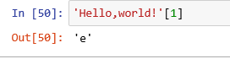

**'Hello, world!'[0:5] =**

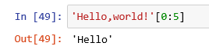

**'Hello, world!'[:5] =**

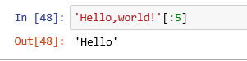

**'Hello, world!'[3:] =**

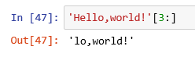

**7. What are the values of the following expressions?**

'Hello'.upper() =**’HELLO’**

'Hello'.upper().isupper() =**True**

'Hello'.upper().lower() =**’hello’**

**8. What are the values of the following expressions?**

**'Remember, remember, the fifth of July.'.split()**

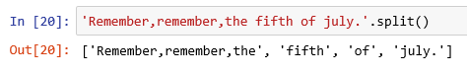

**'-'.join('There can only one.'.split())**

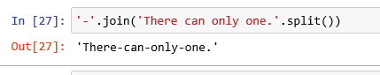

**9. What are the methods for right-justifying, left-justifying, and centering a string?**

**Ans: rjust(len,fillchr) for** right-justifying, **ljust(len,fillchr)** for left-justifying, **center(len,fillchr)** for centering string.

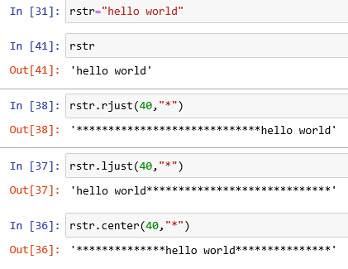

**10. What is the best way to remove whitespace characters from the start or end?**

**Ans: string strip()** is the best way

**e.g;**

