|  |
| --- |
| **Question 1:** |
|  |

**Define a class with a generator which can iterate the numbers, which are divisible by 7, between a given range 0 and n.**

**Ans:**

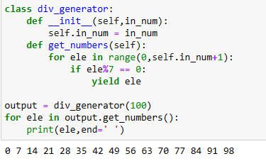

**Question 2:**

|  |
| --- |
| **Write a program to compute the frequency of the words from the input. The output should output after sorting the key alphanumerically.** |
|  |

|  |
| --- |
| **Suppose the following input is supplied to the program:** |
|  |

|  |
| --- |
| **New to Python or choosing between Python 2 and Python 3? Read Python 2 or Python 3.** |
|  |

|  |
| --- |
| **Then, the output should be:** |
|  |

|  |
| --- |
| **2:2** |
|  |

|  |
| --- |
| **3.:1** |
|  |

|  |
| --- |
| **3?:1** |
|  |

|  |
| --- |
| **New:1** |
|  |

|  |
| --- |
| **Python:5** |
|  |

|  |
| --- |
| **Read:1** |
|  |

|  |
| --- |
| **and:1** |
|  |

|  |
| --- |
| **between:1** |
|  |

|  |
| --- |
| **choosing:1** |
|  |

|  |
| --- |
| **or:2** |
|  |

**to:1**

**ans:**

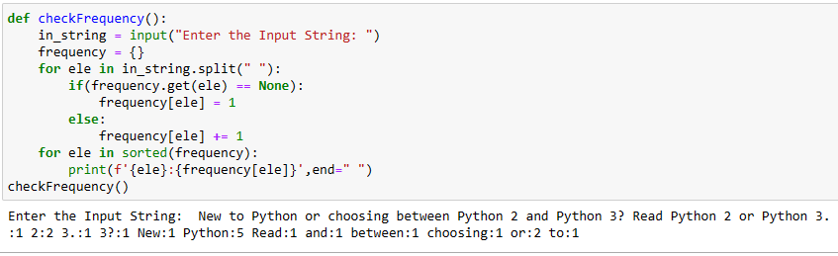

|  |
| --- |
| **Question 3:** |
|  |

|  |
| --- |
|  |
|  |

**Define a class Person and its two child classes: Male and Female. All classes have a method "getGender" which can print "Male" for Male class and "Female" for Female class.**

Ans:

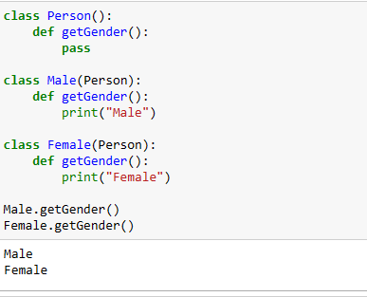

**Question 4:**

**Please write a program to generate all sentences where subject is in ["I", "You"] and verb is in ["Play", "Love"] and the object is in ["Hockey","Football"].**

**Ans:**

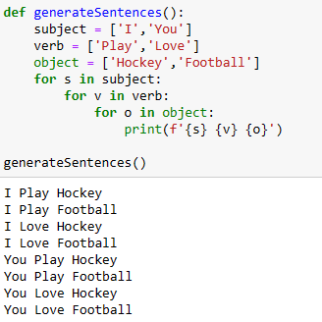

**Question 5:**

**Please write a program to compress and decompress the string "hello world!helloworld!helloworld!hello world!".**

**Ans:**

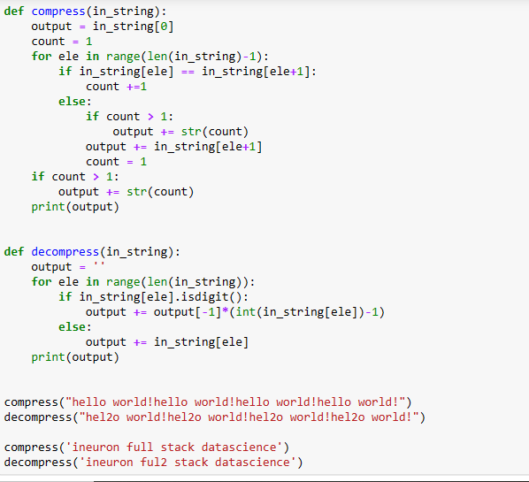

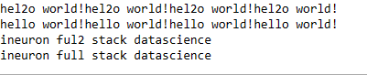

**Question 6:**

**Please write a binary search function which searches an item in a sorted list. The function should return the index of element to be searched in the list.**

**Ans:**

