1. **Write a Python program to find sum of elements in list?**

**Ans:**

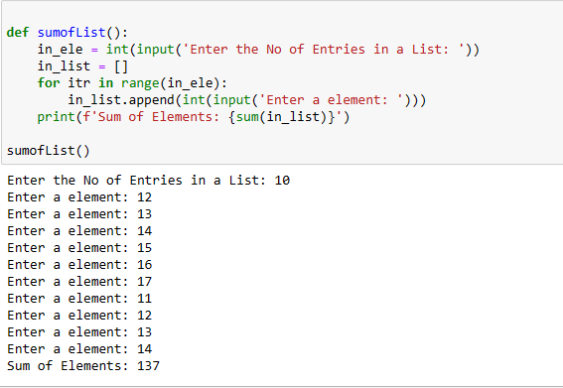

1. **Write a Python program to Multiply all numbers in the list?**

**Ans:**

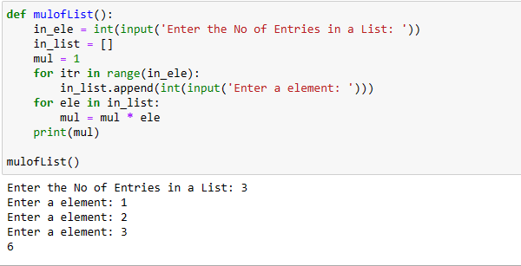

1. **Write a Python program to find smallest number in a list?**

**Ans:**

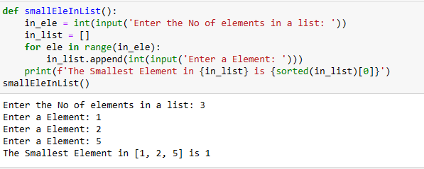

1. **Write a Python program to find largest number in a list?**

**Ans:**

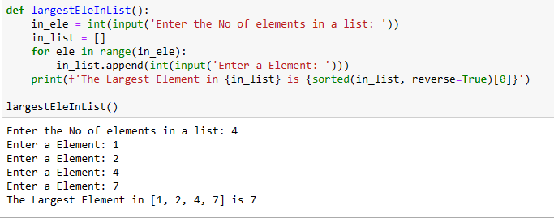

1. **Write a Python program to find second largest number in a list?**

**Ans:**

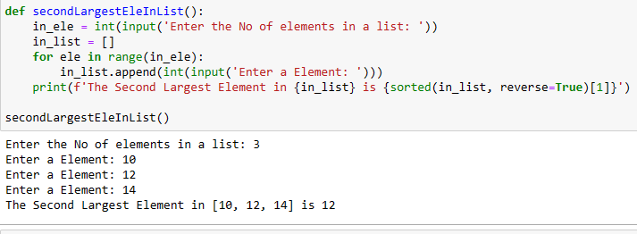

1. **Write a Python program to find N largest elements from a list?**

**Ans:**

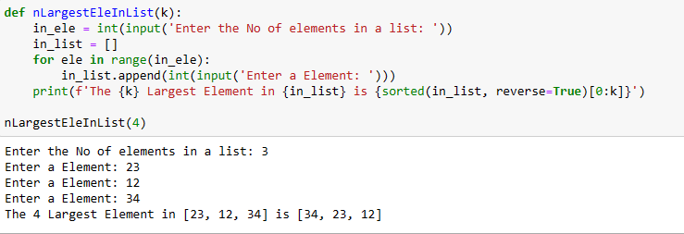

1. **Write a Python program to print even numbers in a list?**

**Ans:**

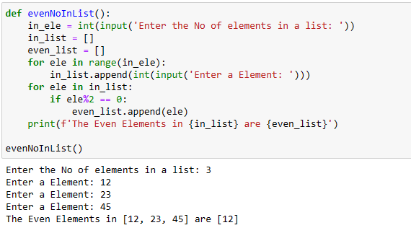

1. **Write a Python program to print odd numbers in a List?**

**Ans:**

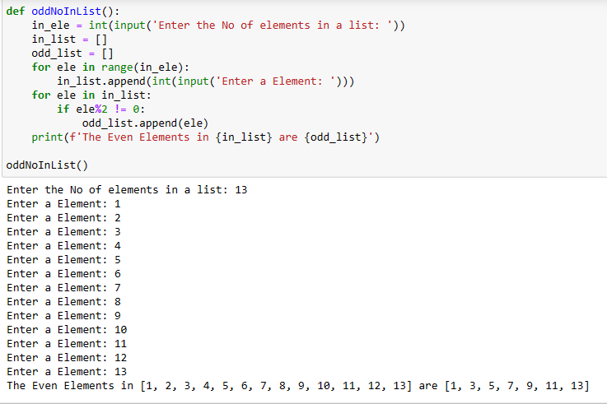

1. **Write a Python program to Remove empty List from List?**

**Ans:**

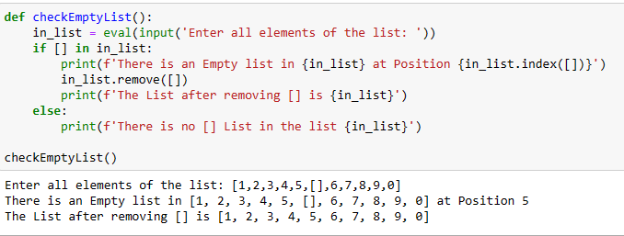

1. **Write a Python program to Cloning or Copying a list?**

**Ans:**

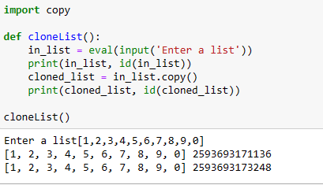

1. **Write a Python program to Count occurrences of an element in a list?**

**Ans:**

