1. **Write a Python program to find words which are greater than given length k?**

**Ans:**

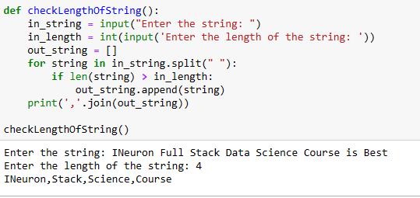

1. **Write a Python program for removing i-th character from a string?**

**Ans:**

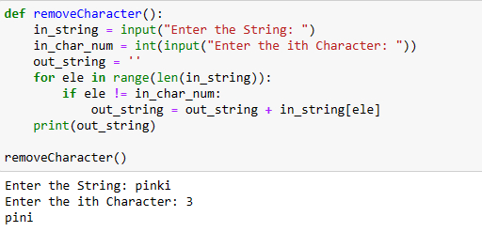

1. **Write a Python program to split and join a string?**

**Ans:**

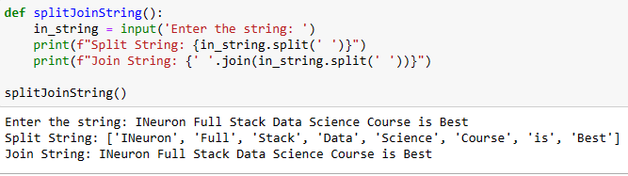

1. **Write a Python to check if a given string is binary string or not?**

**Ans:**

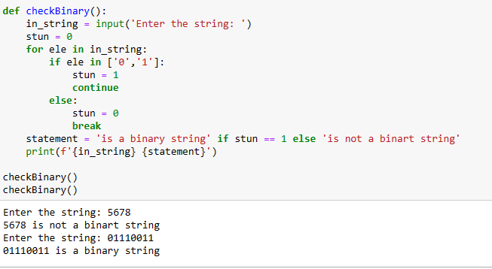

1. **Write a Python program to find uncommon words from two Strings?**

**Ans:**

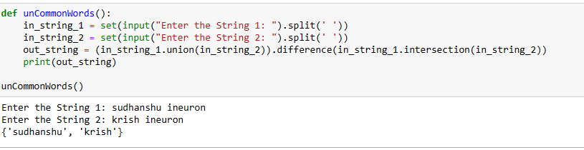

1. **Write a Python to find all duplicate characters in string?**

**Ans:**

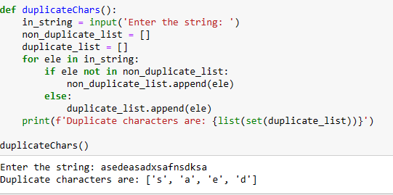

1. **Write a Python Program to check if a string contains any special character?**

**ans:**

