1. **Write a Python program to Extract Unique values dictionary values?**

**Ans:** 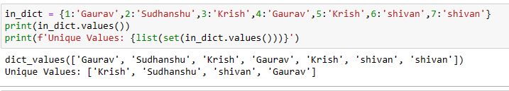

1. **Write a Python program to find the sum of all items in a dictionary?**

**Ans:**

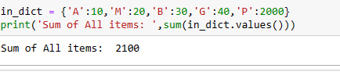

1. **Write a Python program to Merging two Dictionaries?**

**Ans:**

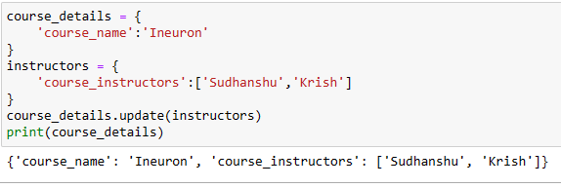

1. **Write a Python program to convert key-values list to flat dictionary?**

**Ans:**

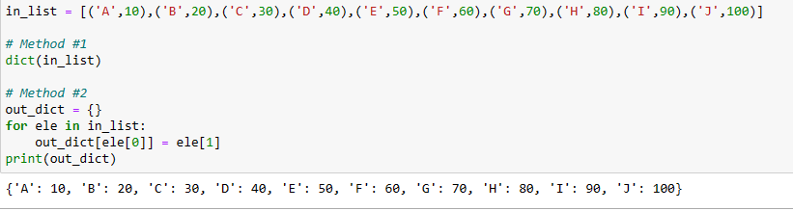

1. **Write a Python program to insertion at the beginning in OrderedDict?**

**Ans:**

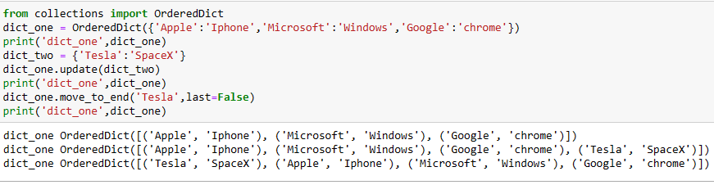

1. **Write a Python program to check order of character in string using OrderedDict()?**

**Ans:**

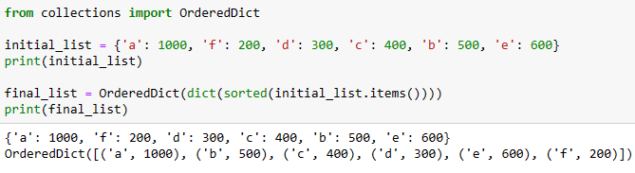

1. **Write a Python program to sort Python Dictionaries by Key or Value?**

**Ans:**

