**Question 1:**

**Please write a program using generator to print the numbers which can be divisible by 5 and 7 between 0 and n in comma separated form while n is input by console.**

**Example:  
If the following n is given as input to the program:**

**100**

**Then, the output of the program should be:**

**0,35,70**

**Ans:** 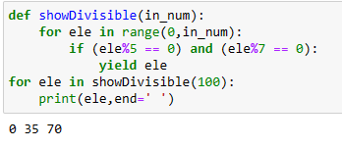

**Question 2:**

**Please write a program using generator to print the even numbers between 0 and n in comma separated form while n is input by console.**

**Example:  
If the following n is given as input to the program:**

**10**

**Then, the output of the program should be:**

**0,2,4,6,8,10**

**Ans:**

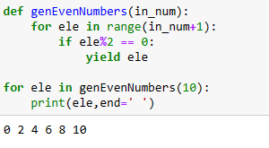

**Question 3:**

**The Fibonacci Sequence is computed based on the following formula:**

**f(n)=0 if n=0  
f(n)=1 if n=1  
f(n)=f(n-1)+f(n-2) if n>1**

**Please write a program using list comprehension to print the Fibonacci Sequence in comma separated form with a given n input by console.**

**Example:  
If the following n is given as input to the program:**

**7**

**Then, the output of the program should be:**

**0,1,1,2,3,5,8,13**

**Ans:**

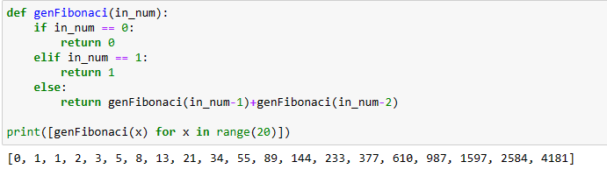

**Question 4:**

**Assuming that we have some email addresses in the "**[**username@companyname.com**](mailto:username@companyname.com)**" format, please write program to print the user name of a given email address. Both user names and company names are composed of letters only.**

**Example:  
If the following email address is given as input to the program:**

[**john@google.com**](mailto:john@google.com)

**Then, the output of the program should be:**

**John**

**Ans:**

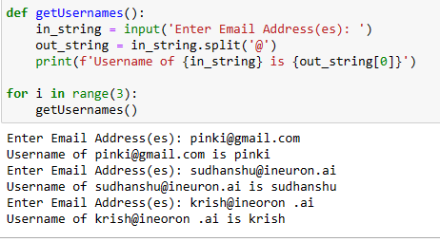

**Question 5:**

**Define a class named Shape and its subclass Square. The Square class has an init function which takes a length as argument. Both classes have a area function which can print the area of the shape where Shape's area is 0 by default.**

**Ans:**

