Question1

Create a function that takes three integer arguments (a, b, c) and returns the amount of integers which are of equal value.

**Examples**

equal(3, 4, 3) ➞ 2

equal(1, 1, 1) ➞ 3

equal(3, 4, 1) ➞ 0

**Notes**

Your function must return 0, 2 or 3.

Ans:

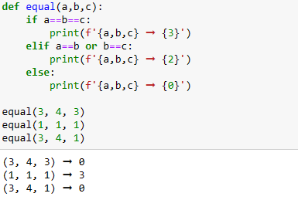

Question2

Write a function that converts a **dictionary** into a **list** of keys-values **tuples**.

### Examples

dict_to_list({

"D": 1,

"B": 2,

"C": 3

}) ➞ [("B", 2), ("C", 3), ("D", 1)]

dict_to_list({

"likes": 2,

"dislikes": 3,

"followers": 10

}) ➞ [("dislikes", 3), ("followers", 10), ("likes", 2)]

### Notes

Return the elements in the list in alphabetical order.

Ans: 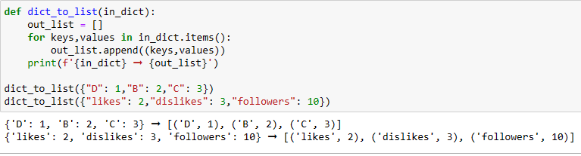

Question3

Write a function that creates a dictionary with each **(key, value)** pair being the **(lower case, upper case)** versions of a letter, respectively.

### Examples

mapping(["p", "s"]) ➞ { "p": "P", "s": "S" }

mapping(["a", "b", "c"]) ➞ { "a": "A", "b": "B", "c": "C" }

mapping(["a", "v", "y", "z"]) ➞ { "a": "A", "v": "V", "y": "Y", "z": "Z" }

### Notes

All of the letters in the input list will always be lowercase.

Ans:

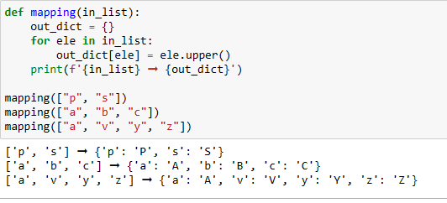

Question4

Write a function, that replaces all vowels in a string with a specified vowel.

### Examples

vow_replace("apples and bananas", "u") ➞ "upplus und bununus"

vow_replace("cheese casserole", "o") ➞ "choosocossorolo"

vow_replace("stuffed jalapeno poppers", "e") ➞ "steffedjelepene peppers"

### Notes

All words will be lowercase. Y is not considered a vowel.

Ans:

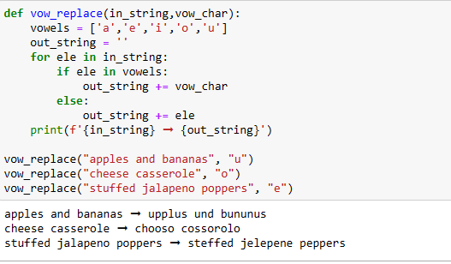

Question5

Create a function that takes a string as input and capitalizes a letter if its ASCII code is even and returns its lower case version if its ASCII code is odd.

### Examples

ascii_capitalize("to be or not to be!") ➞ "To Be oRNoT To Be!"

ascii_capitalize("THE LITTLE MERMAID") ➞ "THeLiTTLemeRmaiD"

ascii_capitalize("Oh what a beautiful morning.") ➞ "oHwHaT a BeauTiFuLmoRNiNg."

Ans:

