1. **Write a Python Program to Find LCM?**

**Ans:**

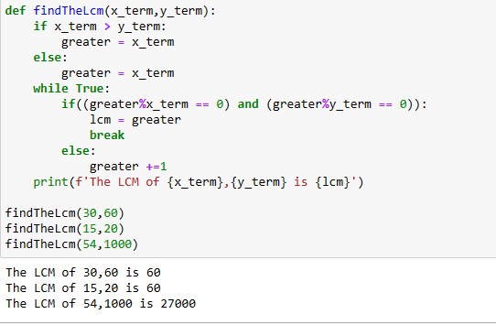

1. **Write a Python Program to Find HCF?**

**Ans:**

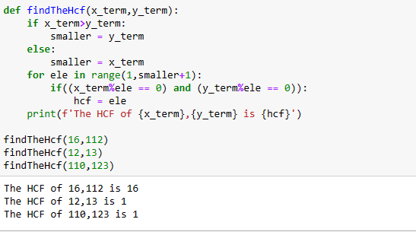

1. **Write a Python Program to Convert Decimal to Binary, Octal and Hexadecimal?**

**Ans:**

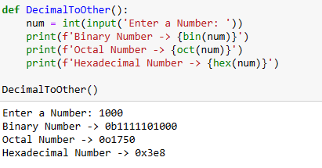

1. **Write a Python Program To Find ASCII value of a character?**

**Ans:**

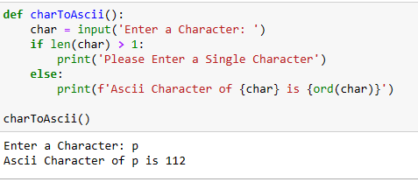

1. **Write a Python Program to Make a Simple Calculator with 4 basic mathematical operations?**

**Ans:**

