1. **Write a Python Program to find sum of array?**

**Ans:**

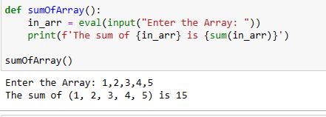

1. **Write a Python Program to find largest element in an array?**

**ans:**

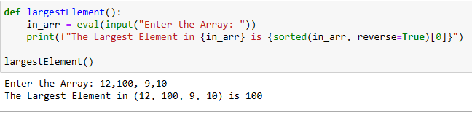

1. **Write a Python Program for array rotation?**

**Ans:**

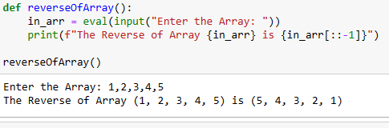

1. **Write a Python Program to Split the array and add the first part to the end?**

**ans:**

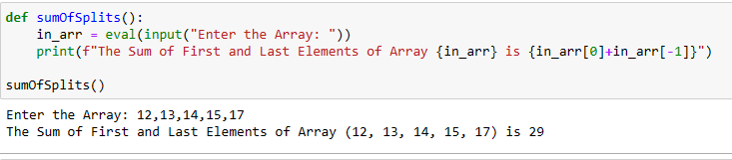

1. **Write a Python Program to check if given array is Monotonic?**

**Ans:**

