1. **Write a Python Program to Add Two Matrices?**

**Ans:** 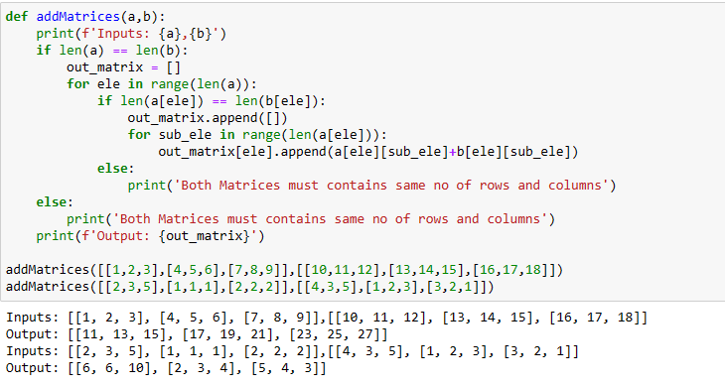

1. **Write a Python Program to Multiply Two Matrices?**

**ans:**

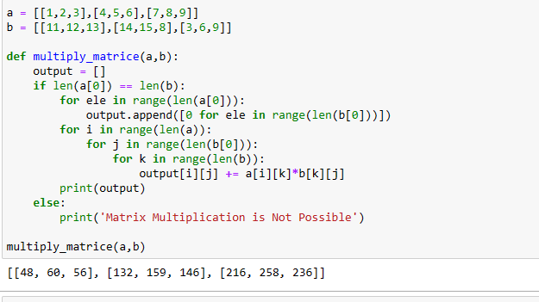

1. **Write a Python Program to Transpose a Matrix?**

**Ans:**

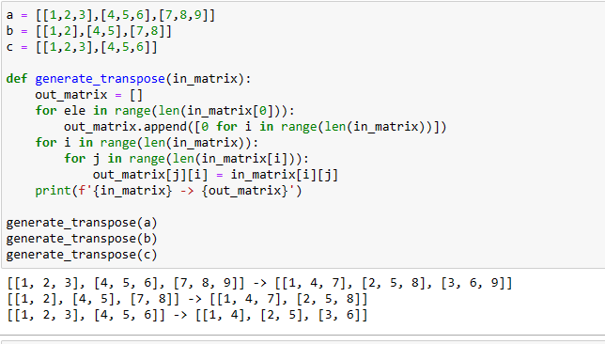

1. **Write a Python Program to Sort Words in Alphabetic Order?**

**Ans:**

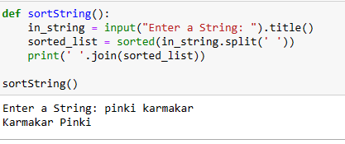

1. **Write a Python Program to Remove Punctuation From a String?**

**Ans:**

