|  |
| --- |
| **Question 1:** |
|  |

|  |
| --- |
| **Write a program that calculates and prints the value according to the given formula:** |
|  |

|  |
| --- |
| **Q = Square root of [(2 * C * D)/H]** |
|  |

|  |
| --- |
| **Following are the fixed values of C and H:** |
|  |

|  |
| --- |
| **C is 50. H is 30.** |
|  |

|  |
| --- |
| **D is the variable whose values should be input to your program in a comma-separated sequence.** |
|  |

|  |
| --- |
| **Example** |
|  |

|  |
| --- |
| **Let us assume the following comma separated input sequence is given to the program:** |
|  |

|  |
| --- |
| **100,150,180** |
|  |

|  |
| --- |
| **The output of the program should be:** |
|  |

**18,22,24**

Ans:

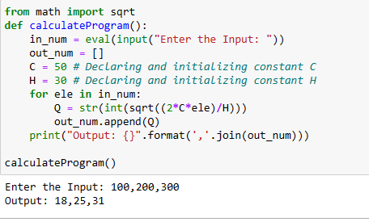

|  |
| --- |
| **Question 2:** |
| **Write a program which takes 2 digits, X,Y as input and generates a 2-dimensional array. The element value in the i-th row and j-th column of the array should be i*j.** | |
|  | |

|  |
| --- |
| **Note: i=0,1.., X-1; j=0,1,¡­Y-1.** |
|  |

|  |
| --- |
| **Example** |
|  |

|  |
| --- |
| **Suppose the following inputs are given to the program:** |
|  |

|  |
| --- |
| **3,5** |
|  |

|  |
| --- |
| **Then, the output of the program should be:** |
|  |

|  |
| --- |
| **[[0, 0, 0, 0, 0], [0, 1, 2, 3, 4], [0, 2, 4, 6, 8]]** |
|  |

Ans:

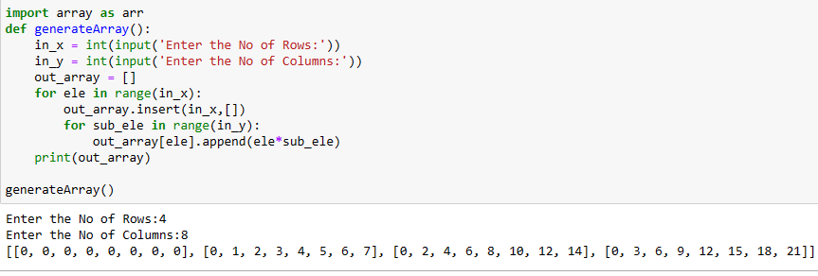

**Question 3:**

|  |
| --- |
| **Write a program that accepts a comma separated sequence of words as input and prints the words in a comma-separated sequence after sorting them alphabetically.** |
|  |

|  |
| --- |
| **Suppose the following input is supplied to the program:** |
|  |

|  |
| --- |
| **without,hello,bag,world** |
|  |

|  |
| --- |
| **Then, the output should be:** |
|  |

**bag,hello,without,world**

**ans:**

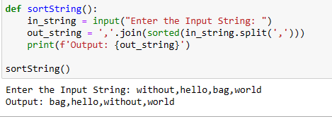

**Question 4:**

|  |
| --- |
| **Write a program that accepts a sequence of whitespace separated words as input and prints the words after removing all duplicate words and sorting them alphanumerically.** |
|  |

|  |
| --- |
| **Suppose the following input is supplied to the program:** |
|  |

|  |
| --- |
| **hello world and practice makes perfect and hello world again** |
|  |

|  |
| --- |
| **Then, the output should be:** |
|  |

**again and hello makes perfect practice world**

**ans:**

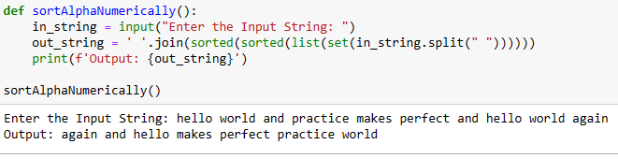

**Question 5:**

|  |
| --- |
| **Write a program that accepts a sentence and calculate the number of letters and digits.** |
|  |

|  |
| --- |
| **Suppose the following input is supplied to the program:** |
|  |

|  |
| --- |
| **hello world! 123** |
|  |

|  |
| --- |
| **Then, the output should be:** |
|  |

|  |
| --- |
| **LETTERS 10** |
|  |

**DIGITS 3**

**Ans:**

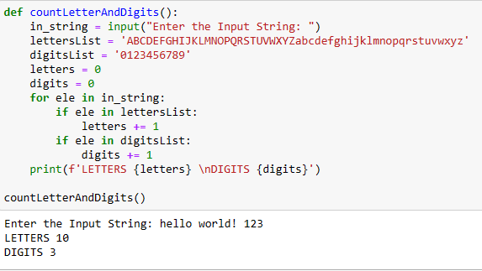

**Question 6:**

|  |
| --- |
| **A website requires the users to input username and password to register. Write a program to check the validity of password input by users.** |
|  |

|  |
| --- |
| **Following are the criteria for checking the password:** |
|  |

|  |
| --- |
| **1. At least 1 letter between [a-z]** |
|  |

|  |
| --- |
| **2. At least 1 number between [0-9]** |
|  |
|  |

|  |
| --- |
| **1. At least 1 letter between [A-Z]** |
|  |

|  |
| --- |
| **3. At least 1 character from [$#@]** |
|  |

|  |
| --- |
| **4. Minimum length of transaction password: 6** |
|  |

|  |
| --- |
| **5. Maximum length of transaction password: 12** |
|  |

|  |
| --- |
| **Your program should accept a sequence of comma separated passwords and will check them according to the above criteria. Passwords that match the criteria are to be printed, each separated by a comma.** |
|  |

|  |
| --- |
| **Example** |
|  |

|  |
| --- |
| **If the following passwords are given as input to the program:** |
|  |

|  |
| --- |
| **ABd1234@1,a F1#,2w3E*,2We3345** |
|  |

|  |
| --- |
| **Then, the output of the program should be:** |
|  |

**ABd1234@1**

Ans:

