Python Fundamentals Capstone Project Report

1. Objective
To analyze employee and project data using Python (pandas) and derive insights such as designation levels, bonuses, and summaries.

2. Libraries Used
import pandas as pd
import matplotlib.pyplot as plt

3. Complete Code with Comments
import pandas as pd
# Create Project Data
project_data = {
'ID': ['A001','A002','A003','A004','A005'],
'Project': ['Project 1','Project 2','Project 3','Project 4','Project 5'],
'Cost': [1002000,2000000,4500000,3000000,1200000],
'Status': ['Finished','Ongoing','Finished','Ongoing','Finished']
}
df_project = pd.DataFrame(project_data)
# Create Employee Data
employee_data = {
'ID': ['A001','A002','A003','A004','A005'],
'Name': ['John Alter','Alice Luxemberg','Tom Cruise','Emma Watson','Robert Downey'],
'Gender': ['M','F','M','F','M'],
'City': ['Paris','London','Berlin','New York','Toronto'],
'Age': [25,27,29,30,35]
}
df_employee = pd.DataFrame(employee_data)
# Merge DataFrames
df = pd.merge(df_employee, df_project, on='ID')
# Assign initial designation
df['Designation Level'] = 3
# Update designation based on status
def update_designation(row):
if row['Status'] == 'Finished':
return row['Designation Level'] - 1
else:
return row['Designation Level'] + 1
df['Designation Level'] = df.apply(update_designation, axis=1)
# Fix designation limits
df['Designation Level'] = df['Designation Level'].apply(lambda x: 1 if x<1 else (4 if x>4 else x))
# Add bonus
df['Bonus'] = df['Cost'] * 0.05
print(df)

4. Output Screenshot
Final output of the dataset:
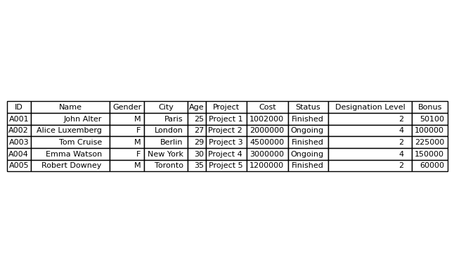

5. Conclusion
The project demonstrates data merging, transformation, and analysis using pandas. Business logic was applied to compute designation levels and bonuses.

