1. We are showing below Life Expectancy total over the years for developed and underdeveloped countries . **Developed countries are coded orange and underdeveloped countries are coded blue showing the trend over the years.**

The data was cleaned and filtered for only developed and underdeveloped countries.

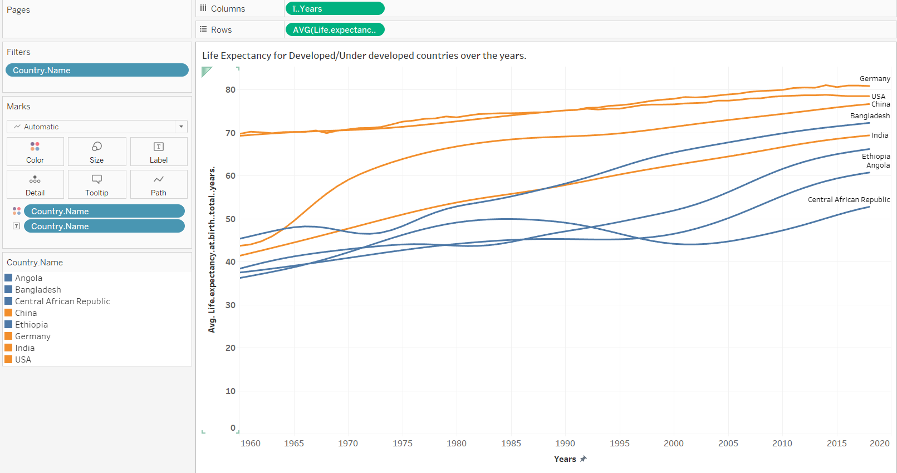

We see above that underdeveloped countries in the start of 1960 and following years had very low Life Expectancy at birth and over the years they have risen from less than 40 to 60 years on an average. Whereas developed countries always had a high life expectancy to begin with and over the years it has risen slowly. Let us take an example of USA(Developed country) and Angola (underdeveloped country) where we see Life Expectancy from 70 years to 80 years for USA and Angola has 38 to 60 years over 60 years.

OR

I have created new columns called Developed and Underdeveloped countries and created two plots which represented in R showing the Life Expectancy trends over the years. We see above that underdeveloped countries in the start of 1960 and following years had very low Life Expectancy at birth and over the years they have risen from less than 40 to 60 years on an average. Whereas developed countries always had a high life expectancy to begin with and over the years it has risen slowly. Let us take an example of USA(Developed country) and Angola (underdeveloped country) where we see Life Expectancy from 70 years to 80 years for USA and Angola has 38 to 60 years over 60 years.

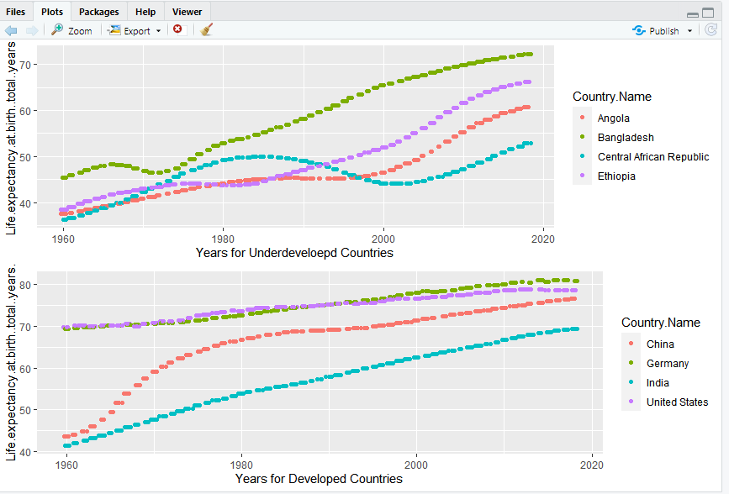

> plot_under=ggplot(Underdeveloped_LE,aes(Years,Life.expectancy.at.birth..total..years.,color=Country.Name))+geom_jitter()+geom_point()+labs(x="Years for Underdeveloepd Countries")

> plot_under

> plot_developed=ggplot(Developed_LE,aes(Years,Life.expectancy.at.birth..total..years.,color=Country.Name))+geom_jitter()+geom_point()+labs(x="Years for Developed Countries")

> grid.arrange(plot_under,plot_developed,nrow=2)

1. A) Below we see Mortality rate for adults for both Male and Female over 60 years for all countries. We have labelled the data as you see below in the legend with categorical labels having ranges like 0-100,100-200 showing Mortality rate values per 1000 births for both male and female. I have clicked photo of animated video to highlight the different trends . Taking an example of three different years with a gap of 20 years.

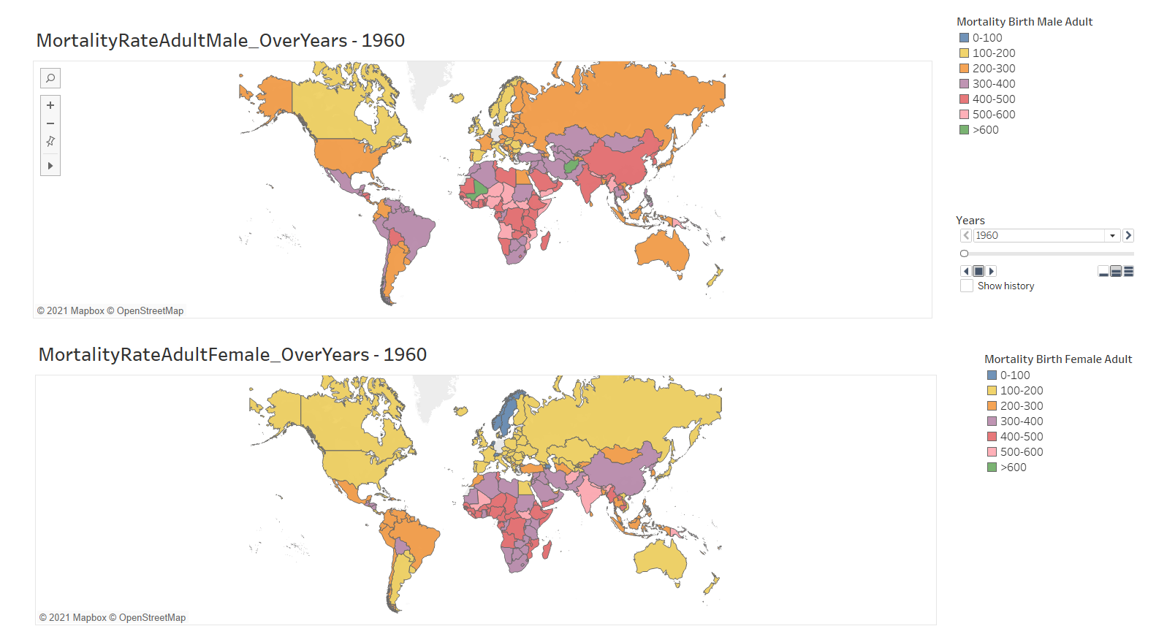

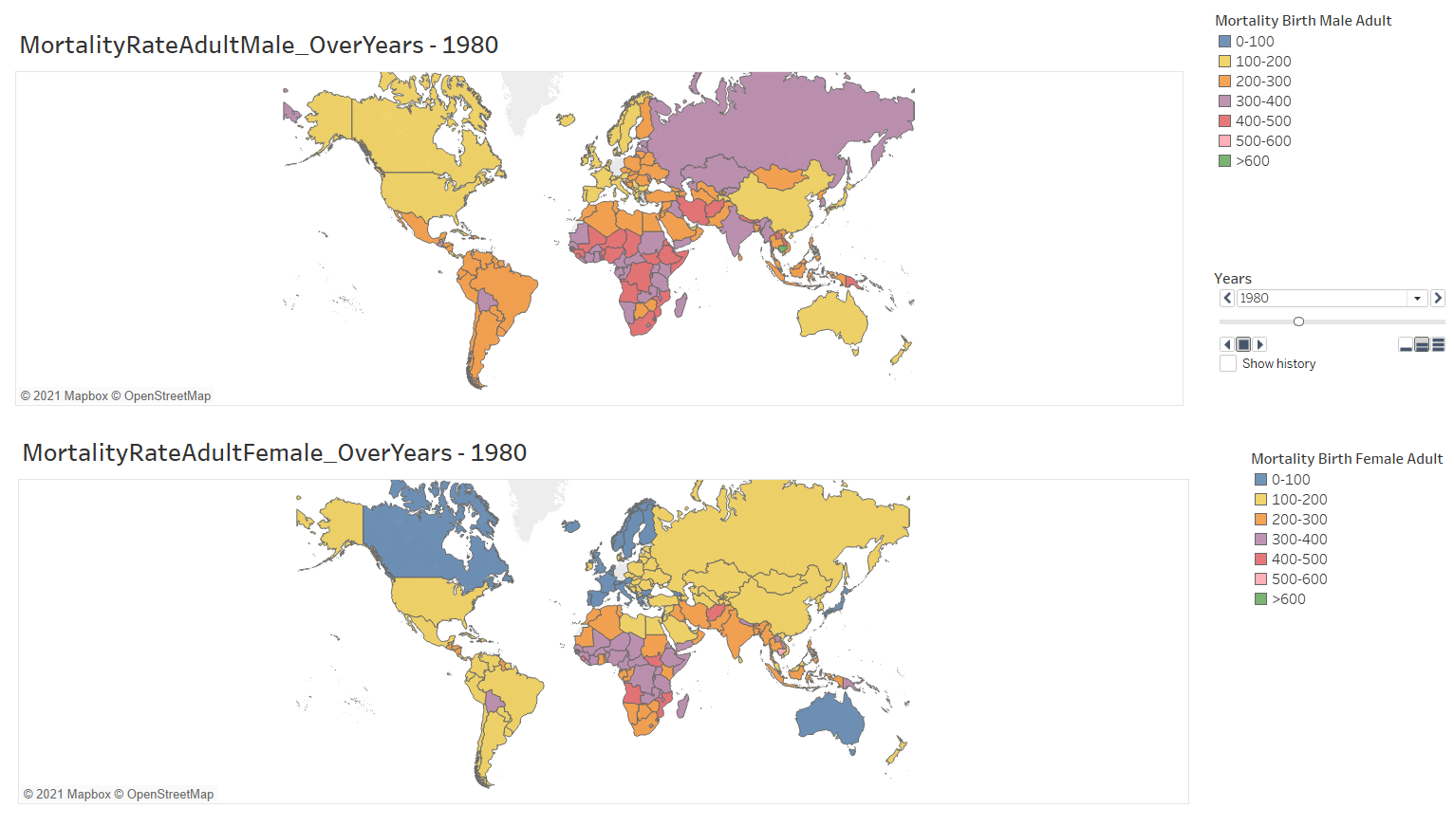

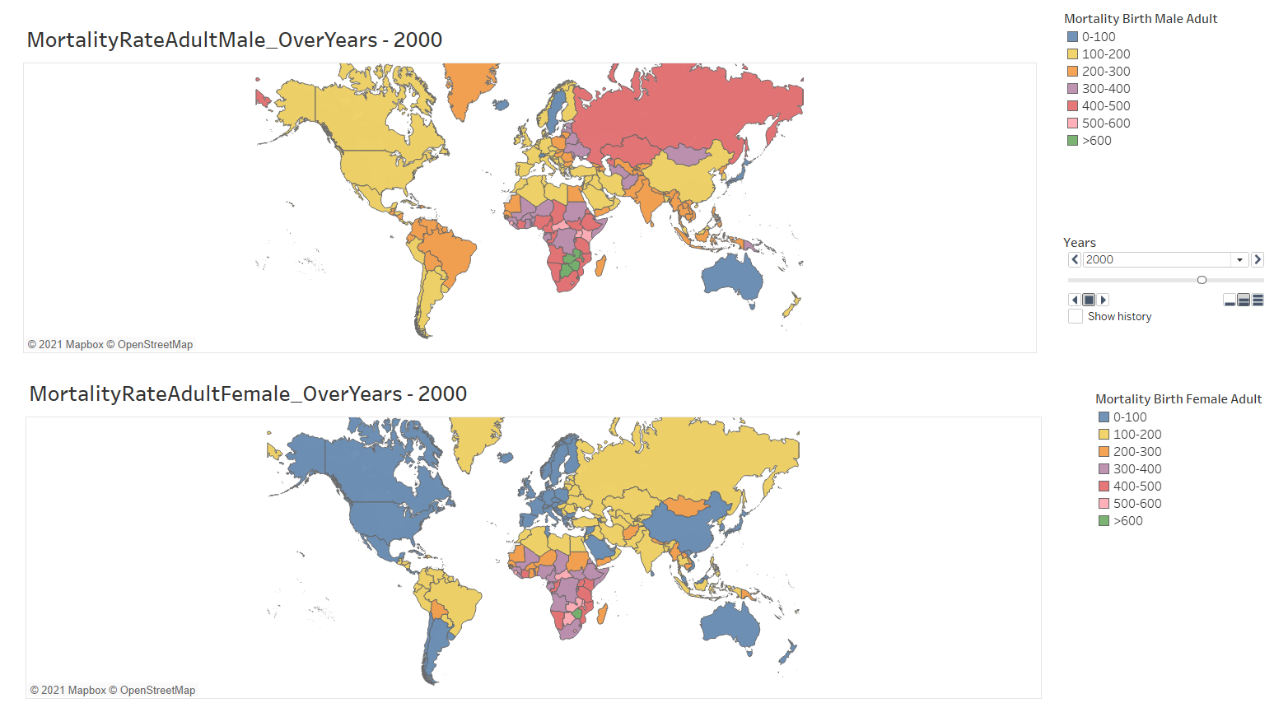

The following image is a comparison geographical map between the mortality rate of adult  male and females over the years from 1960 to 2018. The data doesn’t show values for the year 2019 and 2020.

let us take a sample from a map comparing between two countries, one of the developed countries the united states of America and under -developed  country Angola in three different years.

                                                                             USA                                 ANGOLA

 1960:  Mortality rate of adult male            (200-300)                         (500-600)

             Mortality rate of adult female         (100-200)                         (400-500)

1980:   Mortality rate of adult male            (100-200)                          (400-500)

             Mortality rate of adult female         (100-200)                         (400-500)

                2000:   Mortality rate of adult male            (100-200)                         (400-500)

                             Mortality rate of adult female         (0-100)                              (300-400)

From above, the mortality rate of adult male decreased from 1960 to 1980; however, for female groups there was no substantial decrease. In the 2000 century we see the mortality rate of adult females decreased for both developed and underdeveloped countries. We also see the USA having a low mortality rate compared to Angola.

Over the period of time as shown in above figures 1a and 2b we can see the mortality rate is decreasing for both developed and under developed countries.

From the above graph we knew over the time mortality rate of adult female was decreasing compared to male,

OR

1. B) Below I have compared the mortality rate vs Life expectancy of Developed and Underdeveloped countries for both Male and Female over the years. Have created a new column called Probability of Mortality which is nothing but mortality rate value / 1000 to give actual probability for mortality. We have taken 4 developed countries( USA,Germany,China and India) and 4 underdeveloped countries(Bangaldesh,Angola,Central African Republic and Ethiopia).

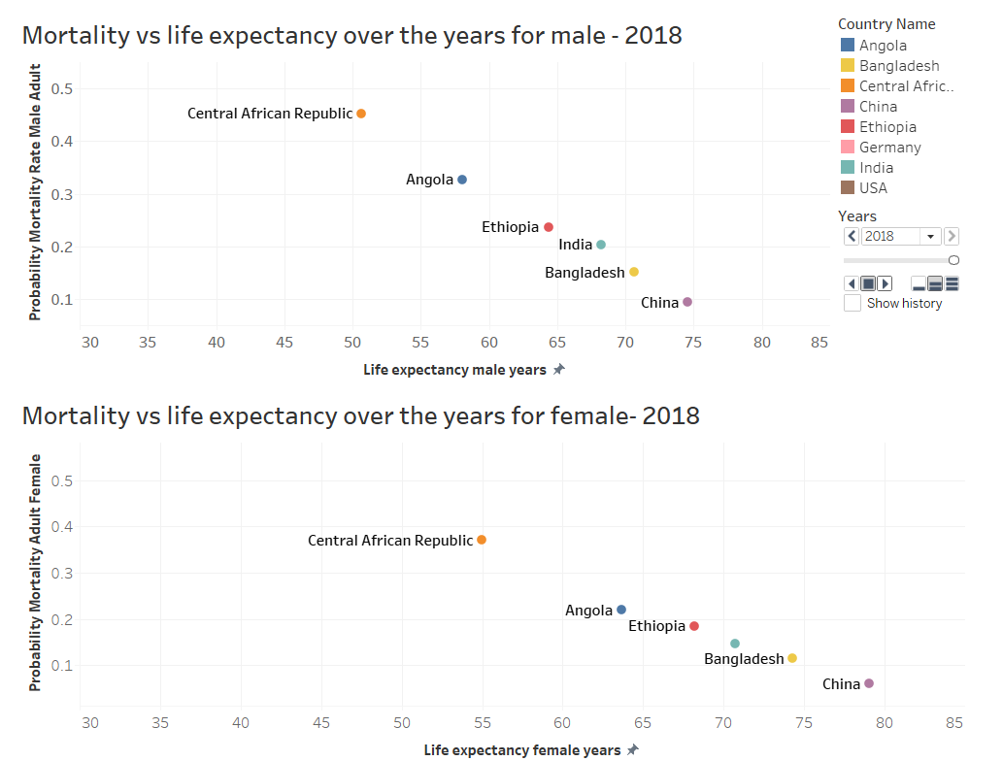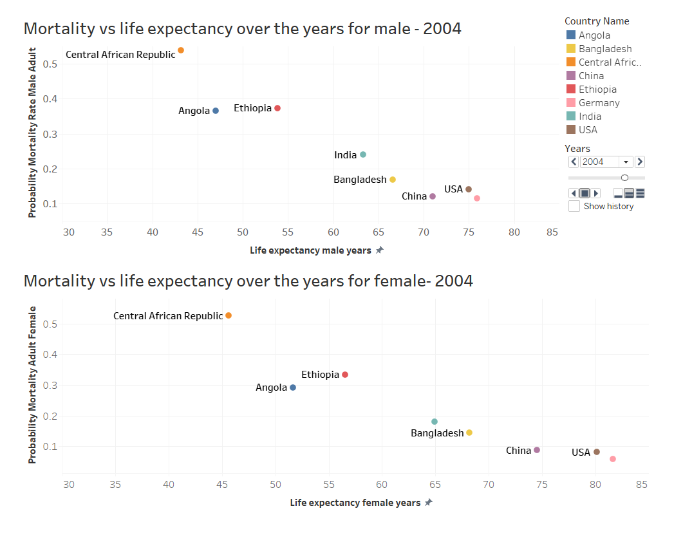

I have taken a picture of my animated video showing two different unique years and comparison of Life expectancy vs probability of Mortality.

In both Male and Female cases, we see a negative trend as Mortality decreases , Life expectancy increases.

Life Expectancy when compared across 2004 and 2018 , we see Female have higher Life Expectancy and lower mortality than compared to Male .

Overall, Mortality is higher for Underdeveloped countries and lower for Developed countries. Both Developed and Underdeveloped countries over the years have mortality rate decreasing which is a good sign.

OR

2.C) Have created a FlexBoard using R showing Life Expectancy vs Mortality probability 4 developed countries( USA,Germany,China and India) and 4 underdeveloped countries(Bangaldesh,Angola,Central African Republic and Ethiopia). I have created from 1960 -2018 years , how the countries have performed with Mortality and Life Expectancy which is same as described in 2(B) above. I have just represented in R below for all years.

**Code below.**

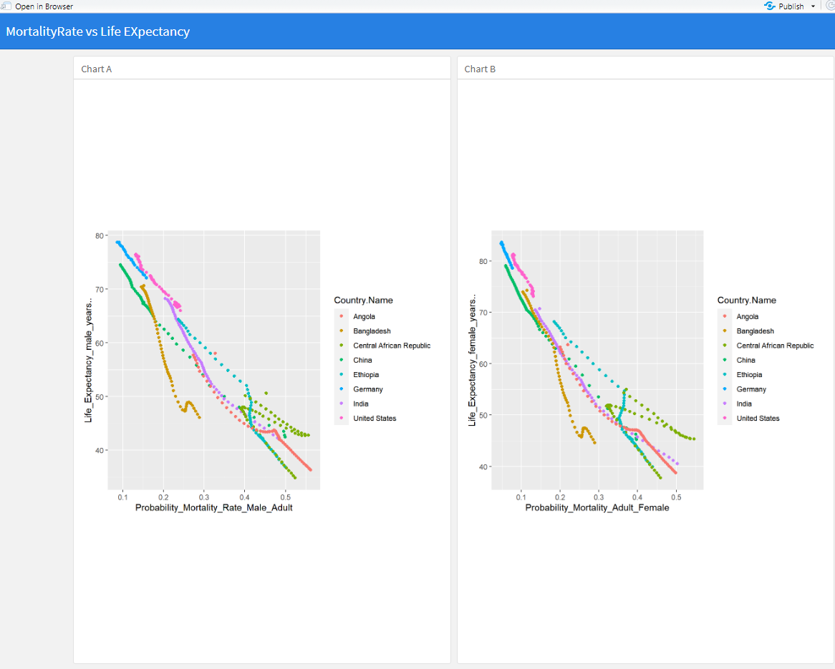

FlexBoard Code run with Shiny for depicting Mortality vs Life Expectancy for both male and Female.

---

title: "MortalityRate vs Life EXpectancy"

output:

flexdashboard::flex_dashboard:

orientation: columns

vertical_layout: fill

runtime: shiny

---

```{r global, include=FALSE}

library(flexdashboard)

library(ggplot2)

library(readxl)

Life_Expect_Filtered_Final_Pinki <- read_excel("C:/Users/shivk/Downloads/Life_Expect_Filtered_Final_Pinki.xlsx")

```

```

---------------------------------------------

Column {data-width=3050}

-----------------------------------------------------------------------

### Chart A

```{r}

ggplot(Life_Expect_Filtered_Final_Pinki,aes(Probability_Mortality_Rate_Male_Adult,Life_Expectancy_male_years..,color=Country.Name))+geom_point()

```

Column {data-width=3050}

-----------------------------------------------------------------------

### Chart B

```{r}

ggplot(Life_Expect_Filtered_Final_Pinki,aes(Probability_Mortality_Adult_Female,Life_Expectancy_female_years..,color=Country.Name))+geom_point()

```

