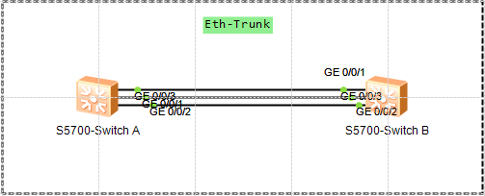

链路聚合就是把两台设备之间的多条物理链路聚合在一起，形成一条逻辑链路。提高链路带宽、可靠性高、在一个聚合口上实现均衡负载

**链路聚合模式有两种**：

- **手动均衡负载模式**

- **静态LACP（Link Aggregation Control Protocol）模式**

主要区别在LACP模式中有些链路充当备份链路，而在手动负载均衡模式中，所有成员都处于转发状态

Eth-Trunk链路两端相连的物理界面的数量、速率、单双工模式、流控方式必须一致

二层链路聚合的配置

interface Eth-Trunk1

interface GigabitEthernet0/0/1

eth-trunk 1

interface GigabitEthernet0/0/2

eth-trunk 1

interface GigabitEthernet0/0/3

eth-trunk 1

[1]查看汇聚链路状态信息

<Switch A>dis interface Eth-Trunk 1

Eth-Trunk1 current state : UP

Line protocol current state : UP

Description:

Switch Port, PVID : 1, Hash arithmetic : According to SIP-XOR-DIP,Maximal BW:

3G, Current BW: 3G, The Maximum Frame Length is 9216

IP Sending Frames' Format is PKTFMT_ETHNT_2, Hardware address is 4c1f-cc24-251c

Current system time: 2017-10-10 22:00:54-08:00

Input bandwidth utilization : 0%

Output bandwidth utilization : 0%

-----------------------------------------------------

PortName Status Weight

-----------------------------------------------------

GigabitEthernet0/0/1 UP 1

GigabitEthernet0/0/2 UP 1

GigabitEthernet0/0/3 UP 1

-----------------------------------------------------

The Number of Ports in Trunk : 3

The Number of UP Ports in Trunk : 3

三层Eth-Trunk的配置

拓扑图

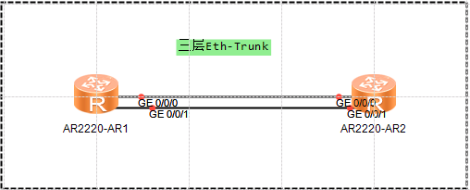

配置

interface Eth-Trunk1

undo portswitch

ip address 192.168.1.1 255.255.255.0

#

interface GigabitEthernet0/0/0

eth-trunk 1

#

interface GigabitEthernet0/0/1

eth-trunk 1

使用undo portswitch，将原本的二层汇聚链路转换成三层汇聚链路。之后可以为三层汇聚链路逻辑口配置IP地址

三层汇聚链路状态信息

[Route A]display interface Eth-Trunk 1

Eth-Trunk1 current state : UP

Line protocol current state : UP

Last line protocol up time : 2017-10-10 21:57:43 UTC-08:00

Description:HUAWEI, AR Series, Eth-Trunk1 Interface

Route Port,Hash arithmetic : According to SIP-XOR-DIP,Maximal BW: 2G, Current BW

: 2G, The Maximum Transmit Unit is 1500

Internet Address is 192.168.1.1/24

IP Sending Frames' Format is PKTFMT_ETHNT_2, Hardware address is 00e0-fcc0-50f6

Current system time: 2017-10-10 22:05:09-08:00

Input: 1 packets, 60 bytes

Unicast: 0, Multicast: 0

Broadcast: 1, Discard: 0

Total Error: 0

Output: 1 packets, 60 bytes

Unicast: 0, Multicast: 0

Broadcast: 1, Discard: 0

Total Error: 0

Input bandwidth utilization : 0%

Output bandwidth utilization : 0%

-----------------------------------------------------

PortName Status Weight

-----------------------------------------------------

GigabitEthernet0/0/0 UP 1

GigabitEthernet0/0/1 UP 1

-----------------------------------------------------

The Number of Ports in Trunk : 2

The Number of UP Ports in Trunk : 2

1.