静态NAT

静态NAT实现了公有地址和地址的一对一映射，一个 公网IP只会分配给唯一且固定的内网主机。

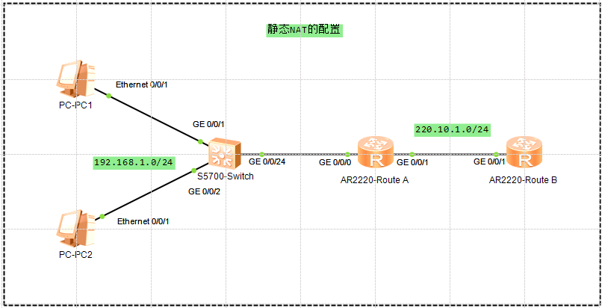

出端口配置静态NAT

[Route]interface GigabitEthernet 0/0/1

[Route-GigabitEthernet0/0/1]ip address 220.10.1.1 255.255.255.0

[Route-GigabitEthernet0/0/1]nat static global 220.10.1.3 inside 192.168.1.1 netmask 255.255.255.255

[Route-GigabitEthernet0/0/1]nat static global 220.10.1.4 inside 192.168.1.2 netmask 255.255.255.255

[Route-GigabitEthernet0/0/1]nat static enable

验证

<Route>**display nat static**

Static Nat Information:

Interface : GigabitEthernet0/0/1

Global IP/Port : 220.10.1.3/----

Inside IP/Port : 192.168.1.1/----

Protocol : ----

VPN instance-name : ----

Acl number : ----

Netmask : 255.255.255.255

Description : ----

Global IP/Port : 220.10.1.4/----

Inside IP/Port : 192.168.1.2/----

Protocol : ----

VPN instance-name : ----

Acl number : ----

Netmask : 255.255.255.255

Description : ----

Total : 2

动态NAT

动态NAT基于地址池来实现公有地址和私有地址的转换

配置公网地址池

[Route]nat address-group 1 172.16.1.3 172.16.1.6

策略 访问控制列表

[Route]acl number 2000

[Route-acl-basic-2000]rule 5 permit source 192.168.1.0 0.0.0.255

端口配置

interface GigabitEthernet0/0/1

[Route-GigabitEthernet0/0/1]nat outbound 2000 address-group 1 **no-pat**

验证

<Route>**display nat address-group 1**

NAT Address-Group Information:

--------------------------------------

Index Start-address End-address

--------------------------------------

1 172.16.1.3 172.16.1.6

--------------------------------------

Total : 1

<Route>**display nat outbound**

NAT Outbound Information:

--------------------------------------------------------------------------

Interface Acl Address-group/IP/Interface Type

--------------------------------------------------------------------------

GigabitEthernet0/0/1 2000 1 no-pat

--------------------------------------------------------------------------

Total : 1

抓包结果

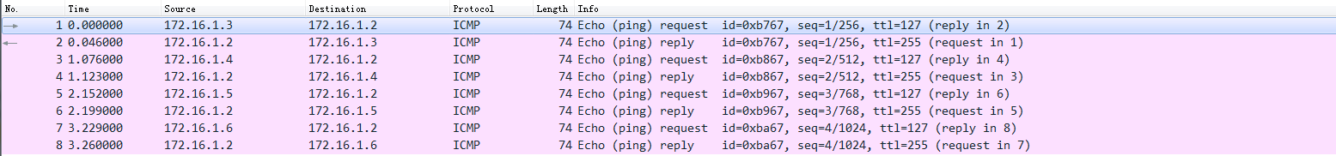

NAPT

网络地址端口转换NAPT允许多个私有地址映射到同一公有地址的不同端口

配置与动态NAT一致，只要最后开启PAT即可

Easy IP的配置

配置

interface GigabitEthernet0/0/1

[Route-GigabitEthernet0/0/1]nat outbound 2000

验证

<Route>display nat outbound

NAT Outbound Information:

--------------------------------------------------------------------------

Interface Acl Address-group/IP/Interface Type

--------------------------------------------------------------------------

GigabitEthernet0/0/1 2000 172.16.1.1 easyip

--------------------------------------------------------------------------

Total : 1

Easy IP的配置相较于动态NAT，不需要设置公网地址池

NAT服务器的配置



