PPP协议是一种点到点的链路层协议，用于全双工的同异步链路上进行点到点的数据传输

特点：

* PPP支持同步传输也支持异步传输。
* 良好的扩展性
* 提供LCP协议，用于各链路层参数的协商
* 提供各种NCP协议，用于网络层参数的协商，更好支持了网络层协议
* 支持认证，CHAP PAP 保证网络的安全性
* 无重传机制，网络开销小、速度快

# PPP协议的配置

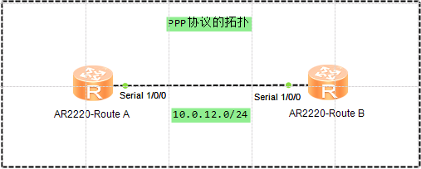

因为华为串口的默认链路协议就是PPP，所以PPP协议默认已经开启

<Route A>display interface Serial 1/0/0

Serial1/0/0 current state : UP

Line protocol current state : UP

Last line protocol up time : 2017-10-22 23:08:29 UTC-08:00

Description:HUAWEI, AR Series, Serial1/0/0 Interface

Route Port,The Maximum Transmit Unit is 1500, Hold timer is 10(sec)

Internet Address is 10.0.12.1/30

Link layer protocol is PPP

LCP opened, IPCP opened

Last physical up time : 2017-10-22 23:06:02 UTC-08:00

Last physical down time : 2017-10-22 23:05:57 UTC-08:00

Current system time: 2017-10-22 23:08:54-08:00

Physical layer is synchronous, Virtualbaudrate is 64000 bps

Interface is DTE, Cable type is V11, Clock mode is TC

Last 300 seconds input rate 6 bytes/sec 48 bits/sec 0 packets/sec

Last 300 seconds output rate 3 bytes/sec 24 bits/sec 0 packets/sec

Input: 50 packets, 2025 bytes

Broadcast: 0, Multicast: 0

Errors: 0, Runts: 0

Giants: 0, CRC: 0

Alignments: 0, Overruns: 0

Dribbles: 0, Aborts: 0

No Buffers: 0, Frame Error: 0

Output: 51 packets, 1054 bytes

Total Error: 0, Overruns: 0

Collisions: 0, Deferred: 0

Input bandwidth utilization : 0%

Output bandwidth utilization : 0%

串口的配置

[Route A]interface Serial 1/0/0

[Route A-Serial1/0/0]link-protocol ppp

[Route A-Serial1/0/0]ip address 10.0.12.1 255.255.255.0

抓包结果

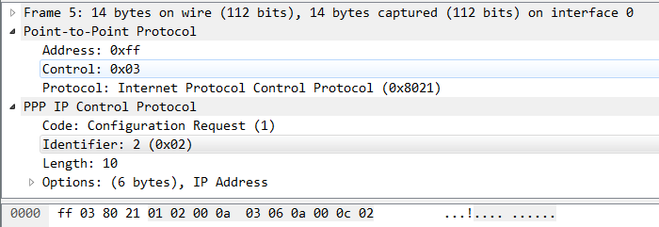

# PPP的认证

## PAP认证

认证方的配置

创建pap用户

[Route A]aaa

[Route A-aaa]local-user huawei password cipher Huawei

[Route A-aaa]local-user huawei service-type ppp

开启PPP的认证模式

[Route A]interface Serial 1/0/0

[Route A-Serial1/0/0]ppp authentication-mode pap

被认证方端口的配置

[Route B]interface Serial 1/0/0

[Route B-Serial1/0/0]ppp pap local-user huawei password cipher Huawei

[Route B-Serial1/0/0]ip address 10.0.12.2 255.255.255.0

认证成功，链路正常

<Route A>display interface Serial 1/0/0

Serial1/0/0 current state : UP

**Line protocol current state : UP**

Last line protocol up time : 2017-10-22 23:14:05 UTC-08:00

Description:HUAWEI, AR Series, Serial1/0/0 Interface

Route Port,The Maximum Transmit Unit is 1500, Hold timer is 10(sec)

Internet protocol processing : disabled

Link layer protocol is PPP

LCP opened

Last physical up time : 2017-10-22 23:14:03 UTC-08:00

Last physical down time : 2017-10-22 23:13:52 UTC-08:00

Current system time: 2017-10-22 23:25:30-08:00

Physical layer is synchronous, Virtualbaudrate is 64000 bps

Interface is DTE, Cable type is V11, Clock mode is TC

Last 300 seconds input rate 7 bytes/sec 56 bits/sec 0 packets/sec

Last 300 seconds output rate 2 bytes/sec 16 bits/sec 0 packets/sec

Input: 168 packets, 5463 bytes

Broadcast: 0, Multicast: 0

Errors: 0, Runts: 0

Giants: 0, CRC: 0

Alignments: 0, Overruns: 0

Dribbles: 0, Aborts: 0

No Buffers: 0, Frame Error: 0

Output: 167 packets, 2004 bytes

Total Error: 0, Overruns: 0

Collisions: 0, Deferred: 0

Input bandwidth utilization : 0%

Output bandwidth utilization : 0%

认证失败，链路DOWN

<Route A>display interface Serial 1/0/0

Serial1/0/0 current state : UP

**Line protocol current state : DOWN**

Description:HUAWEI, AR Series, Serial1/0/0 Interface

Route Port,The Maximum Transmit Unit is 1500, Hold timer is 10(sec)

Internet Address is 10.0.12.1/24

Link layer protocol is PPP

LCP stopped

Last physical up time : 2017-10-22 23:30:21 UTC-08:00

Last physical down time : 2017-10-22 23:30:20 UTC-08:00

Current system time: 2017-10-22 23:30:39-08:00

Physical layer is synchronous, Virtualbaudrate is 64000 bps

Interface is DTE, Cable type is V11, Clock mode is TC

Last 300 seconds input rate 9 bytes/sec 72 bits/sec 0 packets/sec

Last 300 seconds output rate 4 bytes/sec 32 bits/sec 0 packets/sec

Input: 248 packets, 8462 bytes

Broadcast: 0, Multicast: 0

Errors: 0, Runts: 0

Giants: 0, CRC: 0

Alignments: 0, Overruns: 0

Dribbles: 0, Aborts: 0

No Buffers: 0, Frame Error: 0

Output: 250 packets, 3393 bytes

Total Error: 0, Overruns: 0

Collisions: 0, Deferred: 0

Input bandwidth utilization : 0%

Output bandwidth utilization : 0%

## CHAP认证

认证方的配置

开启chap认证

[Route A]interface Serial 1/0/0

[Route A-Serial1/0/0]ppp authentication-mode chap

被认证方端口的配置

[Route B]interface Serial 1/0/0

[Route B-Serial1/0/0]ppp chap user huawei

[Route B-Serial1/0/0]ppp chap password cipher Huawei

[Route B-Serial1/0/0]ip address 10.0.12.2 255.255.255.0