SNMP（Simple Network Management Protocol）简单网络管理协议 实现对不同种类和不同厂商的网络设备进行统一管理，提升网络管理效率。

SNMP基于UDP传输协议，使用161和162端口，规定了NMS和Agent之间如何传递管理信息

SNMP的配置

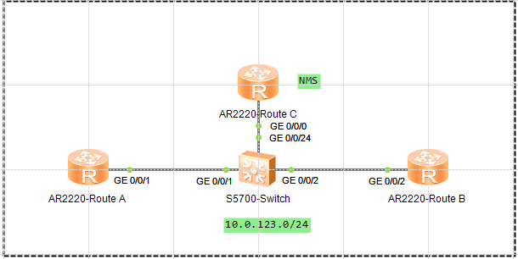

开启SNMP代理

[Route A]snmp-agent

[Route A]snmp-agent sys-info version v2c

配置SNMP读写团体

[Route A]snmp-agent community read public

[Route A]snmp-agent community write private

开启告警功能，并配置管理员信息

[Route A]snmp-agent trap enable

Info: All switches of SNMP trap/notification will be open. Continue? [Y/N]:y

[Route A]snmp-agent trap queue-size 200

[Route A]snmp-agent trap life 60

[Route A]snmp-agent target-host trap-hostname NMS address 10.0.123.254 trap-para

msname public

[Route A]snmp-agent target-host trap-paramsname public v2c securityname public

[Route A]snmp-agent sys-info contact Call the operator at 15757164558

验证

<Route A>**display snmp-agent sys-info**

The contact person for this managed node:

**Call the operator at 15757164558**

The physical location of this node:

Shenzhen China

SNMP version running in the system:

**SNMPv2c**

<Route A>**display snmp-agent community write**

Community name: public

Storage type: nonVolatile

View name: ViewDefault

Community name: private

Storage type: nonVolatile

View name: ViewDefault

Total number is 2

<Route A>**display snmp-agent target-host**

Traphost list:

Target host name: NMS

Traphost address: 10.0.123.254

Traphost portnumber: 162

Target host parameter: public

Total number is 1

Parameter list trap target host:

Parameter name of the target host: public

Message mode of the target host: SNMPV2C

Trap version of the target host: v2c

Security name of the target host: public

Total number is 1