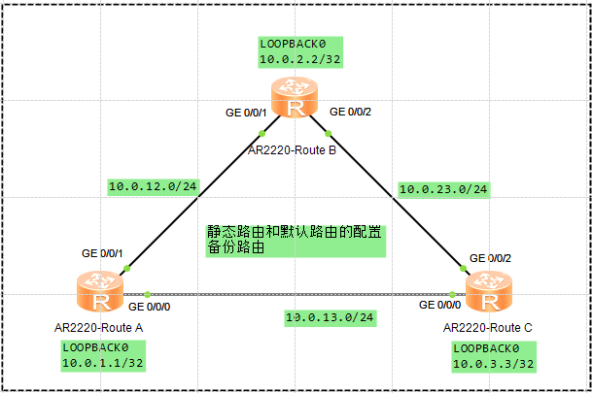

## 静态路由的配置

在AR2配置至AR3的GE0/0/0、LOOPBACK0的静态路由

[Route B]ip route-static 10.0.3.0 255.255.255.0 10.0.23.2

[Route B]ip route-static 10.0.13.0 255.255.255.0 10.0.23.2

### 配置静态备份路由

[Route B]ip route-static 10.0.3.0 255.255.255.0 10.0.12.1 preference 80

[Route B]ip route-static 10.0.13.0 255.255.255.0 10.0.12.1 preference 80

验证

[Route B]display ip routing-table protocol static

Route Flags: R - relay, D - download to fib

------------------------------------------------------------------------------

Public routing table : Static

Destinations : 2 Routes : 4 Configured Routes : 4

Static routing table status : <Active>

Destinations : 2 Routes : 2

Destination/Mask Proto Pre Cost Flags NextHop Interface

10.0.3.0/24 Static 60 0 RD 10.0.23.2 GigabitEthernet 0/0/2

0/0/2

10.0.13.0/24 Static 60 0 RD 10.0.23.2 GigabitEthernet 0/0/2

Static routing table status : <Inactive>

Destinations : 2 Routes : 2

Destination/Mask Proto Pre Cost Flags NextHop Interface

10.0.3.0/24 Static 80 0 R 10.0.12.1 GigabitEthernet 0/0/1

10.0.13.0/24 Static 80 0 R 10.0.12.1 GigabitEthernet 0/0/1

Tracert记录

<Route B>tracert 10.0.3.3

traceroute to 10.0.3.3(10.0.3.3), max hops: 30 ,packet length: 40,press CTRL_C

to break

1 10.0.23.2 130 ms 30 ms 20 ms

关闭Gi0/0/2端口测试备份路由

[Route B]interface GigabitEthernet 0/0/2

[Route B-GigabitEthernet0/0/2]shutdown

Oct 11 2017 16:55:39-08:00 Route B %%01IFPDT/4/IF_STATE(l)[0]:Interface GigabitEthernet0/0/2 has turned into DOWN state.

Tracer记录

[Route B]tracert 10.0.3.3

traceroute to 10.0.3.3(10.0.3.3), max hops: 30 ,packet length: 40,press CTRL_C to break

1 10.0.12.1 60 ms 20 ms 20 ms

2 10.0.13.2 20 ms 20 ms 20 ms

### 配置缺省路由

ip route-static 0.0.0.0 0.0.0.0 10.0.13.2

ip route-static 0.0.0.0 0.0.0.0 10.0.12.2 preference 80