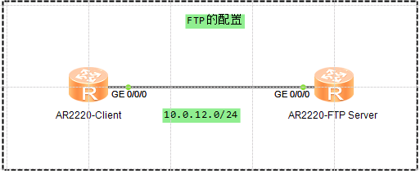

## 网络环境配置

配置IP，准备好网络环境，并测试网络连通性

<Client>ping 10.0.12.2

PING 10.0.12.2: 56 data bytes, press CTRL_C to break

Reply from 10.0.12.2: bytes=56 Sequence=1 ttl=255 time=140 ms

Reply from 10.0.12.2: bytes=56 Sequence=2 ttl=255 time=70 ms

Reply from 10.0.12.2: bytes=56 Sequence=3 ttl=255 time=70 ms

Reply from 10.0.12.2: bytes=56 Sequence=4 ttl=255 time=70 ms

Reply from 10.0.12.2: bytes=56 Sequence=5 ttl=255 time=50 ms

--- 10.0.12.2 ping statistics ---

5 packet(s) transmitted

5 packet(s) received

0.00% packet loss

round-trip min/avg/max = 50/80/140 ms

## FTP Server的配置

开启FTP Server功能

[FTP Server]ftp server enable

AAA用户配置

[FTP Server]aaa

[FTP Server-aaa]local-user huawei password cipher Huawei

[FTP Server-aaa]local-user huawei service-type ftp

[FTP Server-aaa]local-user huawei privilege level 15

[FTP Server-aaa]local-user huawei ftp-directory flash:/dhcp/

Ensp测试，未配置用户的权限等级，FTP会失败，需要注意下

## FTP验证

<FTP Server>display ftp-server

FTP server is running

Max user number 5

User count 0

Timeout value(in minute) 30

Listening port 21

Acl number 0

FTP server's source address 0.0.0.0

从客户端连接FTP服务器成功

<Client>ftp 10.0.12.2

Trying 10.0.12.2 ...

Press CTRL+K to abort

Connected to 10.0.12.2.

220 FTP service ready.

User(10.0.12.2:(none)):huawei

331 Password required for huawei.

Enter password:

230 User logged in.

[Client-ftp]

<FTP Server>display ftp-users

username host port idle topdir

huawei 10.0.12.1 49611 0 flash:/dhcp

## 配置文件传输模式

[Client-ftp]binary

200 Type set to I.

下载文件使用get

上传文件使用put

删除文件使用delete