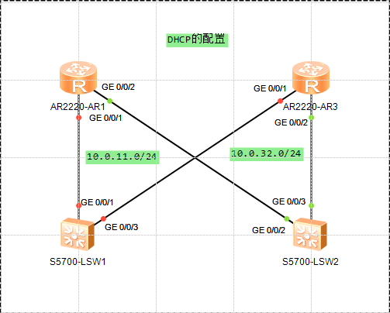

启用DHCP

[Route 1]dhcp enable

创建全局地址池

[Route 1]ip pool pool1

Info: It's successful to create an IP address pool.

[Route 1-ip-pool-pool1]network 10.0.12.0 mask 255.255.255.0

[Route 1-ip-pool-pool1]gateway-list 10.0.12.1

[Route 1-ip-pool-pool1]lease day 1 hour 12 minute 0

端口应用

[Route 1]interface GigabitEthernet 0/0/1

[Route 1-GigabitEthernet0/0/1]dhcp select global

查看

[Route 1]display ip pool name pool1

Pool-name : pool1

Pool-No : 0

Lease : 1 Days 12 Hours 0 Minutes

Domain-name : -

DNS-server0 : -

NBNS-server0 : -

Netbios-type : -

Position : Local Status : Unlocked

Gateway-0 : 10.0.12.1

Mask : 255.255.255.0

VPN instance : --

-----------------------------------------------------------------------------

Start End Total Used Idle(Expired) Conflict Disable

-----------------------------------------------------------------------------

10.0.12.1 10.0.12.254 253 0 253(0) 0 0

-----------------------------------------------------------------------------

在交换机S1上开启DHCP，并通过缺省管理端口VLANIF1向路由器R1申请IP地址

[Switch 1]dhcp enable

[Switch 1]interface Vlanif 1

[Switch 1-Vlanif1]ip address dhcp-alloc

查看

<Switch 1>display ip interface brief

\*down: administratively down

^down: standby

(l): loopback

(s): spoofing

The number of interface that is UP in Physical is 2

The number of interface that is DOWN in Physical is 1

The number of interface that is UP in Protocol is 2

The number of interface that is DOWN in Protocol is 1

Interface IP Address/Mask Physical Protocol

MEth0/0/1 unassigned down down

NULL0 unassigned up up(s)

Vlanif1 10.0.11.254/24 up up

使用接口分配

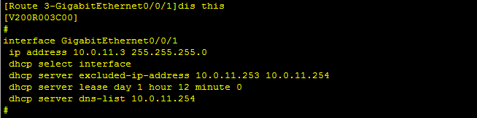

Switch 1上查看

