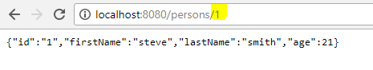

After @@XmlRootElement on bean class

