Chapter 1
INTRODUCTION

  - Project Context
Emergency response refers to the coordinated and immediate actions undertaken to reduce harm to people, property, and the environment following natural or human-induced disasters such as fires, earthquakes, floods, explosions, and major accidents. In the Philippines, fire incidents remain one of the most frequent emergencies managed by the Bureau of Fire Protection (BFP), particularly in urban and semi-urban areas where high population density and complex infrastructure increase vulnerability. Effective fire emergency response depends on rapid access to accurate information, timely decision-making, and efficient coordination among emergency personnel. Strengthening these capabilities directly supports Sustainable Development Goal (SDG) 11: Sustainable Cities and Communities, as it promotes safer and more resilient communities through improved disaster preparedness and response systems. Furthermore, the increasing frequency of fire-related incidents influenced by environmental and climate conditions highlights the relevance of SDG 13: Climate Action, which emphasizes the need for adaptive and proactive disaster risk management strategies (Eker et al., 2024).
The integration of Geographic Information Systems (GIS) has gained substantial importance in disaster and emergency management in recent years. GIS technologies support the collection, visualization, and analysis of spatial data, enabling authorities such as the BFP to monitor incident locations, identify hazard-prone areas, and support operational planning in emergency situations. Recent studies indicate that GIS-based systems enhance situational awareness and improve coordination during fire emergencies by providing spatial context for decision-making (Doan et al., 2024; Choi et al., 2024). This technological advancement aligns with SDG 9: Industry, Innovation, and Infrastructure, as it encourages the adoption of innovative digital solutions to strengthen public safety infrastructure and modernize emergency response systems. However, despite these advancements, many fire management systems still rely on static maps, manual reporting, and fragmented data sources, which limit real-time monitoring and reduce response efficiency.
Several recent studies highlight persistent challenges in fire emergency response systems, particularly in terms of delayed response times, inefficient resource allocation, and limited predictive capabilities. The absence of real-time data integration often leads to poor situational awareness and suboptimal deployment of firefighting resources. Moreover, many systems do not fully utilize historical fire data, environmental conditions, and spatial patterns to assess fire risk proactively. Contemporary research demonstrates that predictive fire risk models incorporating spatial and temporal data can significantly improve the identification of high-risk areas and enhance emergency preparedness (Ersoy et al., 2025; Ecological Informatics, 2022). These improvements are closely aligned with SDG 13: Climate Action, as predictive analytics helps communities anticipate and mitigate fire risks associated with climate change. Additionally, they support SDG 15: Life on Land, as effective fire risk management contributes to the protection of ecosystems, forests, and biodiversity from fire-related damage.
In the municipality of Urbiztondo, the local BFP unit plays a vital role in maintaining public safety and responding to fire-related emergencies within residential, commercial, and public areas. As the municipality continues to develop, increasing population density and expanding infrastructure create additional challenges for fire prevention and emergency response operations. The Bureau of Fire Protection faces difficulties such as limited access to centralized real-time incident data, dependence on manual monitoring and reporting processes, and challenges in identifying high-risk locations before incidents occur. These limitations may affect response efficiency, situational awareness, and resource deployment during emergencies. Hence, the adoption of a GIS-based predictive fire risk analysis and response optimization system significantly assisted the local BFP in improving operational efficiency, enhancing preparedness, and strengthening community resilience against fire-related disasters.
A review of recent literature revealed a critical gap in current fire emergency management frameworks: the lack of an integrated system that combines real-time fire monitoring, predictive fire risk analysis, and resource optimization within a unified GIS-based platform. Most existing systems focus primarily on incident visualization or post-event analysis, without incorporating predictive modeling or intelligent decision-support mechanisms. This lack of integration limits the ability of agencies such as the BFP to anticipate fire occurrences, prioritize high-risk zones, and coordinate response operations effectively (Memisoglu Baykal, 2025; Okta et al., 2026). Addressing this gap was essential not only for improving emergency response efficiency but also for supporting SDG 11 by strengthening community resilience and SDG 9 by advancing the use of innovative technologies in disaster management.
To address these challenges, this study designed and developed PYROSENSE: A Predictive Fire Risk Analysis and Response Optimization System Incorporating Geographic Information System (GIS) Technology. The system was envisioned as a web-based platform that integrates real-time fire incident monitoring, spatial mapping, and predictive analysis to support faster and more informed decision-making for fire responders. It was designed to help identify high-risk areas, improve response time, and optimize the allocation of resources during emergencies. Through this approach, the system promoted a shift from traditional reactive fire response toward a more proactive, data-driven strategy. By enhancing coordination, improving situational awareness, and supporting timely interventions, the system aimed to reduce fire-related damages and contribute to safer and more resilient communities.
  - Objectives of the Project
The project aimed to design, develop, and evaluate PYROSENSE: A Predictive Fire Risk Analysis and Response Optimization System that integrates Geographic Information System (GIS) technology to support fire monitoring and emergency response planning.
Specifically, this project aimed to:
1. Assess the current fire monitoring and response practices in terms of real-timedata availability, response time, and system integration;
2. Determine the system requirements, response optimization, Application Programming Interface (API) for Geographic Information System (GIS), and AI Model for analysis features in the system;
3. Implement and integrate Geographic Information System (GIS) Application Programming Interface (API) for spatial data visualization and mapping functionalities; and
- Evaluate the proposed system through testing and user assessment.

  - Significance of the Project
The development of PYROSENSE was justified by the increasing frequency and severity of fire incidents, as well as the need for faster, more accurate, and data-driven decision-making. By incorporating predictive fire risk analysis and spatial data visualization, the system enhanced situational awareness, improved coordination, and supported proactive fire prevention strategies. This contributed to more effective emergency response and reduced risks to life, property, and the environment. The study would benefitted the following:
Bureau of Fire Protection (BFP) Urbiztondo. This institution was the primary beneficiary of the system in terms of having a centralized and integrated fire incident management platform with real-time monitoring, tracking, and reporting capabilities, improved decision-making processes, optimized resource allocation, reduced response time, and enhanced operational efficiency and effectiveness in fire suppression and prevention.
Emergency Responders and Firefighters. These were the frontline users of the system during fire emergencies. They had access to real-time updates, GIS-based interactive maps, and resource location tracking tools that enhanced situational awareness, improved coordination, made response operations faster and safer, and increased efficiency in handling fire incidents.
Local Government Units (LGUs) and Disaster Risk Reduction and Management Offices. These are the supporting agencies in disaster planning and management. They had access to reliable data analytics, spatial information, and predictive fire risk outputs. Through this system, they were able to strengthen planning and policy-making, improve disaster preparedness, identify high-risk areas, and develop effective fire prevention and mitigation strategies.
Community and General Public. These were the indirect beneficiaries of the system. They experienced improved fire emergency response services and access to safer community environments, increased public safety, reduced loss of life and property, minimized community disruption, and strengthened disaster resilience.
Future Researchers. These were the academic beneficiaries of the study. They were able to have a reference material for GIS-based emergency systems, predictive analytics, and disaster risk management research. This study contributed to their knowledge development, supported future studies, and the advancement of research in technology-driven emergency management systems.
System Developers. The study helped system developers gain ideas and insights in designing and developing integrated emergency management systems. It also served as a guide for improving system functionality, scalability, and adaptability for other disaster-related applications and future technological innovations.
Researchers. These were the direct academic and technical beneficiaries of the project by having an acquisition of knowledge and skills in GIS, predictive analytics, and system development that enhanced their technical competence, research capability, analytical thinking, and problem-solving skills; application of theoretical knowledge into real-world solutions; and contribution to community-oriented innovation.

  - Purpose and Description
The purpose of this capstone project was to design and develop PYROSENSE: an integrated GIS-based system intended to support fire risk assessment, real-time incident monitoring, and response optimization for the BFP Urbiztondo. The system was designed to consolidate spatial data, incident records, and analytical tools into a unified platform that enhanced preparedness, prevention, and emergency response.
PYROSENSE provided key functionalities including GIS-based visualization of fire incidents, fire risk maps and hazard maps, real-time tracking of reported incidents, predictive fire risk analysis based on historical data, and decision-support features for resource allocation and response planning. These capabilities were intended to replace fragmented and manual data handling practices with a centralized, digital, and analytics-driven approach. By integrating these features, PYROSENSE enabled emergency responders and planners to make faster, more informed decisions during fire incidents.
The system was intended for use by authorized personnel involved in fire response and planning. It functioned as a decision-support tool and did not replace existing emergency protocols. By delivering accurate, timely, and spatially informed information, PYROSENSE aimed to improve coordination, reduce response time, and support proactive fire prevention strategies.
Furthermore, PYROSENSE was designed to promote data-driven policy and planning by providing a historical database of fire incidents, risk patterns, and operational outcomes. This allowed authorities to evaluate past responses, identify recurring risk areas, and implement targeted prevention measures. The system also encouraged scalability and adaptability, making it possible to expand its use for other types of hazards, such as floods, typhoons, or industrial accidents, in future enhancements.
Ultimately, the purpose of PYROSENSE was not only to improve operational efficiency and resource management for the Bureau of Fire Protection but also to foster community safety, preparedness, and resilience through timely, accurate, and actionable information.
  - Scope and Delimitation
Scope. This study focused on the design and development of PYROSENSE: an integrated Geographic Information System (GIS)-based platform for fire emergency management. The system was intended to support BFP Urbiztondo in improving fire incident monitoring, situational awareness, and response coordination. It emphasized the use of spatial data, real-time information, and predictive analytics to enhance fire risk assessment and decision-making processes.
The system had five (5) user levels categorized into Administrator, Barangay Officer, Chief, Citizen, and Firefighter. Chief and Administrator user levels accessed the administrative dashboard, reported modules, and maintained accounts. The Chief was able to generate the predictive analysis through historical data, incident data, and other related factors from the analysis of the API model and send datasets for recommendations and suggestions. The Firefighter user level performed updating the status of the incident-related reports, events, and activities. Reporting through the platform was the main capability for the citizens, and viewing spatial data mapping. The Barangay Officer handled reporting for different risk areas and complied with the checklist of BFP to reduce fire-related incidents.
The system included a fire incident visualization module that allowed personnel to view and analyze fire locations and citizens to view spatial data resources, routes, and locations through interactive GIS mapping. It also supported real-time monitoring, enabling emergency responders to track active incidents and update fire-related data efficiently. These features aimed to improve response time and provide accurate situational awareness during emergency operations.
PYROSENSE also incorporated a predictive fire risk analysis module, which evaluated historical fire data, environmental conditions, and spatial patterns to identify high-risk areas. This feature supported proactive fire prevention and preparedness strategies by helping authorities anticipate potential fire occurrences before they happen.
In addition, the system included a resource allocation and response optimization module, which assisted in determining the most efficient deployment of fire trucks, personnel, and equipment during emergencies. This ensured improved coordination and maximized use of available resources during fire incidents.
Lastly, the system provided a centralized record management module that stored and organized fire incident reports, historical data, and response logs. This allowed easier access, retrieval, and analysis of fire-related information, supporting long-term planning and continuous improvement of fire emergency operations within the BFP Urbiztondo.
Delimitation. This study was intentionally limited to fire-related incidents under the operational jurisdiction of the BFP Urbiztondo. The researchers deliberately focused the system on fire emergency management only, excluding other disaster types such as floods, earthquakes, typhoons, and other multi-hazard incidents.
The development of PYROSENSE was intentionally scoped to specific system modules, including fire incident monitoring, predictive fire risk analysis, response optimization, and centralized record management. Additional disaster management functions and broader multi-agency emergency systems were not included in the study to maintain focus and ensure alignment with fire emergency operations.
The system was designed as a decision-support and assistance tool for fire emergency management. It was intentionally developed to enhance situational awareness, improve coordination, and support decision-making processes; however, it did not replace official firefighting procedures, protocols, or authority of the BFP during actual emergency operations.
The researchers also intentionally defined the system features based on the identified requirements gathered during the development phase. Any future enhancements, extended functionalities, or integration with other external systems were not included within the current version of the study.
  - Definition of Terms
This section presents the operational and conceptual definitions of significant terms used in the study entitled PYROSENSE: A Predictive Fire Risk Analysis and Response Optimization System Incorporating Geographic Information System (GIS) Technology. These terms were defined to provide a clearer understanding of the concepts, technologies, processes, and functions relevant to the development and implementation of the system. The definitions were based on how the terms were specifically applied within the context of the study and the functionalities of PYROSENSE.
Application Programming Interface (API). Application Programming Interface refers to a set of rules and protocols that allow different software applications to communicate and exchange data efficiently. In PYROSENSE, it is used to integrate mapping services, fire incident databases, calling and notification systems to support seamless real-time operations and decision-making.
Decision-Support System. Decision-Support System is a core function integrated in PYROSENSE. It refers to a software-based system that processes fire-related data and provides analytical outputs, recommendations, and visual information to support decision-making. In PYROSENSE, it was used to assist the Bureau of Fire Protection (BFP) in making faster, more accurate, and data-driven decisions during fire emergencies, particularly in resource allocation and response planning.
Emergency Response. Emergency Response is a key operational process supported by PYROSENSE. It refers to the coordinated actions and procedures implemented by firefighting personnel to control, manage, and suppress fire incidents while ensuring public safety. In PYROSENSE, it was used to monitor and support real-time fire response activities, improving coordination and operational efficiency during emergencies.
Fire Hazard Map. Fire Hazard Map is a spatial visualization feature in PYROSENSE. It refers to a map-based representation of areas that are vulnerable to fire due to environmental conditions, structural density, or the presence of combustible materials. In PYROSENSE, it was used to identify high-risk locations and support preventive planning and fire risk reduction strategies.
Fire Incident. Fire Incident is the primary data entity recorded in PYROSENSE. It refers to any uncontrolled fire event that requires intervention from authorized firefighting units to prevent damage and ensure public safety. In PYROSENSE, it was used as the main input for monitoring, reporting, and analyzing fire occurrences within the BFP jurisdiction.
Fire Risk Map. Fire Risk Map is a predictive output generated in PYROSENSE. It refers to a spatial analytical map that identifies areas with a higher probability of fire occurrence based on historical data, environmental conditions, and spatial patterns. In PYROSENSE, it was used to support predictive fire risk analysis and assist the BFP in prioritizing high-risk areas for prevention and preparedness.
Geographic Information System (GIS). A Geographic Information System (GIS) is the core spatial technology integrated in PYROSENSE. It refers to a computer-based system that enables the capture, storage, management, analysis, and visualization of geographic and spatial data related to fire incidents, risk areas, and emergency resources. In PYROSENSE, GIS was used to generate interactive maps, perform spatial analysis, and provide real-time visualization to support the BFP in improving situational awareness, response planning, and decision-making during fire emergencies.
Incident Record Management. Incident Record Management is a data management function in PYROSENSE. It refers to the systematic process of collecting, storing, organizing, and analyzing fire incident data and response records. In PYROSENSE, it was used to maintain historical fire data that supports reporting, evaluation, and long-term fire prevention planning.
Operational Efficiency. Operational Efficiency is a performance measure evaluated in PYROSENSE. It refers to the ability of fire response operations to achieve effective results using minimal time, effort, and resources. In PYROSENSE, it was used to evaluate and improve how efficiently the BFP responds to fire incidents using system-generated insights.
Predictive Fire Risk Analysis. Predictive Fire Risk Analysis is an analytical feature of PYROSENSE. It refers to the use of historical fire data, environmental factors, and spatial patterns to estimate future fire-prone areas. In PYROSENSE, it was used to support proactive fire prevention by identifying areas with a high probability of fire occurrence.
Real-Time Monitoring. Real-Time Monitoring is a core feature of PYROSENSE. It refers to the continuous tracking and updating of fire incidents as they occur. In PYROSENSE, it was used to provide immediate updates that enhance coordination, awareness, and response speed during fire emergencies.
Resource Allocation. Resource Allocation is a decision-support function in PYROSENSE. It refers to the strategic distribution of firefighting personnel, vehicles, and equipment based on incident needs and priority. In PYROSENSE, it was used to ensure optimal deployment of BFP resources for faster and more effective fire response.
Risk Mitigation. Risk Mitigation is a preventive strategy supported by PYROSENSE. It refers to planned actions and measures aimed at reducing the likelihood or impact of fire incidents in vulnerable areas. In PYROSENSE, it was used to support fire prevention planning and reduce fire-related risks through data-driven insights.
Situational Awareness. Situational Awareness is a decision-support capability in PYROSENSE. It refers to the understanding of current fire conditions, such as location, severity, spread, and available resources. In PYROSENSE, it was used to help BFP personnel make timely, accurate, and informed decisions during emergency response operations.
Sustainable Development Goals (SDG). Sustainable Development Goals refer to the 17 global goals established by the United Nations to promote sustainable development, safety, and resilience worldwide. In PYROSENSE, it was used as a guiding framework by supporting disaster risk reduction, resilient communities, and improved emergency response aligned with public safety objectives.

Chapter 2
REVIEW OF RELATED LITERATURE AND SYSTEMS

This chapter presents a comprehensive review of related literature and studies relevant to the development of PYROSENSE: A Predictive Fire Risk Analysis and Response Optimization System Incorporating Geographic Information System (GIS) Technology. It establishes the theoretical and technical foundation of the study by examining existing concepts, technologies, and systems related to fire risk analysis, emergency response optimization, and GIS integration. Furthermore, this chapter synthesizes insights from various sources aligned with the study’s specific objectives to guide the system’s design and development.
  - Related Literature
This section presents the related literature and studies relevant to the development of PYROSENSE, including both foreign and local sources from 2021 to the present, with a focus on current fire monitoring practices, fire risk assessment, emergency response planning, Geographic Information System (GIS) integration, artificial intelligence applications, and software evaluation standards. The related literature and studies provide the theoretical and technical foundation for the proposed system.
2.1.1 Current Fire Monitoring and Response Practices
Recent advancements in fire monitoring systems highlight the importance of real-time data collection in improving emergency response. According to Smith (2022), modern systems utilize sensor networks and satellite imagery to detect fire outbreaks early. These technologies improve detection accuracy; however, limitations such as data latency and restricted coverage remain significant challenges, particularly in geographically isolated areas.
Moreover, Johnson and Lee (2023) explained that many fire response systems still depend on traditional reporting mechanisms, where incidents are communicated manually before action is taken. This process creates inefficiencies in coordination and slows down the overall response workflow, especially during large-scale emergencies.
Furthermore, Brown et al. (2021) discussed the integration of smart technologies in fire monitoring. Their study revealed that while these technologies enhance situational awareness, issues in interoperability and data sharing across agencies continue to affect coordination and decision-making.
In the Philippine context, fire monitoring practices remain largely conventional. According to Dela Cruz (2022), local fire departments rely heavily on community reports and basic communication systems. As a result, the absence of centralized monitoring platforms limits their ability to track incidents efficiently.
Additionally, Santos (2023) highlighted that infrastructure plays a key role in response capability. Urban areas benefit from better-equipped fire stations and accessible road networks, while rural areas face constraints due to limited facilities and longer travel distances.
Similarly, Reyes and Garcia (2021) noted that fire prevention strategies in the Philippines are commonly based on historical records. While useful, this approach does not fully capture changing environmental conditions, limiting its effectiveness in identifying emerging risks.
A study by Wilson et al. (2021) examined integrated fire monitoring systems and found that combining multiple data sources improves overall monitoring accuracy. However, the study emphasized that such systems require strong coordination and technological support.
In addition, Martinez et al. (2024) analyzed fire response operations in urban areas and found that external factors such as traffic congestion and infrastructure limitations influence response efficiency. These challenges highlight the need for improved planning and system support.
Likewise, Kim and Park (2022) emphasized the importance of early detection mechanisms in fire monitoring systems. Their findings showed that faster detection contributes to better containment of fire incidents and reduces potential damage.
In a local study, Bautista (2023) examined fire response operations in Metro Manila and identified logistical challenges that affect response effectiveness. The study further highlighted the need for improved coordination among response units to enhance operational efficiency.
Moreover, Lopez et al. (2022) found that community-based fire risk assessment practices are often reactive, focusing on incident response rather than prevention. This limits the ability of communities to reduce risks before incidents occur.
Finally, Cruz and Mendoza (2024) observed that local emergency systems lack integration with modern technologies. Their findings indicate that limited technological adoption continues to affect overall disaster response capability.

2.1.2 System Requirements, Response Optimization, Application Programming Interface (API) for Geographic Information System (GIS), and AI Model Features
Recent developments in emergency management systems emphasize the importance of identifying appropriate system requirements to improve operational efficiency. According to Sommerville (2021), software requirements define the functional and non-functional capabilities necessary for a system to operate effectively. Properly identified requirements improve system reliability and scalability; however, poorly defined specifications may result in operational inefficiencies and system limitations.
Geographic Information System (GIS) technologies play a crucial role in disaster management by enabling spatial analysis and visualization of fire-related data. According to Vargas et al. (2021), OpenStreetMap (OSM) is a freely available and editable mapping platform widely used in geospatial applications because of its accessibility and continuously updated geographic data. This makes OSM suitable for visualizing fire incidents, hazard zones, and emergency resources in disaster management systems.
Moreover, Pressman and Maxim (2022) explained that response optimization systems improve emergency operations by reducing delays in communication and resource deployment. Response optimization refers to the process of identifying the most efficient allocation of personnel, equipment, and routes during emergencies. Their study revealed that optimized workflows enhance emergency coordination, although implementation challenges may arise because of infrastructure and data limitations.
Moreover, open-source map platforms provide cost-effective alternatives to proprietary GIS systems. Sehra et al. (2021) explained that OSM data has been widely adopted for mapping, navigation, and geographic analysis because it can be customized and integrated into web-based applications. Its flexibility makes it valuable for emergency monitoring systems requiring interactive map visualization.
Furthermore, Russell and Norvig (2021) discussed the role of artificial intelligence in predictive analytics and decision-support systems. Artificial intelligence refers to computer-based technologies capable of analyzing patterns and generating predictive outputs using historical and operational data. Their findings showed that AI-driven systems improve predictive accuracy and support proactive emergency planning, but these systems require large datasets and continuous model training to maintain effectiveness.
Additionally, the Geoapify platform supports route matrix analysis and multi-stop route planning, which are useful for dispatching multiple units to different locations. Such routing capabilities improve operational efficiency by minimizing travel delays and enabling better coordination among response teams.
In the Philippine context, Garcia (2023) highlighted the importance of database management systems in handling emergency response records and operational data. Database management systems refer to technologies used to organize, store, and retrieve digital information efficiently. The study emphasized that reliable databases improve accessibility and monitoring operations, although many local systems still experience issues related to fragmented data storage. Many local systems still focus mainly on static hazard maps and manual reporting. Integrating OpenStreetMap with Geoapify can improve these systems through live map interaction, geolocation, and dynamic route guidance for responders. This enhances situational awareness during fire emergencies.
Additionally, Santos and Cruz (2021) explained that user-friendly system interfaces improve usability among emergency personnel with varying levels of technical expertise. User interface refers to the visual and interactive components that allow users to operate a system efficiently. Their findings indicated that intuitive interfaces reduce operational errors and improve emergency response efficiency.
Similarly, Bautista (2022) discussed the importance of scalable architectures in emergency management systems. Scalable systems refer to platforms capable of handling increasing workloads and users without significantly affecting performance. The study justified that scalable architectures improve long-term sustainability; however, system expansion often requires continuous maintenance and infrastructure upgrades.
A study by Nguyen et al. (2024) examined machine learning-based predictive fire risk assessment models and found that these systems effectively identify high-risk areas using historical and environmental datasets. Machine learning refers to a branch of artificial intelligence that enables systems to learn patterns from data and generate predictive outputs automatically. Their study emphasized that predictive analytics improves preparedness and supports proactive fire prevention planning.
In addition, Chen and Liu (2022) analyzed route optimization systems used in emergency response operations. Route optimization refers to the process of identifying the fastest and most efficient travel routes for emergency vehicles. Their findings revealed that optimized routing significantly reduces travel time and improves emergency deployment efficiency during incidents.
Likewise, Kim et al. (2024) emphasized the role of workflow automation in improving operational efficiency within emergency response systems. Workflow automation refers to the use of digital technologies to streamline operational processes and reduce manual intervention. Their findings showed that automation improves consistency and coordination during emergency operations.
In a local study, Dela Cruz and Ramos (2023) developed a decision-support system for emergency response planning in local government units in the Philippines. Decision-support systems refer to technologies capable of analyzing operational data and generating recommendations to assist emergency personnel. The study highlighted that intelligent systems improve emergency preparedness and coordination among response teams.
Moreover, Villanueva et al. (2022) implemented a predictive analytics system for disaster monitoring using historical and environmental datasets. Predictive analytics refers to computational methods used to estimate future risks and trends based on available data. Their findings revealed that predictive technologies improve disaster preparedness and reduce operational delays during emergencies.
Finally, Mendoza and Flores (2024) observed that automated emergency response systems improve operational consistency and resource allocation during disasters. Automated systems refer to technologies capable of processing information and generating operational outputs with minimal manual intervention. Their study indicated that intelligent automation improves response coordination and supports more efficient emergency management operations. Modern GIS solutions should be scalable, affordable, and user-friendly for government agencies and disaster offices. The use of OpenStreetMap as the mapping base, Geoapify for routing services, and OpenRouter for predictive analytics provides a practical framework for intelligent fire monitoring systems such as PYROSENSE. These technologies support real-time visualization, faster emergency response, and data-driven fire prevention.
2.1.3 GIS API Integration for Spatial Visualization and Mapping Functionalities
Recent developments in Geographic Information System (GIS) technologies emphasize the importance of spatial visualization in improving emergency response operations. According to Haklay and Weber (2021), GIS integration enables systems to capture, analyze, and visualize geographic information in real time. Spatial visualization refers to the graphical representation of geographic and operational data using digital maps. Their study justified that interactive mapping systems improve situational awareness and support faster emergency decision-making.
Moreover, Sehra et al. (2021) explained that GIS Application Programming Interfaces (APIs) improve mapping functionalities by allowing systems to access geolocation, routing, and spatial analysis services. GIS APIs refer to software interfaces that enable applications to integrate geographic data and mapping functionalities into digital platforms. Their findings revealed that integrated GIS services improve operational coordination, although implementation may require stable internet connectivity and accurate spatial datasets.
Furthermore, OpenStreetMap has become one of the most widely used open-source mapping platforms for emergency management systems. OpenStreetMap refers to a collaborative geographic database that provides editable and accessible map information for digital applications. Studies showed that its accessibility and flexibility improve map customization and spatial analysis capabilities, making it suitable for integration within emergency response systems such as PYROSENSE.
In the Philippine context, Oñate (2022) developed FireStatPH, a GIS-based fire incident visualization platform designed to analyze fire occurrences in the Philippines. GIS-based visualization refers to the use of interactive digital maps to display and analyze geographic incident information. The study highlighted that spatial visualization improves fire monitoring and supports authorities in identifying high-risk communities.
Additionally, Paculaba and Palaoag (2024) emphasized the importance of GIS technologies in hazard profiling and disaster preparedness. Hazard profiling refers to the process of identifying and categorizing disaster-prone locations based on geographic and environmental analysis. Their findings revealed that GIS integration improves preparedness and supports evidence-based emergency planning.
Similarly, Saflor and Kudhal (2024) discussed the role of digital mapping systems in improving emergency coordination and communication. Digital mapping systems refer to technologies that provide real-time visualization and geographic monitoring capabilities. Their study showed that integrated mapping platforms improve situational awareness and operational efficiency during emergency situations.
A study by Geoapify (2023) examined the effectiveness of routing and geolocation APIs in supporting navigation and emergency deployment systems. Routing APIs refer to technologies capable of calculating optimized travel routes and estimated travel times between locations. Their findings emphasized that routing services improve deployment efficiency and reduce travel delays during emergencies.
In addition, Geoapify route matrix analysis provides functionality for identifying the nearest facilities and estimating travel duration between multiple locations. Route matrix analysis refers to the process of calculating travel distances and response times among several geographic points simultaneously. The study justified that optimized routing improves resource allocation and emergency planning operations.
Likewise, OpenRouter supports the integration of artificial intelligence models for predictive analytics and intelligent data processing. Artificial intelligence integration refers to the incorporation of machine learning and analytical models into applications to automate prediction and decision-making processes. Their findings showed that AI integration improves predictive visualization and enhances fire risk assessment capabilities.
In a local study, Aporto et al. (2025) analyzed geospatial emergency response operations in Iloilo and identified the importance of mapping technologies in improving emergency coordination. Geospatial emergency response refers to the use of spatial technologies to support operational planning and incident monitoring. Their study highlighted that GIS integration improves response efficiency and situational awareness during disasters.
Moreover, Reyes and Garcia (2021) found that many local emergency management systems still rely on static records and manual mapping procedures. Manual mapping refers to the process of recording and visualizing geographic information without automated spatial technologies. Their findings indicated that the absence of integrated GIS platforms limits operational efficiency and delays emergency coordination.
Finally, Cruz and Mendoza (2024) observed that integrating GIS APIs into emergency response systems improves spatial visualization, routing optimization, and operational planning. GIS API integration refers to the incorporation of mapping and geolocation services within digital emergency management platforms. Their study concluded that integrated GIS technologies improve real-time monitoring and support more efficient emergency response operations, which directly supports the mapping and visualization functionalities of PYROSENSE.
2.1.4 System Evaluation and User Acceptability
System evaluation is essential in determining whether a system meets its intended objectives and user requirements. According to ISO/IEC 25010, software quality should be assessed using characteristics such as functional suitability, performance efficiency, compatibility, usability, reliability, security, maintainability, and portability. These standards are widely recognized as a comprehensive framework for measuring software quality.
Moreover, Mulyawan et al. (2021) explained that ISO/IEC 25010 has been widely applied in evaluating academic information systems, government platforms, mobile applications, and decision-support systems. Their review emphasized that selecting appropriate quality characteristics based on system requirements improves the accuracy of evaluation results. This approach ensures that the assessment reflects the actual purpose of the system.
Furthermore, Canlas et al. (2021) used the ISO/IEC 25010 model to evaluate a faculty productivity monitoring and prediction system. Their findings showed that structured software quality assessment improves functionality, usability, and reliability while identifying areas that require enhancement. This demonstrated the value of standards-based evaluation in system development.
In addition, Putra et al. (2024) applied ISO/IEC 25010 in assessing a mobile application and found that usability strongly influences user satisfaction and ease of access. Their study concluded that systems with better usability characteristics are more acceptable to users. This indicates that user-friendly systems have a greater chance of successful adoption.
Similarly, Prameswari and Setyawan (2025) developed a hybrid evaluation model using ISO/IEC 25010 and SERVQUAL to measure website quality from both technical and user perspectives. Their study showed that combining software standards with user perception metrics provides a more holistic evaluation. This supports the importance of balancing technical performance and user satisfaction.
A study by Bimantara and Rochimah (2023) evaluated food delivery applications using ISO/IEC 25010 usability characteristics and found that applications with higher usability scores received better user acceptance. Their results confirm that usability is one of the strongest indicators of system success. Easy-to-use systems are more likely to be adopted consistently.
Likewise, Rumabar et al. (2024) evaluated a digital payment application using ISO/IEC 25010 and found that security, functionality, and reliability significantly affected user trust and satisfaction. Their study highlighted that users value secure and dependable systems. This is especially important for systems handling sensitive data.
In the Philippine context, many local studies focus mainly on functionality and usability while giving less attention to maintainability, compatibility, and portability. This creates gaps in comprehensive quality evaluation. Applying the complete ISO/IEC 25010 framework can improve local system assessment practices.
Moreover, performance evaluation remains a critical factor in system quality. Research shows that response speed, stability, and consistent operation contribute greatly to user satisfaction and trust. Systems that perform efficiently are more reliable during regular and peak usage.
Finally, literature consistently shows that systems achieving high scores in usability, reliability, security, and performance efficiency are more likely to gain user acceptance. This highlighted the importance of applying ISO/IEC 25010 in evaluating systems such as PYROSENSE. Through comprehensive testing, the system was able to ensure quality performance, user satisfaction, and long-term sustainability.
  - Summary of Related Literature
The reviewed literature emphasized the growing importance of integrating predictive analytics, Geographic Information System (GIS) technologies, and emergency response optimization in modern fire management systems. Foreign studies highlighted how advanced fire monitoring systems utilize real-time data collection, sensor networks, and artificial intelligence to improve detection accuracy and preparedness. Researchers such as Smith (2022), Anderson (2022), and Nguyen et al. (2024) demonstrated that predictive systems support proactive disaster management by identifying high-risk areas before incidents occur. However, these systems also face challenges related to data availability, interoperability, infrastructure limitations, and continuous model training.
In the Philippine context, local studies revealed that many fire response operations still rely on traditional and reactive approaches. Studies by Dela Cruz (2022), Reyes and Garcia (2021), and Bautista (2023) showed that local fire departments often depend on manual reporting, historical records, and fragmented communication systems. These limitations reduce operational efficiency, delay emergency coordination, and affect preparedness capabilities. Despite these challenges, researchers emphasized the need for integrating intelligent systems, centralized monitoring platforms, and GIS-based technologies to strengthen disaster response operations.
The literature also highlighted the significance of GIS integration and routing technologies in improving situational awareness and emergency deployment. Studies involving OpenStreetMap, Geoapify, and related GIS APIs demonstrated that spatial visualization, optimized routing, and geolocation services enhance operational coordination and reduce travel delays during emergencies. Local and foreign studies consistently found that GIS technologies improve decision-making, hazard profiling, and emergency planning. However, limitations such as unstable internet connectivity, lack of integrated spatial platforms, and dependency on accurate geographic datasets remain significant concerns.
Furthermore, related studies emphasized the importance of software quality evaluation and user acceptability in developing intelligent emergency management systems. ISO/IEC 25010 was identified as an effective framework for assessing software quality characteristics such as usability, reliability, security, and performance efficiency. Studies revealed that systems with user-friendly interfaces, stable performance, and secure functionalities are more likely to achieve user acceptance and long-term sustainability. Overall, the reviewed literature supported the development of PYROSENSE by establishing the relevance of predictive analytics, GIS integration, response optimization, and comprehensive system evaluation in improving fire risk management and emergency response operations.

Table 2.2.1 Summary of Related Literature and Systems
Authors/Title | Advantages | Disadvantages
Smith (2022) – Modern Fire Monitoring Systems | Modern fire monitoring systems improved early fire detection through sensor networks and satellite imagery. These technologies enhanced monitoring accuracy and situational awareness. | Data latency affected the speed of information processing during emergencies. Coverage limitations reduced effectiveness in geographically isolated areas.
Johnson and Lee (2023) – Traditional Fire Response Systems | Traditional reporting systems were simple and familiar to emergency personnel. They were easier to implement in areas with limited technological infrastructure. | Manual communication created delays in emergency response operations. Inefficient coordination slowed overall disaster management processes.
Brown et al. (2021) – Smart Technologies in Fire Monitoring | Smart technologies improved situational awareness and operational monitoring. They supported better data collection during emergencies. | Interoperability issues affected communication between agencies. Data-sharing limitations reduced coordination efficiency.
Anderson (2022) – Predictive Fire Risk Assessment | Predictive systems identified high-risk areas before incidents occur. They supported proactive disaster preparedness and planning. | Predictive systems require large datasets for accurate analysis. Limited data availability affected prediction reliability.
Taylor et al. (2021) – Response Optimization Systems | Response optimization improved coordination and resource allocation. Structured planning enhanced emergency response efficiency. | Complex implementation may required advanced infrastructure support. Operational planning systems were difficult to maintain.
Nguyen et al. (2024) – Machine Learning Fire Prediction System | Machine learning improved fire risk prediction accuracy. Predictive analytics supported proactive prevention strategies. | Machine learning models required continuous training and updates. System accuracy depended heavily on data quality.
Chen and Liu (2022) – Emergency Routing and Coordination Systems | Route optimization reduced travel time during emergencies. Improved coordination enhanced operational efficiency. | Routing systems depended on stable internet and accurate map data. Traffic and infrastructure limitations may still affect deployment.
Vargas et al. (2021) – OpenStreetMap in GIS Applications | OpenStreetMap was free, accessible, and customizable for GIS integration. It supported spatial visualization and hazard mapping. | Open-source maps may contain incomplete geographic information. Accuracy depended on community-generated updates.
Geoapify (2023) – Routing and Geolocation API | Geoapify improved route calculation and emergency deployment efficiency. It supported real-time navigation and route optimization. | API services required internet connectivity for continuous operation. Routing performance may depend on external service availability.
Russell and Norvig (2021) – Artificial Intelligence in Predictive Analytics | AI systems improved predictive analysis and decision-making. They supported proactive emergency planning operations. | AI systems required extensive datasets and computational resources. Continuous model maintenance was necessary for effectiveness.
Dela Cruz and Ramos (2023) – Decision-Support System for LGUs | Intelligent systems improved emergency preparedness and coordination. Decision-support tools enhanced operational planning. | Integration challenges affected implementation in local government units. Limited technological infrastructure reduced effectiveness.
ISO/IEC 25010 – Software Quality Evaluation Framework | ISO/IEC 25010 provided comprehensive software quality evaluation standards. It improved system usability, reliability, and maintainability assessment. | Comprehensive evaluation required extensive testing procedures. Some local systems failed to evaluate all quality characteristics.

  - Synthesis
The reviewed literature and studies collectively established that modern fire risk management systems increasingly rely on predictive analytics, Geographic Information System (GIS) integration, response optimization, and intelligent decision-support technologies to improve disaster preparedness and emergency operations. Foreign studies emphasized that predictive systems utilizing artificial intelligence, machine learning, and real-time monitoring technologies significantly improve the identification of high-risk areas, operational coordination, and emergency response efficiency. Studies by Anderson (2022), Nguyen et al. (2024), and Russell and Norvig (2021) demonstrated that predictive analytics enables proactive planning by analyzing historical, environmental, and operational datasets to generate risk predictions and support decision-making processes.
Similarly, literature related to GIS technologies highlighted the importance of spatial visualization, geolocation services, and routing optimization in emergency response systems. Studies involving OpenStreetMap, Geoapify, and GIS APIs revealed that interactive mapping and optimized routing improve situational awareness, resource allocation, and deployment efficiency during emergencies. Researchers such as Vargas et al. (2021), Sehra et al. (2021), and Geoapify (2023) emphasized that GIS integration strengthens emergency monitoring by enabling real-time visualization of incidents and identifying efficient response routes. However, these studies also noted challenges related to internet dependency, interoperability, and the need for accurate spatial datasets.
In the Philippine context, local studies revealed that many fire response and disaster management systems remain dependent on traditional and reactive practices. Researchers, including Dela Cruz (2022), Bautista (2023), and Reyes and Garcia (2021), found that local emergency operations often rely on manual reporting systems, static records, and fragmented communication processes. These limitations reduce operational efficiency, delay response coordination, and weaken disaster preparedness. Although several local studies proposed the use of intelligent systems and GIS technologies, most existing implementations remain limited in terms of integration, scalability, predictive functionality, and automation.
Furthermore, the reviewed literature consistently emphasized the importance of software quality evaluation and user acceptability in ensuring the effectiveness of emergency management systems. ISO/IEC 25010 was widely recognized as a reliable framework for evaluating software quality characteristics such as usability, reliability, performance efficiency, maintainability, and security. Studies showed that systems with user-friendly interfaces, optimized performance, and reliable functionalities are more likely to achieve successful adoption and operational sustainability. Overall, the synthesis of related literature supported the development of PYROSENSE as an intelligent and integrated system that combined predictive analytics, GIS-based visualization, response optimization, and software quality standards to address existing limitations in fire risk management and emergency response operations.
  - Technical Background
This section presents the technical foundation of the system, PYROSENSE: A Predictive Fire Risk Analysis and Response Optimization System Incorporating Geographic Information System (GIS) Technology. It discusses how the system operates, the technologies involved, and the tools required for its development, deployment, and implementation. This section also highlights the system’s technical requirements to ensure functionality, efficiency, scalability, and reliability.

    - Technicality of the Project
PYROSENSE was designed to provide an intelligent and data-driven approach to fire risk management by integrating predictive analytics, Geographic Information System (GIS) technology, and response optimization techniques. The system aimed to assist fire personnel and local government units in monitoring fire-prone areas, assessing risk levels, and planning efficient emergency responses.
The platform supported multiple users, including fire department personnel, emergency responders, and authorized local government officials. These users were able to access features such as fire risk prediction, real-time mapping of high-risk locations, and optimized routing for emergency response.
The system utilized predictive analytics to analyze historical fire data, environmental factors (such as temperature, humidity, and population density), and location-based information to identify areas with a high probability of fire occurrence. Through this, the system enabled proactive planning rather than reactive response.
GIS technology was integrated into the system to provide spatial visualization of fire risk data. This allowed users to view fire-prone areas on an interactive map, enhancing situational awareness and supporting better decision-making during emergencies.
Additionally, the system incorporated response optimization features that helped determine the most efficient routes for emergency vehicles. This minimized response time and improved resource allocation during fire incidents.
The system was designed with scalability and modularity in mind, allowing future enhancements such as integration with real-time sensors, mobile applications, and other disaster management systems. Security and data privacy were also considered to ensure that sensitive information is protected.
    - Details of the Technology to be Used
The development of PYROSENSE utilized modern and reliable technologies to ensure system performance, efficiency, and scalability. The technology stack had been carefully selected based on the findings from the reviewed literature, particularly the need for real-time data processing, GIS integration, predictive analytics, and user-centered design. Open-source mapping platforms provided cost-effective and customizable geospatial capabilities, while routing APIs address the response optimization challenges identified in fire response studies, such as traffic congestion and infrastructure limitations. Furthermore, the integration of AI models supported predictive risk analysis by analyzing historical fire incidents, weather patterns, and environmental data to identify high-risk areas before incidents occur.
The system was developed in a Windows-based environment, using Visual Studio Code as the Integrated Development Environment (IDE) due to its flexibility and wide range of extensions that supported web development.
For the front end, the system used HTML5, CSS3, and JavaScript to create a responsive and user-friendly interface. Frameworks such as Tailwind CSS and Bootstrap, and Vite as a build tool, may be utilized to ensure consistent design and responsiveness across different devices.
The back end was developed using Laravel, a server-side PHP framework capable of handling data processing and system logic. Python, a high-level, interpreted, object-oriented programming language, uses the Random Forest Classification model with Scikit-Learn to analyze historical fire-related data and predict risk or incident patterns. A relational database management system such as PostgreSQL was used to store and manage system data, including fire incident records, user information, and spatial data.
For GIS integration, the system utilized a mapping service such as OpenStreetMap and the Geoapify API for GIS routing capabilities. This enabled real-time map visualization, location tracking, and spatial analysis functionalities.
Predictive analytics was implemented using OpenRouter API for the AI model. DEEPSEEK R1 Distill Llama 70B model was used to generate recommendations, suggestions, and preventions. This model helped to translate numeric datasets into human-understandable language and added more related recommendations and suggestions.
Response optimization features were implemented using routing API’s that determined the shortest and most efficient paths for emergency responders. This may include pathfinding techniques.
For deployment, cloud-based platforms were utilized to ensure system accessibility, scalability, and data security. The integration of these technologies provided a robust and efficient foundation for the development of PYROSENSE.
  - Gap
The reviewed literature revealed several gaps in existing fire monitoring, risk assessment, and emergency response systems that justify the development of PYROSENSE. First, many current fire monitoring systems focus mainly on reactive response strategies rather than proactive fire prevention. Existing local systems rely heavily on manual reporting, historical records, and community-based notifications, which delay emergency coordination and reduce operational efficiency. Few systems integrate predictive analytics capable of identifying fire-prone areas before incidents occur.
Second, several studies highlighted the lack of integrated platforms combining predictive analytics, GIS visualization, and response optimization into a single system. Although some systems utilize GIS mapping technologies while others focus on predictive models or routing functionalities, there remains limited integration of these technologies into one comprehensive disaster management platform. Existing implementations often operate independently, reducing coordination efficiency and limiting decision-support capabilities.
Third, many local emergency management systems still experience technological limitations related to fragmented databases, static hazard mapping, and insufficient interoperability between agencies. The absence of centralized and intelligent systems affects real-time monitoring, resource allocation, and operational coordination during emergencies. Furthermore, existing systems often lack workflow automation and intelligent decision-support functionalities that can improve preparedness and response effectiveness.
Another identified gap involves the limited application of advanced AI-driven predictive analytics in local fire risk management systems. While foreign studies demonstrated the effectiveness of machine learning and artificial intelligence in analyzing environmental and historical datasets, local implementations remain limited because of insufficient technological infrastructure, a lack of quality datasets, and integration challenges. This creates a need for a scalable and intelligent system capable of supporting predictive fire risk analysis in the Philippine context.
Additionally, many reviewed systems provide limited routing and deployment optimization capabilities. Response operations are still affected by traffic congestion, infrastructure limitations, and inefficient route planning. Although routing APIs such as Geoapify provide optimized navigation functionalities, few local systems effectively integrate these technologies into emergency response operations.
Finally, literature related to software evaluation revealed that many local systems focus primarily on functionality and usability while neglecting other important software quality characteristics such as maintainability, compatibility, portability, reliability, and security. This creates gaps in comprehensive system assessment and long-term sustainability. Therefore, PYROSENSE aimed to address these gaps by developing an integrated, scalable, and intelligent fire risk management system that combines predictive analytics, GIS technology, response optimization, and ISO/IEC 25010-based software evaluation to improve emergency preparedness and operational efficiency.
  - Conceptual Framework
The conceptual framework of the study illustrates the overall structure and flow of the system, PYROSENSE: A Predictive Fire Risk Analysis and Response Optimization System Incorporating Geographic Information System (GIS) Technology, using the Input–Process–Output (IPO) model. This framework serves as a guide in understanding how the system collected, processed, and transformed data into meaningful outputs that supported fire risk assessment and optimized emergency response planning.

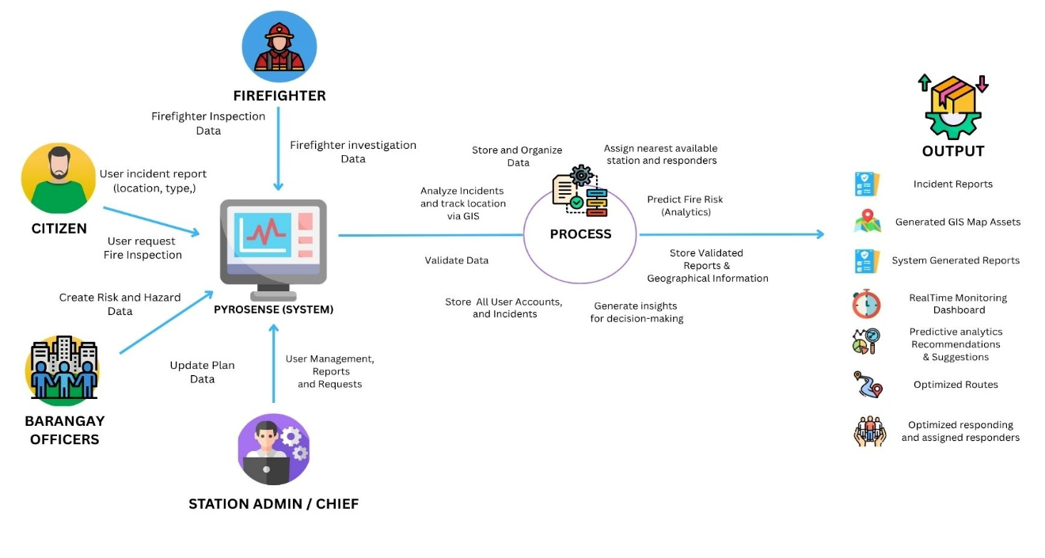

Figure 2.6.1 Conceptual Framework
The input stage consisted of all the necessary data required for the operation of the system. These included incident report inputs such as the location and type of the incident, fire safety inspection requests, historical fire incident records, as well as geographic and location-based data obtained through GIS. In addition, user inputs from fire personnel or authorized users were also considered as part of the input. These data sources provided the foundation for analyzing fire risk, generating accurate predictions, responses, and routing optimizations.
The process stage represented the core functionalities of the system, where the collected data were analyzed and transformed. This included predictive fire risk analysis using an AI Model, which identified patterns and determined the probability of fire occurrence in specific station jurisdictions. The system also integrated Geographic Information System (GIS) technology to perform spatial analysis and visualize fire-prone locations through interactive maps. Furthermore, response optimization was carried out using routing API backend computation logic that determined the most efficient paths and strategies for fire and emergency response. These processes worked together to ensure that the system produced accurate, timely, and reliable results.
The output stage presented the results generated by the system after processing the input data. These outputs included fire risk level classifications, GIS-based visual representations of high-risk areas, and optimized emergency response routes. The information produced by the system served as decision support for fire departments and local government units, enabling them to respond more effectively and efficiently to fire incidents. It also aided in proactive planning and resource allocation to minimize potential damage.
Overall, the conceptual framework ensured a systematic and logical flow of information within the system. It highlighted the integration of predictive analytics, GIS technology, and optimization techniques in achieving the objectives of the study. This framework provided a clear representation of how PYROSENSE functioned as a comprehensive tool for enhancing fire risk management and emergency response operations.

Chapter 3
METHODOLOGY

This chapter presents the developmental and descriptive foundation of PYROSENSE: A Predictive Fire Risk Analysis and Response Optimization System Incorporating Geographic Information System (GIS) Technology for the Bureau of Fire Protection (BFP) Urbiztondo, Pangasinan. Specifically, it covers the requirements analysis, system framework, technical background, implementation plan, and conceptual framework guiding the system’s design and development.
3.1 Requirements Analysis
Requirements analysis is the process of identifying, examining, and documenting the functional and non-functional requirements needed for the development of PYROSENSE: A Predictive Fire Risk Analysis and Response Optimization System Incorporating Geographic Information System (GIS) Technology for the Bureau of Fire Protection (BFP), Urbiztondo, Pangasinan. This study utilized both Descriptive and Developmental research designs to analyze the operational gaps in the current fire risk assessment and emergency response procedures of BFP Urbiztondo. According to Yang, J., Li, X., & Zhang, Y. (2024), it is an essential part of the development phase of a fire response management system that identifies necessary operational needs, causes, risks, and system functionality during a fire-related incident. The descriptive approach focused on determining the need for a digitized and data-driven fire prediction system, while the developmental approach emphasized the engineering and creation of the system. Different data gathering methods, such as interviews, document analysis, internet sources, group study, and observation, were employed to collect reliable and relevant information from stakeholders, including BFP personnel, responders, barangay officials, and community residents. The use of requirement analysis was essential because it ensured that the PYROSENSE system addressed the actual operational challenges experienced by BFP Urbiztondo. Through systematic data collection and stakeholder participation, the researchers were able to identify the necessary system features and technical requirements that support predictive fire analysis, GIS integration, and response optimization. This approach also guaranteed that the developed system was user-centered, reliable, and aligned with the municipality’s emergency response needs.
3.1.1 Population and Locale of the Study
The population of this study included the key stakeholders who are affiliated and associated with fire risk management and emergency response in the municipality of Urbiztondo, Pangasinan. According to Dela Cruz, M. R., & Santos, J. P. (2021), the population and locale of a fire response management system involve firefighters, emergency responders, concerned citizens, and residents in the community that is vulnerable to fire-related cases. The population was divided into four different user levels. The participants included one (1) System Administrator who oversaw the governance and data integrity of the system (designated BFP IT personnel), one (1) BFP Urbiztondo Fire Marshal who oversaw the operational use of the system, an estimated fifteen (15) Fire and Emergency Responders of BFP Urbiztondo who acted as primary end‑users for response optimization, and an estimated 300 Community Residents or Barangay Officials from Urbiztondo’s twenty-one (21) barangays who served as beneficiaries and reporting end‑users of the system. The researchers utilized a purposive sampling method in choosing the participants for the study. The reason for choosing this method was that the researchers were able to target participants who had firsthand knowledge and experience about the existing manual fire risk assessment and response processes within BFP Urbiztondo. The requirements gathered specifically addressed the needs of the participants while still abiding by the set time and resource constraints.
The specific locale of this study was the Municipality of Urbiztondo, Pangasinan, and the Bureau of Fire Protection (BFP) Urbiztondo station. As a growing municipality with identified fire risk zones, mixed residential‑commercial structures, and increasing urban density, Urbiztondo was a strategic and relevant site for the implementation of the PYROSENSE platform. The BFP Urbiztondo faces challenges in rapid fire detection, resource allocation, and response time optimization due to limited personnel and equipment. This made it an ideal site for this study, where a digital solution was sought for modernizing conventional fire risk analysis and facilitating inter‑agency collaboration between the BFP, the local government unit (LGU) of Urbiztondo, and community residents during emergency response.
3.1.2 Data Instrumentation
Data instrumentation is the process of gathering data through various tools and techniques (Kumar R., 2021). It includes the tools used to gather data by researchers to gather, measure, and analyze specific information during the study. The researchers used different types of data instrumentation to gather facts, information, and data for the system.
Interview. An interview guide was used as the primary data collection method to gather in-depth insights and qualitative perspectives from the respondents. According to Sharma and Singh (2023), interviews are significant in gathering context-rich data, as they enable respondents to clarify complex operations and give a deeper understanding of the user experience. For PYROSENSE, a structured interview guide was essential for gathering detailed feedback on the platform's predictive accuracy, GIS interface usability, response efficiency, and overall reliability. The method was customized to align with the unique operational requirements of BFP Urbiztondo and the local DRRM office, ensuring the data collected is both reliable and directly relevant to the system's development.
Document Analysis. The study examined existing records and internal documentation used by BFP Urbiztondo. Davie and Wyatt (2023) stated that document analysis involves interpreting records as artifacts that reflect the values and procedures of an organization. This method was critical for critically assessing BFP Urbiztondo's current workflows, risk assessment practices, and logistical inefficiencies. By reviewing historical fire incident reports, pre‑fire planning maps, response time logs, and equipment inventory records, the development team identified specific gaps in manual record‑keeping and operational procedures that the PYROSENSE system was designed to address.
Internet Sources. Information from websites and internet sources were used to support technical development. According to Cilliers and Viljoen (2021), the use of the internet for data gathering allows for access to updated data in a more informed and comprehensive manner. This instrumentation provided the researchers with technical documentation and best practices for predictive analytics, GIS integration, and fire risk modeling. Peer-reviewed journals and case studies from databases like Google Scholar and ResearchGate, centered on Python/Laravel implementation, geospatial database management, and web-based emergency response systems, were consulted to ensure the credibility of the technical references used in the development of PYROSENSE.
Group Study. A group study approach was employed to facilitate collaborative discussions among key stakeholders. A group study, often in the form of a focus group, is defined as a "research technique that collects data through group interaction on a topic determined by the researcher" (Morgan, 1997). It involves bringing together a small number of individuals to discuss specific issues in a permissive, non-threatening environment, generating rich qualitative data through the dynamic interaction among participants. This method was utilized to gather collective insights and foster consensus on the functional requirements of PYROSENSE. Separate group study sessions were conducted with BFP responders and barangay officials. This allowed the development team to observe how different user groups prioritize features, resolve conflicting needs, and identify potential workflow integration issues, ultimately leading to a more collaborative and user-centered system design.
Observation. An observation method was used to directly record and analyze the existing manual fire response processes. Observation is a primary method of collecting data by systematically recording behavioral patterns, events, and interactions in a natural setting. This study employed Non-Participant Structured Observation, where the researchers watched and recorded participants’ behavior without interfering, using a pre-defined checklist to focus on specific, predetermined activities. This specific observational method was chosen to objectively assess the efficiency and challenges of BFP Urbiztondo's current operations. By using a structured checklist to time specific activities (e.g., report-taking, dispatch communication, equipment retrieval) and observe workflow sequences without direct involvement, the researchers gathered quantifiable baseline data on response times, procedural bottlenecks, and communication gaps. This provided empirical evidence to justify the need for automation and directly informed the functional requirements for the response optimization modules in PYROSENSE.
3.2 Computer Hardware and Software Requirements
Computer hardware and software requirements referred to the minimum technical specifications necessary for the development, testing, and implementation of the PYROSENSE system. The hardware requirements included components such as a processor, memory, storage, operating system, internet connection, display resolution, and input devices. Meanwhile, the software requirements included the operating system, browser, integrated development environment, programming language, database management system, framework, and web server used in system development. IBM (2023) ensures that it operates effectively and efficiently. These specifications support the execution of geospatial processing, predictive analytics, database management, and web-based functionalities of the system. Identifying the appropriate hardware and software requirements ensured that the system performed efficiently and reliably during both development and actual deployment. The selected technologies, including Laravel, PostgreSQL, Visual Studio Code, and Google Chrome, provided compatibility, scalability, and support for GIS-based operations and predictive analytics. These requirements were necessary to maintain system stability, optimize performance, and ensure the successful implementation of PYROSENSE for BFP Urbiztondo.
Table 3.2.1 Minimum Computer Hardware and Software Requirements
Component | Specification
Processor | Intel i3 gen and above
Memory (RAM) | Minimum of 4 GB
Storage | 256 GB
Operating System | Windows 10
Internet Connection | Required for access full functionalities
Display | 1366 x 768 or higher
Input Devices | Keyboard, Mouse, Touchpad
Browser | Google Chrome (latest version)

The listed hardware and software specifications ensured that the system operated efficiently during development and actual use at BFP Urbiztondo. These requirements supported essential tasks such as running GIS servers, executing machine learning models, and managing large geospatial datasets of the municipality. Google Chrome was the recommended browser due to its compatibility and reliable performance with the modern web technologies implemented in the system.
3.3 Software Requirements for System Development
Table 3.3.1 presents the software tools and technologies used for developing and testing PYROSENSE. These tools were chosen for their reliability, ease of use, and suitability for geospatial data processing and predictive analytics tailored to BFP Urbiztondo’s operational context.
Table 3.3.1 Software Requirements for System Development
Component | Specification
Operating System | Windows 10
Browser | Windows 10 Browser Google Chrome
Integrated Development Environment | Visual Studio Code
Terminal/Shell | PowerShell / Terminal
Programming Language | PHP
Front end Technologies | HTML, CSS, Bootstrap, JavaScript
Database Management System  (DBMS) | PostgreSQL
Framework | Laravel
Web Server | XAMPP

These software tools were selected to support structured and efficient system development. Laravel offered a reliable PHP framework for building secure and scalable backend functionalities, while PostgreSQL handled structured data storage and spatial queries for Urbiztondo’s map layers (barangay boundaries, road networks, water sources, critical infrastructure). Visual Studio Code provided a user‑friendly yet powerful coding environment ideal for development tasks. Leaflet.js and OpenStreetMap enabled dynamic GIS visualization, and the Geoapify API provides routing capabilities for response optimization. This setup ensured consistency, reliability, and ease of testing throughout the development process.
3.4 System Framework
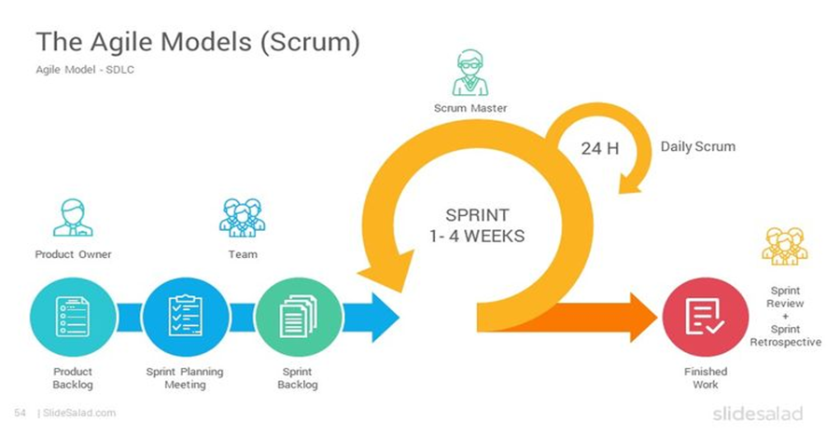
The system framework presents the structured process and methodology followed in the design and development of PYROSENSE. The study adopted the Agile Scrum methodology as the primary framework for system development. According to Dela Cruz, M. R., & Santos, J. P. (2021), the system framework must provide the overall structure of the system, process flow, processing of data, and emergency response. This framework organized the development process into iterative phases, including Product Backlog, Sprint Planning, Sprint Implementation, Daily Scrum, Sprint Review, and Sprint Retrospective. Through continuous collaboration and stakeholder feedback, the methodology supported the incremental development and enhancement of system functionalities such as predictive fire risk modeling, GIS mapping, incident reporting, and response optimization. The Agile Scrum framework was selected because of its flexibility, adaptability, and user-centered approach in software development. Since PYROSENSE involves complex functionalities and multiple stakeholders, Agile Scrum enabled the development team to continuously evaluate system performance, address issues immediately, and incorporate feedback from BFP personnel and community users. This framework ensured that the final system remained responsive, efficient, and aligned with the operational requirements of BFP Urbiztondo.

Figure 3.4.1 Agile Scrum Methodology
The developers chose to employ this methodology due to its adaptability to changing requirements and the user‑centered nature of the approach. In the case of PYROSENSE for BFP Urbiztondo, the users included the administrator, BFP fire marshal, emergency responders, and community residents. The complex functionalities that the software had to support included predictive fire risk modeling, real‑time incident mapping, resource dispatch optimization, and automated emergency notification to barangay officials. The Agile Scrum approach allowed the development team to test critical functionalities in increments.
Furthermore, as Agile Scrum's emphasis on communication and sprint reviews had shown, as discussed by Khan et al. (2023), this helped to greatly enhance transparency, accountability, and satisfaction during the development of the software. This ensured that feedback from BFP Urbiztondo personnel and barangay captains were incorporated into the system quickly, thus creating a better‑functioning, efficient, and user‑oriented platform.
Phases of Agile Scrum
The development of PYROSENSE for BFP Urbiztondo followed the Agile Scrum methodology. Scrum is an iterative approach that emphasizes continuous delivery, stakeholder feedback, and team collaboration. The following outlines the phases based on the Scrum framework illustrated in the development cycle:
Product Backlog. The first step was the exhaustive collection of all necessary features, technical requirements, and specifications for the system. The developers worked meticulously to identify key requirements for the system, including the predictive risk dashboard, real‑time GIS mapping of Urbiztondo’s twenty-one (21) barangays, automated alert system, and resource dispatch optimization tools for BFP Urbiztondo. The requirements then collated into a master list based on their criticality for the system’s architecture. By studying the gaps in the manual process for fire risk assessment at BFP Urbiztondo, the developers ensured that the list was for a system that was not only innovative but also practical for the target users.
Sprint Planning. In the Sprint Planning phase of the project, the development team carried out strategic sessions to identify specific high‑priority items to be executed within a fixed period of time or “Sprint.” The team set specific goals to be achieved during the project iterations. The project development team focused on developing fundamental features such as user authentication, GIS data integration (barangay boundaries, fire hydrant locations, critical facilities), and the predictive risk modeling interface. This phase of the project was essential for resource allocation and efficient time management, as the project development team managed to break down the complex requirements of the system into smaller tasks.
Sprint Implementation. The Implementation phase was the primary technical execution phase for the development of the PYROSENSE platform, which was centered on the development of the web‑based modules by means of rigorous coding and geospatial database integration. For a professional and user‑friendly interface for the platform, the development team opted to employ Bootstrap 5, Tailwind CSS, and Leaflet.js for the development of the GIS interface. This phase was marked by the development of key features for the platform, including the administrative dashboards, predictive risk engine, and the logic for response optimization. This was a critical phase in the development of the platform since it ensured that the integration between real‑time data sources (weather APIs, historical incident data from BFP Urbiztondo) and the response modules were meticulously done so that the end product was a web‑based platform successful in its objective of being a comprehensive all‑in‑one solution for fire risk analysis.
Daily Scrum. Throughout the development lifecycle, the team maintained a series of brief synchronized meetings referred to as Daily Scrums. This provided a platform for the development team to discuss the progress being made on the respective web modules that had been allocated to them. It was also a platform for the development team to share information on any potential “blockers” or issues that could affect the development of the system, such as geospatial data processing bottlenecks or model accuracy issues specific to Urbiztondo’s terrain. This was a key milestone in ensuring that the development of PYROSENSE was on course and that the team remained agile enough to address any issues.
Sprint Review. A Sprint Review meeting was conducted at the end of each sprint, where the newly developed functional web modules were presented to the stakeholders, which included the BFP Urbiztondo Fire Marshal, senior firefighters, and academic advisers. This phase was geared toward ensuring that the “potentially shippable” product increment met quality standards, as well as academic requirements, for each feature developed during the course of the sprint. The feedback that was gathered during these meetings proved useful for the team, as they were able to get a glimpse into how the system performed, hence allowing for necessary adjustments where needed before moving on to the next course of action.
Sprint Retrospective. After this review process, the team carried out a Sprint Retrospective meeting where they reflected on their internal development process. The developers reflected on their process of coding and the ways in which they collaborated in order to identify effective methods and those needing improvement. This process of self‑assessment was very important in optimizing their efficiency and improving their technical collaboration. This way, the developers ensured that the integrated system of PYROSENSE was very efficient, effective, and tailored for the needs of the BFP administrators, responders, and community residents of Urbiztondo through its web‑based and GIS‑integrated nature.
3.5 Tools for Data Analysis – Data Flow Diagram, Use Case, ERD
Tools for data analysis refer to the modeling and visualization techniques used to analyze, organize, and represent the processes, interactions, and database structure of the PYROSENSE system. The study utilized Data Flow Diagrams (DFD), Use Case Diagrams, and Entity-Relationship Diagrams (ERD) to analyze and visualize the system. According to Dela Cruz, M. R., & Santos, J. P. (2021), the tools for data analysis play an important and crucial role in the development of the fire-response management system and explain how data flows from the system, and the relationship of data, system, and user. The Data Flow Diagram illustrated how data moves through the system, including input, processing, storage, and output. The Use Case Diagram identified the interactions between users and the system functionalities, while the Entity-Relationship Diagram presented the relationships among database entities such as users, incidents, reports, stations, and routes. The use of these analytical tools was important because they provide a clear and organized representation of the system architecture and operational workflow. DFDs helped identify inefficiencies and improve data processing. Use Case Diagrams clarified user interactions and system scope, while ERDs ensured proper database structure and data consistency. Together, these tools supported accurate system planning, effective implementation, and reliable database management for the PYROSENSE platform.
Data Flow Diagram. A Data Flow Diagram (DFD) was a visual tool used in system analysis and design to show how data moves through a system. It demonstrated how data enters the system, how it was processed, and how it exited as output. A DFD displayed the sources and destinations of data, the locations where data were stored, and the pathways through which data flowed within the system. By presenting the flow of information clearly, DFDs helped analysts and developers understand system operations, identify inefficiencies, and design more effective methods for processing and managing data.
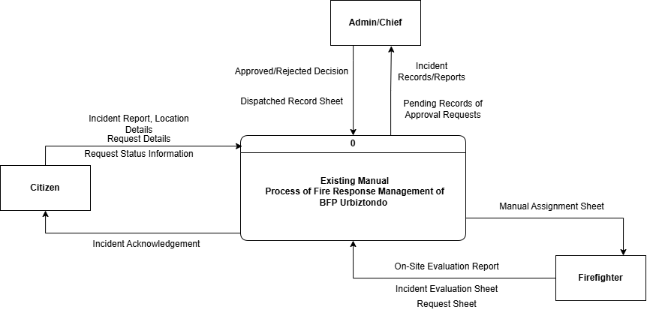

Figure 3.5.1 Level 0 Data Flow Diagram of Existing Process
of Bureau of Fire Protection Urbiztondo
Figure 3.5.1 illustrates the Level 0 Data Flow Diagram of the existing fire incident management process at BFP Urbiztondo. It presented how information was exchanged among the four main external entities: the Citizen/Barangay Official, the BFP Receiving Officer, the Fire Responder, and the Local Government Unit (LGU) in the current manual setup, before the system was developed.
The Citizen/Barangay Official initiated the process by reporting a fire incident through phone calls, text messages, or in‑person visits to the BFP station. The report included the location of the fire, estimated severity, and other relevant details. In the existing process, this information was verbally communicated or written on log sheets.
The BFP Receiving Officer manually recorded the incident details in a logbook, verifies the address, and contacted the available fire responders via radio or phone. The officer also manually tracked the status of the response (e.g., dispatched, on‑scene, fire out). Due to manual handling, data retrieval and monitoring may be slow and prone to errors or lost information.
The Fire Responder received dispatch instructions verbally or via radio, proceeded to the incident location, and manually updated the response status. After the incident, the responder completed a handwritten spot report and submited it to the station.
The LGU (e.g., Mayor’s Office, DRRM Office) received periodic summary reports from BFP, usually through printed documents or email. There was no real‑time data sharing, and coordination was often delayed.
Overall, the diagram presented a high‑level view of the existing manual fire incident management process at BFP Urbiztondo. It highlighted that the current workflow depended on manual recording, verbal communication, and separate coordination among entities, leading to inefficiencies and delayed response.

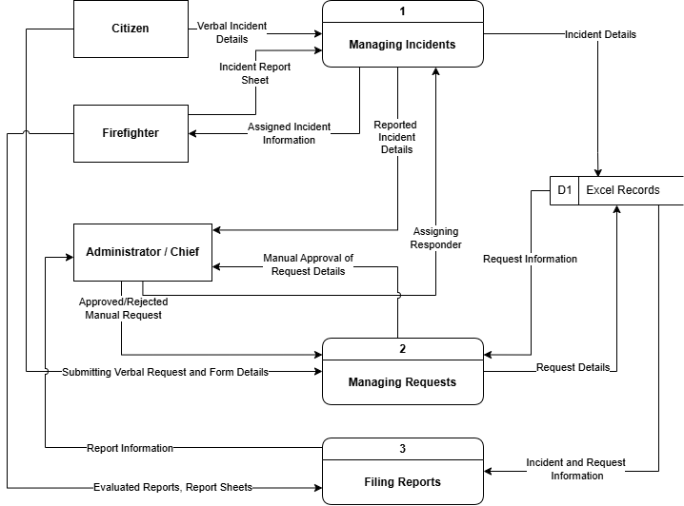
Figure 3.5.2 Level 1 Data Flow Diagram of Existing Process
of Bureau of Fire Protection Urbiztondo
Figure 3.5.2 presents the Level 1 Data Flow Diagram of the Existing System process by breaking down the main processes into sub-processes. The diagram illustrated how the data flowed from the existing external and internal entities, processes, and data store. Process 1.0 handled incident reporting and validated fields such as name, location, incident type, and other details stored in the data store. Process 2.0 handled all requests from the user levels, then validated fields to store in the same data store. The Data store of the existing process used a log book and Excel to file and store records of requests, reports, and incidents. Process 3.0 handled the generation and filing of reports from the data Store, then printed before filing to the chief or station admin.
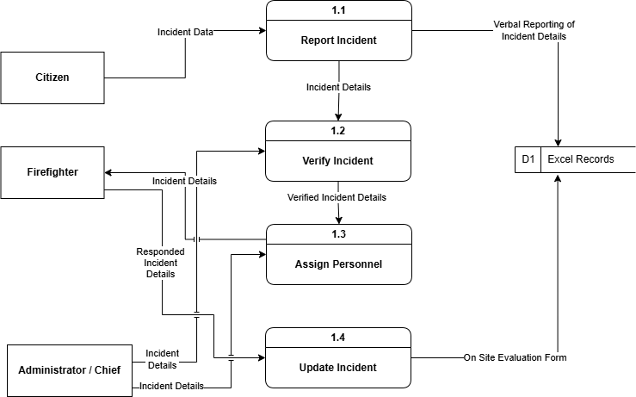

Figure 3.5.3 Level 2 Data Flow Diagram Process 1 of Existing Process
of Bureau of Fire Protection Urbiztondo
Figure 3.5.3, present the Level 2 Data Flow Diagram of the existing process of the BFP. The diagram showed the detailed processes of the main process of how the data flowed from the citizen, firefighter, admin, or chief. Process 1.1 collected reported incidents, then Process 1.2, the administrator or chief verified the report details before proceeding to Process 1.3. In this process, the administrator or chief called and assigned the firefighters or a team to respond to the incident. Once Process 1.3 finished, Process 1.4 updated the report from the evaluated incident. After manually verifying and conducting the response, they collected and stored report forms and sheets in the record files, such as the logbook and Microsoft Excel.

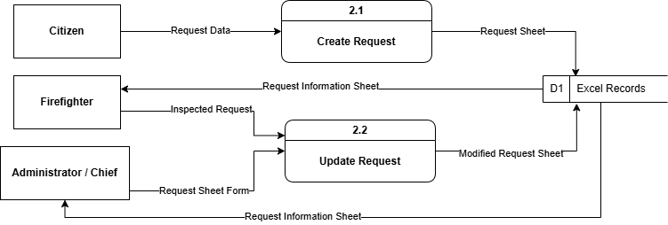

Figure 3.5.4 Level 2 Data Flow Diagram Process 2 of Existing Process
of Bureau of Fire Protection Urbiztondo
Figure 3.5.4 present the Level 2 Data Flow Diagram of the existing process of the BFP. The diagram showed the detailed processes of the main process of how the data flowed from the citizen, firefighter, admin, or chief. Process 2.1 handled the creation of the request. The user submitted an oral or request form sheet, inputting details, then logged into the data store. Before proceeding to Process 2.2, the Administrator or chief retrieved the data or details from the data store manually, then verified the request to make a decision whether to approve or reject, and then updated the data before storing it back to the data store.
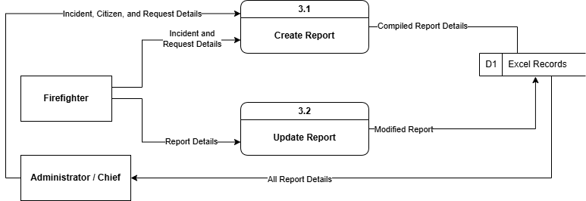
Figure 3.5.5 Level 2 Data Flow Diagram Process 3 of Existing Process
of Bureau of Fire Protection Urbiztondo

Figure 3.5.5 present the Level 2 Data Flow Diagram of the existing process of the BFP. The diagram showed the detailed processes of the main process of how the data flowed from the citizen, firefighter, admin, or chief. Process 3.1 handled the creation of the paper report, the data flowed from the incident report and request details, filling the form sheet for the report before storing it in the records or data store. Process 3.2 happened when the administrator or chief checked and verified the records of the report, then applied the updated details to store updated records.
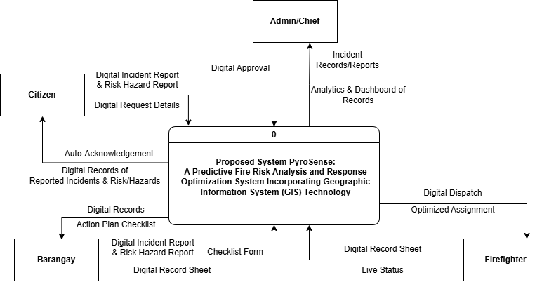
Figure 3.5.6 Level 0 Data Flow Diagram of the System
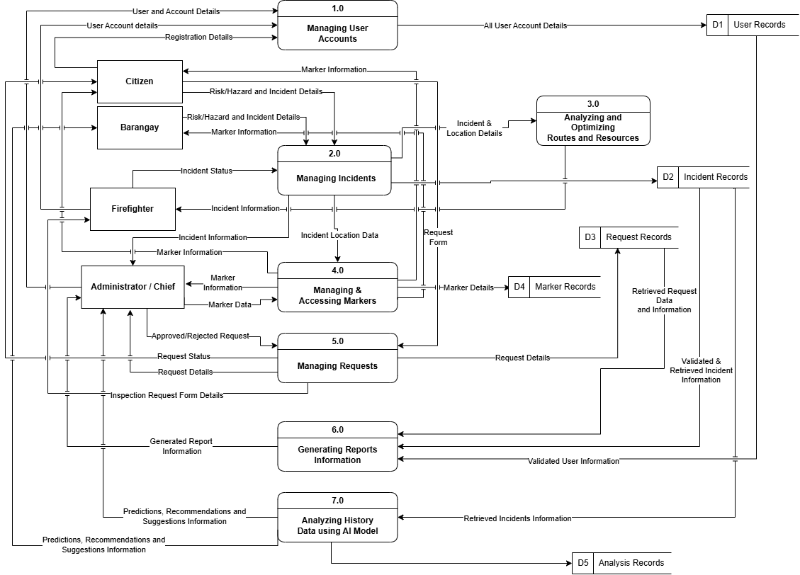
Figure 3.5.6 illustrates the Level 0 Data Flow Diagram of the Proposed System PYROSENSE. The data flowed from the digital entities, processed via the system, and the database as the data store. Citizen and Barangay logged in and submitted a report incident with GPS data into the system, then the system checked and verified data input before storing to the database. After reporting, the system assigned responders and automatically generated routes and other geographic information for user levels. Evaluated report files to the system and generated a form of information that were able to be shared across user levels, so that citizens, firefighters, and administrators were able to view digitally the reported incident response feedback with a secure connection and a record of stored records. The system generated checklist, analysis and mitigations to be verified by the admin/chief and reviewed investigations by firefighter in cooperation by the barangay user level.

Figure 3.5.7 Level 1 Data Flow Diagram of the System
Figure 3.5.7 illustrates the Level 1 Data Flow Diagram of the system. PYROSENSE presented an enhanced version of the current and optimized process. The process 1.0 managed the user account creation of the citizen, barangay, firefighter, administrator, or chief, and it accommodated the user input validation and stored at the data store of user records. The Process 2.0 handled the processing of the incidents that were submitted by the users with input validation, verification, and storing in the data store before proceeding to the next process module. Process 3.0 enhanced and optimized response capability and reduced manual interactions of the firefighter, administrator, or chief in an incident through analyzing spatial and geographic location. Process 4.0 handled the process by which an incident was given marker location. The process 5.0 was handled by firefighter and administrator or chief to manage requests from the users. Generation of reports and information were fall to process 6.0 before finalizing to display information for all users. Process 7.0 analyzed by AI models and machine learning to process records and factors that contributed to the prediction output such as mitigation and action plan checklist.
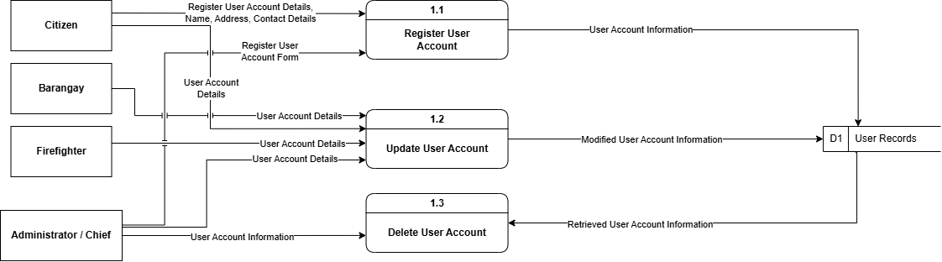

Figure 3.5.8 Level 2 Data Flow Diagram Process 1 of the System
Figure 3.5.8 presents Process 1.0 (User Account Management). The system collected registration data from citizens and the administrator or chief. It then validates the input for completeness and uniqueness before securely storing user records in a centralized data store. This automated process eliminates manual logbooks and enables role‑based access control.

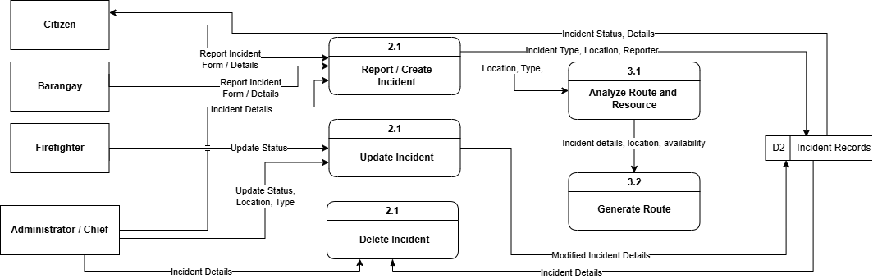

Figure 3.5.9 Level 2 Data Flow Diagram Process 2 and 3 of the System
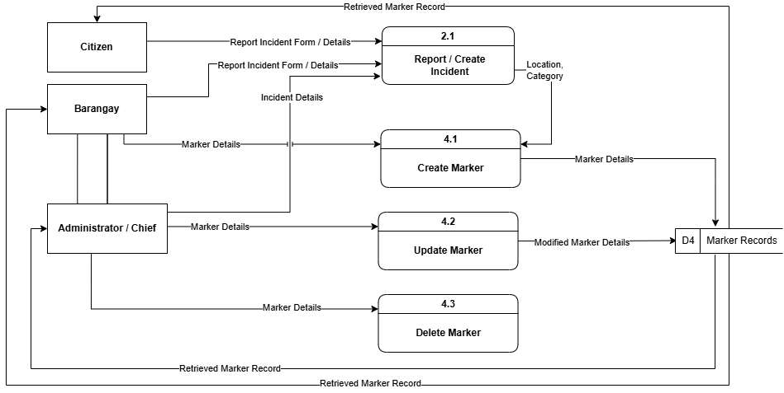
Figures 3.5.9 represents the detail Process 2.0 (Incident Processing) and Process 3.0 (Response Optimization). For incident processing, the system validated GPS locations and incident details, such as type and severity, before storing the report. For response optimization, it queried station records, team rosters, and responder locations to identify the nearest available station and the most suitable response team.

Figure 3.5.10 Level 2 Data Flow Diagram Process 4 of the System
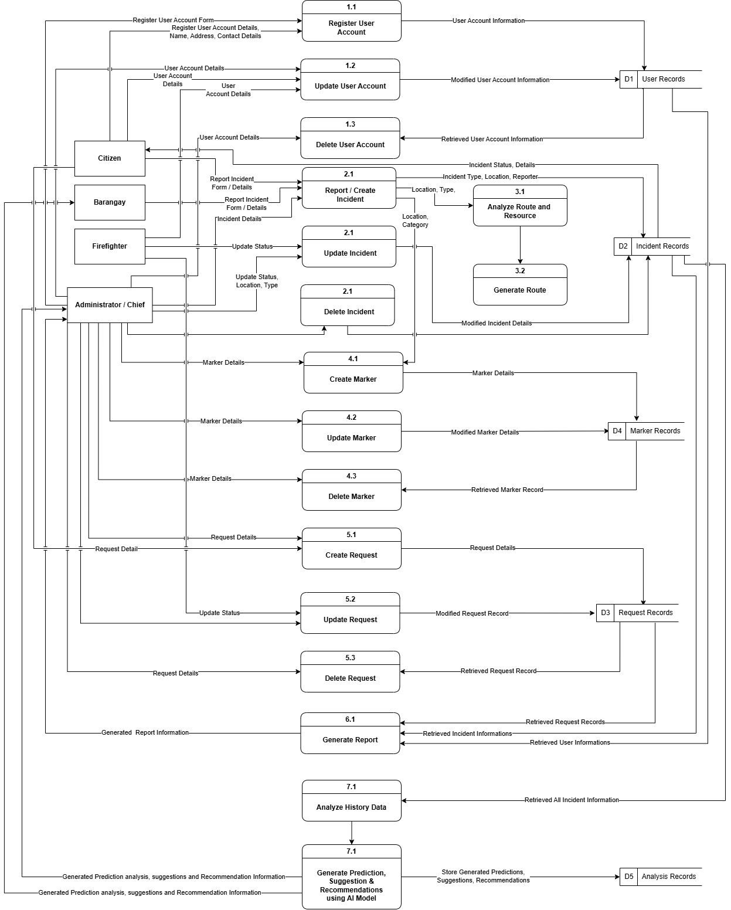
Figure 3.5.10 represents the data generating markers that the system calculated an optimized route using real‑time traffic data and road network information. It then automatically dispatched the selected responders with instant alerts, simultaneously updating the incident status from "reported" to "dispatched." This automation removed the need for manual phone calls and radio coordination, drastically reducing response time.

Figure 3.5.11 Level 2 Data Flow Diagram of the System
Figure 3.5.11 integrates all processes, showing how incident reports triggered automated dispatch, route generation, report generation, analyzing data recommendations, suggestions and post‑incident reporting. After an incident was resolved, firefighters submitted digital investigation reports linked to the original record. Thus, this integrated digital workflow ensured faster emergency response, better resource allocation, and complete paperless record‑keeping for BFP Urbiztondo. Analyzing through AI models and patterns the system generated prediction, recommendation and suggestion that were useful for the mitigation to reduce possible fire related incidents and cooperate with the local barangay to disseminate information and helped to reduce possible incidents that may occur.
Use Case Diagram
A use case diagram is a visual representation that shows how users, known as actors, interact with a system to achieve specific goals. It provides a high‑level overview of the system's functionality by illustrating the different actions or services the system can perform and how users engage with them. By organizing these interactions into a simple visual format, the diagram helps developers and stakeholders understand the system's scope, features, and user behavior more effectively. This makes it an essential tool during the planning and design phase, as it ensures that all participants have a clear and shared understanding of how the system would operate and how users would navigate through it (GeeksforGeeks, 2025).

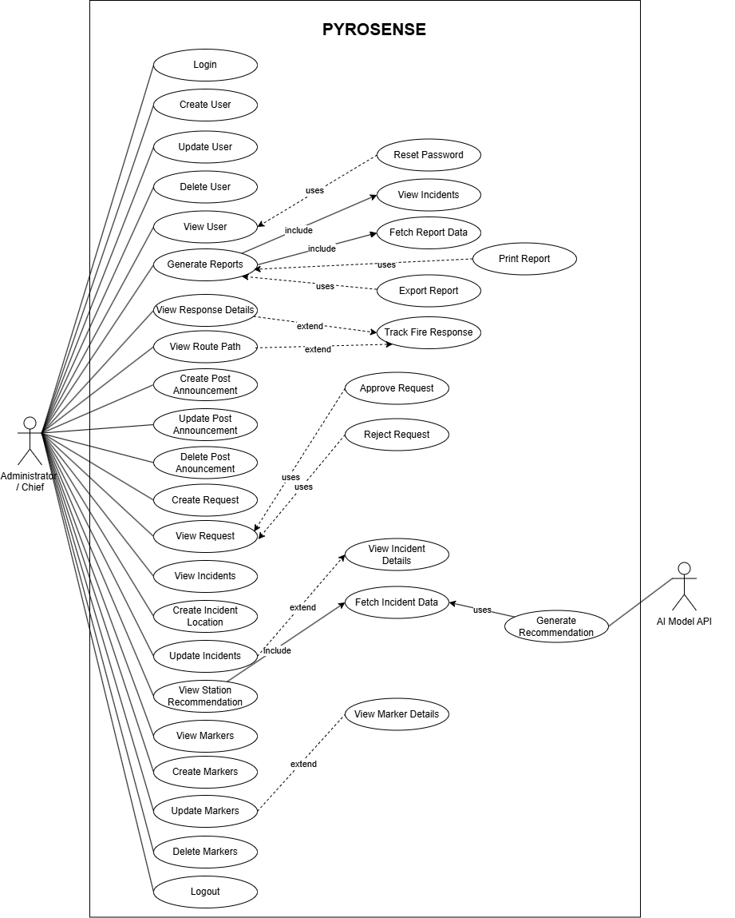
Figure 3.5.12 Shows the Use Case Diagram for the Administrator and Chief
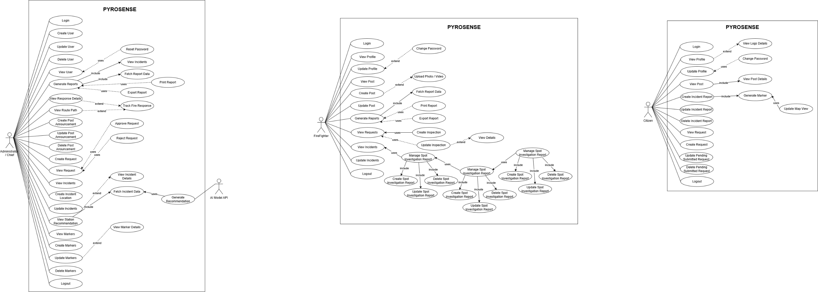
Figure 3.5.12 presents the Use Case Diagram showing the key functions performed by the Administrator and Fire Chief in PYROSENSE. The Administrator was responsible for managing user accounts (firefighters, barangay officials, citizens), system settings, GIS data layers (Urbiztondo map), risk model parameters, and viewing system‑wide analytics reports. The Fire Chief was able to view real‑time incident dashboards, analyze risk heatmaps, generate response performance reports, and manage alert broadcasts to barangay officials. Both actors were able to monitor system activities and ensure that fire response operations were properly coordinated.

Figure 3.5.13 shows the Use Case Diagram for the Firefighter
Figure 3.5.13 shows the Use Case Diagram outlining the key functions of the Firefighter (Responder) within PYROSENSE. The Firefighter was responsible for viewing assigned incidents, accessing optimized routes (via GIS and routing API), updating incident status (e.g., en route, on scene, fire out), submitting spot investigation reports, managing equipment logs, and receiving real‑time alerts. The Firefighter was also able to view incident details, upload photos or videos, and request additional resources if needed. Through these functions, the Firefighter was able to respond to fire incidents efficiently and document critical information for post‑incident analysis.

Figure 3.5.14 shows the Use Case Diagram for the Citizen
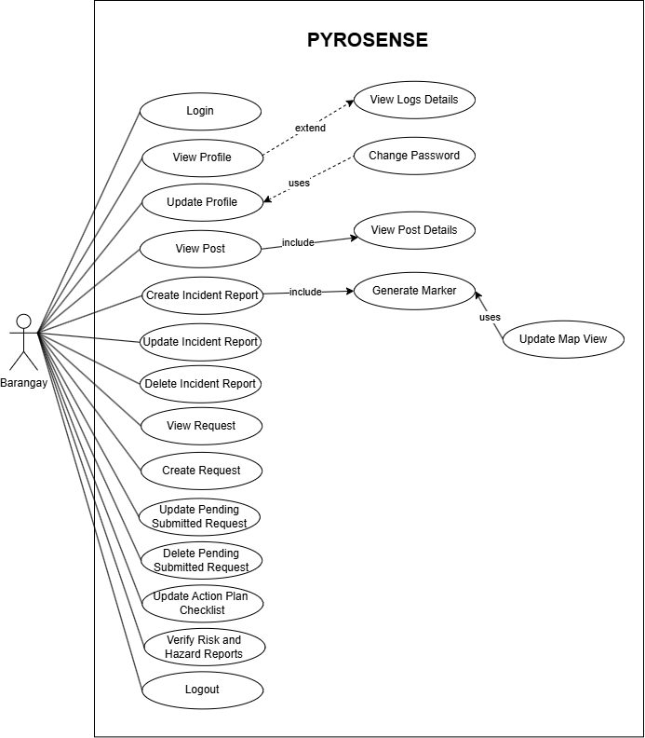
Figure 3.5.14 shows the Use Case Diagram outlining the different actions a Citizen can perform within PYROSENSE. The Citizen was responsible for reporting fire incidents or fire hazards through the web or mobile interface, uploading photos or videos of the incident, viewing real‑time alerts and evacuation maps, receiving safety notifications, and viewing educational fire safety materials. The Citizen was also able to track the status of their reported incident and provide feedback. Through these functions, the Citizen acted as a first‑responder informant, enabling faster detection and reporting of fire incidents to BFP Urbiztondo.

Figure 3.5.15 shows the Use Case Diagram for the Barangay
Figure 3.5.15 shows the Use Case Diagram outlining the different actions a Barangay can perform within PYROSENSE. The Barangay was responsible for reporting fire incidents or fire risk and hazards through the web or mobile interface, uploading photos or videos of the incident, viewing real‑time alerts and evacuation maps, receiving safety notifications, and viewing educational fire safety materials. The Barangay was also able to track the status of their reported incident and provide feedback and receive tasked outline for action plan checklist generated by the administrator or chief and cooperation with the firefighters.
Entity Relationship Diagram. An Entity‑Relationship Diagram (ERD) is a graphical representation used in database design to show the entities in a system and the relationships among them. It serves as a structural model that identifies the major data components of the database, such as users, incident reports, risk zones (barangays of Urbiztondo), environmental data, response resources (fire trucks, equipment, hydrants), alerts, evacuation routes, and investigation reports. In the PYROSENSE system, the ERD was essential for illustrating how these entities were connected to support predictive fire risk analysis and response optimization operations. It helped developers and researchers understand the database structure, maintain data consistency, reduce design errors, and ensure that the system database was properly organized and reliable throughout the implementation of the project.

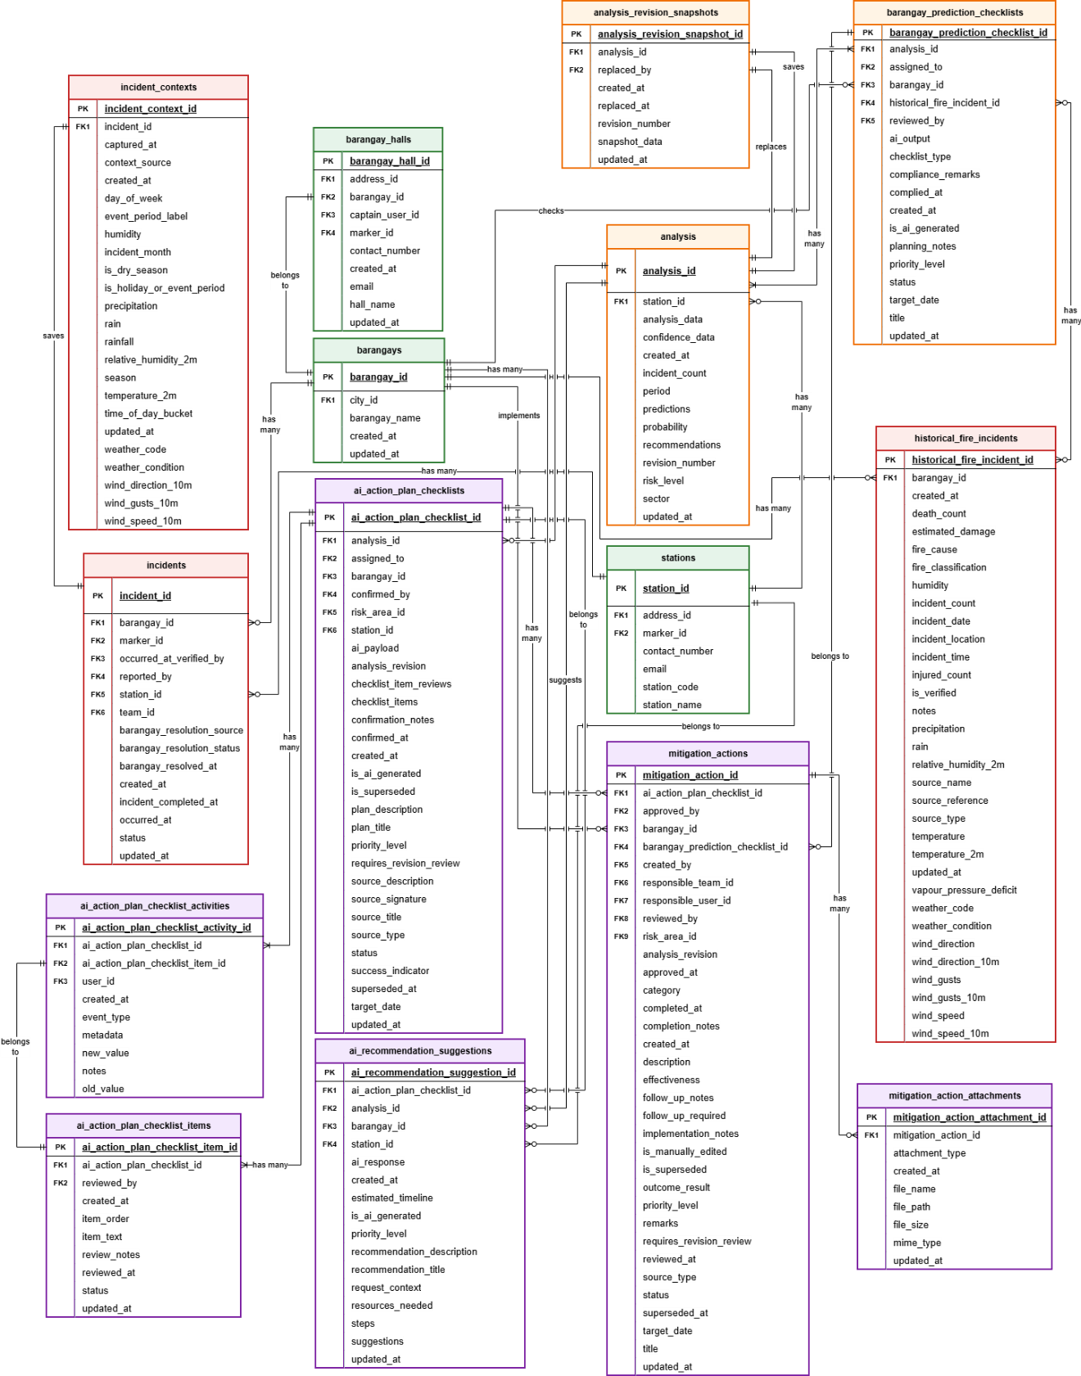

Figure 3.5.16 Entity Relationship Diagram of PYROSENSE
Predictive Analysis Module
Figure 3.5.16 shows the database structure of the predictive analysis module of PYROSENSE; in this diagram context, it illustrated how the system managed, organized, and processed historical fire-related data in order to generate predictions, identify risk levels, and support decision-making for fire prevention and preparedness. It showed the workflow of how the system collected data from stations, barangays, and incident-related records, then transformed these stored values into analytical outputs. The main process of predictive analysis was centered on the historical_data table, which contained the necessary fields used by the system, such as station_id, incident_count, month, year, average_temperature, season, near_water, density, materials, peak_hours, occupancy, type_incident, accessibility, and risk_level.
The sub-processes of predictive analysis were reflected in the suggestions_checklist, recommendation_checklist, barangay_prediction_checklist, ai_action_plan_checklists, ai_action_plan_checklists_items and ai_recommendation_suggestions tables. These tables stored the recommended actions, generated plans, compliance remarks, checklist items, status updates, and priority levels based on the prediction results. The barangay_fire_records table also supported the predictive process by storing localized fire-related observations such as fire_cause, fire_classification, incident_count, incident_date, temperature, humidity, wind_speed, and wind_direction, which provided additional context for barangay-level analysis and forecasting.
Overall, the predictive analysis database structure of PYROSENSE allowed the system to collect accurate historical and environmental data, process these through analytical and machine learning methods, and produce reliable outputs in the form of predictions, mapped risk areas, and recommended action plans. The flow of predictive analysis seamlessly connected stations, barangays, fire records, and AI-generated recommendations, making the system capable of supporting proactive fire risk assessment and preparedness planning across different areas.
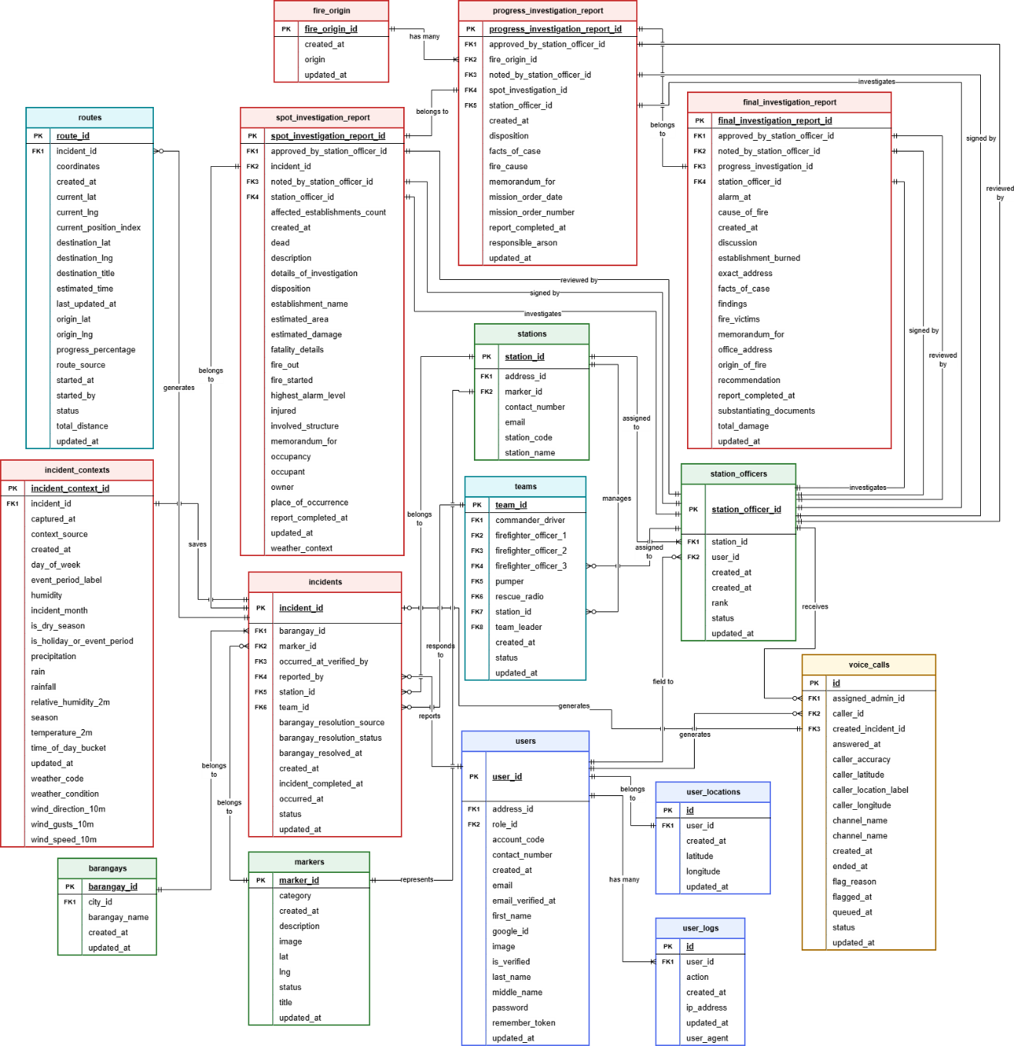

Figure 3.5.17 Entity Relationship Diagram of PYROSENSE
Core Module Fire Response and Request Module
Figure 3.5.17 presents an illustration of the Entity Relationship Diagram Core Module of the PYROSENSE that stored the processed and validated data for the response management of the system and the user request into the generated information. This Fire Response and Request Module Diagram offered the service and transaction of the report and response, request for certifications, and helped to visualize the process of requesting, validating, and generating a request information result. These response tables were named incidents, markers, user_location, station_officers, teams, stations, routes, and report tables such as spot_investigation_report, progress_investigation_report, and final_investigation_report. The incidents covered and stored data or details of reported incidents, such as date of report, status, and incident type. The markers table stored geographic information like latitude and longitude that synchronized with the incident details and appears on the entire map system. Along with the response tables, the station_officers fielding user officers, rank, and availability that comes from a certain station and had a team inclusion were needed to perform the system’s fire response module. Through the fsic_request table, the user was able to request inspections, which was verified by officers.
Furthermore, the structure of tables enhanced the flow of the data and the workflow of response management during a fire-related incident, and easily generated a certificate for fire safety inspection. Through these data tables, it enhanced the system performance to search and assign the nearest station and ready-to-go teams for an immediate and timely response, and get inspection request certification when it was approved, with or without going to the said station.
Data Dictionary. A Data Dictionary is a structured reference used in database design to describe and organize all data elements within the system. It identifies each field in every table, such as incident details, user information, risk zone boundaries (barangay‑level), environmental readings, and response records, and specifies its data type, size, description, and purpose. By clearly defining these properties, the data dictionary standardizes how data is named, stored, and interpreted across the system. This was essential in the development of the system because processed such as risk prediction, incident handling, resource dispatch, and user management depended on consistent and well‑defined data fields. The data dictionary also served as a guide for developers, database designers, and system users (BFP personnel) by providing a clear understanding of how each field was used, how tables were related, and how data were able to be retrieved, processed, and analyzed efficiently.
Table 3.5.1 represents the the ai_action_plan_checklist_activities table used to store ai action plan checklist activity records in the system. It was linked to ai action plan checklist items, ai action plan checklists, and users. It contained the fields required to manage each ai action plan checklist activity record.
Table 3.5.1 ai_action_plan_checklist_activities
Fields | Data Type | Null | Constrained | Description
ai_action_plan_checklist_activity_id | bigint(20) | No | PK | Unique identifier for the ai action plan checklist activity record.
ai_action_plan_checklist_id | bigint(20) | No | FK1 | References the related ai action plan checklist record used by this ai action plan checklist activity entry.
ai_action_plan_checklist_item_id | bigint(20) | Yes | FK2 | References the related ai action plan checklist item record used by this ai action plan checklist activity entry.
user_id | bigint(20) | Yes | FK3 | References the related user record used by this ai action plan checklist activity entry.
event_type | varchar(40) | No |  | Stores the event type value for this ai action plan checklist activity record.
old_value | varchar(80) | Yes |  | Stores the old value value for this ai action plan checklist activity record.
new_value | varchar(80) | Yes |  | Stores the new value value for this ai action plan checklist activity record.
notes | text | Yes |  | Additional notes recorded for the ai action plan checklist activity.
metadata | json | Yes |  | Structured metadata associated with the ai action plan checklist activity record.
created_at | timestamp | No |  | Date and time when the ai action plan checklist activity record was created.

Table 3.5.2 represents the Checklist Item that stores AI action plan checklist items records. It was linked to AI action plan checklists and users. It contained the core fields needed by the system for this dataset.
Table 3.5.2 ai_action_plan_checklist_items
Fields | Data Type | Null | Constrained | Description
ai_action_plan_checklist_item_id | bigint(20) | No | PK | Unique identifier for the ai action plan checklist item record.
ai_action_plan_checklist_id | bigint(20) | No | FK1 | References the related ai action plan checklist record used by this ai action plan checklist item entry.
reviewed_by | bigint(20) | Yes | FK2 | References the related user record used by this ai action plan checklist item entry.
created_at | timestamp | No |  | Date and time when the created event happened for this ai action plan checklist item record.
item_order | int(10) | No |  | Stores an item order value for this ai action plan checklist item record.
item_text | text | No |  | Stores an item text value for this ai action plan checklist item record.
review_notes | text | Yes |  | Stores a review notes value for this ai action plan checklist item record.
reviewed_at | timestamp | Yes |  | Date and time when the reviewed event happened for this ai action plan checklist item record.
status | enum | No |  | Stores the selected status category for this ai action plan checklist item record.
updated_at | timestamp | No |  | Date and time when the updated event happened for this ai action plan checklist item record.

Table 3.5.3 represents the AI Action Plan Checklist table used to store AI action plan checklist records. It was linked to analysis, stations, barangays, and users. It contained the core fields needed by the system for this dataset.
Table 3.5.3 ai_action_plan_checklists
Fields | Data Type | Null | Constrained | Description
ai_action_plan_checklist_id | bigint(20) | No | PK | Unique identifier for the ai action plan checklist record.
analysis_id | bigint(20) | Yes | FK1 | References the related analysi record used by this ai action plan checklist entry.
assigned_to | bigint(20) | Yes | FK2 | References the related user record used by this ai action plan checklist entry.
barangay_id | bigint(20) | Yes | FK3 | References the related barangay record used by this ai action plan checklist entry.
confirmed_by | bigint(20) | Yes | FK4 | References the related user record used by this ai action plan checklist entry.
station_id | bigint(20) | Yes | FK5 | References the related station record used by this ai action plan checklist entry.
ai_payload | json | Yes |  | Stores an ai payload value for this ai action plan checklist record.
checklist_item_reviews | json | Yes |  | Stores a checklist item reviews value for this ai action plan checklist record.
checklist_items | json | No |  | Stores a checklist items value for this ai action plan checklist record.
confirmation_notes | text | Yes |  | Stores a confirmation notes value for this ai action plan checklist record.
confirmed_at | timestamp | Yes |  | Date and time when the confirmed event happened for this ai action plan checklist record.
created_at | timestamp | No |  | Date and time when the created event happened for this ai action plan checklist record.
is_ai_generated | tinyint(1) | No |  | Boolean flag that shows whether the ai action plan checklist is ai generated.
plan_description | text | Yes |  | Stores a plan description value for this ai action plan checklist record.
plan_title | varchar(255) | No |  | Stores a plan title value for this ai action plan checklist record.

Table 3.5.4 represents the AI Recommendation and Suggestion table used to store AI recommendation suggestions records. It was linked to analysis, AI action plan checklists, stations, and barangays. It contained the core fields needed by the system for this dataset.
Table 3.5.4 ai_recommendation_suggestions
Fields | Data Type | Null | Constrained | Description
ai_recommendation_suggestion_id | bigint(20) | No | PK | Unique identifier for the ai recommendation suggestion record.
ai_action_plan_checklist_id | bigint(20) | Yes | FK1 | References the related ai action plan checklist record used by this ai recommendation suggestion entry.
analysis_id | bigint(20) | Yes | FK2 | References the related analysi record used by this ai recommendation suggestion entry.
barangay_id | bigint(20) | Yes | FK3 | References the related barangay record used by this ai recommendation suggestion entry.
station_id | bigint(20) | Yes | FK4 | References the related station record used by this ai recommendation suggestion entry.
ai_response | longtext | Yes |  | Stores an ai response value for this ai recommendation suggestion record.
created_at | timestamp | No |  | Date and time when the created event happened for this ai recommendation suggestion record.
estimated_timeline | text | Yes |  | Stores an estimated timeline value for this ai recommendation suggestion record.
is_ai_generated | tinyint(1) | No |  | Boolean flag that shows whether the ai recommendation suggestion is ai generated.
priority_level | enum | No |  | Stores the selected priority level category for this ai recommendation suggestion record.
recommendation_description | text | Yes |  | Stores a recommendation description value for this ai recommendation suggestion record.
recommendation_title | varchar(255) | No |  | Stores a recommendation title value for this ai recommendation suggestion record.
request_context | json | Yes |  | Stores a request context value for this ai recommendation suggestion record.
resources_needed | json | Yes |  | Stores a resources needed value for this ai recommendation suggestion record.
steps | json | Yes |  | Stores a steps value for this ai recommendation suggestion record.
suggestions | json | Yes |  | Stores a suggestions value for this ai recommendation suggestion record.
updated_at | timestamp | No |  | Date and time when the updated event happened for this ai recommendation suggestion record.

Table 3.5.5 represents the Analysis table that was used to store information about cities or municipalities served by BFP Urbiztondo. It contained a primary key identifier for each city and stored information such as the city name, province reference, and timestamps.
Table 3.5.5 analysis
Fields | Data Type | Null | Constrained | Description
analysis_id | bigint(20) | No | PK | Unique identifier for the analysis record.
station_id | dropForeign | Yes | FK1 | References the related station record used by this analysis entry.
analysis_data | json | Yes |  | Stores an analysis data value for this analysis record.
confidence_data | varchar(255) | Yes |  | Stores a confidence data value for this analysis record.
created_at | timestamp | No |  | Date and time when the created event happened for this analysis record.
incident_count | int(11) | No |  | Number of incidents recorded.
period | varchar(255) | Yes |  | Stores a period value for this analysis record.
predictions | json | Yes |  | Stores a predictions value for this analysis record.
probability | varchar(255) | Yes |  | Stores a probability value for this analysis record.
recommendations | json | Yes |  | Stores a recommendations value for this analysis record.
risk_level | varchar(255) | Yes |  | Risk level assigned to the record.
sector | varchar(255) | Yes |  | Stores a sector value for this analysis record.
updated_at | timestamp | No |  | Date and time when the updated event happened for this analysis record.

Table 3.5.6 represents the analysis_revision_snapshots table used to store analysis revision snapshot records in the system. It was linked to analysis, and users. It contained the fields required to manage each analysis revision snapshot record.
Table 3.5.6 analysis_revision_snapshots
Fields | Data Type | Null | Constrained | Description
analysis_revision_snapshot_id | bigint(20) | No | PK | Unique identifier for the analysis revision snapshot record.
analysis_id | bigint(20) | No | FK1 | References the related analysis record used by this analysis revision snapshot entry.
revision_number | int(10) | No |  | Stores the revision number value for this analysis revision snapshot record.
snapshot_data | json | No |  | Stores the snapshot data value for this analysis revision snapshot record.
replaced_by | bigint(20) | Yes | FK2 | References the related user record used by this analysis revision snapshot entry.
replaced_at | timestamp | No |  | Date and time when the replaced event occurred for the analysis revision snapshot record.
created_at | timestamp | Yes |  | Date and time when the analysis revision snapshot record was created.
updated_at | timestamp | Yes |  | Date and time when the analysis revision snapshot record was last updated.

Table 3.5.7 represents the Barangay Fire Records table that was used to store barangay fire records in the system. It contained important fields such as barangay_fire_record_id as the primary key identifier, barangay_hall_id for the related barangay hall, incident_id for the related incident, reported_by for the related user, timestamps, fire_cause, and fire_classification, along with other details needed for each barangay fire record.

Table 3.5.7 barangay_fire_records
Fields | Data Type | Null | Constrained | Description
barangay_fire_record_id | bigint(20) | No | PK | Unique identifier for the barangay fire record.
barangay_hall_id | bigint(20) | No | FK1 | References the related barangay hall record used by this barangay fire record entry.
incident_id | bigint(20) | Yes | FK2 | References the related incident record used by this barangay fire record entry.
reported_by | bigint(20) | Yes | FK3 | References the related user record used by this barangay fire record entry.
created_at | timestamp | No |  | Date and time when the created event happened for this barangay fire record.
fire_cause | varchar(255) | Yes |  | Stores a fire cause value for this barangay fire record.
fire_classification | enum | No |  | Stores the selected fire classification category for this barangay fire record.
Humidity | float | Yes |  | Stores a humidity value for this barangay fire record.
incident_count | int(10) | No |  | Number of incidents recorded.
incident_date | date | No |  | Date when the incident event for this barangay fire record occurred.
Notes | text | Yes |  | Additional notes or remarks for the record.
Temperature | float | Yes |  | Stores a temperature value for this barangay fire record.
updated_at | timestamp | No |  | Date and time when the updated event happened for this barangay fire record.
wind_direction | varchar(255) | Yes |  | Stores a wind direction value for this barangay fire record.
wind_speed | float | Yes |  | Stores a wind speed value for this barangay fire record.

Table 3.5.8 represents the Barangay Hall table that was used to store barangay hall records in the system. It contained important fields such as barangay_hall_id as the primary key identifier, address_id for the related full address, barangay_id for the related barangay, captain_user_id for the related barangay officer, marker_id for the related marker, barangay_halls_captain_officer_fk, and contact_number, along with other details needed for each barangay hall record.
Table 3.5.8 barangay_halls
Fields | Data Type | Null | Constraint | Description
barangay_hall_id | bigint(20) | No | PK | Unique identifier for the record.
address_id | bigint(20) | Yes | FK1 | Reference to the full addresses record.
barangay_id | bigint(20) | No | FK2 | Reference to the barangay record.
captain_user_id | bigint(20) | Yes | FK3 | Reference to the barangay officer record.
marker_id | bigint(20) | Yes | FK4 | Reference to the marker record.
contact_number | varchar(255) | Yes |  | Contact number associated with the record.
created_at | timestamp | No |  | Date and time when the record was created.
Email | varchar(255) | Yes |  | Email address associated with the record.
hall_name | varchar(255) | No |  | Stores the hall name of the record.
updated_at | timestamp | No |  | Date and time when the record was last updated.

Table 3.5.9 represents the Barangay Officers table that was used to store barangay officers’ records in the system. It contained important fields such as barangay_officer_id as the primary key identifier, barangay_id for the related barangay, user_id for the related user, timestamps, position, and status, along with other details needed for each barangay officer record.
Table 3.5.9 barangay_officers
Fields | Data Type | Null | Constraint | Description
barangay_officer_id | bigint(20) | No | PK | Unique identifier for the record.
barangay_id | bigint(20) | No | FK1 | Reference to the barangay record.
user_id | bigint(20) | Yes | FK2 | Reference to the user record.
created_at | timestamp | No |  | Date and time when the record was created.
position | varchar(255) | No |  | Stores the position of the record.
status | enum | No |  | Current status of the record.
updated_at | timestamp | No |  | Date and time when the record was last updated.

Table 3.5.10 represents the Barangay Prediction Checklists table that was used to store barangay prediction checklists records in the system. It contained important fields such as barangay_prediction_checklist_id as the primary key identifier, analysis_id for the related analysis, barangay_hall_id for the related barangay, reviewed_by for the related user, and ai_output, along with other details needed for each barangay prediction checklist record.
Table 3.5.10 barangay_prediction_checklists
Fields | Data Type | Null | Constrained | Description
barangay_prediction_checklist_id | bigint(20) | No | PK | Unique identifier for the barangay prediction checklist record.
analysis_id | bigint(20) | Yes | FK1 | References the related analysi record used by this barangay prediction checklist entry.
assigned_to | bigint(20) | Yes | FK2 | References the related user record used by this barangay prediction checklist entry.
barangay_id | bigint(20) | No | FK3 | References the related barangay record used by this barangay prediction checklist entry.
historical_fire_incident_id | bigint(20) | Yes | FK4 | References the related historical fire incident record used by this barangay prediction checklist entry.
reviewed_by | bigint(20) | Yes | FK5 | References the related user record used by this barangay prediction checklist entry.
ai_output | text | No |  | Stores an ai output value for this barangay prediction checklist record.
checklist_type | enum | No |  | Stores the selected checklist type category for this barangay prediction checklist record.
compliance_remarks | text | Yes |  | Stores a compliance remarks value for this barangay prediction checklist record.
complied_at | timestamp | Yes |  | Date and time when the complied event happened for this barangay prediction checklist record.
created_at | timestamp | No |  | Date and time when the created event happened for this barangay prediction checklist record.
is_ai_generated | tinyint(1) | No |  | Boolean flag that shows whether the barangay prediction checklist is ai generated.
planning_notes | text | Yes |  | Stores a planning notes value for this barangay prediction checklist record.
priority_level | enum | No |  | Stores the selected priority level category for this barangay prediction checklist record.
status | enum | No |  | Stores the selected status category for this barangay prediction checklist record.
target_date | date | Yes |  | Date when the target event for this barangay prediction checklist record occurred.
title | varchar(255) | No |  | Title of the record.
updated_at | timestamp | No |  | Date and time when the updated event happened for this barangay prediction checklist record.

Table 3.5.11 represents the barangays table that was used to store barangays records in the system. It contained important fields such as barangay_id as the primary key identifier, city_id for the related city, barangay_name, and timestamps, along with other details needed for each barangay record.
Table 3.5.11 barangays
Fields | Data Type | Null | Constraint | Description
barangay_id | bigint(20) | No | PK | Unique identifier for the record.
city_id | bigint(20) | No | FK1 | Reference to the city record.
barangay_name | varchar(255) | No |  | Name of the barangay.
created_at | timestamp | No |  | Date and time when the record was created.
updated_at | timestamp | No |  | Date and time when the record was last updated.

Table 3.5.12 represents the boundary location table that was used to store boundary location records in the system. It contained important fields such as id as the primary key identifier, station_id for the related station, timestamps, geojson, and name, along with other details needed for each boundary location record.
Table 3.5.12 boundary_location
Fields | Data Type | Null | Constraint | Description
id | bigint(20) | No | PK | Unique identifier for the record.
station_id | bigint(20) | Yes | FK1 | Reference to the station record.
created_at | timestamp | No |  | Date and time when the record was created.
geojson | json | No |  | Stores the geojson of the record.
name | varchar(255) | Yes |  | Name of the record.
updated_at | timestamp | No |  | Date and time when the record was last updated.

Table 3.5.13 represents the City table that was used to store information about cities or municipalities served by BFP Urbiztondo. It contained a primary key identifier for each city and stores information such as the city name, province reference, and timestamps.
Table 3.5.13 cities
Fields | Data Type | Null | Constraint | Description
city_id | bigint(20) | No | PK | Unique identifier for the record.
province_id | bigint(20) | No | FK1 | Reference to the province record.
city_name | varchar(255) | No |  | Name of the city.
created_at | timestamp | No |  | Date and time when the record was created.
postal_code | varchar(255) | Yes |  | Stores the postal code of the record.

Table 3.5.14 represents the Comment table used to store user comments on posts or incident updates. It contained a primary key identifier for each comment and stores information such as the related post, commenting user, comment content, and timestamps.
Table 3.5.14 comments
Fields | Data Type | Null | Constraint | Description
comment_id | bigint(20) | No | PK | Unique identifier for each comment.
post_id | bigint(20) | No | FK1 | Reference to the related post.
user_id | bigint(20) | No | FK2 | ID of the user who created the comment.
content | Text | No
  Text content of the comment.
created_at | timestamp | Yes |  | Date and time when the comment was created.
updated_at | timestamp | Yes |  | Date and time when the comment was last updated.

Table 3.5.15 represents the community_activity_requests table used to store community activity request records in the system. It contained the fields required to manage each community activity request record.
Table 3.5.15 community_activity_requests
Fields | Data Type | Null | Constrained | Description
community_activity_request_id | bigint(20) | No | PK | Unique identifier for the community activity request record.
requester_user_id | bigint(20) | No |  | Stores the requester user id value for this community activity request record.
requester_role | varchar(60) | Yes |  | Stores the requester role value for this community activity request record.
submitted_from | varchar(40) | Yes |  | Stores the submitted from value for this community activity request record.
station_id | bigint(20) | Yes |  | Stores the station id value for this community activity request record.
barangay_id | bigint(20) | Yes |  | Stores the barangay id value for this community activity request record.
request_type | varchar(80) | No |  | Stores the request type value for this community activity request record.
title | varchar(255) | No |  | Display title used for the community activity request.
description | text | No |  | Descriptive details recorded for the community activity request.
preferred_date | date | Yes |  | Calendar date recorded for the preferred of the community activity request.
preferred_start_time | time | Yes |  | Time recorded for the preferred start of the community activity request.
preferred_end_time | time | Yes |  | Time recorded for the preferred end of the community activity request.
contact_name | varchar(255) | Yes |  | Name used to identify the community activity request.
contact_number | varchar(60) | Yes |  | Contact information associated with the community activity request.
status | varchar(40) | No |  | Current workflow status of the community activity request record.
review_notes | text | Yes |  | Stores the review notes value for this community activity request record.
reviewed_by | bigint(20) | Yes |  | Stores the reviewed by value for this community activity request record.
reviewed_at | timestamp | Yes |  | Date and time when the reviewed event occurred for the community activity request record.
converted_event_id | bigint(20) | Yes |  | Stores the converted event id value for this community activity request record.
created_at | timestamp | Yes |  | Date and time when the community activity request record was created.
updated_at | timestamp | Yes |  | Date and time when the community activity request record was last updated.

Table 3.5.16 represents the documents table that was used to store document records in the system. It contained important fields such as document_id as the primary key identifier, fsic_request_id for the related fsic request, timestamps, dti, mayors_permit, and tin_id, along with other details needed for each document record.
Table 3.5.16 documents
Fields | Data Type | Null | Constraint | Description
document_id | bigint(20) | No | PK | Unique identifier for the record.
fsic_request_id | bigint(20) | No | FK1 | Reference to the fsic request record.
created_at | timestamp | No |  | Date and time when the record was created.
dti | varchar(255) | Yes |  | Stores the dti number of the record.
mayors_permit | varchar(255) | Yes |  | Stores the mayors permit of the record.
tin_id | varchar(255) | Yes |  | Stores the tin id of the record.
updated_at | timestamp | No |  | Date and time when the record was last updated.
Table 3.5.17 represents the Equipment table that was used to store information about firefighting equipment types. It contained a primary key identifier for each equipment type and stores information such as the equipment name, equipment category reference, and timestamps.
Table 3.5.17 equipment
Fields | Data Type | Null | Constrained | Description
equipment_id | bigint(20) | No | PK | Unique identifier for the equipment record.
category | enum | Yes |  | Stores the selected category category for this equipment record.
created_at | timestamp | No |  | Date and time when the created event happened for this equipment record.
equipment_name | varchar(255) | No |  | Official name of the equipment.
type | enum | Yes |  | Stores the selected type category for this equipment record.
updated_at | timestamp | No |  | Date and time when the updated event happened for this equipment record.

Table 3.5.18 represents the Equipment to Station table that was used to store inventory records of equipment available at each fire station. It contained a primary key identifier for each inventory recorded and stored information such as the station, equipment type, available quantity, damaged quantity, maintenance quantity, and timestamps.

Table 3.5.18 equipments_to_stations
Fields | Data Type | Null | Constrained | Description
equipment_station_id | bigint(20) | No | PK | Unique identifier for the equipment to station record.
equipment_id | bigint(20) | No | FK1 | References the related equipment record used by this equipment to station entry.
station_id | bigint(20) | No | FK2 | References the related station record used by this equipment to station entry.
available_quantity | int(11) | No |  | Stores an available quantity value for this equipment to station record.
created_at | timestamp | No |  | Date and time when the created event happened for this equipment to station record.
damaged_quantity | int(11) | No |  | Stores a damaged quantity value for this equipment to station record.
maintenance_quantity | int(11) | No |  | Stores a maintenance quantity value for this equipment to station record.
updated_at | timestamp | No |  | Date and time when the updated event happened for this equipment to station record.

Table 3.5.19 represents the event activities table that was used to store event activities records in the system. It contained important fields such as event_id as the primary key identifier, station_id for the related station, activity_type, barangay, timestamps, end_time, and event, along with other details needed for each event activity record.
Table 3.5.19 event_activities
Fields | Data Type | Null | Constraint | Description
event_id | bigint(20) | No | PK | Unique identifier for the record.
station_id | bigint(20) | No | FK1 | Reference to the station record.
activity_type | varchar(255) | No |  | Stores the activity type of the record.
barangay | varchar(255) | Yes |  | Stores the barangay of the record.
created_at | timestamp | No |  | Date and time when the record was created.
end_time | time | No |  | Stores the end time of the record.
event | varchar(255) | No |  | Stores the event of the record.
event_date | date | No |  | Stores the event date of the record.
notes | text | Yes |  | Additional notes or remarks for the record.
schedule | varchar(255) | Yes |  | Stores the schedule of the record.
start_time | time | No |  | Stores the start time of the record.
status | varchar(255) | No |  | Current status of the record.
updated_at | timestamp | No |  | Date and time when the record was last updated.

Table 3.5.20 represents the Final Investigation Report table that was used to store final investigation reports after a fire incident. It contained a primary key identifier for each final report and stored information such as the related progress investigation, investigating officer, total damage cost, exact address, and timestamps.

Table 3.5. 20 final_investigation_report
Fields | Data Type | Null | Constraint | Description
final_investigation_report_id | bigint(20) | No | PK | Unique identifier for the record.
progress_investigation_id | bigint(20) | No | FK1 | Reference to the progress investigation report record.
station_officer_id | bigint(20) | No | FK2 | Reference to the station officer record.
created_at | timestamp | No |  | Date and time when the record was created.
exact_address | text | No |  | Stores the exact address of the record.
total_damage | float | No |  | Stores the total damage of the record.
updated_at | timestamp | No |  | Date and time when the record was last updated.

Table 3.5.21 represents the Fire Origin table that was used to store possible origins or causes of fire. It contained a primary key identifier for each fire origin type and stored information such as the origin description and timestamps.
Table 3.5.21 fire_origin
Fields | Data Type | Null | Constraint | Description
fire_origin_id | bigint(20) | No | PK | Unique identifier for each fire origin.
origin | varchar(255) | No |  | Description of the fire origin.
created_at | timestamp | Yes |  | Date and time when the record was created.
updated_at | timestamp | Yes |  | Date and time when the record was last updated.

Table 3.5.22 represents the FSIC Approval table that was used to store Fire Safety Inspection Certificate (FSIC) approval records. It contained a primary key identifier for each approval and stored information such as the related FSIC request, approving officer, approval date, approval status, remarks, FSIC number, issue and expiry dates, and timestamps.
Table 3.5.22 fsic_approvals
Fields | Data Type | Null | Constraint | Description
id | bigint(20) | No | PK | Unique identifier for each approval record
fsic_request_id | bigint(20) | No | FK1 | Reference to the related FSIC request.
approve_by | bigint(20) | No |  | ID of the officer who approved the request.
approve_date | date | Yes |  | Date when the request was approved.
is_approved | tinyint(1) | Yes |  | Indicates whether the request is approved (1 = Yes, 0 = No).
approve_remarks | text | Yes |  | Additional remarks or comments regarding the approval.
fsic_number | varchar(255) | Yes |  | Official FSIC certificate number issued.
date_issued | date | Yes |  | Date when the FSIC was issued.
valid_until | date | Yes |  | Expiration date of the FSIC.
created_at | timestamp | Yes |  | Date and time when the record was created.
updated_at | timestamp | Yes |  | Date and time when the record was last updated.

Table 3.5.23 represents the FSIC Inspection table that was used to store on‑site inspection results for FSIC applications. It contained a primary key identifier for each inspection and stored information such as the related FSIC request, inspecting officer, inspection date, remarks, compliance status, and timestamps.
Table 3.5.23 fsic_inspections
Fields | Data Type | Null | Constraint | Description
Id | bigint(20) | No | PK | Unique identifier for the record.
fsic_request_id | bigint(20) | No | FK1 | Reference to the fsic request record.
station_officer_id | bigint(20) | No | FK2 | Reference to the station officer record.
created_at | timestamp | No |  | Date and time when the record was created.
inspection_date | date | Yes |  | Stores the inspection date of the record.
inspection_remarks | text | Yes |  | Stores the inspection remarks of the record.
is_compliant | tinyint(1) | Yes |  | Stores the is compliant of the record.
updated_at | timestamp | No |  | Date and time when the record was last updated.

Table 3.5.24 represents the FSIC Request table that was used to store FSIC requests submitted by business owners. It contained a primary key identifier for each request and stores information such as the requesting user, request code, business details, address, registration numbers, request status, and timestamps.
Table 3.5.24 fsic_requests
Fields | Data Type | Null | Constraint | Description
id | bigint(20) | No | PK | Unique identifier for each request.
user_id | bigint(20) | No | FK1 | ID of the user who submitted the request.
request_code | varchar(255) | No |  | Unique code for tracking the request.
data_requested | date | No |  | Date when the request was submitted.
business_name | varchar(255) | No |  | Name of the business establishment.
owner_name | varchar(255) | No
  Name of the business owner.
business_type | varchar(255) | Yes |  | Type/category of the business.
building_address | varchar(255) | No |  | Address of the establishment.
barangay | varchar(255) | No |  | Barangay where the business is located.
city | varchar(255) | No |  | City where the business is located.
province | varchar(255) | No |  | Province where the business is located.
dti_sec_registration_no | varchar(255) | Yes |  | Business registration number.
mayors_permit_no | varchar(255) | Yes |  | Mayor’s permit number.
tin_number | varchar(255) | Yes |  | Tax Identification Number.
status | enum | No |  | Current status of the request.
created_at | timestamp | Yes |  | Date and time when the record was created.
updated_at | timestamp | Yes |  | Date and time when the record was last updated.

Table 3.5.25 represents the Full Address table that was used to store structured address components. It contained a primary key identifier for each address and stored information such as the street name, barangay reference, postal code reference, and timestamps.
Table 3.5.25 full_addresses
Fields | Data Type | Null | Constraint | Description
address_id | bigint(20) | No | PK | Unique identifier for each address.
street | varchar(255) | No |  | Street name of the address.
barangay_id | bigint(20) | No | FK1
  Reference to the barangay.
created_at | timestamp | Yes |  | Date and time when the record was created. Type
updated_at | timestamp | Yes
  Date and time when the record was last updated.

Table 3.5.26 represents the historical fire incidents table used to store historical fire incidents records in the system. It contained important fields such as historical_fire_incident_id as the primary key identifier, barangay_id for the related barangay, incident_id for the related incident, timestamps, death_count, estimated_damage, and fire_cause, along with other details needed for each historical fire incident record.
Table 3.5.26 historical_fire_incidents
Fields | Data Type | Null | Constrained | Description
historical_fire_incident_id | bigint(20) | No | PK | Unique identifier for the historical fire incident record.
barangay_id | bigint(20) | Yes | FK1 | References the related barangay record used by this historical fire incident entry.
incident_id | bigint(20) | Yes | FK2 | References the related incident record used by this historical fire incident entry.
created_at | Timestamp | No |  | Date and time when the created event happened for this historical fire incident record.
death_count | int(10) | No |  | Stores a death count value for this historical fire incident record.
estimated_damage | Decimal | Yes |  | Stores an estimated damage value for this historical fire incident record.
fire_cause | varchar(255) | Yes |  | Stores a fire cause value for this historical fire incident record.
fire_classification | Enum | No |  | Stores the selected fire classification category for this historical fire incident record.
humidity | Float | Yes |  | Stores a humidity value for this historical fire incident record.
incident_count | int(10) | No |  | Number of incidents recorded.
incident_date | Date | No |  | Date when the incident event for this historical fire incident record occurred.
incident_location | varchar(255) | Yes |  | Stores an incident location value for this historical fire incident record.
incident_time | Time | Yes |  | Time when the incident event for this historical fire incident record occurred.
injured_count | int(10) | No |  | Stores an injured count value for this historical fire incident record.
is_verified | tinyint(1) | No |  | Boolean flag that shows whether the historical fire incident is verified.
notes | Text | Yes |  | Additional notes or remarks for the record.
source_name | varchar(255) | No |  | Official name of the source.
source_reference | varchar(255) | Yes |  | Stores a source reference value for this historical fire incident record.
source_type | Enum | No |  | Stores the selected source type category for this historical fire incident record.
temperature | Float | Yes |  | Stores a temperature value for this historical fire incident record.
updated_at | Timestamp | No |  | Date and time when the updated event happened for this historical fire incident record.
weather_condition | varchar(255) | Yes |  | Stores a weather condition value for this historical fire incident record.
wind_direction | varchar(255) | Yes |  | Stores a wind direction value for this historical fire incident record.
wind_speed | Float | Yes |  | Stores a wind speed value for this historical fire incident record.

Table 3.5.27 represents the Hydrant table that was used to store information about fire hydrants. It contained a primary key identifier for each hydrant and stored information such as the hydrant code, responsible station, map marker, hydrant type, and timestamps.
Table 3.5.27 hydrants
Fields | Data Type | Null | Constraint | Description
hydrant_id | bigint(20) | No | PK | Unique identifier for the record.
marker_id | bigint(20) | No | FK1 | Reference to the marker record.
station_id | bigint(20) | No | FK2 | Reference to the station record.
created_at | timestamp | No |  | Date and time when the record was created.
hydrant_code | varchar(255) | No |  | Stores the hydrant code of the record.
type | enum | Yes |  | Stores the type of the record.
updated_at | timestamp | Yes |  | Date and time when the record was last updated.

Table 3.5.28 represents the images table that was used to store images records in the system. It contained important fields such as image_id as the primary key identifier, final_investigation for the related final investigation report, progress_investigation for the related progress investigation report, spot_investigation for the related spot investigation report, timestamps, and path, along with other details needed for each image record.
Table 3.5.28 images
Fields | Data Type | Null | Constraint | Description
image_id | bigint(20) | No | PK | Unique identifier for the record.
final_investigation | bigint(20) | Yes | FK1 | Reference to the final investigation report record.
progress_investigation | bigint(20) | Yes | FK2 | Reference to the progress investigation report record.
spot_investigation | bigint(20) | Yes | FK3 | Reference to the spot investigation report record.
created_at | timestamp | No |  | Date and time when the record was created.
path | varchar(255) | No |  | Stores the path of the record.
updated_at | timestamp | No |  | Date and time when the record was last updated.

Table 3.5.29 represents incident_contexts table used to store incident context records in the system. It was linked to incidents. It contained the fields required to manage each incident context record.

Table 3.5.29 incident_contexts
Fields | Data Type | Null | Constrained | Description
incident_context_id | bigint(20) | No | PK | Unique identifier for the incident context record.
incident_id | bigint(20) | No | FK1, UQ | References the related incident record used by this incident context entry.
incident_month | smallint | Yes |  | Stores the incident month value for this incident context record.
season | varchar(40) | Yes |  | Stores the season value for this incident context record.
day_of_week | varchar(20) | Yes |  | Stores the day of week value for this incident context record.
time_of_day_bucket | varchar(40) | Yes |  | Stores the time of day bucket value for this incident context record.
is_holiday_or_event_period | boolean | No |  | Indicates whether the holiday or event period condition applies to the incident context.
event_period_label | varchar(255) | Yes |  | Stores the event period label value for this incident context record.
temperature | decimal(6,2) | Yes |  | Stores the temperature value for this incident context record.
humidity | decimal(6,2) | Yes |  | Stores the humidity value for this incident context record.
rainfall | decimal(8,2) | Yes |  | Stores the rainfall value for this incident context record.
wind_speed | decimal(8,2) | Yes |  | Stores the wind speed value for this incident context record.
weather_condition | varchar(255) | Yes |  | Stores the weather condition value for this incident context record.
is_dry_season | boolean | No |  | Indicates whether the dry season condition applies to the incident context.
context_source | varchar(40) | No |  | Stores the context source value for this incident context record.
captured_at | timestamp | Yes |  | Date and time when the captured event occurred for the incident context record.
created_at | timestamp | Yes |  | Date and time when the incident context record was created.
updated_at | timestamp | Yes |  | Date and time when the incident context record was last updated.
wind_direction | varchar(20) | Yes |  | Stores the wind direction value for this incident context record.
temperature_2m | decimal(6,2) | Yes |  | Stores the temperature 2m value for this incident context record.
relative_humidity_2m | decimal(6,2) | Yes |  | Stores the relative humidity 2m value for this incident context record.
precipitation | decimal(8,2) | Yes |  | Stores the precipitation value for this incident context record.
rain | decimal(8,2) | Yes |  | Stores the rain value for this incident context record.
wind_speed_10m | decimal(8,2) | Yes |  | Stores the wind speed 10m value for this incident context record.
weather_code | int(10) | Yes |  | Stores the weather code value for this incident context record.
wind_gusts | decimal(8,2) | Yes |  | Stores the wind gusts value for this incident context record.
wind_gusts_10m | decimal(8,2) | Yes |  | Stores the wind gusts 10m value for this incident context record.
wind_direction_10m | decimal(8,2) | Yes |  | Stores the wind direction 10m value for this incident context record.

Table 3.5.30 Revisions represents the incident_occurrence_revisions table used to store incident occurrence revision records in the system. It was linked to incidents, and users. It contained the fields required to manage each incident occurrence revision record.
Table 3.5.30 incident_occurrence_revisions
Fields | Data Type | Null | Constrained | Description
incident_occurrence_revision_id | bigint(20) | No | PK | Unique identifier for the incident occurrence revision record.
incident_id | bigint(20) | No | FK1 | References the related incident record used by this incident occurrence revision entry.
previous_occurred_at | timestamp | Yes |  | Date and time when the previous occurred event occurred for the incident occurrence revision record.
occurred_at | timestamp | No |  | Date and time when the occurred event occurred for the incident occurrence revision record.
source | varchar(50) | No |  | Stores the source value for this incident occurrence revision record.
verified_by_user_id | bigint(20) | Yes | FK2 | References the related user record used by this incident occurrence revision entry.
created_at | timestamp | Yes |  | Date and time when the incident occurrence revision record was created.
updated_at | timestamp | Yes |  | Date and time when the incident occurrence revision record was last updated.

Table 3.5.31 represents the Incident table that was used to store reported fire or emergency incidents. It contained a primary key identifier for each incident and stored information such as the incident status, incident type, map marker, assigned team, reporting user, and timestamps.
Table 3.5.31 incidents
Fields | Data Type | Null | Constraint | Description
incident_id | bigint(20) | No | PK | Unique identifier for the record.
marker_id | bigint(20) | No | FK1 | Reference to the marker record.
reported_by | bigint(20) | No | FK2 | Reference to the user record.
team_id | bigint(20) | Yes | FK3 | Reference to the team record.
created_at | timestamp | No |  | Date and time when the record was created.
status | enum | No |  | Current status of the record.
updated_at | timestamp | No |  | Date and time when the record was last updated.

Table 3.5.32 represents the Inspection Checklist table that was used to store detailed checklist items from FSIC inspections. It contained a primary key identifier for each checklist record and stored information such as the related FSIC inspection, compliance flags for fire protection, alarm system, electrical safety, housekeeping, hazards, planning, remarks, and timestamps.

Table 3.5.32 inspection_checklists
Fields | Data Type | Null | Constraint | Description
id | bigint(20) | No | PK | Unique identifier for each checklist.
fsic_inspection_id | bigint(20) | No | FK
  Reference to the related
  FSIC inspection.
fire_protection | tinyint(1) | Yes
  Indicates if fire protection
  measures are compliant.
alarm_system | tinyint(1) | Yes
  Indicates if alarm systems
  are present and functional.
standard_material_used | tinyint(1) | Yes |  | Indicates if standard materials are used.
electrical | tinyint(1) | Yes
  Indicates if electrical systems
  are safe.
housekeeping | tinyint(1) | Yes |  | Indicates if proper housekeeping is observed.
hazard | tinyint(1) | Yes |  | Indicates presence of hazards.
planning | tinyint(1) | Yes
  Indicates compliance
  with safety planning.
remarks | text | Yes
  Additional notes or findings.
created_at | timestamp | Yes |  | Date and time when the record was created.
updated_at | timestamp | Yes
  Date and time when the record was last updated.

Table 3.5.33 represents the Marker table that was used to store geographic markers for incidents, hydrants, stations, and other points of interest. It contained a primary key identifier for each marker and stored information such as the title, description, latitude and longitude coordinates, status, marker category, associated media, and timestamps.
Table 3.5.33 markers
Fields | Data Type | Null | Constraint | Description
marker_id | bigint(20) | No | PK | Unique identifier for the record.
category | enum | Yes |  | Stores the category of the record.
created_at | timestamp | No |  | Date and time when the record was created.
description | text | Yes |  | Detailed description of the record.
image | longtext | Yes |  | Image or image path associated with the record.
lat | decimal | No |  | Latitude coordinate of the location.
lng | decimal | No |  | Longitude coordinate of the location.
status | enum | No |  | Current status of the record.
title | varchar(255) | No |  | Title of the record.
updated_at | timestamp | No |  | Date and time when the record was last updated.

Table 3.5.34 represents the mitigation_action_attachments table used to store mitigation action attachment records in the system. It was linked to mitigation actions. It contained the fields required to manage each mitigation action attachment record.
Table 3.5.34 mitigation_action_attachments
Fields | Data Type | Null | Constrained | Description
mitigation_action_attachment_id | bigint(20) | No | PK | Unique identifier for the mitigation action attachment record.
mitigation_action_id | bigint(20) | No | FK1 | References the related mitigation action record used by this mitigation action attachment entry.
file_path | varchar(255) | No |  | Stores the file path value for this mitigation action attachment record.
file_name | varchar(255) | Yes |  | Name used to identify the mitigation action attachment.
mime_type | varchar(255) | Yes |  | Stores the mime type value for this mitigation action attachment record.
file_size | bigint(20) | Yes |  | Stores the file size value for this mitigation action attachment record.
attachment_type | varchar(40) | No |  | Stores the attachment type value for this mitigation action attachment record.
created_at | timestamp | Yes |  | Date and time when the mitigation action attachment record was created.
updated_at | timestamp | Yes |  | Date and time when the mitigation action attachment record was last updated.

Table 3.5.35 represents the mitigation_actions table used to store mitigation action records in the system. It was linked to ai action plan checklists, barangay prediction checklists, barangays, risk areas, teams, and users. It contained the fields required to manage each mitigation action record.
Table 3.5.35 mitigation_actions
Fields | Data Type | Null | Constrained | Description
mitigation_action_id | bigint(20) | No | PK | Unique identifier for the mitigation action record.
barangay_id | bigint(20) | No | FK1 | References the related barangay record used by this mitigation action entry.
risk_area_id | bigint(20) | Yes | FK2 | References the related risk area record used by this mitigation action entry.
barangay_prediction_checklist_id | bigint(20) | Yes | FK3 | References the related barangay prediction checklist record used by this mitigation action entry.
ai_action_plan_checklist_id | bigint(20) | Yes | FK4 | References the related ai action plan checklist record used by this mitigation action entry.
title | varchar(255) | No |  | Display title used for the mitigation action.
category | varchar(80) | No |  | Stores the category value for this mitigation action record.
priority_level | varchar(30) | No |  | Stores the priority level value for this mitigation action record.
status | varchar(30) | No |  | Current workflow status of the mitigation action record.
target_date | date | Yes |  | Calendar date recorded for the target of the mitigation action.
completed_at | timestamp | Yes |  | Date and time when the completed event occurred for the mitigation action record.
description | text | No |  | Descriptive details recorded for the mitigation action.
remarks | text | Yes |  | Stores the remarks value for this mitigation action record.
created_by | bigint(20) | Yes | FK5 | References the related user record used by this mitigation action entry.
reviewed_by | bigint(20) | Yes | FK6 | References the related user record used by this mitigation action entry.
reviewed_at | timestamp | Yes |  | Date and time when the reviewed event occurred for the mitigation action record.
created_at | timestamp | Yes |  | Date and time when the mitigation action record was created.
updated_at | timestamp | Yes |  | Date and time when the mitigation action record was last updated.
responsible_team_id | bigint(20) | Yes | FK7 | References the related team record used by this mitigation action entry.
responsible_user_id | bigint(20) | Yes | FK8 | References the related user record used by this mitigation action entry.
source_type | varchar(40) | Yes |  | Stores the source type value for this mitigation action record.
approved_by | bigint(20) | Yes | FK9 | References the related user record used by this mitigation action entry.
approved_at | timestamp | Yes |  | Date and time when the approved event occurred for the mitigation action record.
implementation_notes | text | Yes |  | Stores the implementation notes value for this mitigation action record.
completion_notes | text | Yes |  | Stores the completion notes value for this mitigation action record.
outcome_result | text | Yes |  | Stores the outcome result value for this mitigation action record.
effectiveness | varchar(40) | Yes |  | Stores the effectiveness value for this mitigation action record.
follow_up_required | boolean | No |  | Stores the follow up required value for this mitigation action record.
follow_up_notes | text | Yes |  | Stores the follow up notes value for this mitigation action record.
analysis_revision | int(10) | Yes |  | Stores the analysis revision value for this mitigation action record.
is_superseded | boolean | No |  | Indicates whether the superseded condition applies to the mitigation action.
requires_revision_review | boolean | No |  | Stores the requires revision review value for this mitigation action record.
is_manually_edited | boolean | No |  | Indicates whether the manually edited condition applies to the mitigation action.
superseded_at | timestamp | Yes |  | Date and time when the superseded event occurred for the mitigation action record.

Table 3.5.36 represents the notifications table used to store notification records in the system. It contained the fields required to manage each notification record.
Table 3.5.36 notifications
Fields | Data Type | Null | Constrained | Description
id | uuid | No | PK | Unique identifier for the notification record.
type | varchar(255) | No |  | Stores the type value for this notification record.
notifiable_type | varchar(255) | No |  | Stores the notifiable type value for this notification record.
notifiable_id | bigint(20) | No |  | Stores the notifiable id value for this notification record.
data | text | No |  | Stores the data value for this notification record.
read_at | timestamp | Yes |  | Date and time when the read event occurred for the notification record.
created_at | timestamp | Yes |  | Date and time when the notification record was created.
updated_at | timestamp | Yes |  | Date and time when the notification record was last updated.

Table 3.5.37 represents the OTP Request table that was used to store one‑time password requests for email verification. It contains a primary key identifier for each OTP request and stores information such as the requesting user, email, request ID, verification status, expiration time, IP address, user agent, and timestamps.

Table 3.5.37 otp_requests
Fields | Data Type | Null | Constrained | Description
id | bigint(20) | No | PK | Unique identifier for the otp request record.
user_id | bigint(20) | Yes | FK1 | References the related user record used by this otp request entry.
created_at | timestamp | No |  | Date and time when the created event happened for this otp request record.
email | varchar(255) | Yes |  | Email address associated with the record.
expires_at | datetime | No |  | Date and time when the expires event happened for this otp request record.
ip_address | varchar(255) | Yes |  | IP address recorded for the user session or activity.
is_verified | tinyint(1) | No |  | Boolean flag that shows whether the otp request is verified.
otp_code | varchar(255) | Yes |  | Code used to identify the otp in the system.
phone | varchar(255) | No |  | Phone number associated with the record.
request_id | varchar(255) | No |  | Identifier assigned to the request associated with this otp request record.
updated_at | timestamp | No |  | Date and time when the updated event happened for this otp request record.
user_agent | varchar(255) | Yes |  | Browser or device information captured for the session.
verified_at | timestamp | Yes |  | Date and time when the verified event happened for this otp request record.

Table 3.5.38 represents the Post table that was used to store announcements, reports, or public information posts. It contained a primary key identifier for each post and stored information such as the author user, content, images, video, poll data, post type, importance flag, pin status, like/comment/share counts, scheduled time, soft delete flag, and timestamps.
Table 3.5.38 posts
Fields | Data Type | Null | Constrained | Description
id | bigint(20) | No | PK | Unique identifier for the post record.
user_id | bigint(20) | No | FK1 | References the related user record used by this post entry.
comments_count | int(11) | No |  | Stores a comments count value for this post record.
content | text | No |  | Stores a content value for this post record.
created_at | timestamp | No |  | Date and time when the created event happened for this post record.
images | json | Yes |  | Stores an images value for this post record.
is_important | tinyint(1) | No |  | Boolean flag that shows whether the post is important.
is_pinned | tinyint(1) | No |  | Boolean flag that shows whether the post is pinned.
likes_count | int(11) | No |  | Stores a likes count value for this post record.
poll_data | json | Yes |  | Stores a poll data value for this post record.
post_type | enum | No |  | Stores the selected post type category for this post record.
scheduled_for | timestamp | Yes |  | Stores a scheduled for value for this post record.
shares_count | int(11) | No |  | Stores a shares count value for this post record.
updated_at | timestamp | No |  | Date and time when the updated event happened for this post record.
video | varchar(255) | Yes |  | Stores a video value for this post record.

Table 3.5.39 represents the Post Like table that was used to store user likes on posts. It contained a primary key identifier for each like record and stored information such as the liked post, the liking user, and timestamps.
Table 3.5.39 post_likes
Fields | Data Type | Null | Constraint | Description
id | bigint(20) | No | PK
  Unique identifier for each like.
post_id | bigint(20) | No | FK1
  Reference to the liked post.
user_id | bigint(20) | No | FK2
  ID of the user who liked the post.
created_at | Timestamp | Yes
  Date and time when the like was created.
updated_at | timestamp | Yes
  Date and time when the
  record was last updated.
Table 3.5.40 represents the Progress Investigation Report table that was used to store progress investigation reports during the investigation phase. It contained a primary key identifier for each progress report and stored information such as the fire origin, spot investigation reference, investigating officer, responsible person (if arson), fire cause, and timestamps.
Table 3.5.40 progress_investigation_report
Fields | Data Type | Null | Constraint | Description
progress_investigation_report_id | bigint(20) | No | PK
  Unique identifier for the report.
fire_origin_id | bigint(20) | Yes | FK1
  Reference to the fire origin.
spot_investigation_id | bigint(20) | No | FK2
  Reference to the initial
  investigation report.
station_officer_id | bigint(20) | No | FK3
  ID of the assigned officer.
responsible_arson | varchar(255) | Yes
  Identified responsible person
  (if applicable).
fire_cause | varchar(255) | No
  Determined cause of the fire.
created_at | timestamp | Yes |  | Date and time when the report was created.
updated_at | timestamp | Yes
  Date and time when the
  record was last updated.
Table 3.5.41 represents the province table that was used to store province information. It contained a primary key identifier for each province and stored information such as the province name and timestamps.
Table 3.5.41 provinces
Fields | Data Type | Null | Constraint | Description
province_id | bigint(20) | No | PK | Unique identifier for each province.
province_name | varchar(255) | No |  | Name of the province.
created_at | timestamp | Yes
  Date and time when the
  record was created.
updated_at | timestamp | Yes
  Date and time when the
  record was last updated.

Table 3.5.42 represents the risk_area_photos table used to store risk area photo records in the system. It was linked to risk areas. It contained the fields required to manage each risk area photo record.
Table 3.5.42 risk_area_photos
Fields | Data Type | Null | Constrained | Description
risk_area_photo_id | bigint(20) | No | PK | Unique identifier for the risk area photo record.
risk_area_id | bigint(20) | No | FK1 | References the related risk area record used by this risk area photo entry.
photo_path | varchar(255) | No |  | Stores the photo path value for this risk area photo record.
photo_name | varchar(255) | Yes |  | Name used to identify the risk area photo.
caption | varchar(255) | Yes |  | Stores the caption value for this risk area photo record.
created_at | timestamp | Yes |  | Date and time when the risk area photo record was created.
updated_at | timestamp | Yes |  | Date and time when the risk area photo record was last updated.

Table 3.5.43 represents the risk areas table that was used to store risk areas records in the system. It contained important fields such as risk_area_id as the primary key identifier, barangay_hall_id for the related barangay hall, marker_id for the related marker, patrolled_by for the related barangay officer, reported_by for the related user and timestamps, along with other details needed for each risk area record.
Table 3.5.43 risk_areas
Fields | Data Type | Null | Constraint | Description
risk_area_id | bigint(20) | No | PK | Unique identifier for the record.
barangay_hall_id | bigint(20) | No | FK1 | Reference to the barangay hall record.
marker_id | bigint(20) | No | FK2 | Reference to the marker record.
patrolled_by | bigint(20) | Yes | FK3 | Reference to the barangay officer record.
reported_by | bigint(20) | Yes | FK4 | Reference to the user record.
created_at | timestamp | No |  | Date and time when the record was created.
estimated_radius | decimal | Yes |  | Stores the estimated radius of the record.
hazard_type | enum | No |  | Stores the hazard type of the record.
mode | enum | No |  | Stores the mode of the record.
near_hydrant | tinyint(1) | No |  | Stores the near hydrant of the record.
near_water_source | tinyint(1) | No |  | Stores the near water source of the record.
risk_factor | enum | No |  | Stores the risk factor of the record.
risk_score | decimal | Yes |  | Stores the risk score of the record.
status | enum | No |  | Current status of the record.
updated_at | timestamp | No |  | Date and time when the record was last updated.

Table 3.5.44 represents the Role table that was used to store user roles in the system. It contained a primary key identifier for each role and stored information such as the role name and timestamps.
Table 3.5.44 roles
Fields | Data Type | Null | Constraint | Description
role_id | bigint(20) | No | PK | Unique identifier for each role.
role | varchar(255) | No |  | Name of the user role (e.g., admin, firefighter).
created_at | timestamp | Yes
  Date and time when the
  record was created.
updated_at | timestamp | Yes
  Date and time when the
  record was last updated.

Table 3.5.45 represents the Route table that was used to store optimized response routes for emergency vehicles. It contained a primary key identifier for each route and stored information such as route coordinates, total distance, estimated time, status, destination details, current position, progress percentage, start time, last update, associated incident, and timestamps.
Table 3.5.45 routes
Fields | Data Type | Null | Constraint | Description
route_id | bigint(20) | No | PK | Unique identifier for the record.
incident_id | bigint(20) | Yes | FK1 | Reference to the incident record.
coordinates | json | No |  | Stores the coordinates of the record.
created_at | timestamp | No |  | Date and time when the record was created.
current_lat | decimal | Yes |  | Stores the current lat of the record.
current_lng | decimal | Yes |  | Stores the current lng of the record.
current_position_index | int(11) | No |  | Stores the current position index of the record.
destination_lat | decimal | Yes |  | Stores the destination lat of the record.
destination_lng | decimal | Yes |  | Stores the destination lng of the record.
destination_title | varchar(255) | Yes |  | Stores the destination title of the record.
estimated_time | decimal | No |  | Stores the estimated time of the record.
last_updated_at | timestamp | Yes |  | Stores the last updated at of the record.
progress_percentage | decimal | No |  | Stores the progress percentage of the record.
started_at | timestamp | Yes |  | Stores the started at of the record.
started_by | varchar(255) | Yes |  | Stores the started by of the record.
status | enum | No |  | Current status of the record.
total_distance | decimal | No |  | Stores the total distance of the record.
updated_at | timestamp | No |  | Date and time when the record was last updated.

Table 3.5.46 represents the Session table that was used to store user session data. It contained a primary key identifier for each session and stored information such as the user ID, IP address, user agent, session payload, and last activity timestamp.
Table 3.5.46 sessions
Fields | Data Type | Null | Constraint | Description
id | varchar(255) | No | PK
  Unique session identifier.
user_id | bigint(20) | Yes | FK1
  Reference to the logged-in user.
ip_address | varchar(45) | Yes
  IP address of the user.
user_agent | text | Yes
  Browser/device information.
payload | longtext | No
  Session data stored.
last_activity | int(11) | No |  | Timestamp of last activity.

Table 3.5.47 represents the Spot Investigation Report table that was used to store initial on‑spot investigation reports after a fire is extinguished. It contained a primary key identifier for each spot report and stored information such as the investigating officer, number of dead and injured, property owner, fire start and end times, estimated damage, occupancy type, estimated area, related incident, and timestamps.
Table 3.5.47 spot_investigation_report
Fields | Data Type | Null | Constraint | Description
spot_investigation_report_id | bigint(20) | No | PK
  Unique identifier for the report.
station_officer_id | bigint(20) | No | FK1
  ID of the assigned officer.
dead | int(11) | No
  Number of casualties.
injured | int(11) | No
  Number of injured individuals.
owner | varchar(255) | Yes |  | Owner of the affected property.
fire_started | timestamp | Yes
  Timestamp when the fire started.
fire_out | timestamp | Yes |  | Timestamp when the fire was extinguished.
estimated_damage | double | No |  | Estimated damage cost.
occupancy | Enum | No |  | Type of occupancy (e.g., residential, commercial).
estimated_area | double | No
  Estimated affected area.
incident_id | bigint(20) | No | FK2 | Reference to the related incident.
created_at | timestamp | Yes |  | Date and time when the record was created.
updated_at | timestamp | Yes |  | Date and time when the record was last updated.
weather_context | Json | Yes |  | Stores a weather context value for this spot investigation report record.

Table 3.5.48 Coverage represents the station_barangay_coverage table used to store station barangay coverage records in the system. It was linked to barangays, and stations. It contained the fields required to manage each station barangay coverage record.
Table 3.5.48 station_barangay_coverage
Fields | Data Type | Null | Constrained | Description
station_barangay_coverage_id | bigint(20) | No | PK | Unique identifier for the station barangay coverage record.
station_id | bigint(20) | No | FK1 | References the related station record used by this station barangay coverage entry.
barangay_id | bigint(20) | No | FK2 | References the related barangay record used by this station barangay coverage entry.
coverage_type | varchar(40) | No |  | Stores the coverage type value for this station barangay coverage record.
source | varchar(60) | Yes |  | Stores the source value for this station barangay coverage record.
is_active | boolean | No |  | Indicates whether the active condition applies to the station barangay coverage.
created_at | timestamp | Yes |  | Date and time when the station barangay coverage record was created.
updated_at | timestamp | Yes |  | Date and time when the station barangay coverage record was last updated.
boundary_sync_status | varchar(30) | Yes |  | Stores the boundary sync status value for this station barangay coverage record.
boundary_sync_attempted_at | timestamp | Yes |  | Date and time when the boundary sync attempted event occurred for the station barangay coverage record.
boundary_sync_error | text | Yes |  | Stores the boundary sync error value for this station barangay coverage record.

Table 3.5.49 represents the Station table that was used to store information about fire stations. It contained a primary key identifier for each station and stored information such as the station name, station code, contact number, email, map marker reference, address reference, and timestamps.
Table 3.5.49 stations
Fields | Data Type | Null | Constraint | Description
station_id | bigint(20) | No | PK | Unique identifier for the record.
address_id | bigint(20) | Yes | FK1 | Reference to the full address record.
marker_id | bigint(20) | No | FK2 | Reference to the marker record.
contact_number | varchar(255) | Yes |  | Contact number associated with the record.
email | varchar(255) | Yes |  | Email address associated with the record.
station_code | varchar(255) | No |  | Code used to identify the fire station.
station_name | varchar(255) | No |  | Name of the fire station.
station_id | bigint(20) | No | PK | Unique identifier for the record.
address_id | bigint(20) | Yes | FK1 | Reference to the full addresse record.

Table 3.5.50 represents the Station Officer table that was used to store officers assigned to each fire station. It contained a primary key identifier for each assignment and storeed information such as the station, user account, rank, employment status, and timestamps.
Table 3.5.50 station_officers
Fields | Data Type | Null | Constraint | Description
station_officer_id | bigint(20) | No | PK | Unique identifier for the record.
station_id | bigint(20) | No | FK1 | Reference to the station record.
user_id | bigint(20) | No | FK2 | Reference to the user record.
created_at | Timestamp | No |  | Date and time when the record was created.
rank | Enum | No |  | Stores the rank of the record.
status | Enum | No |  | Current status of the record.
updated_at | Timestamp | No |  | Date and time when the record was last updated.

Table 3.5.51 represents the Team table that was used to store response team compositions. It contained a primary key identifier for each team and stored information such as the pumper, team leader, firefighter officers, rescue radio operator, commander driver, team status, and timestamps.
Table 3.5.51 teams
Fields | Data Type | Null | Constraint | Description
team_id | bigint(20) | No | PK | Unique identifier for the record.
commander_driver | bigint(20) | Yes | FK1 | Reference to the station officer record.
firefighter_officer_1 | bigint(20) | Yes | FK2 | Reference to the station officer record.
firefighter_officer_2 | bigint(20) | Yes | FK3 | Reference to the station officer record.
firefighter_officer_3 | bigint(20) | Yes | FK4 | Reference to the station officer record.
pumper | bigint(20) | Yes | FK5 | Reference to the station officer record.
rescue_radio | bigint(20) | Yes | FK6 | Reference to the station officer record.
team_leader | bigint(20) | Yes | FK7 | Reference to the station officer record.
created_at | timestamp | No |  | Date and time when the record was created.
status | Enum | No |  | Current status of the record.
updated_at | timestamp | No |  | Date and time when the record was last updated.

Table 3.5.52 represents the User Location table that was used to store real‑time or last known locations of users. It contained a primary key identifier for each location record and stored information such as the user, current latitude, current longitude, and timestamps.
Table 3.5.52 user_locations
Fields | Data Type | Null | Constraint | Description
id | bigint(20) | No | PK | Unique identifier for each user location record.
user_id | bigint(20) | No | FK
  Reference to the user
  associated with the location.
latitude | decimal(10,7) | No
  Latitude coordinate of
  the user’s current location.
longitude | decimal(10,7) | No
  Longitude coordinate of the user’s current location.
created_at | timestamp | Yes
  Date and time when the
  location record was created.
updated_at | timestamp | Yes
  Date and time when the record was last updated.

Table 3.5.53 represents the user logs table that was used to store user log records in the system. It contained important fields such as id as the primary key identifier, user_id for the related user, actions, and timestamps, along with other details needed for each user log record.
Table 3.5.53 user_logs
Fields | Data Type | Null | Constraint | Description
id | bigint(20) | No | PK | Unique identifier for the record.
user_id | bigint(20) | No | FK1 | Reference to the user record.
actions | varchar(255) | No |  | Stores the actions of the record.
created_at | timestamp | No |  | Date and time when the record was created.
updated_at | timestamp | No |  | Date and time when the record was last updated.

Table 3.5.54 represents the User table that was used to store system user accounts. It contained a primary key identifier for each user and stored information such as the account code, first name, middle name, last name, role, address, contact number, email, email verification status, password, remember token, and timestamps.
Table 3.5.54 users
Fields | Data Type | Null | Constraint | Description
user_id | bigint(20) | No | PK | Unique identifier for the record.
address_id | bigint(20) | Yes | FK1 | Reference to the full addresse record.
role_id | bigint(20) | No | FK2 | Reference to the role record.
account_code | varchar(255) | No |  | Stores the account code of the record.
contact_number | int(11) | No |  | Contact number associated with the record.
created_at | timestamp | No |  | Date and time when the record was created.
email | varchar(255) | Yes |  | Email address associated with the record.
email_verified_at | timestamp | Yes |  | Stores the email verified at of the record.
first_name | text | No |  | Stores the first name of the record.
google_id | varchar(255) | Yes |  | Stores the google id of the record.
image | varchar(255) | Yes |  | Image or image path associated with the record.
last_name | text | No |  | Stores the last name of the record.
middle_name | text | No |  | Stores the middle name of the record.
password | varchar(255) | Yes |  | Encrypted password for the account.

Table 3.5.55 represents voice_calls table used to store voice call records in the system. It was linked to incidents, stations, and users. It contained the fields required to manage each voice call record.
Table 3.5.55 voice_calls
Fields | Data Type | Null | Constrained | Description
id | bigint(20) | No | PK | Unique identifier for the voice call record.
channel_name | varchar(255) | No | UQ | Name used to identify the voice call.
caller_id | bigint(20) | No | FK1 | References the related user record used by this voice call entry.
assigned_admin_id | bigint(20) | Yes | FK2 | References the related user record used by this voice call entry.
station_id | bigint(20) | Yes | FK3 | References the related station record used by this voice call entry.
incident_id | bigint(20) | Yes | FK4 | References the related incident record used by this voice call entry.
status | varchar(24) | No |  | Current workflow status of the voice call record.
queued_at | timestamp | Yes |  | Date and time when the queued event occurred for the voice call record.
answered_at | timestamp | Yes |  | Date and time when the answered event occurred for the voice call record.
ended_at | timestamp | Yes |  | Date and time when the ended event occurred for the voice call record.
created_at | timestamp | Yes |  | Date and time when the voice call record was created.
updated_at | timestamp | Yes |  | Date and time when the voice call record was last updated.
created_incident_id | bigint(20) | Yes | FK5 | References the related incident record used by this voice call entry.
caller_latitude | decimal(10,7) | Yes |  | Stores the caller latitude value for this voice call record.
caller_longitude | decimal(10,7) | Yes |  | Stores the caller longitude value for this voice call record.
caller_accuracy | int(10) | Yes |  | Stores the caller accuracy value for this voice call record.
caller_location_label | varchar(255) | Yes |  | Stores the caller location label value for this voice call record.
flagged_at | timestamp | Yes |  | Date and time when the flagged event occurred for the voice call record.
flagged_by | bigint(20) | Yes | FK6 | References the related user record used by this voice call entry.
flag_reason | varchar(160) | Yes |  | Stores the flag reason value for this voice call record.

3.6 The Implementation Plan
In this section, the developers present the implementation plan for PYROSENSE at the Bureau of Fire Protection Urbiztondo, Pangasinan. This plan ensured a structured and organized deployment of the system, covering each phase from preparation to full implementation at the BFP station.
The implementation of the system aimed to improve the process of fire risk analysis, emergency response coordination, and resource management for BFP Urbiztondo through a centralized GIS‑integrated digital platform. It provided an automated and efficient solution for community residents of Urbiztondo, BFP responders, the Fire Marshal, and system administrators by integrating features such as risk heatmapping (per barangay), incident reporting, resource dispatch optimization, alert broadcasting, and analytics dashboards.
Before the development and deployment of the system, the developers conducted planning, interviews, and requirement‑gathering activities with BFP Urbiztondo personnel to identify common challenges experienced in traditional fire risk assessment and manual emergency response in the municipality. The information gathered helped determine the system’s major functionalities, including user registration (for barangay officials), incident reporting, risk prediction (using AI models), resource tracking (fire trucks, water supply), and report generation (monthly fire statistics for BFP).
The development of the system followed the Agile Scrum methodology, which allowed the developers to implement the platform in short and iterative development cycles. Each sprint focused on a particular module, such as user management (BFP and barangay), GIS data integration (Urbiztondo base map), predictive modeling (fire risk scores per barangay using OpenRouter API), incident handling, and reporting. Feedback collected during each phase was used to improve the usability, efficiency, and overall performance of the system.
Once the system reached functional completeness and passed internal testing, the developers prepared it for pilot implementation at BFP Urbiztondo. This phase included installing and configuring the system on a local server within the BFP station, setting up the database with Urbiztondo’s geospatial data, preparing user accounts for all BFP personnel and barangay captains, and ensuring that all required modules were operational.
Following installation, an orientation session was conducted for the target users. This included demonstrations of the major workflows of the system, such as incident reporting via web, risk map visualization of Urbiztondo, dispatch coordination, and alert management. User guides and training materials were also prepared to help users understand the system more effectively.
A user training program was then conducted for the different stakeholders of the platform. Community residents (or their representatives, the barangay officials) were trained on how to report incidents and receive alerts; BFP responders were guided on how to use the dispatch and routing modules (Geoapify API); the BFP Fire Marshal was instructed on how to analyze risk data and manage responses; and the designated BFP IT administrator was oriented on monitoring system activities and generating reports. The goal of this training was to ensure that all users could operate the system efficiently and independently. During the initial launch of the system, the developers remained available to provide technical support and address any issues encountered by the users. Feedback gathered during this stage was used to make necessary adjustments, enhance system performance, and improve the overall user experience.
By following this implementation plan, the developers aim to deliver a reliable, efficient, and user‑friendly platform that enhances fire risk management processes and improves emergency response coordination for the Bureau of Fire Protection Urbiztondo, Pangasinan, through the use of digital and GIS technology.
Table 3.6.1 Implementation Plan
Strategies | Activities | Personnel Involved | Duration
Approval from BFP Urbiztondo | Submission of the proposal and formal request for system implementation approval to the BFP Fire Marshal | Project Group Members, BFP Urbiztondo Fire Marshal | 1 Day
System Installation and Setup | Deployment of the system on BFP station server, database setup (Postgre/Supabase), software installation (Laravel environment, GIS libraries), and configuration of user access for BFP personnel and barangay officials | Project Group Members, Assigned BFP IT personnel | 2 Day
Intro Session Materials | Preparation of printed guides (Tagalog/English), video tutorials, and walkthrough presentations specific to BFP Urbiztondo workflows | Project Group Members | 8 hours
Users Training and Onboarding | Conducting training sessions for barangay officials (21 captains), BFP responders (approx. 15), Fire Marshal, and administrator | Project Group Member, System End‑users | - Days

3.7 Statistical Tools
Scoring Scale of the Questionnaire Survey. The proponents used a Likert Scale to gather responses and calculate the general weighted mean in ascertaining the level of user acceptability of the system in terms of fire and other related incident tendencies encountered by the BFP. Each category utilized a five-point Likert Scale where 5 corresponds to Strongly Agree, 4 to Agree, 3 to Neutral, 2 to Disagree and 1 to Strongly Disagree.
Table 3.7.1 Descriptive Interpretation of User Acceptability Testing
Numerical Equivalent | Weighted  Value | Descriptive  Equivalent | Descriptive Interpretation
5 | 4.51 - 5.00 | Highly Acceptable | Strongly Agree
4 | 3.51 - 4.50 | Acceptable | Agree
3 | 2.51 - 3.50 | Neutral | Neutral
2 | 1.51 - 2.50 | Not Acceptable | Disagree
1 | 1.00 - 1.50 | Strongly Not Acceptable | Strongly Disagree

A mean score of 4.51 to 5.0 was interpreted as an indication of a very high level of acceptability, indicating that the system effectively met the user requirements and expectations. Contrarily, a score between 1.00 and 1.50 was deemed as a very low level of acceptability, signifying the ineffectiveness of the system and user dissatisfaction for not meeting the needs and requirements. Comprehensive and thorough probing of these lesser scores was crucial to determine the areas that needed improvement and to assert the system effectivity was closely meeting the preferences, needs, and expectations of the user. This evaluation approach was utilized to assess user satisfaction, to guide the system for advancement, and to attain optimizeerformance and overall effectiveness of the system and user experience.

Descriptive Interpretation of Weighted Mean Score Ranges

The sampling technique that was utilized for testing the user acceptability was purposive sampling. Moreover, the average weighted mean was used in assessing the level of acceptability in terms of Functional Suitability, Performance Efficiency, Compatibility, Interaction Capability, Reliability, Security, Maintainability, Flexibility, and Safety.

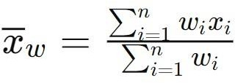
where:

𝑥̄w represents the weighted average mean

𝑥𝑖 represents each individual observation in the dataset

𝑤𝑖 represents the weight assigned to each individual observation
𝑛 is the number of values in the dataset
∑^{𝑛}𝑖=1𝑤𝑖𝑥𝑖 is the sum of the products of each individual observation and its weight
∑^{𝑛}𝑖=1𝑤𝑖 is the sum of the weights

3.8 Network Diagram
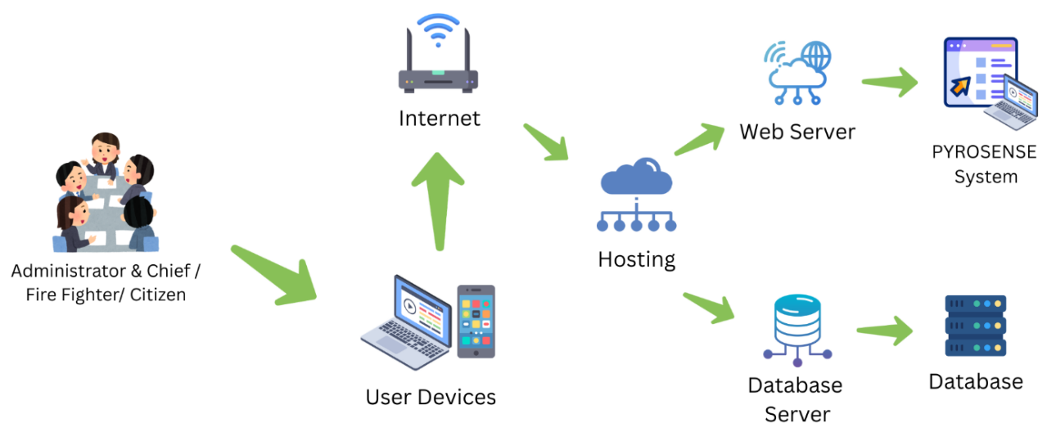
The network diagram illustrates the interaction and flow of data, devices, and users within the PYROSENSE system. It showed how system administrators, chiefs, citizens, and firefighters interacted with and managed the platform using devices such as laptops, desktop computers, and mobile phones through the Internet. As a web-based platform, PYROSENSE served as the centralized system that managed processes such as incident data inputs, user requests, resource allocation optimization, and response time management, stored and generated predictive analysis information for support decision making. Through this architecture, it supported streamlined, coordinated, and efficient response management, providing service accessibility and centralized access to data and services.

3.8.1 Network Diagram
Figure 3.8.1 presents the network architecture of the PYROSENSE system. It streamlined how the core users of the system, the Administrator, Chief, Citizen, and Firefighter, interact through internet connectivity using different devices. These users acted as the client side of the system and interact with the web-based platform to perform their assigned functions. Through this setup, the Administrator monitored system and user activities, the Firefighter managed investigation and response operations, the Citizen created requests and report an incident, and the Provider submitted bids and respond to service-related opportunities.
Chapter 4
RESULT AND DISCUSSION

This chapter presents the results and discussion of the development and implementation of PYROSENSE: A Predictive Fire Risk Analysis and Response Optimization System Integrating Geographic Information System (GIS) Technology. It discusses the identified user requirements and the technical solutions implemented to address the needs of the intended users in monitoring, reporting, analyzing, and responding to fire incidents. The chapter also presents the technical characteristics of the system and the hardware and software requirements used in its development and operation. The system is evaluated based on the ISO/IEC 25010:2023 software quality characteristics, including Functional Suitability, Performance Efficiency, Compatibility, Interaction Capability, Reliability, Security, Maintainability, Flexibility, and Safety.
4.1 User Requirements
The development of PyroSense was guided by the identified needs and requirements of its intended users, particularly the Bureau of Fire Protection (BFP), barangay officials, firefighters, and citizens within the jurisdiction of BFP Urbiztondo. The user requirements were derived from the existing fire incident reporting and response processes, the identified limitations of the current system, and the functional objectives of the proposed system.
The system consists of four user levels. Chief and Administrator are represented by the BFP Fire Marshals; they are the personnel above who manage the information and records of fire incidents and related data that were submitted by the firefighters. Supporting the Administrator and Chief were the firefighters; they inspect, investigate, respond, and execute the plans. Cooperation of the Barangay officials helps to reduce the possible occurrence of fire incidents and implement the mitigation and predictive plan. Lastly, the individuals or citizens received information that was approved and verified by the BFP and helped report possible risks of fire incidents.
Administrator and Chief. The Administrator and Chief require functions that support the review, decision-making, monitoring, and coordination of fire-related operations. This includes assigning appropriate response teams to reported fire incidents, assigning investigators, and reviewing investigation reports after field investigations. They also require support in planning and developing preventive measures for fire-related risks across different barangays, as the existing planning process may require considerable time to organize information and formulate appropriate measures. For Administrator and Chief, the requirements indicate that need a centralized means of managing the different stages of fire incident response, from initial fire report review, team assignment to investigation, report review, incident monitoring, planning, and report management. They serve as the overall supervision and administration of the system. The administrator role is the BFP Urbiztondo Chief Administrative Section SF03 Lani C. Padilla, having full access on user management, report management and generation, forecast prediction generation and submission of incident and response information. The BFP Urbiztondo Acting Municipal Fire Marshal, SF04 Teresa C. Pascua, handles review and permission-based execution and implements the data gathered as information. Overall, they handle the general supervision and administration of the system for general purposes, goals, and concerns of the citizens.
Additionally, the PyroSense provides the administrator and chief to handle the management of data-based information and operations to its assigned station such as incident, response, risk-information, forecasting and mitigation-planning. The system provides the overseer with map dashboard that visualize the overall data in geographic view, that enables them to monitor and identify areas that needed attention.
Firefighters. The firefighters are the primary operational users. They are responsible for executing plans implemented by the administrator and chief, verifying, responding, and investigating fire-related incidents. Firefighter has the access to maps with operational information, such as incidents that require immediate attention; report generation for the spot, progress, and final investigation report for fire incidents; and executing approved, implemented mitigation and predictive plans.
In addition, they are responsible for the entire operation of the BFP Urbiztondo in the whole municipality, allowing the cooperation with the barangay officials. Monitoring, responding and navigating in the field are now given with such information by the system that helps the firefighter to respond and pinpoint the incident immediately.
Barangay Officers. They are the partner of the BFP Urbiztondo they are consists of Barangay Captain, Kagawad, Secretary, Sangguniang Kabataan (SK) Officials and Barangay Police (tanod) to monitor the possible risk area, hot zone and resources vicinity of different barangays. They update the plan and mitigation planned given by the BFP Urbiztondo to their respective barangay. The Barangay Officers has the visual map for resources, risk areas, and the entire vicinity of their barangay. Reporting and recording fire incidents are now connected to the BFP Urbiztondo through the system eliminating redundant and different format record of the barangay and the station.
Citizens. The target of the information, source and primary system user. Citizen handles reporting risk and fire incidents through manual call and physical report to the station that deemed to rely on manual processes and they could not see progress status and record of reports they submitted. The system provides information that was verified and approved by the BFP Urbiztondo. Based on the requirements for the citizens, the PyroSense provides the citizen to interact the system with their input that contributes to the wellness of the area, and allows them to report fire incidents, view progress status, history reports, possible risk and hazard, call to the desired station, view announcements, updates and awareness.
The existing process primarily relies on phone calls, text messages, personal reporting, logbooks, and radio or verbal communication. These procedures may result in delays in recording incidents, verifying locations, coordinating responders, and accessing historical fire-related information. Therefore, the users require a centralized system that can organize incident information, provide geographic visualization, assist in response coordination, and support fire risk analysis.
PyroSense was designed to address these requirements through a web-based platform that integrates Geographic Information System (GIS) technology. The system provides users with features for fire incident reporting, geographic visualization, risk analysis, response optimization, user management, and information management.
4.2 Technical Solutions
To address the identified user requirements, we the developers implements a set of technical solutions that integrate web-based technologies, GIS services, database management, and external APIs to the PyroSense. These solutions were designed to improve the organization of fire incident information, geographic visualization, fire risk analysis, awareness and emergency response support.
Analytical Prediction Monitoring. A process of continuous tracking, monitoring and combining systems data, patterns, and statistical data to forecast, learn and or predict possible future events. The solution developed to support the Bureau of Fire Protection (BFP) Urbiztondo in analyzing historical and previous records of fire incident cases, hot zone areas, risk areas, and related information and identifying patterns and trends that indicates increase fire risk vulnerability. The BFP Urbiztondo have particularly hot zone areas, fire incident events occur at unexpected time and location and collection of historical previous incidents. The existing collection of historical incidents provides valuable information; however, reviewing and combining these records manually can make it difficult to identify recurring patterns and generate timely risk-based information. The PyroSense addressed the problem and provide the analytical prediction monitoring as solution to displays the trends, results and patterns based on factors, data sets and collections allowing authorized personnels to generate and monitor the current and predicted based results. Furthermore, the system combines the data gathered and provides information to predict possible future events allowing the firefighters and fire marshals to generate and improve the plan generated by the artificial intelligence, to raise awareness, create preventive plan that help to reduce possible fire occurrence and readiness of each barangay and station personnels.
Automated Narrative Generation. The process of generating narrative texts for reports using system collected data. The investigation report conducted by the firefighter investigator often took hours to accomplish report with the narrative. The PyroSense provides the narrative generation from the inputs of the firefighter in the form and combines it with the data connected in the report from the system then an action button to generate accurate results with BFP current investigation format. The firefighter creates report for the incident with the three phases of reports known as spot, progress and final investigation report while correcting the sentences and grammar of the report in each narrative. This system feature helps the firefighter to generate a narrative using results from the incident reported and investigation data that allows the firefighter to describe and use their country’s native language and converts into English narrative that helped them to make the report easier and information accurate.
Fire and Hazard Risk Visualization. A geographical visualization displayed in the map of the fire and hazard risk areas. Map displays areas that are categorized in different levels of risk that provides useful information for the citizens and barangay officers. The system uses the feature to provide and support visualizing risks zones data to the interactive map and this data includes to the learning of the prediction model. The system provides the users to view the classification of level of a specific barangay, and enables the administrator and chief decision-making to do course of action, help for preventing and predicting plans, and to reduce possible occurrence of fire incident related cases.
Geolocation and Interactive Mapping. Geolocation is a process to locate and find the user’s location through data device, Wireless Fidelity (Wi-Fi), or Internet Protocol (IP) address in the real-world setting. Interactive Mapping a mapping tool that allow users to interact the geographic information dynamically. Display data and resources in the interactive map while geolocation allowing users to locate themselves. The system implements this feature to allow users to navigate the map, interact with its component layers and visualize data that helps users display their location and retrieve information for what available resources and to give awareness for risk zone areas.
Location-based Reporting. A reporting feature that captures the user’s geographic location via Global Positioning System (GPS) of the device or browser and incident as submitted report. Reporting an incident through the system allowing to capture the geographic location of the user as part of submitted report. In the system, the feature captures real and accurate user location for the incident, risk and hazard reports and this enables to visualize in the map the actual incident and its corresponding location for incident awareness and response coordination for the BFP Urbiztondo.
Mitigation Management. A proactive process of identifying, analyzing, planning, and implementing strategies to prevent and reduce certain damage, impact and severity of potential fire risk. Mitigation management focuses on reducing the risk and impact of a possible event through planning and implementation. Assessing early the potential risk can help to reduce possible risk outcome by proactive planning. In the system, the mitigation plan was generated by the analysis, prediction and Artificial Intelligence (AI) model as draft allowing the administrator or chief to review and update for customization. The mitigation management cycles from the BFP Urbiztondo administrator and chief approving or rejecting the generated and proposed plan before disseminating to the barangay officers in their respective barangay. Approved plan made the barangay officer cooperate with the firefighters to monitor, implement and supervise the mitigation plan to reduce potential fire incident outcomes and area readiness.
Predictive Analytics. The analysis and calculation of the historical data, patterns, statistical model and machine learning that predicts future possible events and spot hidden trends. The predictive analytics uses regression, classification and decision tree to analyze complex patterns and give the odds of a future result, these data processes by the embedded machine learning thus, generated data passed through the AI model to generate human readable outcomes packaged with AI generated mitigation plan, recommendation and suggestion drafts. The system implements the predictive analytics to find trends using historical data, seasonal pattern, weather pattern, response pattern, risk zone areas and availability of resources to support BFP Urbiztondo in fire-risk monitoring than relying on guesses. The predictive analytics serves as a decision support tool to improve mitigation planning and preparedness and solely not replacing the authorized personnel plans and ideas.
Response Optimization. Refers to the overall response process optimizing and deciding allocation of resources and routes in an incident. It ensures immediate response are followed and resources are allocated properly even without human intervention, the available nearby station to respond to fire incident and giving fastest available route to the firefighters. The PyroSense incorporates this feature allowing the system to decide and allocate suitable and available nearest station responders and gives optimized route path to a reported fire incident. This system feature helps the user to connect the reported fire incident and give immediate response feedback.
Web-based Call. A communication feature that works through the internet inside a browser or app. Through the internet and web application it makes and receives voice call without relying on telephone network, mobile or hotline call. This feature supports the PyroSense to immediately connect and locate the caller allowing firefighter to verify the call purpose and made audit to punish those prank callers through collecting IP addresses.

4.3 Technology Used
The technology used are the framework, Application Programming Interfaces (APIs), programming language, platforms and database used to develop and operate the system. The technology used allows the users to communicate with the system and the developers to build, update and implement the system. Technologies were used to implement and provide a clearer exchange of data to convert data into information such as incident, geographic, risk, and announcements for the citizens. Additionally, it supports the life cycle and improvement of the system features ensuring the core functionalities, purpose and operations are developed and maintained.
Application Programming Interface (API). A set of rules and protocols that allows different systems, web application, and services to communicate, integrate and share data with each other. There are three most common ways to design and interact with APIs known as Representational State Transfer (REST), Simple Object Access Protocol (SOAP) and Graph Query Language (GraphQL). REST is an architectural style that has multiple endpoints and uses JavaScript Object Notation (JSON) as a data format and its primary use case are public web APIs, services, mobile apps, and standard Create, Read, Update, and Delete (CRUD) operations. SOAP is a protocol and strictly uses Extensible Markup Language (XML) – a flexible text format for transporting, storing and organizing data and a single endpoint via strict contract and has a defined fixed data structure and most commonly used in bank transfers, and enterprise systems. GraphQL uses strictly a JSON data format and has single endpoint giving only the requested data and it is most commonly used in complex and nested data for mobile applications and highly integrated environment.
An API acts as a bridge of service and web applications that enables communication with other systems to retrieve and send data. According to Faiella et al., (2022) disaster information system uses REST API to communicate and enable systems to perform the CRUD operations as a back-end application component. The system retrieves data from API services using REST API to communicate, process and displays information as fast, simple and flexible.
Additionally, mapping and routing capabilities retrieved to the Geoapify API that handles routing, reverse geocoding and mapping data. Geoapify (2022) finding quickest and shortest routes between different locations in the most efficient way is the goal. The system provides location data and endpoints to the service, retrieving and visualizing in the map the route and GIS information data immediately.
Moreover, weather capability of the system was also integrated using the Open-Meteo API, a web service that sends weather report data like temperature, wind speed, season, humidity and rainfall. The accuracy, reliability and performance of the weather data Open-Meteo API was furtherly improved, Zippenfenig (2023). The system relies on the Open-Meteo API for the accuracy of weather data such as the historical data and forecast weather especially on a certain area or region. Lastly, the calling ability of the system needs to be working and thus, allowing users to use the system without creating account. Voice call API like Agora resolves the problem by allowing the system connects the administrator, firefighter, barangay and citizen in call through web browser and track user via GPS and IP addresses. According to Agora, Inc. (2024) voice calling and connecting multiple end users that allows real-time interactions. The voice calling mechanism was used to allow users to have another way of communication in regards to emergency response, such users don’t have mobile network, Agora solves it by calling through internet connectivity. Security API like Google OAuth 2.0 allows to use and share the specific user data to an application, website and systems while keeping credentials and information, Google (2026). The system utilized Google OAuth 2.0 to log in users and ease the access to different functionalities and features to the authorized user via google accounts for convenient and less registration process.
Overall, these APIs integrated with PyroSense and furtherly improved account usage, security, mapping functionality and communication. It allows users to operate, navigate, access and interact with reliable information with ease.
ChatGPT. An artificial intelligence (AI) chatbot that understand human generated text and natural responses and perform tasks like answering questions, reasoning, logical thinking, write, create images and code. According to OpenAI (2025) certain model like ChatGPT 4.1 mini is a fast, efficient and reliable small model that gives improved instruction-following, coding, reasoning, and overall intelligence. Performing fast, reasonable and intelligent small model that reduces the backlog processes and give immediate response to the end user. ChatGPT 4.1 mini as a fallback AI model of the PyroSense, the specific model translates the machine language from the built-in python machine learning model specifically from the data, trends and patterns to produce human readable data interpretation and reasoning in a fast manner. It provides firefighters generated plans and mitigation for review that supports the administration with decision-making and mitigation-planning.
DeepSeek. An artificial intelligence (AI) company and advanced reasoning chatbot platform specializing builds for high-performing, open-weight large language models and focused on building world-leading artificial intelligence that was established in 2023. DeepSeek focus on expanding large artificial intelligence model for building high-performing and innovative systems. It offers large language models like DeepSeek R1, DeepSeek V3, and latest the DeepSeek V4 that specializes in various fields like image generation, reasoning, coding expertise, multimodal, and advance mathematical problem solving. Xie et al. (2025) an emergency response integrates DeepSeek R1: Distill Llama 70B as the AI-assisted framework to operate and help to build natural disaster prevention, mitigation, and emergency decision making, response management and allocation of resources. The system used the model DeepSeek R1: Distill Llama 70B as the primary artificial intelligence model for its achievement for advance natural language generation, tool orchestration, optimized dialogue, advance reasoning, data extraction and generation as translator of data trend and patterns to predict or forecast, recommendation and suggestion to human readable language. By utilizing REST architecture, both system and the model communicate using requests to send and retrieve data allowing user queries to the model and response with intelligent and diverse recommendation, suggestion and prediction plan. The capability of the system was maximized by using the model having seamless interaction to the user and reliable results.
Git and GitHub. Git is a version control system that tracks the changes of the actual source code to see what changed, rollback previous version, create branches and merging code projects safely. GitHub is an online platform hosting git repository. Relatively, git give control to the versions and easy tracking the progress, update and rollback and GitHub manages and hosts git repositories thus, both technologies communicate to each other allowing continuous innovation and continuous deployment. According to the Government of British Columbia (2026), Git and GitHub describes as support tool for continuous innovation (CI), version tracking, source code management and collaborative development. PyroSense used the git as the version control to manage different version across updates and GitHub to host the repository and connect to the system’s hosting service in the world wide web.
JavaScript. A web development core programming language to make the website content and layout dynamic, interactive and responsive. It enables the website engaging, interactive and responsive through different features such as form validation, notification management, animation, updates, and multiple requests while performing another task. A system specifically emergency response management use JavaScript for its behavior and real time collaboration of responders and system providing real-time reporting, alerts and system-responder emergency assistance, Enelo et al. (2021). The system developed through JavaScript to maintain the responsiveness, interactivity, asynchronous, engaging visual content and behavior. Using the JavaScript, the system was allowed to perform multiple tasking without reloading the entire page and sending requests over other requests and making interaction smooth and easy.
PHP and Laravel. The Hypertext Preprocessor (PHP) is a server-side programming language that used to build dynamic web application, websites, and web services. It handles backend logics, program tasks, processing form, validating data variables, communicate with databases, manages user session, authentication and data processing to the frontend. Laravel is a framework that built using PHP. It enables developer to build the backend and frontend of the web services, application and sites. Blade is the frontend for the Laravel making the project monolithic. Mohsin and Muyeed (2024) developed emergency-response system using Laravel and PHP specifically fire management system includes the features such as automatic notification of fire brigades, and fire emergencies. PyroSense built on Laravel allowing the system to have dynamic frontend, backend and its structure that enables the developers to build dynamically in nature. Core business and heavy logic of the fire station runs to and developed using Laravel and PHP enabling the full capability of the system from reporting to responding and generation of report data, process location-based reports, fire emergency route-time calculation, resources processing allocation and user interface design. The Model-View-Controller (MVC) architecture was one of the reason the PyroSense used and it allows developers to build clean, elegant, readable and easy to maintain code structure that achieve streamline and secure development.
Random Forest. A machine learning algorithm that combines different result data of many decision trees to forecast and predict trends and patterns. Random Forest create multiple trees with different samples such as collection and datasets combination of samples in different multiple trees results to producing reliable prediction. Nikolaychuk et al. (2024) used Random Forest to map wildfire susceptibility, using different data factors such as vegetation, meteorological, historical wildfire, infrastructure build and emergency-situation data. Furthermore, a study compared Random Forest and SVM for forecasting fire susceptibility, random forest achieved more than 94% precision rate on validating datasets stated in the study of Science of the Total Environment (2024). The algorithm specifically has two main purposes; Classification that predicts categories such as low, medium or high and Regression that predicts numerical value to the expected total number of incidents or outcome. The system used Random Forest Classification and Regression for predicting and classifying fire incident and risks based on historical datasets, meteorological data, emergency-situation, geographic coverage, current data, accessibility and risk susceptibility and generate number values and datasets continuing to pass on artificial intelligence model for translation of values and codes to human readable language. It is strongly used to combine multiple decision trees that analyze factors, support decision, opinion and combining those tree modules resulting in reliable predictions and by allowing both machine learning algorithm and artificial intelligence exchange data the result to predict and widen scope of ideas, recommendation, plans and suggestions that helps Bureau of Fire Protection (BFP) Urbiztondo authorized personnels and performs effectively and efficiently.
PostgreSQL. An open-source relational database management system (RDBMS) for storing, managing, organizing, and retrieving structured data. PostgreSQL uses Structured Query Language (SQL) to work with data stored in tables. It supports SQL to communicate the database storage and system including features such as relationships, queries, transactions, validation and constraint, functions, permissions, and display tables, rows and column for a reliable web-based systems. Faiella et al., (2022) developed disaster data management using PostgreSQL to implement the physical model and establish database technology features. PostgreSQL used another technology the Supabase as the database hosting service environment. Supabase uses interface to visualize data connections, raw tables and columns, configuration and security authorization. The system utilizes PostgreSQL as its primary relational database management system. The database stores prediction results, historical fire incident data, saved weather data, risk areas, vulnerability, susceptibility of an area, current fire records, managing firefighter and user data, investigation reports, checklist, audit and mitigations. PyroSense used the technology to handle important application data safely, for its strong data integrity, extensible, performance and scalability and it supports JavaScript Object Notation (JSON) that utilized by other APIs to exchange data into information to the system.
Progressive Web Application (PWA). A web application that uses modern web technologies that provides experience similarly to a native mobile or desktop application. PWA allows web application to run on mobile and desktop devices at the home screen reducing manual navigating to its specified uniform resource locator (URL). It supports features such as installability, offline and limited connectivity support, fast loading, responsive, background synchronization and app-like interface. Adetunji et al. (2023) developed a progressive web application emergency notification system that allows users to access the web system from the browser and store to the home screen like a native mobile application. PyroSense implements the progressive web application technology allowing the web system to behave similarly to a mobile application. Users can install to the home screen of the mobile and desktop from a supported browser and synchronizes report after reconnecting and caching data and layout sheets makes the system works on offline environment for viewing purposes.
Python. A high-level and general-purpose programming language commonly used in data processing, statistical analysis, machine learning, automation, backend development and artificial intelligence. Executes written instructions, codes and functions and building artificial intelligence and machine learning through certain libraries and logics. Frameworks and libraries in python have different purposes such as automation, machine learning, artificial intelligence, graphical visualization and coding. Through python it allows developers, programmers to code using built in libraries, classes, functions enabling fast and reliable development of systems and programs. Rodriguez et al. (2022) used Python in the development for wildfire prediction implementing machine-learning methods for predicting large possible wildfires, grid searching for each classifier finding optimal hyperparameters, model training and evaluation of wildfire predictions using Scikit-learn and train several models including Random Forest, Multi-Layer Perceptron, Support Vector Machine and LOGistic regression. PyroSense used python as the machine-learning portion of the prediction feature. Models such as Scikit-Learn and Pandas are also implemented. The system used Scikit-Learn to supply machine learning algorithms enabling training and test splitting of data, probability calibration, model evaluation metrics and calculations. Pandas often used to organize rows, tables and columns similar to spreadsheets, load exported data records, converting values into correct data types, and preparing and testing datasets. Lastly, PyroSense used Joblib saves the trained machine learning model to a file and loads data when requesting a prediction feature, by implementing this model it helped the system to reuse already trained datasets, trends and patterns for predictions rather than training the machine learning algorithm again and again. It enables BFP Urbiztondo administrator and chief to generate prediction based on datasets and train model for better accuracy and result. These provides the station personnels to have machine learning embedded in the system and helps them to communicate with other models for the analysis of patterns and trends in a certain period.
ISO/IEC 25010:2023. ISO/IEC 25010:2023 is a software product quality model that provides criteria for specifying, measuring, and evaluating the quality of software products. In this study, the standard served as the basis for evaluating the developed system through its quality characteristics, including Functional Suitability, Performance Efficiency, Compatibility, Interaction Capability, Reliability, Security, Maintainability, Flexibility, and Safety. Each characteristic was defined through specific indicators that were relevant to the functions and requirements of PYROSENSE. For example, Functional Suitability assessed whether the system provided the required functions for fire incident reporting, monitoring, mapping, analysis, and response support, while Performance Efficiency assessed the system's responsiveness and processing performance.
The researchers used ISO/IEC 25010:2023 as the software quality evaluation framework for assessing the developed PYROSENSE system. The standard was incorporated into the survey questionnaire to measure the quality of the system based on the perceptions and experiences of the 139 respondents, consisting of administrators or chiefs, firefighters, barangay officers, and citizens. The criteria were translated into specific survey statements and evaluated using a five-point Likert scale.
The standard was justified for use in the study because the researchers needed a structured and measurable basis for determining whether PYROSENSE met the identified functional and non-functional requirements. Instead of evaluating the system only through general user satisfaction, the ISO/IEC 25010:2023 criteria allowed the researchers to evaluate specific aspects of software quality using measurable survey statements. The resulting weighted means provided quantitative evidence of how the respondents perceived the quality and performance of the developed system.
For the non-functional requirements, Reliability and Security were particularly important to the evaluation of PYROSENSE. Reliability was used to determine whether the system could consistently perform its functions, remain available when needed, and recover information after unexpected failures or events. The survey therefore included Faultlessness, Availability, and Recoverability as indicators. Recoverability was specifically included to determine whether the system could properly recover its data after a failure or unexpected event. This was justified because PYROSENSE manages centralized fire incident records and operational information that need to remain accessible and recoverable.
Security was used to evaluate how PYROSENSE protects its users, data, and system functions. The security criteria included Confidentiality, Integrity, Non-repudiation, and Authenticity. Confidentiality was defined as restricting system features and pages to authorized users. Integrity referred to ensuring that authorized users could access and manage sensitive information according to their assigned permissions. Non-repudiation referred to the system's ability to properly record and maintain user activities for accountability and verification. Authenticity referred to verifying a user's identity before allowing access to protected features and authorized accounts.
These security indicators were justified because PYROSENSE contains user accounts, fire incident records, operational information, and other data that require controlled access and accountability. The questionnaire statements were therefore designed to determine whether respondents perceived that the system appropriately protected information and verified users. For example, the survey measured whether system features could only be accessed by authorized users, whether user activities were properly recorded, and whether user identity was verified before accessing protected features.
Overall, ISO/IEC 25010:2023 provided the researchers with a systematic basis for connecting the technical implementation of PYROSENSE with the survey evaluation. The standard's quality characteristics were converted into measurable questionnaire statements, allowing the researchers to determine whether the system's implemented features satisfied the identified functional and non-functional requirements. Therefore, its use strengthened the evaluation by providing a structured framework for measuring the quality, reliability, security, maintainability, flexibility, and safety of the developed system.
4.4 Hardware and Software Requirements
This section describes the minimum requirements of the hardware and software for the development and deployment lifecycle of the system. The Components must meet at least the minimum specified requirement criteria for the hardware and software to achieve optimal workflow, performance and reliable web application. The table below provides detailed information about the minimum software and hardware requirements of the system.
Table 4.1 presents the minimum computer hardware components to develop, maintain and run the system. The table consists of minimum specification required for hardware components such as Solid-State Drive (SSD) and Hard Disk Drive (HDD) for storage, computer processor for processing data, device display for output, memory and other input devices ensuring efficient and supports smooth performance of the system.

Table 4.1 Minimum Hardware Requirements for Computer and Mobile Device
Component | Specification
Processor | Intel Core i3 13th Generation
Memory (RAM) | DDR3 8GB
Solid State Drive / SSD | 256 GB
Hard Disk Drive / HDD | 256 GB
Display | 1920p x 1080p
Input Devices | Keyboard, Mouse, Touchpad – Wired/Wireless

Processor. The computer processor or the Computer Processing Unit (CPU) that serves as a core computing processing of the hardware for calculating, processing, execution and managing tasks. It performs operations, calculation such as arithmetic logic, computer processing logic, and processing of the input and output that entirely affects speed and performance. In the system, it serves as the medium to allow output and input devices to communicate and run the browser, Intel Core i3 13th Generation was deemed to be the minimum requirement for processing power to use and run the system through browsers.
Memory. A physical device storing data persisting to information as temporarily or permanently. Random Access Memory (RAM) stores data, functions and instructions temporarily that the CPU requires. The RAM performs fast processing instructions before passing other instructions, calculations and tasks to the processing unit.
Solid-State Drive (SSD). a non-volatile fast data storage device using modern flash memory and microchips instead of traditional mechanical spinning disks. The solid-state drive saves and stores data permanently without needing the electricity to keep the files, quick access of files and the transfer speed is generally above than the hard disk drive that results in faster boot and data transfer. It is required to at least have size greater than the installed system configuration and installed browser.
Hard Disk Drive (HDD). A non-volatile storage device using traditional data storage to store and retrieve digital data and information. The data storage saving and retrieving files in a traditional computing way. Minimum hardware requirement that used upon development and running the system on the browser, some of the users uses computer with hard disk drive.
Display. An output device used to display interface and commonly known as the monitor. The displays responsibility is to present computer processed data to information. Screens used different displaying technologies such as LED, OLED and LCD allowing output display vivid, clear and readable. It delivers graphics, multimedia formats in different screen resolution to improve interactivity and overall user experience. It manages to display the web system in the screen and users to read with.
Input Devices. These are computer hardware components used to data entry and command a computer and systems. Keyboard, mouse and touchpad allow users to provide and send data instruction to the computer system for processing and enables user interaction between the user and the system. PyroSense utilized these input devices components to interact, send and retrieve data information.
Table 4.2 displays the determined minimum software requirements that was essential in the system’s development cycle and ensuring optimal workflow and environment to develop and run the system. The identified software requirements help user to identify which versions of different platform can the system run without breaking layout design and feature capability.

Table 4.2 Minimum Software Requirements
Component | Specification
Operating System | Windows 10, Android 11
Web Browser | Microsoft Edge 120, Chrome 120, Mozilla FireFox 120, Opera and Safari 17
Integrated Development Environment | Visual Studio Code
Database Management | PostgreSQL

Operating System (OS). A system software that manages computer hardware and software resources allowing users and applications to interact and provide services with the device. It controls and coordinates the whole device and its main job is to manage CPU and running programs, memory allocation, storing files, controlling input and output devices and providing security and user accounts. It provides user interface the user interacts with and to communicate to the other software and hardware components. Without operating system the input, output and software programs such as applications and utilities would not be able to run in the hardware.
Web Browser. A software application used to access, display and interact with different websites and web applications through uniform resource locator (URL) on the internet. The web browser reads and interprets hypertext mark-up language (HTML), cascading style sheet (CSS) and runs JavaScript to perform the websites composition. The browser allows user to interact with the system, and responsible for loading, interpreting and displaying. It supports cross platform to work across devices as long as the device supports the required version technology to run a browser.
Integrated Development Environment (IDE). A software application and a workspace for developers and programmers that provides programming tools for writing, editing, testing, debugging and managing source codes and software projects within one environment. The integrated development environment and other development tools such as utilities, version control, repository and debugging utilities that works together to create and manage software projects. It supports collaboration with different team and developers promoting teamwork and innovation, thus, the environment makes the project creation, debugging, testing and coding efficiently and clean. Current environment supports artificial intelligent collaboration, automation and continuous integration and continuous deployment (CI/CD) pipeline for determining and reducing errors, debugging capability, fast-creation process and software delivery.
Database Management. Refers to the process of organizing, structuring, securing, managing and retrieving data in a database. The database management system (DBMS) provides features to store data and retrieve data from the system or an application. It is responsible for securing and updating data information and records consistency. It allows users to access simultaneously the system and application with the specific user credentials and authorization provided in the database.
4.5 Findings and Analysis of the System
The findings and analysis of the study reveal the current fire monitoring and response process of the Bureau of Fire Protection (BFP) Urbiztondo, the solution, the proposed and implementation process of the system. The manual and current fire monitoring, reporting and response practices involve paper-based forms and reports, traditional method for reporting fire incidents, generation of preventive plans and response practices. Citizens reports an incident manually such as calling through mobile number and physical reporting, thus, firefighter personnels navigate and respond to the incident as directed from the oral and physical report. In comparison, the proposed system extends the fire incident with location-based reporting, response optimization with geographic information system (GIS) assistance and allowing the system to allocate resources, assisted generation of investigation reports through incident-based reports, and automated AI-assisted prediction, recommendation, suggestion and mitigation plan that streamlines the BFP Urbiztondo response time, report generation, incident monitoring and preventive planning.
4.5.1 The Assessment of the Current Fire Monitoring and Response Practices
This specific objective of the study was to assess the current fire monitoring and response practices of the Bureau of Fire Protection (BFP) Urbiztondo regarding in the real-time data availability and in response of the firefighter personnels with the reported fire incidents whether the current manual process could be combined in integrating the system. Monitoring fire incident is the main operation of the BFP Urbiztondo, areas with high risks, historical and previous report records was particularly written in log books and excel spreadsheets. Additionally, current reporting method was to call via BFP mobile network and on-site reporting only. Community awareness, drills and orientation was processed through manual request and scheduling of events and review of the chief and administrator was required that could last and verify other schedules and activities first. The BFP Urbiztondo abide routines, protocols, training procedures and actions to prepare, resolve and respond to fire incidents. During the data gathering, response time has a set minimum within fifteen minutes and the required personnels to respond fire incident was seven personnels with different roles covering each other positions, problems like insufficient responders and navigation to incident occurred, due to lack of personnels stationed firefighter can respond to an incident at least two breaking the required total of responder assigned. Investigation report process was to investigate and conduct report to the fire out incident categorized to three phases such as spot investigation report, progress investigation report and final investigation report. The first phase of report must be done within twenty-four hours after the fire was extinguished then the chief and the administrator manually review the submitted report before proceeding to the next phase. The manual system process of the BFP to respond to fire emergency was crucial and required with individual intervention and participation. The station currently used excel spreadsheet to store and pertain previous incidents, investigation reports and other data records.
The objective focused on identifying on how fire-related concerns were reported, communicated with the BFP, monitored, addressed, and investigated before the implementation of the proposed system. It also focused on assessing the mandatory response time management and the availability of resources on how BFP firefighters conduct training, respond and investigate fire related incidents.
Furthermore, the findings showed that existing practices relied largely on conventional manual reporting and monitoring procedures that affect the accessibility of information. Additionally, the respondents such as adults relied on existing and traditional communication of reporting an incident and does not have own and exact information record and indicates some limitations that pertains to the availability of centralized and real-time information for monitoring reported incidents. Also, the result showed that the firefighter needs navigation on how they respond to fire incident area where road accessibility was difficult and no other nearby resources are available. Moreover, firefighter needed to pinpoint location of the prank callers and wanted to call without using mobile network. These finding results provided as a basis to identify areas where additional communication method for monitoring, reporting, and response practices could improve the existing process.
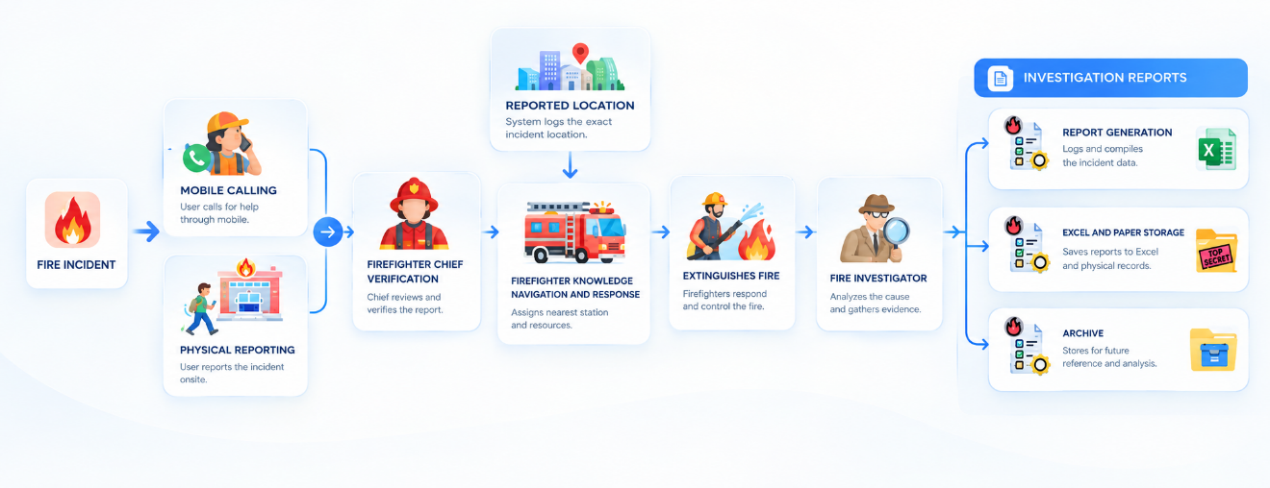

VS.
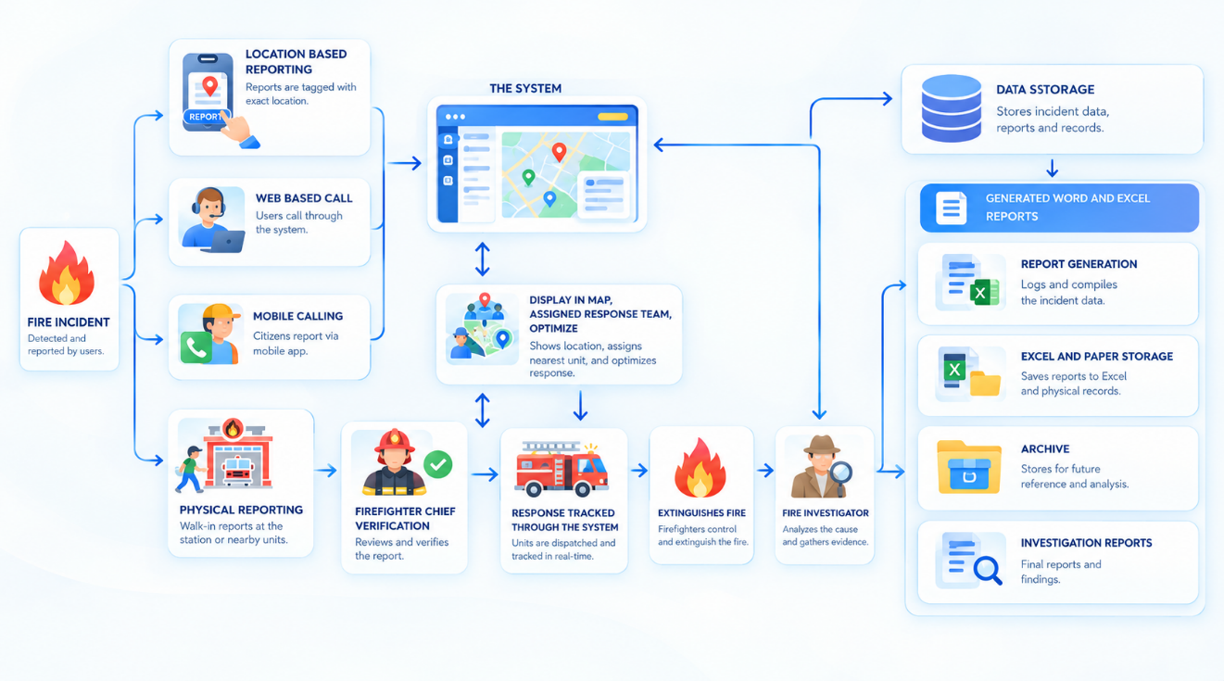

Figure 4.1 COMPARISON OF CURRENT AND PYROSENSE PROCESSES
Figure 4.1 describes the comparison of the current processes and PyroSense processes in the fire response and monitoring of the incidents. The current process handles the fire incident reporting through mobile call and physical-report, the fire incident report needs verification to the authorized personnel before the team assignment and response management. After the fire was extinguished, the station assigns fire arson investigator to the incident to conduct the initial or the spot investigation report, the spot report reviews by the chief and administrator before proceeding to the next phase of investigation. The reports related to incident and investigation saved in the excel spreadsheet and folder storage. In contrast, the PyroSense process adds another method reporting incidents, the web-based call that uses the system to call the station and send the location of the caller, report submission through the system allows firefighter to get the incident location immediately. The system supports fast and optimized use of resources, assigning responder teams based on the availability of personnels and resources in the station through the system. Additionally, the investigation submitted reports can be digitally reviewed and allows firefighter to generate the report with assistance of the artificial intelligence to its narrative. The station administration verifies, reviews and approved processes to investigations after the submission allowing the investigators to continue investigation further. Finally, the database of the PyroSense allows the administration to implement, generate mitigation plan, analyze trends, and gather digital information to display visually that supports the BFP Urbiztondo in decision-making and planning ideas.
Furthermore, the current practices improved and innovated by the PyroSense and does not replace other method of communication for reporting incidents, the system supports the organization and users to access information on digital screen, report incidents with location based, manage station resources and responses to the fire incidents.

4.5.2 Identify the System Requirements and System Technologies such as GIS APIs, and AI Models
This specific objective of the study was to determine functional and non-functional requirements and different system technologies such as application programming interfaces (APIs), artificial intelligence (AI) model, and geographic information system (GIS) needed for the development of the proposed system ensures that the requirements align with current practices and how they applied and implemented. This objective focused on identifying system technologies and features to support intended function of the institution and its operation to implement in the proposed system.
The system features and functionalities were aligned, followed and structured based on Bureau of Fire Protection (BFP) Urbiztondo fire operational needs. Most of the operational needs related to the fire incidents were identified and constructed with these feature that includes geographic navigation from the responder to incidents, optimized resource allocation pertains to response management, location-based reporting module, announcement and awareness platform, spread of information and mitigation planning. These features were determined based on user and operational needs regarding to reporting, responding, monitoring fire related incidents and availability of information to support the core functionalities and features of the intended proposed system ensuring that personnels like the chief, administrator, firefighters, barangay officers and citizens are able to perform operational task needed to respond and accomplish the fire incident effectively, accurately and efficiently. The selected application programming interface (API) were suitable to support the core features that were determined. The geographic API selected were the Geoapify and OpenStreet Map (OSM) that aligned to the functionality that the BFP Urbiztondo needed to visually display in the map and navigate reported incident with the most appropriate, nearest and fastest route. Furthermore, the analysis feature in the system were introduced and carefully selected an appropriate artificial intelligence (AI) model. Trained algorithm and datasets were translated into human readable language to determine and predict possible outcomes generated by the artificial intelligence model. The DeepSeek R1: Distill Llama 70B pertains advance calculation, reasoning, and translating capability that suits the feature needs. ChatGPT 4.1 mini as the fallback AI model that has reputation for its small, reliable and fast generation and was selected when the primary AI model was not available.
In terms of authorized access, the system provides full operational control to secured feature services like account management, report generation, prediction, mitigation and geographic resource were assigned specifically to the chief and administrator. The system assigned firefighters to operate the navigation to incident, respond, track, investigate and file reports regarding to the fire incident related cases. On the other hand, citizens are able to report incident, review and track the progress, and view informational announcements. Collaboration to the station by the barangay officer were introduced allowing identifying risk and hazard areas, complying to the plans headed by the Bureau of Fire Protection (BFP) Urbiztondo and reported incident within vicinity were recorded in the specific barangay. These results indicate that the functional requirements in terms of completeness, correctness and appropriateness were effectively satisfied by the developed system.
The determined non-functional requirements demonstrate that the system has strong compliance with the established standards aligned to the secured and reliable web system such as availability, data integrity, flexibility, maintainability, reliability, security and usability. Availability is evident through the progressive web application and availability in the web browser and users can access whenever they need. Data Integrity is achieved through user submission reports and display information in the dashboard. Flexibility is noticeable through cross-platform, browser and device compatibility. Maintainability is evident in system updates and user account management allowing the system to be maintained without further server down on updates. Reliability is observed through the systems performance, offline capability of the progressive web app, assisted form generation, and secured storage of data without loss. Security is achieved through user authentication and access control, credentials, and protected data storage. Usability is achieved through user interface, clear and concise cues and instructions, responsiveness of the system, and ease of navigation of user with minimal learning effort.
Moreover, the integration of application programming interfaces and artificial intelligence model technologies particularly the geographic mapping feature and the analysis prediction collaborated with the DeepSeek model enhances the system’s overall operational capabilities allowing dynamic and flexible preventive mitigation planning through prediction and analysis to partially display using the geographic feature. These technologies enhanced the system’s ability to determine and forecast possible trend outcomes regarding fire incident cases, visualized geographic vicinity, risk zone area, routing possibilities and assistance of report narrative generation that supports real-time response coordination. As a result, it verifies that the system meets the expected conventional software standards including additional ai-assisted decision-making.
In general, as the results were evident it clearly indicates that the features and functionalities of the developed system is fully coordinated with both functional and non-functional requirements. The developed system supports optimized operations, secure data handling, real-time report analytics, intelligent predictive capability and mitigation planning accurately and effectively. Therefore, the identification and determination of the system functionalities and features in cooperation with the presented requirements have been accomplished.
Functional Requirements. These are the requirements that are specific tasks, services, functionalities or features that a system must be able to perform. It defines how a system interactivity to the usable needs of the user that the developer must align and design to complete and achieve certain objectives. With these functional requirements, it supports the system to perform operational tasks and functions intended to accomplish one desired action.


Figure 4.2 Predictive Analytics Dashboard
Figure 4.2 represents the predictive analytics dashboard that displays predicted analytic results of trained datasets and AI-generated outputs. The systems categorized the current month predicted analysis and the next month. The prediction results all informative data such as classification of low, medium and high-risk areas, probability vulnerability, generated recommendation, suggestion and mitigation plan allowing the authorized firefighter personnels to interpret overall predictive data perceptions necessary for decision-making. It enables the firefighter to visualize data into information, ideate, improve and generate mitigation plan to future possible incidents and to prevent possible causes that could stimulate.
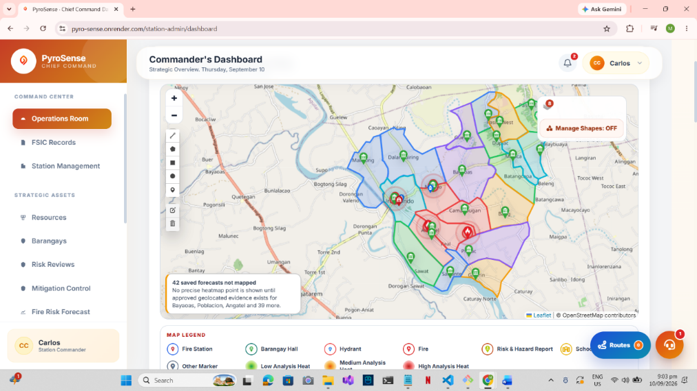

Figure 4.3 Operational and Geographic Mapping Dashboard
Figure 4.3 represents the system’s operational and geographic mapping dashboard that visualizes the analytical incident data and geographic capability displaying resources, vicinity areas, route responding, and other geographic information. The reported fire incident would occur at the map after it was submitted then firefighter personnel can easily locate and navigate. It supports BFP officials to enhance response time and improve data visualization using map including tracking of the firefighter actual response allowing reporter of the incident the current location of the responding fire response team.
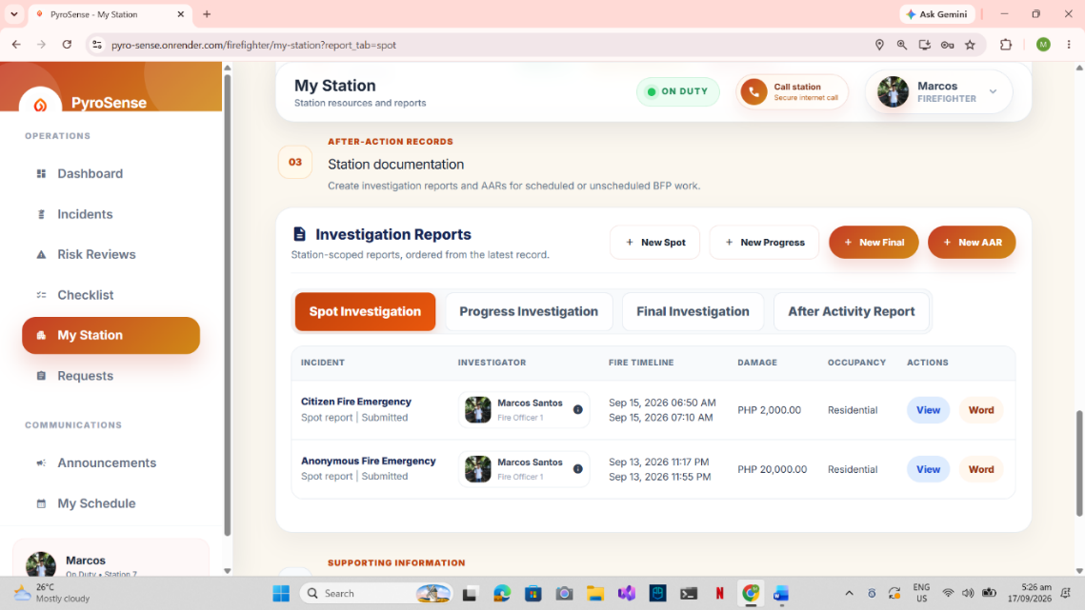

Figure 4.4 Investigation Reports Dashboard
Figure 4.4 represents the investigation report dashboard that displays the different investigation reports pertaining to an incident. This page manages the investigation report from creation, update, and deletion. Investigation report requires investigation data from the fire incident. It supports the firefighter to create investigation reports, download the file and review progress track to the administration.
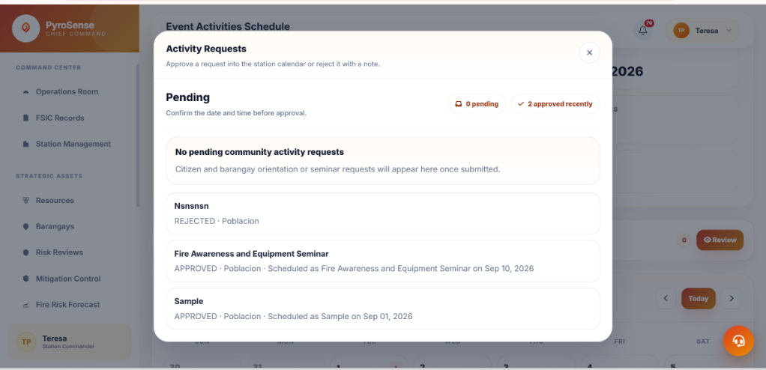

Figure 4.5 Request Dashboard
Figure 4.5 represents the request dashboard that displays the overall request from the citizen and barangay for the community requests. This page categorized through requests status that allows the chief and administrator to manage and review requests for the community awareness, orientation or drill submitted by the barangay and citizen.


Figure 4.6 Investigation Report AI-Assisted Narrative Form
Figure 4.6 represents the investigation report with artificial intelligence assisted narrative form. This form pertains to data gathering on the after-fire incident investigation that allows firefighter inspectors and investigators to input gathered data and convert into accurate and reliable report narrative. It helps firefighters to easily accomplish report, input investigation details and description to create and generate the narrative and investigation report before submission review.
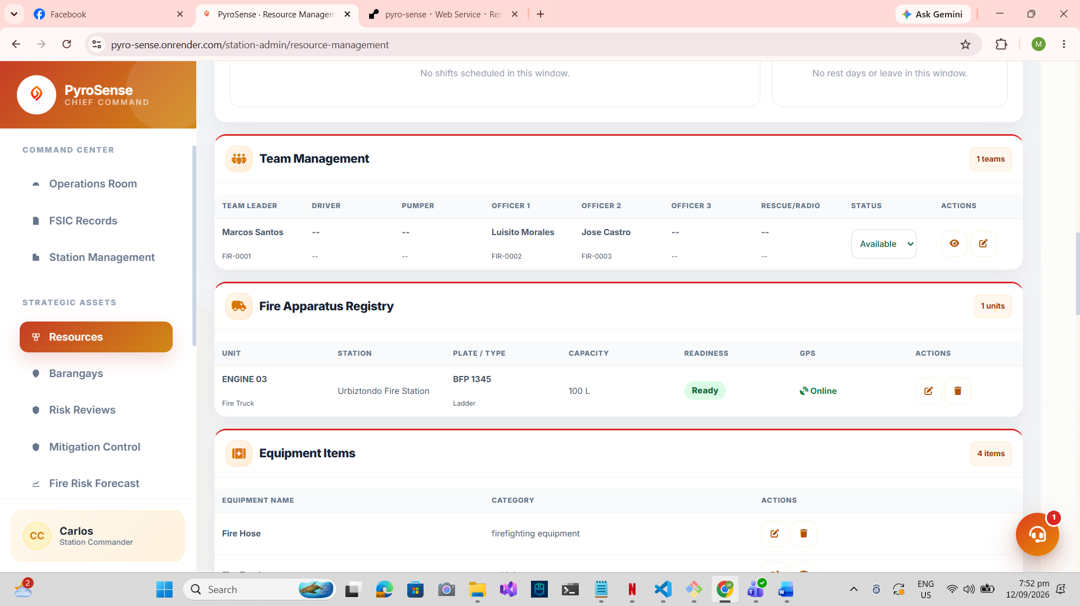
Figure 4.7 Resources Dashboard
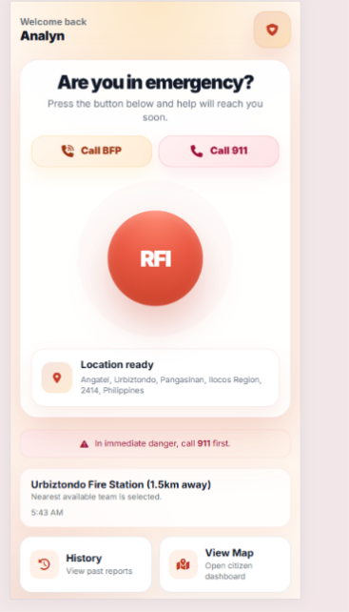
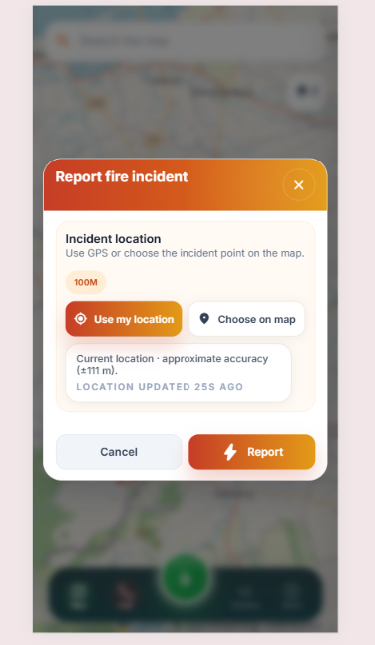
Figure 4.7 represents the resources dashboard that includes the overall resources of the station. This page allows the chief and administrator to manage resources such as personnels, teams, equipment, and user accounts that supports the system feature to optimize resource allocation and response management.

.

Figure 4.8 Citizen Reporting Dashboard and Form
Figure 4.8 represents the citizen’s perspective dashboard and form this particularly displays the overall geographic information regarding to approved risk and hazard areas, resources and nearby related incident cases. The fire report form achieves one-click report with user’s current location to be submitted in the station. The dashboard and form were in single page that supports data visualization in map and seamless location-based reporting and enables citizen to report quickly and visualize the data in nearby citizens, reporter, barangay officers in their vicinity, firefighters, administrator and chief in the map of their perspective covered station.
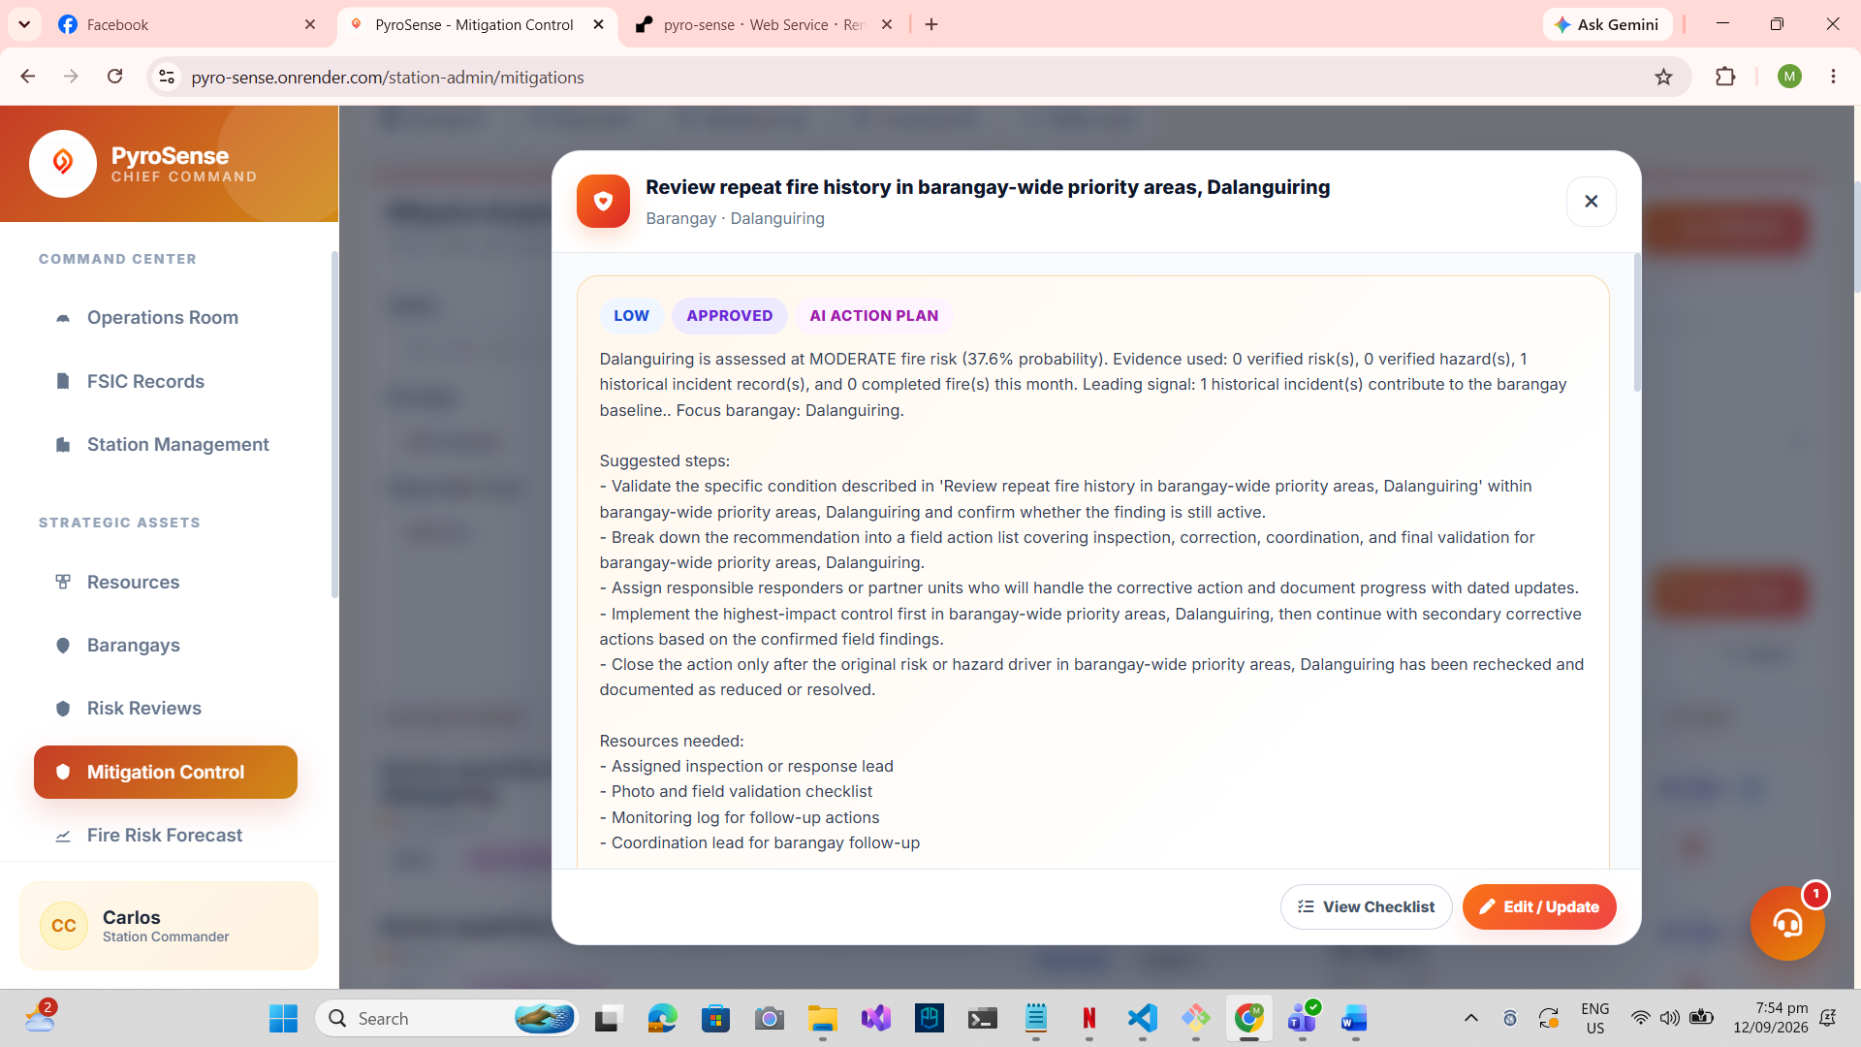
Figure 4.9 Mitigation Dashboard
Figure 4.9 represents the mitigation dashboard that displays the mitigation plans generated per specific area. This page provides actions to the firefighters and the head of the station pertaining to the progress of mitigation and allows the chief to review, edit and track progress of the artificial intelligence drafted mitigation plan based on analysis and predictions. It supports the firefighters to implement and uphold the mitigation plan across different concerned barangays and monitors specific barangays with mitigation plan to review and track progress to the implementation and upholding the approved mitigation plans.


Figure 4.10 Checklist Dashboard
Figure 4.10 represents the checklist dashboard that displays the generated checklist from the analysis and predictions. This page manages the generated checklist to specific barangay that allows chief and administrator to review the checklist before handing-out to certain concerned barangays. It supports the system to cooperate different user level to track the current state of specific barangay and helps firefighters to monitor the area with little intervention. The checklist exclusively for the barangay officer to conduct and follow the checklist to increase the protection against risk and possible fire vulnerabilities and to assist the firefighter and the station to monitor specific barangays.

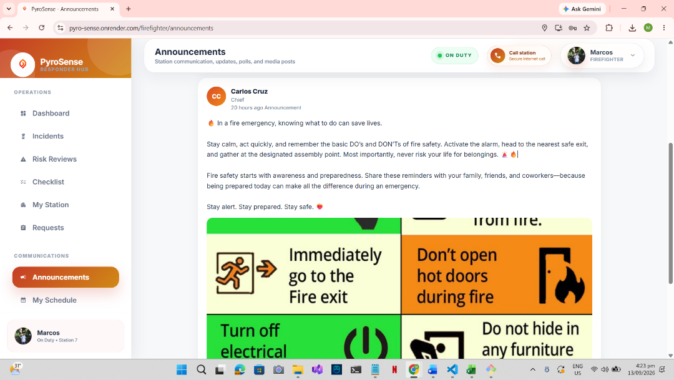

Figure 4.11 Announcement Dashboard
Figure 4.11 represents the announcement dashboard that displays the uploaded announcement of the firefighters, station chief and administrator. This page was designed for information awareness regarding to legitimate and valid posts, updates and announcement of the Bureau of Fire Protection. It enables users to view information across different stations regarding to announced updates, drills and awareness. It also supports the firefighters and the station to spread the reliable information with ease of access.
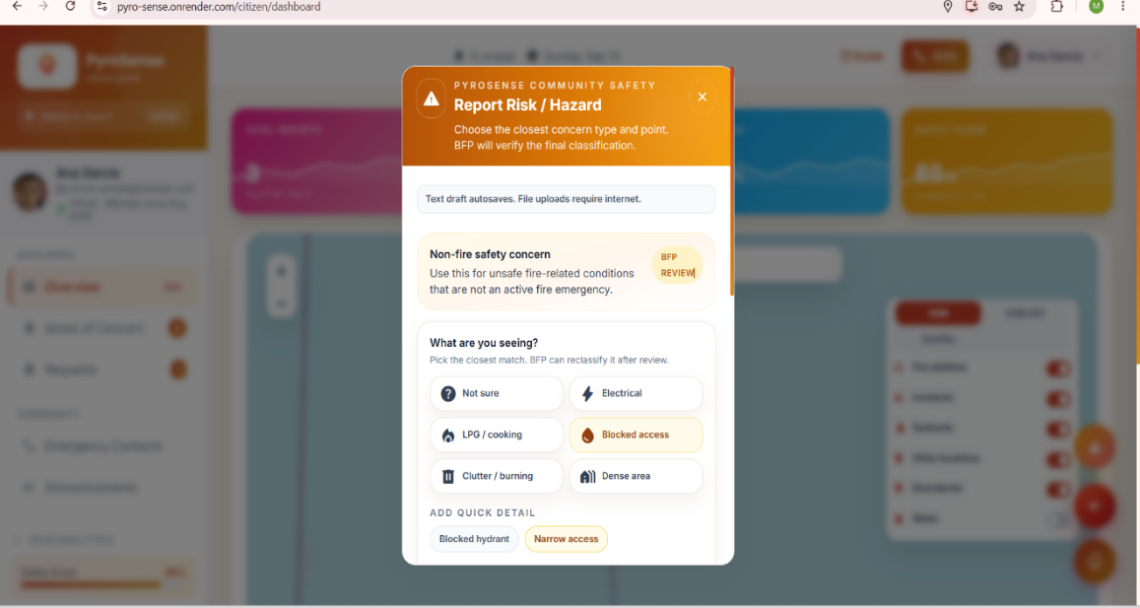

Figure 4.12 Risk and Hazard Form
Figure 4.12 represents the risk and hazard form that contains data pertaining to risk and hazard inclusivity. This form helps firefighter to monitor possible risk areas and allows concerned citizen and barangay officer to report to the station. The chief and administrator review the submitted risk and hazard form and verified reports were recorded. It helps the prediction module to generate recommendation and suggestion pertaining to what risks or hazards were present.
Non-Functional Requirements. Describes how well the system should perform rather than specific functions. Non-functional requirements needed by the system were distinguished such as availability, data integrity, flexibility, maintainability, performance efficiency, reliability, accuracy, security and usability. These requirements determine how effectively, secured, reliably and efficiently the system perform its intended functions. These requirements are important to the system, it allows the system to perform efficiently, loads the page quickly, securing form submissions, and displaying reliable data. It ensures that the system is responsive, accessible, easy to use and secure across different platforms and devices whenever the user needs the system.
Accuracy. A quality constraint that defines the system produced output information regarding to its precision, predictions, calculations, correctness, and free from errors. It is the system ability to system on how the output is correctly represented without significant errors. It supports the system to provide accurate results. Inaccurate information may lead to incorrect assessment. The system should provide accurate data and results to support monitoring and decision-making.

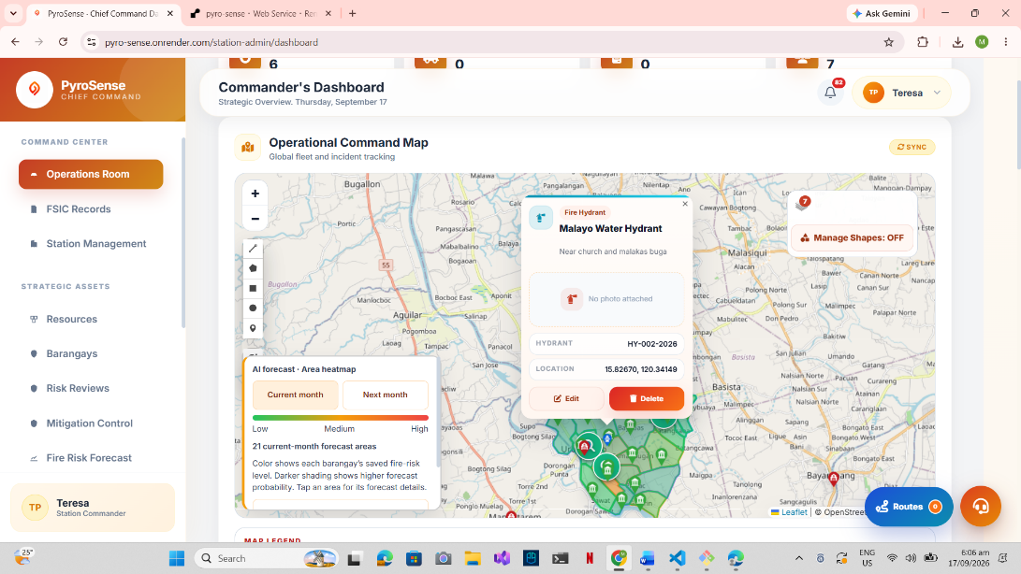

Figure 4.13 Operational Dashboard Mapping
Figure 4.13 presents the operational dashboard mapping that provides accurate and informative view of data collected and visualized as map resources through citizen and barangay fire report and firefighter response. The operational dashboard mapping highlights the information to be viewed information on a map scale. It includes operational routing response that supports the system to display the response information timely, and to enable firefighter to navigate through the incident reported with accuracy and precise result.
Availability. An essential non-functional requirement that ensures the system is accessible to users when needed. The system allows users to access important functions such as fire incident reporting, fire monitoring, and geographic information while minimizing service interruptions. It is necessary because it supports the system to remain available where delays or inaccessible services may affect timely reporting. It enables essential functions to remain usable when needed even under non-ideal conditions

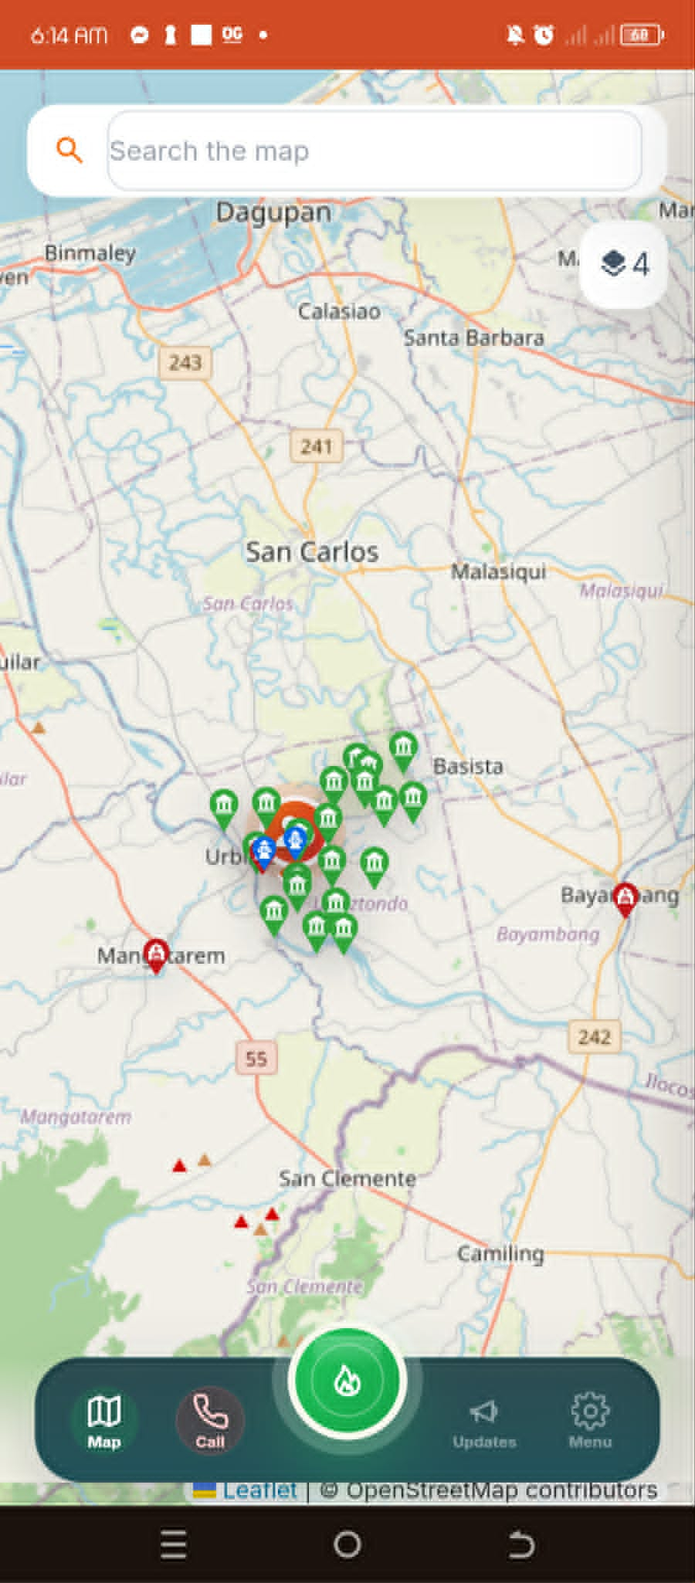

Figure 4.14 Citizen Dashboard Progressive Web App
Figure 4.14 displays the progressive web application and offline capability of the developed system. The system data and information remain visible with offline capability and visited pages are cached that allows user to view information and available data.
Data Integrity. It refers to the completeness, accuracy, consistency and reliability of data throughout the system cycle. It enables the system to validate user inputs, controlling data modification through authentication to preserve accurate incident information and ensures the data stored in data storage remains consistent. It supports the system developed to maintain reliable information and prevent incorrect data, modification of data records, inconsistency and inaccurate. Therefore, data integrity protects the correctness and consistency of data in the system cycle.

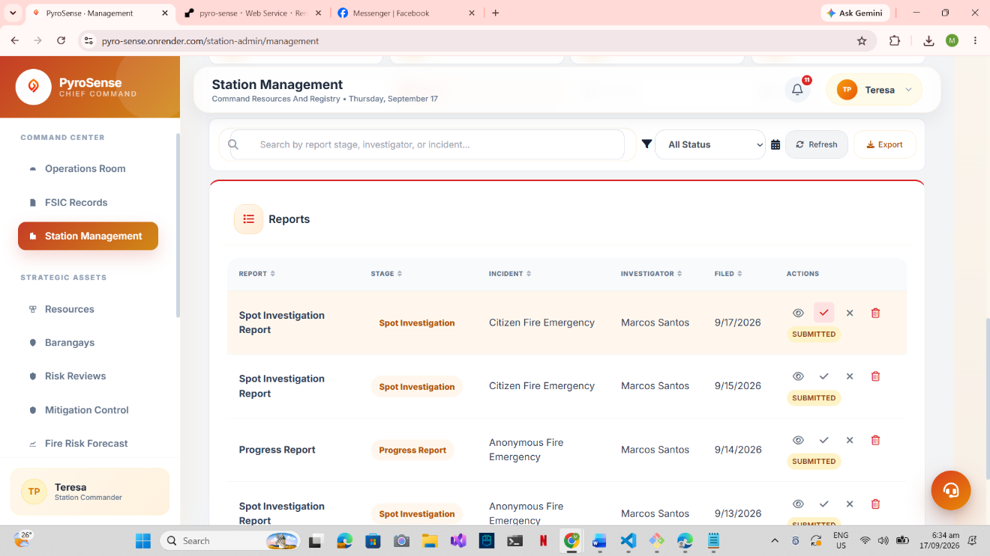

Figure 4.15 Report Table
Figure 4.15 presents the reports displayed in the table form. The reports submitted needs verification of the chief or administrator to control accuracy and integrity of submitted data. After verification, the next phases of the report will be available to the investigator firefighters that allow to continuously investigate the information to the fire incident.
Flexibility. The system’s ability to adapt to changes in environment, requirements operational needs and devices with minimal disruptions. The developed system designed to be flexible in different environment and devices, and minimal updates or changes should not disrupt or rebuild the entire system. It is incorporated to allow update and additional features to be built without destroying its intended functions.
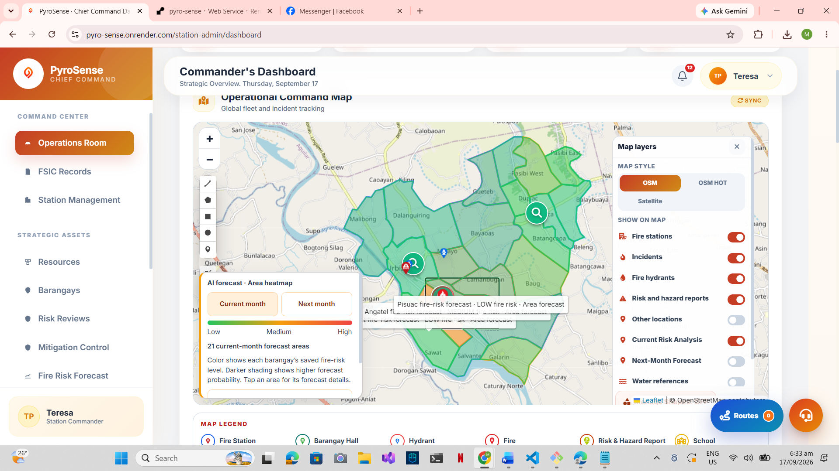
Figure 4.16 Operational Dashboard
Figure 4.16 displays the operational dashboard and map layer controls to resources. The system display of information was flexible that allow users to filter resources and display data on the map. This ensures the firefighter to visualize the map resources efficiently to conclude information the nearest resources that were available during response.
Maintainability. Refers to how a system can easily be modified, updated, tested, corrected or improved. The system integrated components for its functional requirements such as APIs, GIS, and prediction module. It allows the system to be modified, fixed, updated, and resolve issues without significantly affecting other components of the system.

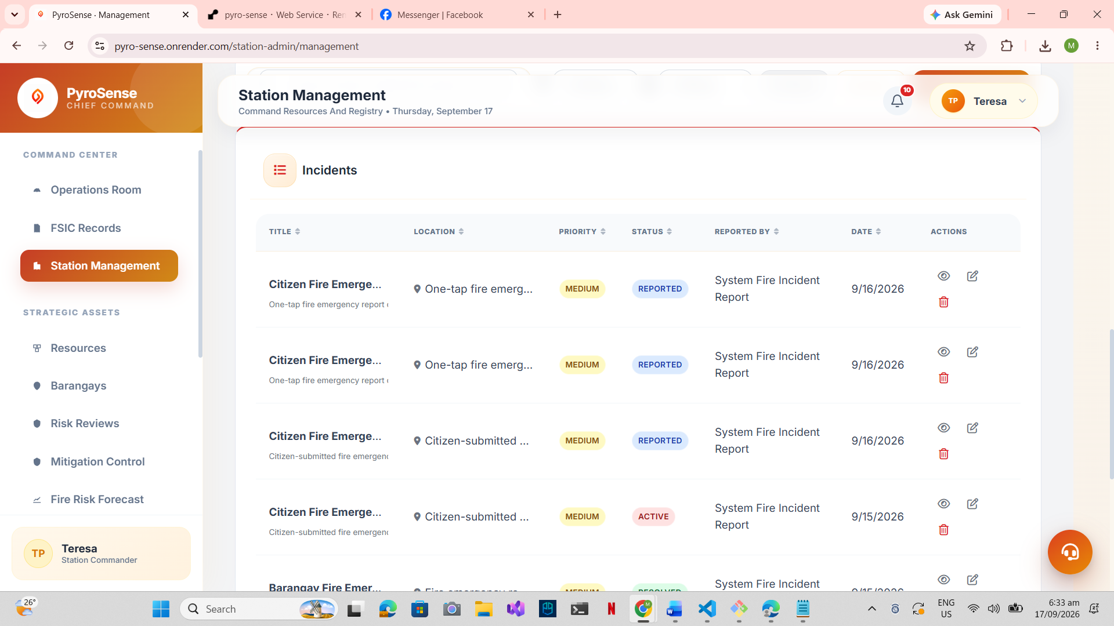
Figure 4.17 Incidents List
Figure 4.17 illustrates the station management dashboard pertaining the incidents list of display. This page allows the chief and administrator to manage fire incidents, reports, personnels and user accounts including updating of details, and deactivating accounts and resources.
Reliability. A requirement that pertains to the quality of the system to be dependable and consistent to its performance or result. The system capability to perform intended functions consistently and correctly under expected circumstances and conditions. It supports the system to display reliable results enhancing the system’s trustworthiness.

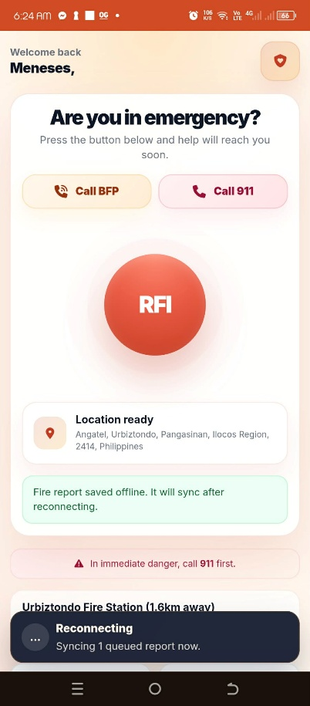

Figure 4.18 Mobile View Reporting Dashboard
Figure 4.18 illustrates the mobile view of the developed system and progressive web application view. The developed system allows the user to submit report offline and synchronize when the internet go live. Displaying information reliability with offline usage was monitored. This feature allows the user to report when low connectivity and reconnect when disconnected.
Security. A non-functional requirement concerned to the securing of pages, data storage, system features, functions, and protecting user accounts. It focuses on keeping the system secured through user inputs to prevent misuse, unauthorized access, before giving access and authorization to different users.

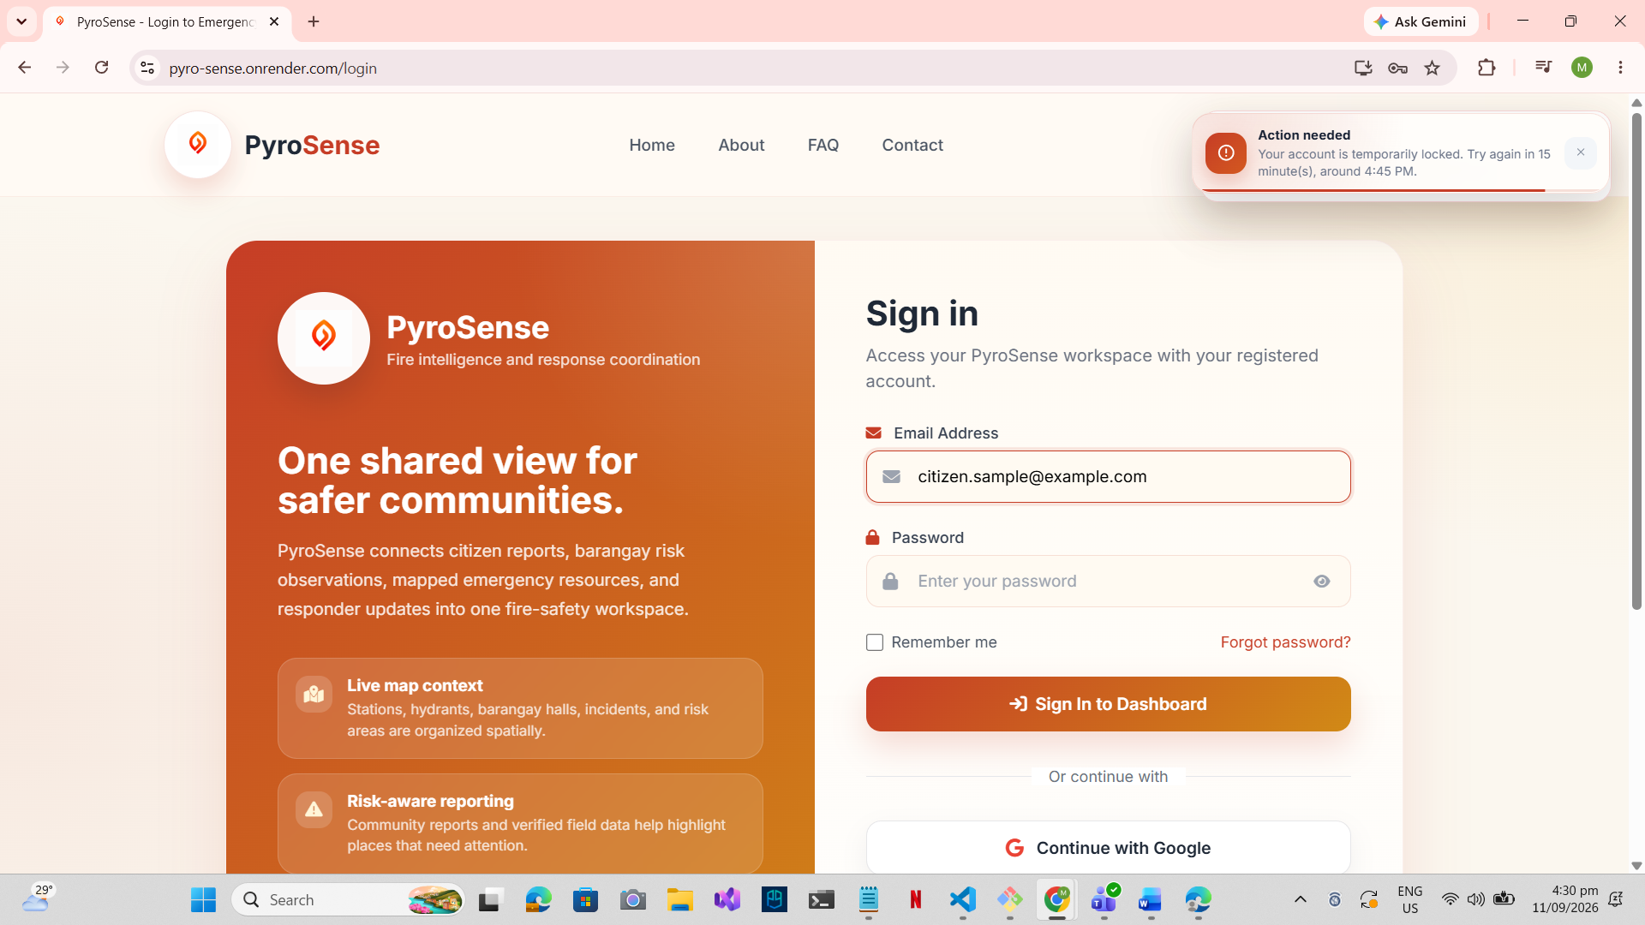
Figure 4.19 Login Form
Figure 4.19 represents the login form of the developed system, securing web pages through user authentication and authorization. The security of the developed system enforced the authentication and authorization that allows the system to verify first the credentials of the user input before directing an access to perspective dashboard pages. Upon the login input with wrong password through email, the system temporarily locks the account for 15 minutes to prevent multiple attempts of entering the system.
Usability. A non-functional requirement that describes how the system can easily be learned, navigate, understand, and use the system to complete certain actions and functions. The system provides different users for the user interface understandable, easy to learn and navigate allowing the ease of use to perform intended task functions.

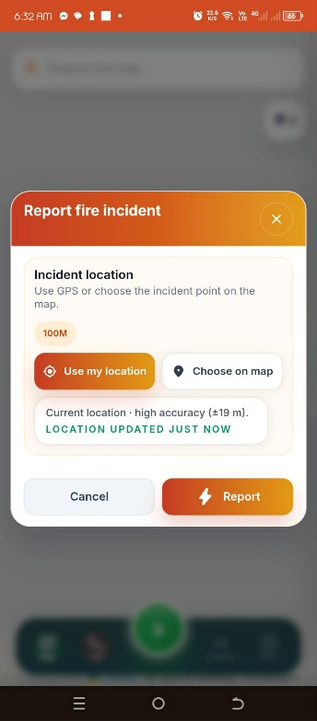

Figure 4.20 Fire Report Form
Figure 4.20 displays the fire incident report form of the developed system. The incident form allows user to select current location selection and choose on the map within 100 meters. This non-functional requirement was incorporated to easily learn and navigate through incident reporting. It allows the user to replace the map location within the specified area, and supports a usable selection to adjust the incident location.
Non-repudiation. A non-functional requirement that describes how the system records and maintains user activities to provide accountability and verification. The system needs to properly record user actions and transactions, ensuring that activities performed within the system can be traced and verified when necessary. PyroSense integrated this requirement to track and monitor changes of data and information within the organization and it allows chief and administrator to distinguish the user related to the changes.

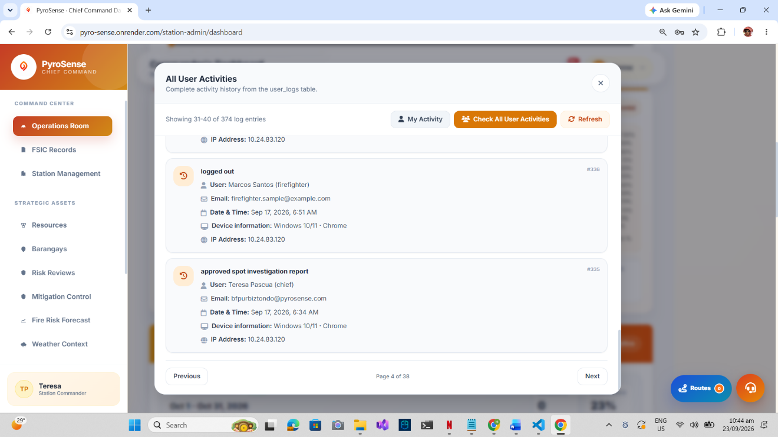

Figure 4.21 Audit Logs
Figure 4.21 presents the audit logs of the developed system. It enables the chief and administrator to track the personnels and users to the creation, deletion and modification of the data and information related to the incident, investigation, reports and execution.
Confidentiality. A non-functional requirement that describes how the system protects information from unauthorized access or disclosure. The system needs to restrict access to features, pages, and sensitive information based on authorized users and their assigned permissions. It provides the station records, features, data and information only accessible within the organization and authorized personnels only and ensures that the administrator and chief controls the flow of data and information.

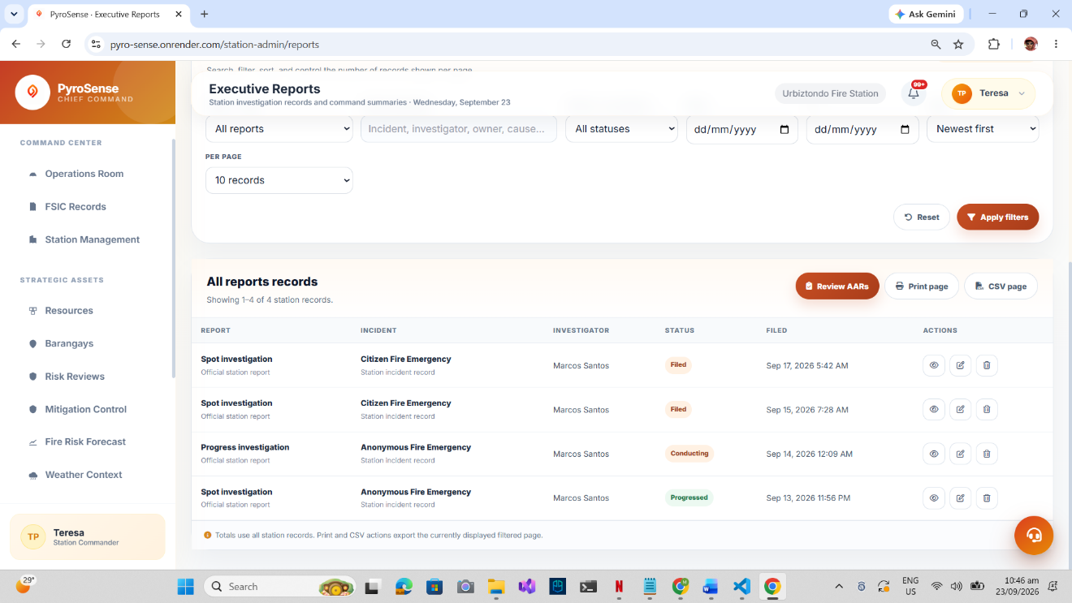

Figure 4.22 Executive Reports
Figure 4.22 describes the executive reports in the chief and administrator page. It ensures that the confidential data and reports can be modified only at the administrator and chief pages and only be viewed by authorized personnels.
4.5.3 Implementation and Integration of the Determined Technologies and Requirements
This specific objective reveals the implemented and integrated determined system technologies and system requirements such as geographic information system (GIS), application programming interfaces (APIs), artificial intelligence (AI) models, functional requirements and non-functional requirements. These technologies maintained, enhanced the developed system functionalities and features efficiently and effectively, and provide solutions to institution’s current problems and challenges. It supports the developed system to perform intended functions effectively and efficiently.
The assessed problem related to fire incident reporting was to locate and determine whether the report was reliable, timely, or not. The current method and existing communication channels were to report on-site or through mobile network calls that imposed limitation regarding to the availability of reporter’s location and knowledge. Aligned to the identified problem, the system implements additional method of communication with the Bureau of Fire Protection (BFP) Urbiztondo such as location-based reporting and browser call using internet connectivity. The location-based reporting that uses global positioning system (GPS) that allow firefighter to visualize reported incident location and proximity that helps to spread information to other responders and navigate thoroughly. Additionally, the browser call directly connects to the station through internet connection that the chief and administrator could respond whether it was a reliable or falsified report. Resource optimization helps to allocate responders immediately with current resources the station has. Through the system feature, the responders would have fast-access to incident information and monitoring by providing a centralized and location-based view of fire-related information.
Moreover, another problem was to visualize and navigate to the incident location when reported was unclear and vague. The stationed firefighter personnels has training, seminar, orientation and knowledge to its assigned station and covered area, however, even though they were well informed, unclarity still occur to responding personnels to get in the nearest and fastest way possible. The designed solution was developed in the system that allows firefighter personnels to digitally visualize in the map and navigate to the incident with minimal user intervention such as the incident location, information, fastest and nearest accessible path. Without the integration of the determined system technologies of the geographic information system application programming interfaces like OpenStreet Map that serves as a bridge to display the map information and resources, and the Geoapify routing ability to specific location, the solution capability would not be that effective.
Furthermore, fire incident has three investigation phase process such as spot investigation report, progress investigation report and final investigation report. Currently investigation report production generally occupies time on constructing narrative report. The report data was thoroughly reviewed and inputting manual data to applications such as Microsoft word would take up a lot of time. The solution focused on creating investigation report as a digital form with ai-assisted narrative generator that allows firefighter to investigate on-site and generate report immediately. Through this feature, the firefighter would focus more on investigation and use on-site report generation to fill up investigation field inputs through mobile browser or progressive web application that attain fast and efficient report generation. The aim of the feature is to generate and construct investigation report fast, accurate, efficient and reliable. Since investigation report conducts three phases, the two remaining phases can select the previous report submitted that allows the system to retrieve the accurate data result and combining the field input from the proceeding investigation and it enables the firefighter to submit the report precisely based data from investigation and reported incident.
The fire-readiness and planning of the Bureau of Fire Protection was carefully designed through previous records. The current method of the BFP was to document, ideate and inspect manually records to construct preventive plan. The system incorporates features such as analysis, prediction, mitigation, recommendation and suggestion that provides useful information, planning and idealistic approach generated by the machine learning and artificial intelligence model that accurately used previous records, system records, weather factors, vicinity and readiness of an area to fire-related incidents. Integrate system technology in the feature system was the artificial intelligence and machine learning model that communicate with each other to visualize trend and pattern based on saved datasets and translates by the DeepSeek model to generate prediction, analysis, mitigation plans, checklists, recommendations and suggestions. It helps and supports the BFP to visualize trends, potential patterns, generate fast accurate preventive mitigation planning, and idea on how many incidents could possibly occur based on datasets and systematically translated by the artificial intelligence model ensuring preventive measurements to possible fire incidents would be implemented.
In general, these implemented and integrated technologies improved the operations and functions of the major features that allow firefighter to monitor and respond to fire incidents effectively and efficiently. These technologies support the operational functions of the Bureau of Fire Protection (BFP) Urbiztondo that improves and innovates the operations, monitoring, planning, reporting, investigating and response operations.
4.5.4 Evaluation and User Assessment Test of the Developed System
This specific objective represents the findings and evaluation of the developed system to determine the extent to which it satisfied the selected ISO/IEC 25010:2023 software quality criteria. The quality of the developed system was assessed using a descriptive survey method, with respondents evaluating the system through the ISO/IEC 25010:2023 questionnaire.
The ISO/IEC 25010:2023 is an international standard under the SQuaRE (System and software Quality Requirements and Evaluation) series. It provides product quality model to specify, evaluate, measure and determine the ICT and software product quality. It is the edition released in November 2023 second to the ISO/IEC 25010 software quality model using the nine characteristics on evaluating the software product which are the functional suitability, performance efficiency, compatibility, interaction capability, maintainability, reliability, security, flexibility, and safety. The product quality model ISO/IEC 25010:2023 was used and adopted because it provides comprehensive criteria in assessing software quality. The standard criteria implemented and served as a structural basis to determine the overall quality and acceptability of the developed system. The researchers adapted the software criteria to identify and measure the system’s quality regarding to response management functionalities and design orientation.
The table 4.3 presents the respondent distribution on the conducted survey based on different roles. The citizens were the majority of the respondents in the evaluation of the system in the survey accumulating 71.94% total participation. Second to the citizens, compromising at 21.58% participation was the barangay officers. Following by the Bureau of Fire Protection (BFP) Urbiztondo firefighters at 5.04% participation rate. Lastly, the admin and chief participation in the conducted survey accounting to 1.44%. In summary, the totality of respondents participated in the system evaluation survey was 139 individuals.
Table 4.3 Survey Respondents
Role | Number of Respondents | Percentage
Administrator / Chief | 2 | 1.44 %
Firefighter | 7 | 5.04 %
Barangay Officer | 30 | 21.58 %
Citizen | 100 | 71.94 %
Total | 139 | 100 %

Table 4.4 presents the tabulation rating of the five-point likert scale to interpret the results of the survey. Each scale value corresponds to an equivalent interpretation rating and specific range to analyze the responses weighted mean. The rating scale value of 5 is the highest rating and ranging from 4.51 to 5.00 average weighted mean and evaluated as Agree. The second highest rating scale value is 4 ranging from average of 3.51 to 4.50 weighted mean interpreted as Agree. Neutral interpretation falls between 2.41 to 3.50 weighted mean with a scale value of 3. On contrary, the range from 1.51 to 2.50 weighted mean interpreted as Disagree and has a scale value of 2. Lastly, the lowest of all scale is the Strongly Disagree with value of 1 and weighted mean range of 1.00 to 1.50. The scale serves as a guideline for the evaluation of the understanding of respondents to the developed system to interpret data whether it satisfies the user needs.
Table 4.4 Rating Scale
Scale | Range | Interpretation
5 | 5.00 – 4.51 | Strongly Agree
4 | 4.50 – 3.51 | Agree
3 | 3.50 – 2.51 | Neutral
2 | 2.50 – 1.51 | Disagree
1 | 1.50 – 1.00 | Strongly Disagree

Functional Suitability. a product capability to provide essential functions that meet the user needs and requirements under specified conditions. The category has three sub-category which are important aspects, the functional completeness a system capability to serve users objective and intended function to complete a certain task, the functional correctness evaluates the system to provide accurate results when used by authenticated users and functional appropriateness a capability provides functions handling to complete task with proper steps given without unnecessary extra actions and measures the effectiveness of the system.
Table 4.5 displays the data evaluated in the survey according to the functional suitability. The administrator and chief group (n = 2), evaluates the system characteristic category in three different statements falling to the weighted mean for functional completeness – 4.50, functional correctness – 4.50 and functional appropriateness – 4.0 accumulating the functional suitability average weighted mean of 4.33 which interpreted as Strongly Agree that indicates the full operational functionality of report generation, geographic information management, prediction, response management and incident verification of the developed system delivered accurate and reliable results. The respondent group for firefighters (n = 7), the evaluated average weighted mean of 4.05 corresponds as Agree that describes the system’s information delivers a precise and accurate results such as navigation routing, geographic display of information, report generation and response that performs needs of user and its intended functions. For the barangay officers (n = 30), the results interpreted as Agree with average weighted mean of 4.12 indicating useful, accurate information regarding incident and resources visualization. Lastly, the citizen respondents (n = 100) with an average weighted mean of 3.86 depicts as Agree demonstrates an agreeable function state of the system in terms of location-based reporting and information dissemination. In general, all respondents (n = 139) the functional suitability in terms of functional completeness obtained a mean of 3.99 and interpreted as Agree that indicates the system can provide all features needed to monitor and report fire incidents. The functional correctness received the highest mean of 4.03, interpreted as Agree suggesting that the system provides accurate results. The functional appropriateness obtained a mean of 3.79 and interpreted as Agree indicates that the developed system perform intended functions effectively. The functional suitability of the system concluded the overall average weighted mean of 3.94 demonstrates that the developed system has a strong, reliable, precise, accurate results and working properly under different conditions. These results demonstrate that the developed system’s functionality were suitable in all different roles to satisfy user needs in regards to the reporting and monitoring incident information.
Table 4.5 Functional Suitability System Evaluation
n = 139
Functional Suitability | Statement | Mean | Interpretation
Functional Completeness | The system provides all the features that I need to monitor and report fire incidents. | 3.99 | Agree
Functional Correctness | The system provides correct and accurate results such as geographic and fire incident information. | 4.03 | Agree
Functional Appropriateness | The system performs its intended functions and features effectively without requiring unnecessary actions. | 3.79 | Agree
 | Average Weighted Mean | 3.94 | Agree
Legend: 5 – Strongly Agree, 4 – Agree, 3 – Neutral, 2 – Disagree, 1 – Strongly Disagree

Performance Efficiency. The system capability to perform efficiently, in terms of speed, responsiveness, use of resources and intended functions within the scoped specified time while carrying out tasks. In PyroSense, it is important because fire incident information would need to be processed and displayed promptly. It helps the administrator, chief, firefighters, barangay officers and citizens to access information, incident reporting, maps, forecasting, and risk assessment without unnecessary delays.
Table 4.6 presents the data findings and evaluation results of the performance efficiency of the developed system. The results shown the average weighted mean of 3.81 and interpreted as Agree, demonstrating that the respondents recognized the system as performing efficiently in terms of its time behavior, resource utilization and capacity. The resource utilization received the highest mean of 3.86 and interpreted as Agree, demonstrating that the system information updates and map resources were refreshed in real-time with minimal delay. Meanwhile, the respondents agreed on the system’s performance in a timely manner behavior ranging with a mean of 3.84 that regards to the system capability to quickly load the pages and information. Lastly, the lowest sub-category obtained a mean of 3.73 and interpreted as Agree, indicating that the system capability to perform efficiently even with many users accessing at the same time was efficiently satisfied. Overall, the system’s performance efficiency received positive interpretation and it indicates that the system operates at the satisfactory level needed by the users and respondents within an acceptable speed, utilization, and capacity to handle fire incident reporting, monitoring and document reports.
Table 4.6 Performance Efficiency Evaluation Results
n = 139
Performance Efficiency | Statement | Mean | Interpretation
Time Behavior | Information and pages load quickly when using the system. | 3.84 | Agree
Resource Utilization | The map location and information update and refresh in real-time with minimal delay. | 3.86 | Agree
Capacity | The system performs efficiently even with many users logged in and accessing at the same time. | 3.73 | Agree
 | Average Weighted Mean | 3.81 | Agree
Legend: 5 – Strongly Agree, 4 – Agree, 3 – Neutral, 2 – Disagree, 1 – Strongly Disagree

Compatibility. The system capability to exchange information with other systems, web applications, or services to operate the system and perform the features and functions required within the same environment and resources. The compatibility supports the system to communicate with other web app, systems or services to exchange data and evaluate into more reliable and useful information. It enables the developed system to integrated other component needed for the features like prediction, mitigation planning, mapping services and authentication of users. With the help of other system and services like Open-Meteo sends weather forecast data and historical data, artificial intelligence model to translate computation, mathematical patterns and datasets into human readable to generate prediction and mitigation planning based on results, and OpenStreet Map and Geoapify responsible for mapping services and display. In general, these compatible services support and enable the developed system to operate functionality at its effective capability.
Table 4.7 display the evaluation results of the compatibility based on the conducted survey to the respondents. The system compatibility to other devices based on gathered results from the respondents that the system operates properly within the same environment such as the browser and progressive web applications and co-existent with other devices such as mobile phones, tablets and computers, obtained a mean of 3.91 and interpreted as Agree. The system’s interoperability obtained a mean of 3.85 and interpreted as Agree that suggests a strong system integration with other web services to exchange data and information effectively and efficiently to support the developed system major functionalities like prediction, analysis, mitigation planning, mapping services, narrative generation, and web browser call. Overall, the average weighted mean of the compatibility obtained a mean of 3.88 and interpreted as Agree. Based on the overall results, the respondents agree on the characteristic capability of the system to be used in different devices and communicate to other services to perform intended functions.
Table 4.7 Compatibility Evaluation Results
n = 139
Compatibility | Statement | Mean | Interpretation
Co-existence | The system operates properly across different devices such as computers, tablets and phones. | 3.91 | Agree
Interoperability | The system integrates and communicates effectively with external APIs to support features such as GPS, map services, AI services, and calling functionality. | 3.85 | Agree
 | Average Weighted Mean | 3.88 | Agree
Legend: 5 – Strongly Agree, 4 – Agree, 3 – Neutral, 2 – Disagree, 1 – Strongly Disagree

Interaction Capability. The system capability to interact with user and exchange information through user interface to complete tasks and intended functions. It supports the system to interact with users through navigation, labels, icons and display of information that allows the user to perform functions and to interact the system with ease. The developed system incorporated the learnability, operability, user error protection, user engagement and self-descriptiveness to improve system to user interaction.
Table 4.8 presents the evaluation results for the interaction capability of the developed system. Among the five sub-categories of the interaction capability, the operability obtained the highest mean of 3.92 perceived that the overall respondents Agree that the constructed navigation was concise and consistent. Secondly, the self-descriptiveness received the mean of 3.89 and interpreted as Agree, indicating the developed system provides hints and cues on data inputs and information display. Meanwhile, the user error protection evaluation resulted to the mean of 3.88 and portrayed as Agree, the result shown perceived that the system provides notification system for invalid input, data format and upload errors to prevent system crash that can be followed at ease. Furthermore, the learnability of the system obtained a mean of 3.77 and interpreted as Agree, the system’s learnability requires minimum effort to perform functions such as fire incident reporting, mapping, alerts and navigation through pages. Lastly, the user engagement obtained a mean of 3.74 and described as Agree, the evaluation results suggest that the respondents feel the ease of use of the system even without its guide and assistance. The overall interpretation of the interaction capability described as Agree that obtained the mean of 3.84, demonstrates that the system interaction capability was at satisfactory level based on the evaluation results.
Table 4.8 Interaction Capability Evaluation Results
n = 139
Interaction Capability | Statement | Mean | Interpretation
Learnability | Learning the system requires minimum effort. | 3.77 | Agree
Operability | The system’s navigation is concise and consistent. | 3.92 | Agree
User Error Protection | Notifications, labels, icons, and instructions can follow at ease with invalid alert hints. | 3.88 | Agree
User Engagement | I feel satisfied and at ease when using the system even without its assistance. | 3.74 | Agree
Self-Descriptiveness | The system provides useful hints and cues for me to understand what the feature can do. | 3.89 | Agree
 | Average Weighted Mean | 3.84 | Agree
Legend: 5 – Strongly Agree, 4 – Agree, 3 – Neutral, 2 – Disagree, 1 – Strongly Disagree

Reliability. The ability of the system to perform intended functions correctly, consistently and reliably under certain conditions and certain period of time. It supports the system major functions like predictions, analysis, incident monitoring and response management performs consistently and correctly during normal system operation. It functions to process and display information that the users can depend on the system when performing respective tasks.
Table 4.9 displays the evaluation result of the system reliability of PYROSENSE. The statement “The system operates and remains operational upon use without crashing or freezing” obtained a mean of 3.68, interpreted as Agree. This indicates that the respondents generally perceived the system as stable during use. The result is relevant to the major system features because users need continuous access when submitting fire incidents, viewing the operational and geographic mapping dashboard, checking incident information, generating investigation reports, and accessing predictive analysis. The availability statement, “The system is available anytime,” obtained a mean of 3.70, also interpreted as Agree. This result supports the implementation of PYROSENSE as a web-based and progressive web application, allowing users to access the system through supported browsers and devices whenever the system is available. This capability directly addresses the identified need for more accessible and centralized fire incident information. The recoverability statement, “The data recovers properly after failure or unexpected event,” obtained the highest mean of 3.83, interpreted as Agree. This indicates that respondents recognized the system's ability to preserve or recover information after unexpected events, which is important because PYROSENSE stores incident reports, investigation records, historical fire data, risk information, mitigation plans, and other operational records. Overall, reliability obtained an average weighted mean of 3.74, interpreted as Agree, demonstrating that the developed system was perceived as dependable for supporting fire monitoring, reporting, analysis, and response management.

Table 4.9 Reliability Evaluation Results
n = 139
Reliability | Statement | Mean | Interpretation
Faultlessness | The system operates and remains operational upon use without crashing or freezing. | 3.68 | Agree
Availability | The system is available anytime. | 3.70 | Agree
Recoverability | The data recovers properly after failure or unexpected event. | 3.83 | Agree
 | Average Weighted Mean | 3.74 | Agree
Legend: 5 – Strongly Agree, 4 – Agree, 3 – Neutral, 2 – Disagree, 1 – Strongly Disagree

Security. The capability of the system to protect information, user accounts, system features, and stored records from unauthorized access or improper modification. This characteristic is important for PYROSENSE because the system manages fire incident information, investigation reports, user records, resource information, predictive results, mitigation plans, and other operational data. The system also assigns different permissions to the Administrator, Chief, Firefighter, Barangay Officer, and Citizen user levels. These access controls ensure that sensitive functions such as account management, report management, prediction generation, mitigation planning, and resource management are only available to authorized personnel. This approach is consistent with the system requirements identified in Chapter 4, where security and data integrity were established as important non-functional requirements.
Table 4.10 shows that confidentiality obtained a mean of 3.95, interpreted as Agree, indicating that respondents agreed that system features and pages can only be accessed by authorized users. This is supported by the role-based access implemented in PYROSENSE, where each user level is provided with functions appropriate to their responsibilities. The integrity criterion obtained the highest mean of 4.04, interpreted as Agree. The statement, “Authorized users can access and manage sensitive data and information according to their assigned permissions,” reflects the system's use of authentication and access control to manage information according to user responsibilities. This is particularly important for maintaining accurate fire incident and investigation records. The non-repudiation criterion obtained a mean of 3.95, interpreted as Agree, indicating that respondents agreed that user activities are properly recorded and maintained for accountability and verification. This is relevant to the system's record management and audit-related functions, particularly when users submit reports, update incident information, or perform authorized actions. Meanwhile, authenticity obtained a mean of 3.99, interpreted as Agree, showing that respondents recognized the system's ability to verify user identity before providing access to protected features. Overall, Security achieved an average weighted mean of 3.98, interpreted as Agree, indicating that the system provides a satisfactory level of protection for user access, operational information, and stored records.
Table 4.10 Security Evaluation Results
n = 139
Security | Statement | Mean | Interpretation
Confidentiality | The system features and pages can only be accessed by authorized users. | 3.95 | Agree
Integrity | Authorized users can access and manage sensitive data and information according to their assigned permissions. | 4.04 | Agree
Non-repudiation | The system ensures that user activities are properly recorded and maintained for accountability and verification. | 3.95 | Agree
Authenticity | The system verifies user identity before allowing to access the protected features and their authorized accounts. | 3.99 | Agree
 | Average Weighted Mean | 3.98 | Agree
Legend: 5 – Strongly Agree, 4 – Agree, 3 – Neutral, 2 – Disagree, 1 – Strongly Disagree

Maintainability. The ability of the system to be modified, updated, corrected, and tested without significantly affecting its existing functions. This characteristic is important for PYROSENSE because the system integrates several components, including GIS services, external APIs, database management, predictive analytics, artificial intelligence, reporting modules, and user management. Since the system was developed using an Agile approach, continuous improvement and adjustment of features are part of the development process. The use of structured technologies and modular system components supports the ability of the developers to maintain the system as operational requirements change.
Table 4.11, the modifiability criterion obtained a mean of 3.69, interpreted as Agree. The statement, “The system can be improved or modified without affecting existing functions and easily updates when changes are required,” indicates that respondents generally recognized the system's capability to accommodate improvements. This applies to features such as the GIS mapping components, reporting forms, predictive analysis, mitigation management, and user account management, which may require future updates based on operational needs. The testability criterion obtained a higher mean of 3.85, interpreted as Agree. The statement, “The functions and features of the system can be tested to verify whether it meets the user specified requirements,” indicates that the system features can be evaluated to determine whether they continue to satisfy the identified requirements of BFP personnel, barangay officers, and citizens. The use of Agile Scrum also supports this characteristic because system features were developed and evaluated incrementally through testing and feedback. Overall, the Maintainability category obtained an average weighted mean of 3.77, interpreted as Agree, showing that the developed system was perceived to be maintainable and capable of undergoing testing, correction, and future improvement.
Table 4.11 Maintainability Evaluation Results
n = 139
Maintainability | Statement | Mean | Interpretation
Modifiability | The system can be improved or modified without affecting existing functions and easily updates when changes are required. | 3.69 | Agree
Testability | The functions and features of the system can be tested to verify whether it meets the user specified requirements. | 3.85 | Agree
 | Average Weighted Mean | 3.77 | Agree
Legend: 5 – Strongly Agree, 4 – Agree, 3 – Neutral, 2 – Disagree, 1 – Strongly Disagree

Flexibility. The ability of the system to adapt to different environments, devices, platforms, browsers, and operational requirements with minimal disruption. This characteristic supports the intended use of PYROSENSE as a web-based system and progressive web application because its users have different roles and may access the system using computers, tablets, and mobile devices. The system's use of browser-based technologies and PWA functionality support access across supported devices while maintaining the major system features such as incident reporting, GIS visualization, resource viewing, and information dissemination.
Table 4.12 presents the evaluation results for flexibility. The installability criterion obtained a mean of 3.92, interpreted as Agree, indicating that respondents agreed that the system can be installed and configured on supported devices. This result is associated with the progressive web application capability of PYROSENSE, which allows the web application to be added to the home screen of supported mobile and desktop devices. The adaptability criterion obtained a mean of 3.91, interpreted as Agree, showing that respondents recognized the system's ability to operate across different platforms, devices, and web browsers. This supports the system requirement for accessibility among different user groups, particularly citizens and barangay officers who may use mobile devices, and BFP personnel who may use computers or other supported devices. The replaceability criterion obtained the highest mean of 3.99, interpreted as Agree, indicating that respondents agreed that user data and settings can be accessed across supported devices and platforms. Overall, Flexibility obtained an average weighted mean of 3.94, interpreted as Agree, demonstrating that the system can accommodate different access environments while maintaining its intended functions.
Table 4.12 Flexibility Evaluation Results
n = 139
Flexibility | Statement | Mean | Interpretation
Installability | The system can be installed and configured on devices. | 3.92 | Agree
Adaptability | The system can be accessed on different platforms, devices and web browsers. | 3.91 | Agree
Replaceability | User data and settings can be accessed across supported devices and platforms. | 3.99 | Agree
 | Average Weighted Mean | 3.94 | Agree
Legend: 5 – Strongly Agree, 4 – Agree, 3 – Neutral, 2 – Disagree, 1 – Strongly Disagree

Safety. The capability of the system to prevent unsafe actions, unauthorized modifications, and conditions that may negatively affect system operations or decision-making. In PYROSENSE, safety is important because the system is designed to support emergency response and fire risk management. The system does not replace the official procedures and authority of BFP personnel; instead, it serves as a decision-support and assistance tool that provides information, geographic visualization, predictive results, mitigation plans, and response-related recommendations. Therefore, appropriate restrictions and controlled access are necessary to prevent unauthorized changes to operational information.
Table 4.13 shows that the operational constraint criterion obtained a mean of 3.65, interpreted as Agree. The statement, “The system applies appropriate actions and restrictions to prevent unauthorized and unsafe modification of data during operations,” indicates that respondents generally agreed that the system provides controls that help protect operational information. This is supported by the role-based access structure, where users are given specific permissions according to their responsibilities. The risk identification criterion obtained a higher mean of 3.85, interpreted as Agree. The statement, “The system can identify certain conditions and visualize factor patterns that may cause potential fire incidents, hazard, and risk areas based on analysis and predictions,” directly relates to the predictive analytics, fire and hazard risk visualization, and mitigation management features of PYROSENSE. The system uses historical incident information, weather-related data, spatial information, risk areas, and other available datasets to support the identification of possible fire-risk patterns. These outputs can assist the BFP in preparing mitigation plans and identifying areas requiring attention. Overall, the Safety category obtained an average weighted mean of 3.75, interpreted as Agree, indicating that the respondents recognized the system's ability to provide operational restrictions and risk-related information that can support safer fire prevention and response planning.

Table 4.13 Safety Evaluation Results
n = 139
Safety | Statement | Mean | Interpretation
Operational Constraint | The system applies appropriate actions and restrictions to prevent unauthorized and unsafe modification of data during operations. | 3.65 | Agree
Risk Identification | The system can identify certain conditions and visualize factor patterns that may cause potential fire incidents, hazard, and risk areas based on analysis and predictions. | 3.85 | Agree
 | Average Weighted Mean | 3.75 | Agree
Legend: 5 – Strongly Agree, 4 – Agree, 3 – Neutral, 2 – Disagree, 1 – Strongly Disagree

Table 4.14 presents the overall evaluation results of PYROSENSE based on the nine selected ISO/IEC 25010:2023 software quality characteristics. The results show that all evaluated characteristics obtained an interpretation of Agree, indicating that the respondents generally found the developed system acceptable across its major software quality dimensions. Security obtained the highest weighted mean of 3.98, followed by Functional Suitability and Flexibility, both with mean of 3.94, while Compatibility obtained a mean of 3.88, Interaction Capability mean of 3.84, Performance Efficiency mean of 3.81, Safety with mean of 3.75, Maintainability with mean of 3.77, and Reliability with a mean of 3.74. The overall average weighted mean was 3.85, interpreted as Agree. These findings indicate that the system generally satisfied the identified quality requirements and was perceived as capable of supporting the intended users and operational functions of BFP Urbiztondo.
The results further demonstrate that the quality characteristics were reflected in the actual system features developed from the identified operational problems. The Functional Suitability result of 3.94 supports the completeness, correctness, and appropriateness of functions such as location-based reporting, incident monitoring, geographic mapping, investigation report generation, predictive analytics, resource allocation, and response optimization. Performance Efficiency obtained 3.81, indicating that users agreed that information and pages load quickly, map locations and information update with minimal delay, and the system can perform efficiently with multiple users. Compatibility obtained 3.88, reflecting the integration of different services such as GPS, mapping services, AI services, weather data, and calling functionality. Interaction Capability obtained 3.84, supporting the use of clear navigation, labels, notifications, icons, instructions, and system cues to help users accomplish reporting, mapping, monitoring, and other tasks with minimal effort. These results correspond with the original system objective of developing an integrated platform that improves access to information, situational awareness, coordination, and response support.
The remaining quality characteristics also demonstrate how PYROSENSE addresses the limitations identified in the existing fire monitoring and response practices. Reliability, with a mean of 3.74, indicates that users generally agreed that the system can remain operational, be available when needed, and recover information after unexpected events. Security, which obtained the highest overall category mean of 3.98, reflects the importance of authentication, authorization, data integrity, and accountability in managing fire-related information. Maintainability and Flexibility, with means of 3.77 and 3.94, respectively, demonstrate that the system can be tested, modified, updated, installed, and accessed through supported devices and platforms. Safety obtained 3.75, showing that the system can apply restrictions while also identifying and visualizing possible fire-risk conditions through its predictive and GIS-based features. These findings are consistent with the system requirements identified during development, particularly availability, data integrity, flexibility, maintainability, reliability, security, usability, and performance efficiency.
Table 4.14 Overall Evaluation Results
Category | Weighted Mean | Interpretation
Functional Suitability | 3.94 | Agree
Performance Efficiency | 3.81 | Agree
Compatibility | 3.88 | Agree
Interaction Capability | 3.84 | Agree
Reliability | 3.74 | Agree
Security | 3.98 | Agree
Maintainability | 3.77 | Agree
Flexibility | 3.94 | Agree
Safety | 3.75 | Agree
Average Weighted Mean | 3.85 | Agree
Legend: 5 – Strongly Agree, 4 – Agree, 3 – Neutral, 2 – Disagree, 1 – Strongly Disagree

4.6 Evaluation of the Proposed Computer-Based Solution
The evaluation of the proposed computer-based solution was conducted to determine whether PYROSENSE effectively addressed the operational needs and problems identified during the assessment of the existing fire monitoring and response practices of BFP Urbiztondo. The existing process relied on phone calls, text messages, personal reporting, logbooks, spreadsheets, and verbal communication, which created limitations in incident recording, location verification, responder coordination, and access to historical information. The proposed computer-based solution addressed these limitations by integrating location-based reporting, interactive GIS mapping, response optimization, centralized records, investigation report generation, predictive analytics, mitigation planning, and communication features into one web-based platform.
The gathered evaluation results show that the proposed solution was positively received by the 139 respondents, consisting of administrators or chiefs, firefighters, barangay officers, and citizens. The survey results demonstrate that the developed features correspond to the different responsibilities and requirements of the intended users. For firefighters, the location-based reporting, geographic mapping, routing, response optimization, and investigation report features provide information needed for incident response and documentation. For administrators and chiefs, the dashboard, resource management, predictive analytics, mitigation management, and report management features support supervision and decision-making. For barangay officers, the risk and hazard visualization, checklist, mitigation, and reporting features support fire prevention and coordination with the BFP. For citizens, the reporting form, location capture, map visualization, announcements, and verified information provide an accessible means of reporting incidents and viewing relevant fire-risk information. This user-centered distribution is consistent with the identified requirements and intended system roles established in the study.
Overall, the proposed computer-based solution obtained an average weighted mean of 3.85, interpreted as Agree, across the nine software quality characteristics. The result indicates that PYROSENSE was generally accepted by the respondents as a suitable computer-based solution for fire incident monitoring, reporting, analysis, and response support. The evaluation also shows that the system's features were not developed independently from the identified problems; rather, they were designed to respond directly to the limitations of the existing process. Location-based reporting addresses the difficulty of identifying the exact location of reported incidents, GIS mapping and Geoapify routing support navigation and response coordination, resource optimization assists in identifying suitable available responders, automated narrative generation reduces the effort required in preparing investigation reports, while predictive analytics, risk visualization, mitigation planning, recommendations, and suggestions support proactive fire-risk management. Thus, the overall evaluation indicates that the developed PYROSENSE system satisfactorily met the identified functional and non-functional requirements and provided an integrated computer-based solution aligned with the operational needs of BFP Urbiztondo.

BIBLIOGRAPHY
A. Journal References
Anderson, P. (2022). Predictive fire risk assessment systems and disaster preparedness. International Journal of Disaster Management, 14(2), 45–58. https://doi.org/10.1016/j.ijdm.2022.01458.

Aporto, J., Ramos, K., & Villaflor, M. (2025). Geospatial emergency response operations in Iloilo. Philippine Journal of Disaster Risk Studies, 8(1), 66–79. https://doi.org/10.5281/pjdrs.2025.80166.

Bautista, R. (2023). Fire response operations and logistical challenges in Metro Manila. Philippine Safety and Emergency Journal, 5(2), 21–35. https://doi.org/10.4772/psej.2023.05221.

Bimantara, A., & Rochimah, S. (2023). Evaluation of food delivery applications using ISO/IEC 25010 usability characteristics. International Journal of Interactive Mobile Technologies, 17(6), 77–91. https://doi.org/10.3991/ijim.v17i06.38901.

Brown, T., Miller, J., & Adams, P. (2021). Smart technologies in fire monitoring systems. International Journal of Emergency Technologies, 9(4), 112–126. https://doi.org/10.1109/ijet.2021.09112.

Canlas, M., Reyes, J., & Dizon, P. (2021). Faculty productivity monitoring and prediction system evaluation using ISO/IEC 25010. Philippine Computing Journal, 13(1), 55–69. https://doi.org/10.1080/pcj.2021.130155.

Chen, Y., & Liu, H. (2022). Route optimization systems in emergency response operations. Journal of Transportation and Safety Systems, 18(3), 101–117. https://doi.org/10.1016/j.jtss.2022.18101.

Cruz, M., & Mendoza, A. (2024). Integration of GIS APIs in local emergency systems. Asian Journal of Disaster Management, 10(1), 44–58. https://doi.org/10.1080/ajdm.2024.100144.

Dela Cruz, M. (2022). Fire monitoring practices among local fire departments in the Philippines. Philippine Journal of Public Safety, 7(3), 33–47. https://doi.org/10.5281/pjps.2022.70333.

Dela Cruz, M., & Ramos, P. (2023). Decision-support systems for emergency response planning in local government units. Journal of Local Governance Technology, 6(2), 70–85. https://doi.org/10.1007/jlgt.2023.62070.

Geoapify. (2023). Routing and geolocation API for emergency deployment systems. Journal of GIS and Navigation Technologies, 12(1), 50–63. https://doi.org/10.1080/jgnt.2023.120150.

Johnson, R., & Lee, K. (2023). Traditional fire response systems and operational inefficiencies. Emergency Operations Review, 11(1), 27–39. https://doi.org/10.1177/eor.2023.110127.

Kim, J., & Park, S. (2022). Early detection mechanisms in fire monitoring systems. Fire Safety Technology Journal, 14(3), 74–89. https://doi.org/10.1016/fstj.2022.14374.

Mulyawan, A., Prasetyo, B., & Hidayat, R. (2021). ISO/IEC 25010 application in software quality evaluation. International Journal of Software Engineering and Applications, 12(3), 54–68. https://doi.org/10.5121/ijsea.2021.12354.

Nguyen, P., Tran, H., & Le, D. (2024). Machine learning-based predictive fire risk assessment systems. Artificial Intelligence for Disaster Management, 5(2), 99–114. https://doi.org/10.1016/j.aidm.2024.52099.

Oñate, J. (2022). FireStatPH: A GIS-based fire incident visualization platform. Philippine Geospatial Journal, 3(1), 25–39. https://doi.org/10.5281/pgj.2022.30125.

Paculaba, M., & Palaoag, T. (2024). GIS technologies in hazard profiling and disaster preparedness. Journal of Environmental and Hazard Studies, 17(2), 48–63. https://doi.org/10.1080/jehs.2024.17248.

Prameswari, D., & Setyawan, A. (2025). Hybrid ISO/IEC 25010 and SERVQUAL evaluation model for website quality. International Journal of Web Engineering, 18(1), 83–97. https://doi.org/10.1007/ijwe.2025.18083.

Putra, I., Santoso, H., & Wijaya, M. (2024). Mobile application assessment using ISO/IEC 25010. Journal of Mobile Computing Research, 10(2), 58–72. https://doi.org/10.1016/j.jmcr.2024.100258.

Reyes, P., & Garcia, L. (2021). Fire prevention strategies and hazard mapping in the Philippines. Philippine Journal of Disaster Studies, 6(4), 90–104. https://doi.org/10.5281/pjds.2021.60490.

Rumabar, T., Wijanarko, D., & Setiawan, F. (2024). Digital payment application evaluation using ISO/IEC 25010. Journal of Information Security and Systems, 9(3), 112–126. https://doi.org/10.1007/jiss.2024.93112.

Russell, S., & Norvig, P. (2021). Artificial intelligence in predictive analytics and decision-support systems. AI Systems and Applications Journal, 21(2), 130–145. https://doi.org/10.1016/j.aisa.2021.212130.

Saflor, E., & Kudhal, M. (2024). Digital mapping systems in emergency coordination. Journal of Disaster Communication Systems, 7(2), 60–75. https://doi.org/10.1080/jdcs.2024.72060.

Sehra, S., Kaur, H., & Singh, R. (2021). Open-source GIS platforms and web-based mapping applications. Geoinformatics and Spatial Analysis Journal, 18(1), 21–36. https://doi.org/10.1016/j.gsaj.2021.18021.

Smith, D. (2022). Modern fire monitoring systems and real-time data collection. International Journal of Fire Safety Engineering, 10(2), 50–65. https://doi.org/10.1016/j.ijfse.2022.10250.

Sommerville, I. (2021). Software requirements and system reliability in emergency management systems. Software Systems Journal, 17(1), 12–26. https://doi.org/10.1007/ssj.2021.17112.

Taylor, M., Roberts, L., & Evans, C. (2021). Response optimization systems in emergency operations. Journal of Emergency Logistics, 8(3), 70–84. https://doi.org/10.1177/jel.2021.83070.

Vargas, L., Chen, M., & Torres, P. (2021). OpenStreetMap applications in disaster management systems. Journal of Geographic Information Systems, 13(4), 102–118. https://doi.org/10.4236/jgis.2021.134102.

Wilson, G., Harris, T., & Young, B. (2021). Integrated fire monitoring systems and multi-source data coordination. Journal of Emergency Monitoring Systems, 9(2), 84–98. https://doi.org/10.1016/j.jems.2021.92084.

B. Electronic Books
Kumar, R. (2021). Research methodology: A step-by-step guide for beginners (5th ed.). SAGE Publications.

Morgan, D. L. (1997). Focus groups as qualitative research (2nd ed.). SAGE Publications.

Pressman, R. S., & Maxim, B. R. (2022). Software engineering: A practitioner’s approach (9th ed.). McGraw-Hill Education.

Russell, S., & Norvig, P. (2021). Artificial intelligence: A modern approach (4th ed.). Pearson Education.

Sharma, R., & Singh, P. (2023). Qualitative data collection and interview methods. Springer.

Sommerville, I. (2021). Software engineering (10th ed.). Pearson Education.
C. Internet Sources
Geoapify. (2023). Geoapify routing and geolocation API documentation. https://www.geoapify.com/

IBM. (2023). IBM documentation for system requirements and software technologies. https://www.ibm.com/docs/

ISO/IEC. (2011). ISO/IEC 25010 systems and software quality requirements and evaluation. https://iso25000.com/index.php/en/iso-25000-standards/iso-25010

OpenRouter. (2024). OpenRouter AI platform and API documentation. https://openrouter.ai/

OpenStreetMap Foundation. (2024). OpenStreetMap mapping and geospatial platform. https://www.openstreetmap.org/

ResearchGate. (2024). ResearchGate academic publication database. https://www.researchgate.net/

Scikit-learn Developers. (2024). Scikit-learn machine learning library documentation. https://scikit-learn.org/.

Visual Studio Code. (2024). Visual Studio Code integrated development environment. https://code.visualstudio.com/.

Apache Friends. (2024). XAMPP Apache distribution for PHP development. https://www.apachefriends.org/index.html.

