**Ex.No1**

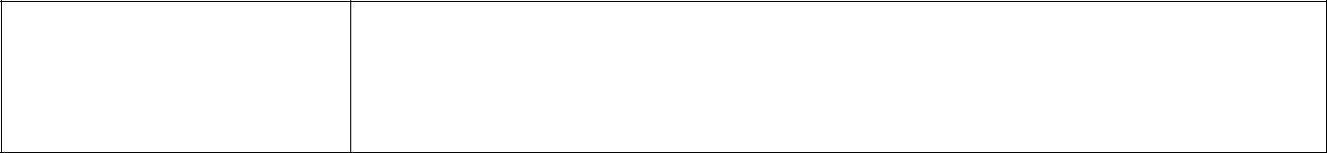

**CONSOLE INPUT**

**AIM:- To accept a character from console and check the case of the character.**

**PROCEDURE:-**

1. Open Visual Studio by clicking

**Start🡪All Programs🡪Microsoft Visual Studio.**

2. To create a Console application

**Select Projects🡪New project and click on Console application icon.**

1. In the name text box type the name of the Console application and click OK.
2. The screen changes to coding window.
3. Type the code inside Static void Main(string[] args)
4. Press F5 to execute the application.

**CODING:-**

**static void Main(string[] args)**

**{**

**Console.WriteLine("Enter a Alphabet");**

**char ch = Convert.ToChar(Console.ReadLine()); if(char.IsUpper(ch))**

**{**

**Console.WriteLine("Upper case");**

**}**

**else if(char.IsLower(ch))**

**{**

**Console.WriteLine("Lower case");**

**}**

**else**

**{**

**Console.WriteLine("Other character");**

**}**

**Console.ReadLine();**

**}**

**OUTPUT:-**

**RESULT:- Thus we have created a console application to check whether the given character is upper case or lower case or other character.**



***Littleflower* Polytechnic College** **Page 2**

**Component based technology practical**

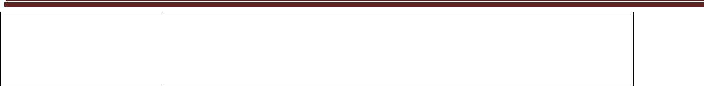

**EX.NO : 2**

**CHECKING FOR VOWELS**

**DATE:**

**AIM:- To write a program to accept any character from keyboard and display whether it is vowel or not.**

**PROCEDURE:-**

1) Open Visual Studio by clicking

**Start🡪All Programs🡪Microsoft Visual Studio.**

2) To create a Windows application

**Select File🡪New project and click on Windows application icon.**

1. A new form is created, place a Label , 2 Textboxes and a button in the form.
2. Double click on the button and add the following code in the ***CLICK()*** event of the button.
3. Press F5 to execute the application.

**CODING:-**

**private void button1_Click(object sender, EventArgs e)**

**{**

**string c;**

**c=textBox1.Text.ToUpper();**

**if (c == "A" || c == "E" || c == "I" || c == "O" || c == "U")**

**{**

**textBox2.Text="VOWEL";**

**}**

|  | **else** | | | |
| --- | --- | --- | --- | --- |
|  | **{** |  |  |  |
|  | **textBox2.Text="NOT VOWEL";** | | | |
|  | **}** |  |  |  |
|  | **}** |  |  |  |
|  |  |  |  |  |
| **Form** |  |  | **Output** |  |
| **design** |  |  |  |  |
|  |  |  |  |
|  |  |  |  |  |
|  |  |  |  |  |

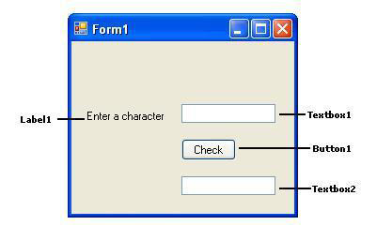

**RESULT:- Thus we have created a windows application to check whether the given character is vowel or not.**



***Littleflower* Polytechnic College** **Page 3**

**Component based technology practical**



**EX.NO : 3**

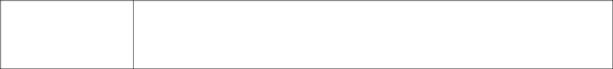

**CONVERTING CASE OF THE CHARACTERS**

**DATE:**

**AIM:- To write a C# .NET program to accept a string and convert the case of the**

**characters.**

**PROCEDURE:**

1. Open the C# windows application project and add a form to it.
2. Add a **Label** , **2 Text Boxes** and 2 **buttons** to the form.
3. Double click on Button1 and type the code in click() event.
4. Double click on Button2 and type the code in click() event.
5. After adding the coding run the program by pressing **‘F5’ .**

**CODING:-**

private void button1_Click(object sender, EventArgs e)

{

String s;

string outputString = string.Empty;

s = textBox1.Text;

foreach (char c in s)

{

if (Char.IsLower(c))

{

outputString+=char.ToUpper(c);

textBox2.Text = outputString;

}

else

{

outputString += char.ToLower(c);

textBox2.Text = outputString;

}

}

}

private void button2_Click(object sender, EventArgs e)

{

textBox1.Clear();

textBox2.Clear();

}

| **Form Design:** | **Output:** |
| --- | --- |
|  |  |

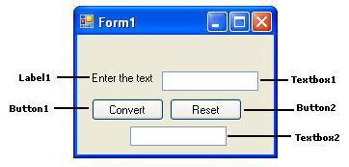

**RESULT:- Thus we have created a windows application to convert the case of the given character.**



***Littleflower* Polytechnic College** **Page 4**

**Component based technology practical**

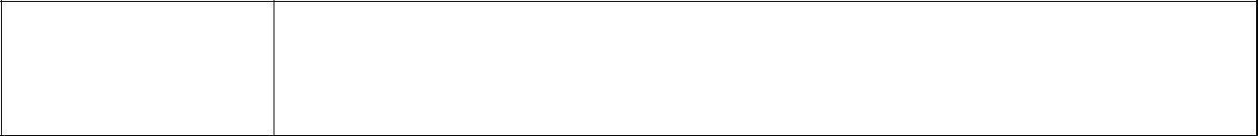

**EX.NO : 4**

**IMPLEMENTING A TEXT EDITOR**

**DATE:**

**AIM:- To develop a menu based C# .net application to implement a text editor with cut, copy, paste, save and close operation.**

**PROCEDURE:-**

1. Open Microsoft Visual studio and create a new windows application
2. Add a menu strip from the toolbar and type the names of the menu as follows:

**File -> New , Save As, Close**

**Edit -> Cut, Copy, Paste**

**Exit -> End**

3. Include a Label, Textbox and a button in the form.

Edit the following code in the Load event of the **Form1** **label1.Visible = false;**

**textBox1.Visible = false;**

**button1.Visible = false;**

1. Edit the following code in the click event of the **New** option in the **file** menu **richTextBox1.Clear();**
2. Edit the following code in the click event of the **SaveAs** option in the **file menu** **label1.Visible = true;**

**textBox1.Visible = true;**

**button1.Visible = true;**

1. Edit the following code in the click event of the **Button 1**. **richTextBox1.SaveFile(textBox1.Text);**

**label1.Visible = false;**

**textBox1.Visible = false;**

**button1.Visible = false;**

1. Edit the following code in the click event of the **Close** option in the file menu. **richTextBox1.Clear();**
2. Edit the following code in the click event of the **Cut** option in the edit menu. **richTextBox1.Cut();**
3. Edit the following code in the click event of the **Copy** option in the edit menu. **richTextBox1.Copy();**
4. Edit the following code in the click event of the **Paste** option in the edit menu. **richTextBox1.Paste();**
5. Edit the following code in the click event of the **end** option in the exit menu.

**Close();**

1. Run the application.



***Littleflower* Polytechnic College** **Page 5**

**Component based technology practical**



| **Form Design** | **Output** |
| --- | --- |
|  |  |

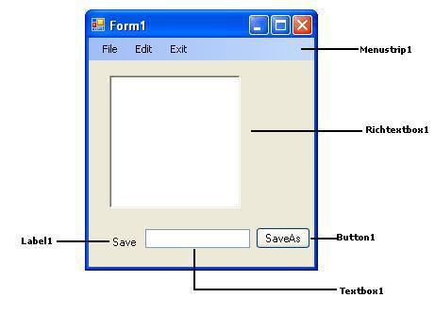

**RESULT:- Thus we have created a windows application to convert the case of the given character.**



***Littleflower* Polytechnic College** **Page 6**

**Component based technology practical**

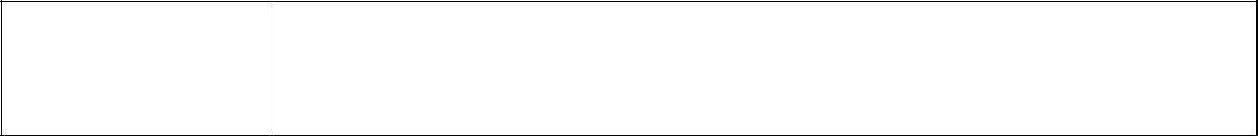

**EX.NO : 5**

**IMPLEMENTING A CALCULATOR**

**DATE:**

**AIM:-** To write a C# program to implement a calculator with memory and recall operations.

**PROCEDURE:-**

1. Open Microsoft Visual studio and create a new Windows application .
2. Include a textbox and 18 buttons in the form.
3. Edit the following code inside the public partial class **form1** before all the sub functions

**double a,**

**m,result; char op;**

1. Edit the following code in click event of the **cancel** button **textBox1.Clear();**
2. Edit the following code in click event of the **memory** button **m =** **Convert.ToInt32(textBox1.Text);** **textBox1.Clear();**
3. Edit the following code in click event of the **recall** button **textBox1.Text = m.ToString();**
4. Edit the following code in click event of **1 button** **textBox1.AppendText("1");**
5. Edit the following code in click event of **2 button** **textBox1.AppendText("2");**
6. Similarly edit the corresponding code for **3,4,5,6,7,8,9** and **0 buttons**
7. Edit the following code in click event of **+ button**

**a = Convert.ToDouble(textBox1.Text);**

**op = '+';**

**textBox1.Clear();**

1. Edit the following code in click event of **- button** **a = Convert.ToDouble(textBox1.Text); op = "-"**

**textBox1.Clear()**

1. Edit the following code in click event of **\* button** **a = Convert.ToDouble(textBox1.Text); op = "*"**

**textBox1.Clear()**

1. Edit the following code in click event of **/ button.** **a = Convert.ToDouble(textBox1.Text); op = "/"**

**textBox1.Clear()**

1. Edit the following code in click event of **= button**. **switch(op)**

**{**

**case '+':**

**{**

**result = a+Convert.ToInt32(textBox1.Text );**

**textBox1.Text = Convert.ToString(result);**

**break;**

**}**

**case '-':**

**{**

**result = a - Convert.ToInt32(textBox1.Text);**



***Littleflower* Polytechnic College** **Page 7**

**Component based technology practical**



**textBox1.Text = Convert.ToString(result);**

**break;**

**}**

**case '*':**

**{**

**result = a * Convert.ToInt32(textBox1.Text);**

**textBox1.Text = Convert.ToString(result);**

**break;**

**}**

**case '/':**

**{**

**result = a / Convert.ToInt32(textBox1.Text);**

**textBox1.Text = Convert.ToString(result);**

**break;**

**}**

**}**

12. Run the application

| **Form design:** | **Output:** |
| --- | --- |
|  |  |

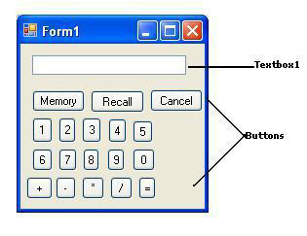

**RESULT:- Thus we have created a windows application to implement a calculator.**



***Littleflower* Polytechnic College** **Page 8**

**Component based technology practical**

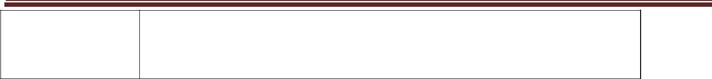

**EX.NO : 6**

**DISPLAYING DATE USING CALENDAR CONTROL**

**DATE:**

**AIM:-**

**To develop a form in C# .net to pick a date from calendar control and display the day, month, year details in separate text boxes.**

**PROCEDURE:-**

1. Open Microsoft visual studio and create a new windows application.
2. Drag a DateTimePicker control and a button from the toolbox.
3. Double click on the form and type the following code.

**private void Form1_Load (object sender, EventArgs e)**

**{**

**textBox1.Text = Convert.ToString (dateTimePicker1.Value.Day); textBox2.Text = Convert.ToString(dateTimePicker1.Value.Month); textBox3.Text = Convert.ToString(dateTimePicker1.Value.Year);**

**}**

1. Double click on the button and type the following code:

**private void dateTimePicker1_ValueChanged(object sender, EventArgs e)**

**{**

**textBox1.Text = Convert.ToString(dateTimePicker1.Value.Day); textBox2.Text = Convert.ToString(dateTimePicker1.Value.Month); textBox3.Text = Convert.ToString(dateTimePicker1.Value.Year);**

**}**

| **Form Design** | **Output** |
| --- | --- |
|  |  |

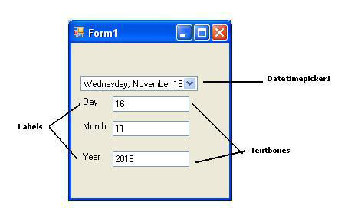

**RESULT:- Thus we have created a C# windows application to implement a DateTime Picker.**



***Littleflower* Polytechnic College** **Page 9**

**Component based technology practical**



**EX.NO : 7**

**TIMER BASED QUIZ**

**DATE:**

**AIM:-** **To develop a C# .net application to perform timer based quiz .**

**Procedure:**

1. Open Microsoft Visual studio and create a new window application.
2. Add a label, group box, 3 radio buttons, timer and a button in the form.

Edit the following code inside the **class Form1** before all the sub functions.

Dim Quest(4, 3), Ans(4, 1) As String

Dim i As Integer = -1

3. Edit the following code in the load event of **Form1.**

Quest(0, 0) = "In whick year India won the criket world cup?"

Quest(0, 1) = "1973"

Quest(0, 2) = "1983"

Quest(0, 3) = "1987"

Quest(1, 0) = "Scanner is a _____________ device"

Quest(1, 1) = "Input"

Quest(1, 2) = "Output"

Quest(1, 3) = "I/O"

Quest(2, 0) = "Which one of the following is a browser?"

Quest(2, 1) = "Visual Basic"

Quest(2, 2) = "Java"

Quest(2, 3) = "InternetExplorer"

Quest(3, 0) = "____________ is the desciple of Jesus came to India?"

Quest(3, 1) = "Thomas"

Quest(3, 2) = "Andrew"

Quest(3, 3) = "Philip"

Quest(4, 0) = "Tsunami hit India on ____________"

Quest(4, 1) = "24-12-2006"

Quest(4, 2) = "26-12-2004"

Quest(4, 3) = "26-12-2006"

Ans(0, 0) = "1983"

Ans(1, 0) = "Input"

Ans(2, 0) = "InternetExplorer"

Ans(3, 0) = "Thomas"

Ans(4, 0) = "26-12-2004"

Timer1.Enabled = True

Button1.Enabled = False

1. Edit the following code in Tick event of **Timer1**

i = i + 1

If (i = 5) Then

Timer1.Enabled = False

Button1.Enabled = True

Else

RadioButton1.Checked = False

RadioButton2.Checked = False



***Littleflower* Polytechnic College** **Page 10**

**Component based technology practical**



RadioButton3.Checked = False

TextBox1.Text = Quest(i, 0)

RadioButton1.Text = Quest(i, 1)

RadioButton2.Text = Quest(i, 2)

RadioButton3.Text = Quest(i, 3)

End If

5. Edit the following code in the CheckedChanged event of Ans(i, 1) = RadioButton1.Text

**RadioButton1.**

* 1. Edit the following code in the CheckedChanged event of **RadioButton2**. Ans(i, 1) = RadioButton2.Text
  2. Edit the following code in the CheckedChanged event of **RadioButton3.** Ans(i, 1) = RadioButton3.Text

1. Edit the following code in the Click event of the **Button1.**

Dim j As Integer

Dim count As Integer = 0

For j = 0 To 4

If (Ans(j, 0) = Ans(j, 1)) Then

count += 1

End If

Next

MsgBox("You have scored " & count & "marks")

1. Run the Application.

| **Form design:** | **Output:** |
| --- | --- |
|  |  |

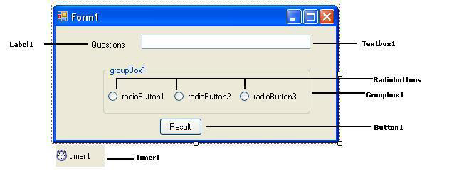

**RESULT:- Thus we have created a C# application for a timer based quiz program.**



***Littleflower* Polytechnic College** **Page 11**

**Component based technology practical**



**EX.NO : 8**

**IMPLEMENTING A COMMON DIALOG BOX**

**DATE:**

**Aim:** To develop a C#.Net application using the File and Directory controls to implement acommon dialog box.

**Procedure:**

1. Open Microsoft Visual Studio and create a new Windows Application.
2. Create a windows form and drag a Openfiledialog and Folderbrowserdialog and 2 buttons into the form.
3. Double click on the **Button1** and type the following code.

**OpenFileDialog dlg = new OpenFileDialog();**

**dlg.ShowDialog();**

**if (dlg.ShowDialog() == DialogResult.OK)**

**{**

**string fileName;**

**fileName = dlg.FileName;**

**textBox1.Text =fileName;**

**}**

1. Double click on **Button2** and type the following code.

**FolderBrowserDialog dlg = new**

**FolderBrowserDialog(); dlg.ShowDialog();**

**if (dlg.ShowDialog() == DialogResult.OK)**

**{**

**string folderName;**

**folderName = dlg.SelectedPath;**

**textBox1.Text = folderName;**

**}**

5. Run the Application.

| **Form Design:** | **Output:** |
| --- | --- |
|  |  |

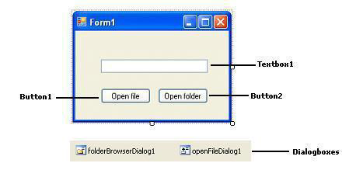

**RESULT:- Thus we have created a C# windows application to implement a common dialog box.**



***Littleflower* Polytechnic College** **Page 12**

**Component based technology practical**



**EX.NO : 9**

**CREATING A DATABASE APPLICATION USING ADO .NET**

**DATE:**

**Aim:** To develop a database application to store the details of students using ADO.NET.

**Procedure:**

1. Create a table stud in a SQL server database student.(Using SQL Query Analyzer)

**Create table stud(regno varchar(10),Sname varchar(10),dept varchar(15));**

1. Open Microsoft Visual studio and create a new windows application.
2. Add 3 labels, 3 textboxes and a button into the form.

Edit the following line at the top of the coding before any other code. **using System.Data.SqlClient;**

1. Edit the following code inside the **class form** before all the sub functions.

**SqlConnection con=new SqlConnection();**

**SqlCommand com=new SqlCommand();**

1. Edit the following code in the load event of ex9 **Form1**. **con.ConnectionString = "Data source=cc1sys22;Integrated**

**security=true;Database=pubs";**

**com.Connection = con;**

**con.Open();**

1. Edit the following code in the click event of the **Button1**. **private void button1_Click(object sender, EventArgs e)**

**{**

**if (textBox1.Text =="" || textBox2 .Text =="" || textBox3 .Text =="")**

**{**

**MessageBox.Show("Please fill all the details");**

**}**

**else**

**{**

**com.CommandText = "insert into stud values('" + textBox1.Text + "','" + textBox2.Text + "','" + textBox3.Text + "')";**

**com.ExecuteNonQuery();**

**MessageBox.Show("1 record is inserted");**

**textBox1.Clear()**

**textBox2.Clear()**

**textBox3.Clear()**

}

}

7.Run the Application.



***Littleflower* Polytechnic College** **Page 13**

**Component based technology practical**



| **Form design:** | **Output :** |
| --- | --- |
|  |  |

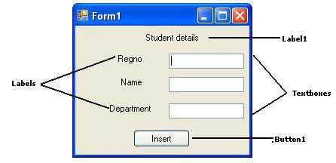

**RESULT: Thus we have created an ADO .Net application using C# .Net to insert a record into the database.**



***Littleflower* Polytechnic College** **Page 14**

**Component based technology practical**



| **EX.NO : 10** | **DATABASE APPLICATION TO INSERT AND MODIFY DATA** |
| --- | --- |
|  |
| **DATE:** | **USING ADO .NET** |
|  |
|  |  |

**Aim:** To develop a database application using ADO.NET with insert, delete and updateapplications.

**Procedure:**

1. Create a table stud in a SQL server database student. (Using SQL Query Analyzer)

**Create table stud(regno varchar(10),Sname varchar(10),dept varchar(15));**

1. Open Microsoft Visual studio and create a new Windows Applications.
2. Add a combobox, 2 textboxes and 4 buttons in the form.
3. Edit the following line at the top of the coding before any other code.

**Imports System.Data.SqlClient**

1. Edit the following code inside the **class Form1** before all the sub functions.

**SqlConnection con = new SqlConnection();**

**SqlCommand com = new SqlCommand();**

**SqlDataReader dr, dr1,dr2;**

1. Edit the following code in the Load event of **Form1**

**con.ConnectionString = "Data source=cc1sys22; Integrated security=true;Database=pubs"; com.Connection = con;**

**con.Open();**

**com.CommandText = "select * from pubs";**

**dr = com.ExecuteReader();**

**while(dr.Read())**

**{**

**comboBox1.Items.Add(dr.GetString(0));**

**}**

**dr.Close();**

1. Edit the following code in the click event of the **Button1.**

**textBox2.Clear();**

**textBox3.Clear()**

**com.CommandText = "insert into pubs values('" + comboBox1.Text + "','" + textBox2.Text**

* + **"','" + textBox3.Text + "')"; com.ExecuteNonQuery(); MessageBox.Show("1 record is inserted");**

1. Edit the following code in the click event of the **Button2.**

**com.CommandText = "select * from pubs where regno='" + comboBox1.SelectedItem + "'"; dr = com.ExecuteReader();**

**if (dr.Read())**

**{**

**textBox2.Text = dr.GetString(1);**

**textBox3.Text = dr.GetString(2);**

**}**

**dr.Close();**

1. Edit the following code in the click event of the **Button3.**

**com.CommandText = "update pubs set sname='"+textBox2.Text+"',dept='"+textBox3.Text+"' where regno='" + comboBox1.SelectedItem + "'";**

**dr1 = com.ExecuteReader();**

**MessageBox.Show("1 Record updated");**

**dr1.Close();**



***Littleflower* Polytechnic College** **Page 15**

**Component based technology practical**



1. Edit the following code in the click event of **Button4.**

**com.CommandText = "delete pubs where regno='" + comboBox1.Text + "'"; dr2 = com.ExecuteReader();**

**MessageBox.Show("1 Record deleted"); comboBox1.Items.Remove(comboBox1.SelectedItem); textBox2.Clear();**

**textBox3.Clear();**

**dr2.Close();**

1. **Run the Application.**

| **Form Design:** | **Output:** |
| --- | --- |
|  |  |

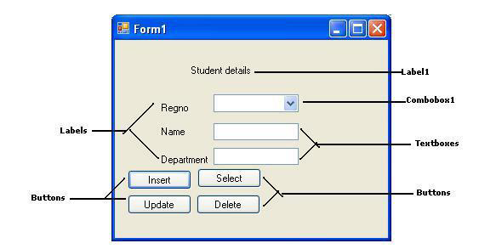

**RESULT: Thus we have created an ADO.Net application using C# .Net to insert, update and delete the records from the table.**



***Littleflower* Polytechnic College** **Page 16**

**Component based technology practical**



| **EX.NO : 11** | **DATABASE APPLICATION TO DISPLAY DATA USING** |
| --- | --- |
|  |
| **DATE:** | **DATAGRID** |
|  |
|  |  |

**AIM:-**

**To Develop a C# .NET application using datagrid to display records.**

**PROCEDURE:-**

1. Open the C# Windows application Project and add a form to it.
2. Open the Tool Box, Click the DataGridView tool and place it on the Form by dragging the mouse.
3. Add a datasource for the project and choose the datasource type as **database.**
4. Select the data connections and database object as the table.
5. Run the application. The records will be displayed in the Datagridview.

| **Form design:** | **Output:** |
| --- | --- |
|  |  |

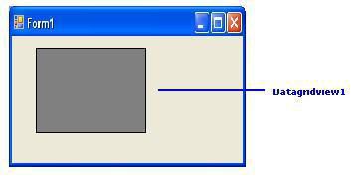

**RESULT:-Thus we have created an ADO .Net application using C# .Net to display the data in the datagrid view.**

|  |  |  |  |
| --- | --- | --- | --- |
|  |  |  |  |
|  | **EX.NO : 2** | **DEVELOP A WINDOWS APPLICATION TO READ AN XML** |  |
|  |  |  |
|  | **DATE:** | **DOCUMENT INTO A DATASET** |  |
|  |  |  |  |

**AIM**: To create an application for accessing the details from XML document containing subject,mark scored and year of passing into a DataSet.

**Procedure:**

1. Create a windows application in C#.Net.
2. Drag the Datagrid view control and a button into the form.
3. Create an XML file with the following code and save the file as mark.xml

**<?xml version=”1.0”?>**

**<students>**

**<student>**

**<subject> JAVA </subject>**

**<mark> 98 </mark> <year>**

**2012 </year>**

**</student>**

**<student>**

**<subject> ASP .NET </subject>**

**<mark> 100 </mark> <year>**

**2013 </year>**

**</student>**

**<student>**

**<subject> C++ </subject>**

**<mark> 97 </mark>**

**<year> 2012 </year>**

**</student>**

**</students>**

4. Create a windows application using C# .net and design a form with a Datagridview and a button.

Include the namespace at the beginning of the program.

**using System.Data.SqlClient;**

5.Type the following code under **public class Form1**

**DataSet ds=new DataSet();**

1. Type the following code in the click event of Button1 **private void button1_Click(object sender, EventArgs e)**

{

**ds.ReadXml("d:/student.xml");**

**dataGridView1.DataMember = "student";**

**dataGridView1.DataSource = ds;**

}

6.Run the application.



***Littleflower* Polytechnic College** **Page 21**

**Component based technology practical**



| **Form design:** | **Output:** |
| --- | --- |
|  |  |

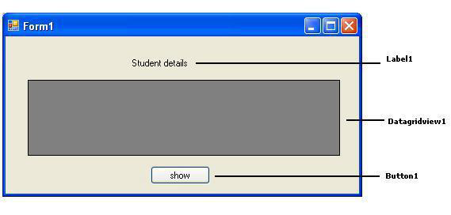

**Result: Thus we have created a windows application to read an XML document into the dataset.**



***Littleflower* Polytechnic College** **Page 22**

**Component based technology practical**



| **EX.NO : 3** | **DEVELOP A WINDOWS APPLICATION TO READ AN XML DOCUMENT** |
| --- | --- |
|  |
| **DATE:** | **INTO A DATASET** |
|  |  |

**AIM**:Develop a Window application to read an XML document containing employeename,code,Basic pay, HRA, DA into a Dataset

**PROCEDURE:**

1. Create a windows application using C#.Net
2. Drag the Datagrid view control and a button into the form.
3. Create an XML file with the following code and save the file as employee.xml

**<?xml version="1.0"?>**

**<employees>**

**<employee>**

**<code> E101 </code>**

**<name> ASHOK </name>**

**<basicpay> 12000 </basicpay>**

**<hra> 1500 </hra>**

**<da> 8000 </da>**

**</employee>**

**<employee>**

**<code> E102 </code>**

**<name> BALA </name>**

**<basicpay> 15000 </basicpay>**

**<hra> 2000 </hra>**

**<da> 9000 </da>**

**</employee>**

**</employees>**

4. Create a windows application using C# .net and design a form with a Datagridview and a button.

Include the namespace at the beginning of the program.

**using System.Data.SqlClient;**

5.Type the following code under **public class Form1**

**DataSet ds=new DataSet();**

1. Type the following code in the click event of Button1 **private void button1_Click(object sender, EventArgs e)**

{

**ds.ReadXml("d:/employee.xml");**

**dataGridView1.DataMember = "employee";**

**dataGridView1.DataSource = ds;**

**}**

6.Run the application.



***Littleflower* Polytechnic College** **Page 23**

**Component based technology practical**



| **Form design:** | **Output:** |
| --- | --- |
|  |  |

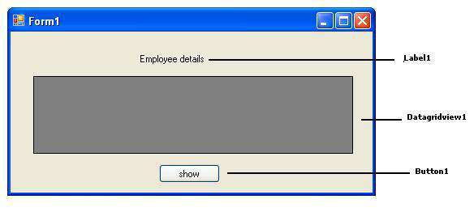

**Result: Thus we have created a windows application using C# .Net to read the XML document into the Dataset.**



***Littleflower* Polytechnic College** **Page 24**

**Component based technology practical**



| **EX.NO : 4** |  |
| --- | --- |
|  | **DEVELOP A WINDOW APPLICATION TO READ THE DATABASE AND GENERATE** |
| **DATE:** | **XML DOCUMENT.** |
|  |  |

**AIM: To develop a windows application to read employee records from database and generate XML document containing Employee records.**

**PROCEDURE:**

1. Create an employee table in Microsoft SQL Server

CREATE TABLE EMPL(EMPCODE VARCHAR(10),ENAME VARCHAR(20),DEPT VARCHAR(20))

* 1. Create a windows application and drag a label and a button into the form.

1. Include the namespaces at the beginning of the program.

**using System.Data.SqlClient ;**

**using System.Xml;**

1. Double click on the button and type the following code:

**private void button1_Click(object sender, EventArgs e)**

**{**

**SqlConnection con = new SqlConnection("Data Source=cc1sys22; Integrated security=true;Database=pubs");**

**string str = "select * from employee";**

**SqlDataAdapter da = new SqlDataAdapter(str,con); DataSet ds = new DataSet();**

**da.Fill**

**(ds,"employee");**

**ds.WriteXml("d:/employee.xml");**

**MessageBox.Show("xml file created");**

**}**

| **Form design:** | **Output:** |
| --- | --- |
|  |  |

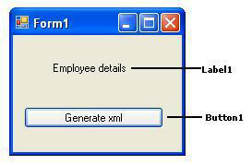

**Result: Thus we have developed a windows application to generate an XML document from the database containing the Employee records.**