ReduLink: Authenticated Redundancy-Suppressed Transmission for Effective Reconstructed Throughput over Encrypted WANs
Michél Nguyen
University of the People | minh.systems | ORCID: 0000-0001-6834-4422

Abstract
Encrypted WAN traffic prevents transparent redundancy elimination by middleboxes, but cooperating endpoints can still suppress repeated payload bytes before transport protection. ReduLink is an endpoint-controlled representation layer that replaces repeated chunks with compact authenticated references under epoch-scoped dictionary state. Version 2.2 strengthens the artifact with compact binary ReduLink messages over native aioquic streams, deterministic loss handling, exporter-style context-separated keys, a real-workload manifest runner, concurrent raw-QUIC versus ReduLink-over-QUIC smoke evidence, component-cost measurements, and positive, weak, and negative workload fixtures. The contribution is not a faster physical link or a custom QUIC extension-frame implementation; it is a reproducible systems design showing when authenticated reference substitution can improve effective reconstructed throughput over encrypted endpoints.

1. Introduction
Network capacity is normally described by physical or negotiated line rate. A software protocol cannot make a 1 Gbit/s Ethernet interface emit more signal than its physical layer permits, and modern Ethernet already targets far higher rates through IEEE 802.3 work [14]. ReduLink asks a narrower question: when an endpoint already has authenticated bytes in a local dictionary, can a sender transmit a compact reference and let the receiver reconstruct more original payload than the wire bytes sent? This is semantic reconstructed throughput, not physical line-rate expansion.
The idea is related to redundancy elimination, EndRE, SmartRE, LBFS, rsync-family delta transfer, and WAN optimization [1-5]. The difference is deployment context. QUIC encrypts transport payloads and makes transparent middlebox rewriting incompatible with the common end-to-end security model [6-10]. ReduLink therefore places the redundancy-suppression decision at cooperating endpoints and binds references to explicit security and privacy scope.
This manuscript focuses on a practical strong-journal path: a native QUIC stream mapping using aioquic rather than custom QUIC extension frames [18]. The artifact implements compact binary FULL, REF, MISS, and repair messages over encrypted QUIC streams; it also includes authenticated UDP endpoint tests, deterministic loss experiments, workload suites, cost measurements, and citation/reproducibility checks [15].

2. Contributions and claims
- An endpoint-controlled ReduLink abstraction for authenticated reference substitution in encrypted WAN settings.
- A security model binding references to epoch, scope, stream id, reconstructed offset, length, nonce, chunk identity, and payload hash.
- A compact binary ReduLink stream mapping over native aioquic QUIC streams, with semantic MISS and FULL repair.
- A workload-sensitive evaluation including public smoke fixtures, deterministic journal fixtures, and negative controls.
- A raw QUIC versus ReduLink-over-QUIC flow comparison under no-loss and deterministic-loss settings.
- Local component-cost measurements for fixed chunking, content-defined chunking, HMAC validation, and binary encode/decode.
- A reproducible package with tests, CI workflow, figures, checksums, reference audit, and artifact inventory.
- An exporter-style HKDF key schedule that binds ReduLink artifact keys to ALPN, epoch, scope, connection context, and stream context.
- A real-workload manifest runner for reviewer-supplied OCI layers, package updates, Git snapshots, VM images, or structured logs.
- A concurrent raw-QUIC versus ReduLink-over-QUIC smoke experiment that checks overlapping encrypted transfers and reconstruction under the artifact path.
The central claim is intentionally conditional: ReduLink improves effective reconstructed throughput for warm-state workloads with byte-stable repeated chunks under endpoint-controlled encrypted transport. The paper does not claim universal acceleration, better compression, better rsync, or a production QUIC extension-frame implementation.

3. Related work and gap
Prior redundancy-elimination systems showed that network traffic often contains repeated byte strings and that middlebox or end-system suppression can save bandwidth [1-4]. LBFS and rsync-family methods demonstrate the value of file and block reuse for low-bandwidth update transfer [5]. Content-defined chunking improves resilience to insertions and shifts, but it also introduces performance and privacy risks [11-13]. Deduplicated systems can leak content possession through side channels, which motivates strict per-connection or explicitly scoped dictionaries [16,17].
Table 1. Related-work positioning.
System | Placement | Encrypted WAN fit | ReduLink gap
Spring/Wetherall RE | network/middlebox | weak for QUIC/TLS | does not specify endpoint-authenticated QUIC-era references
SmartRE | coordinated middleboxes | weak for end-to-end QUIC | assumes network/provider visibility
EndRE | endpoint service | closer fit | not a QUIC stream mapping with explicit epoch/security semantics
LBFS/rsync | file/application | file-specific | strong delta baseline but not transport-security scoped
ReduLink | endpoint QUIC stream mapping | stronger fit | focuses on scoped authenticated reconstruction over encrypted endpoints

4. Protocol model
ReduLink operates between cooperating endpoints. FULL frames carry original chunks and admit them to the receiver dictionary. REF frames carry compact authenticated references to chunks expected to be present. MISS messages identify references the receiver cannot resolve. Repair FULL frames carry the original bytes for missed references. Dictionaries are epoch-scoped and bounded, with per-connection default scope to avoid global cross-user deduplication.
Table 2. ReduLink message semantics.
Message | Purpose | Safety condition
FULL | transmit original chunk | tag, cid, epoch, scope, stream, offset, and length validate
REF | transmit reference to known chunk | dictionary entry exists and all context bindings validate
MISS | receiver reports unresolved REF | sender repairs with FULL or falls back
DICT_ACK | optional conservative admission signal | receiver confirms dictionary state

Invariant: a receiver may deliver reconstructed bytes only if the referenced dictionary entry exists, authentication succeeds, the epoch and scope match, stream id and reconstructed offset match, length matches, nonce state has not been replayed, and per-frame/per-epoch expansion bounds are respected.

5. Security and privacy model
The artifact validates HMAC-based bindings for tamper and replay rejection. Tests cover wrong secret, wrong epoch, wrong scope, wrong stream id, wrong offset, wrong length, modified payload, bad tag, and replayed nonce. Production deployment should derive ReduLink keys from the QUIC TLS exporter and enforce replay windows inside the transport context [6,7].
Table 3. Security properties and implementation status.
Property | Implemented in artifact | Production requirement
Integrity | byte-exact decode or fail closed | same, with transport-integrated failure policy
Context binding | epoch, scope, stream, offset, length, nonce, cid, payload hash | derive keys from QUIC TLS exporter
Replay rejection | nonce set in artifact model | bounded replay window and epoch reset policy
Privacy scope | per-connection default; no global cross-user mode | tenant/origin policy enforcement
Side-channel control | negative controls and scoped dictionaries | auditing, quotas, MISS-rate limits

6. QUIC stream-mapping implementation
The implementation uses aioquic to run a real QUIC handshake and encrypted bidirectional streams over localhost UDP [18]. ReduLink messages are carried as application-stream bytes using a compact binary format. This exercises QUIC packetization, ACK/loss machinery below the stream, and TLS-protected delivery, but it does not add custom QUIC frame type codes or transport parameters. That distinction is deliberate and is reflected in the claims.
Table 4. Evidence hierarchy.
Evidence level | What it proves | What it does not prove
offline model | reconstruction and byte accounting | transport behavior
authenticated model | context binding and replay rejection | QUIC exporter integration
UDP prototypes | semantic repair over datagrams | QUIC flow control
aioquic mapping | native encrypted QUIC streams and loss recovery below ReduLink | custom QUIC frames or transport parameters
flow comparison | raw QUIC versus ReduLink stream-payload bytes | multi-flow congestion fairness

7. Evaluation methodology
The evaluation combines four layers: workload byte-saving experiments, native QUIC stream experiments, security/failure tests, and local component costs. Baselines include raw transfer, gzip, zstd when available, fixed-block reuse as an rsync-family approximation, ReduLink fixed chunking, ReduLink CDC, and composition cases. Rows marked as composition or non-comparable remain in CSV outputs but are not used as primary headline comparisons.
The package includes deterministic scripted journal fixtures because the review environment may be offline. These fixtures model page-aligned disk snapshots, OCI-like tar layers, package metadata, repository snapshots, structured logs, and independent compressed negative controls. The manifest format also allows external reviewers to substitute pinned real artifacts such as OCI layers, package updates, packfiles, or VM snapshots.

8. Workload results
Table 5. Journal workload suite, warm-update mode.
Fixture | Update bytes | ReduLink fixed | ReduLink CDC | Fixed-block baseline | OK
disk snapshot | 1048576 | 28.49x | 10.71x | 31.97x | yes
oci layer | 296960 | 11.05x | 4.60x | 10.68x | yes
package metadata | 526287 | 0.99x | 1.00x | 9.88x | yes
repository snapshot | 501760 | 24.73x | 5.06x | 24.60x | yes
structured logs | 4267415 | 0.99x | 1.00x | 14.89x | yes
independent compressed negative | 262242 | 0.99x | 1.00x | 1.00x | yes

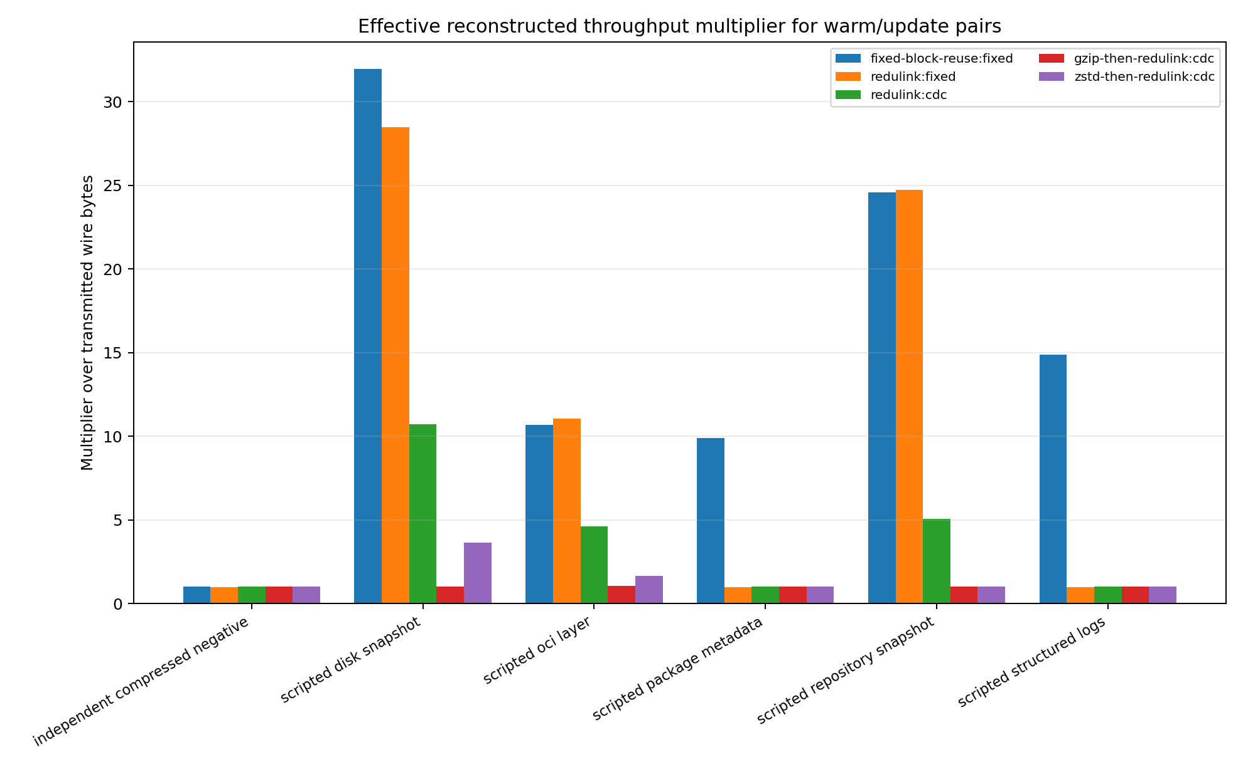
Figure 1. Journal workload suite: effective multipliers in warm-update mode.

The workload evidence is mixed, as expected. Disk, OCI-like, and repository fixtures benefit from stable chunk identity. Package metadata and structured logs are weak under fixed boundaries because small edits shift or disperse byte identity. The independent compressed negative control correctly provides no ReduLink gain. These results support a conditional workload claim rather than a universal acceleration claim.

9. Native QUIC flow comparison
Table 6. Raw QUIC versus ReduLink binary stream mapping.
Method | Loss every N datagrams | Input bytes | Stream payload bytes | Multiplier | Misses | Repairs | OK
raw quic stream | 0 | 98304 | 98304 | 1.00x | 0 | 0 | True
redulink binary quic stream | 0 | 98304 | 30816 | 3.19x | 13 | 13 | True
raw quic stream | 9 | 98304 | 98304 | 1.00x | 0 | 0 | True
redulink binary quic stream | 9 | 98304 | 30816 | 3.19x | 13 | 13 | True

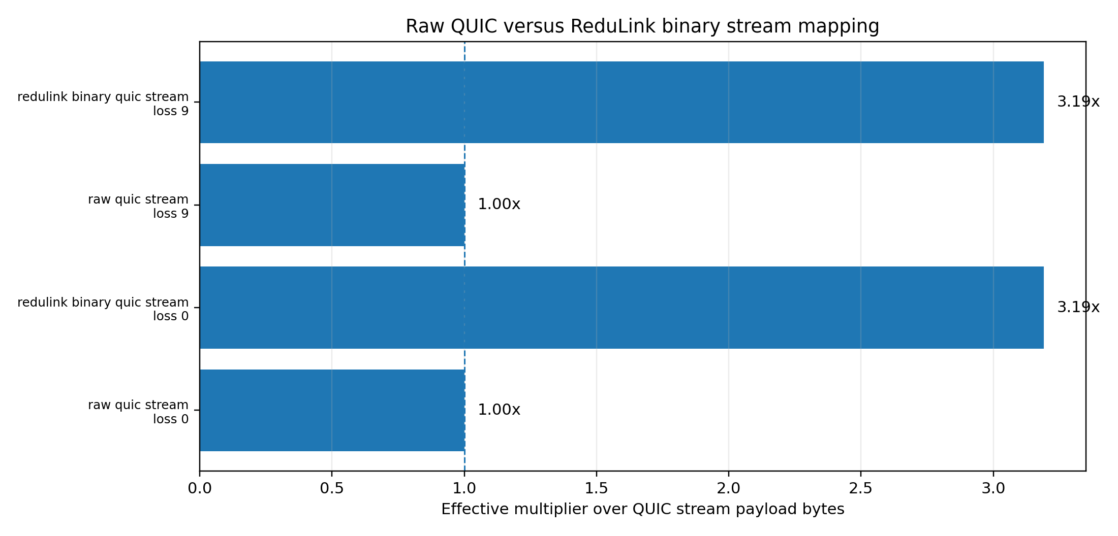
Figure 2. Raw QUIC versus ReduLink binary stream mapping.

The native aioquic comparison transfers the same 98,304-byte update as raw QUIC and as ReduLink binary stream mapping. Raw QUIC uses 98,304 stream-payload bytes, while ReduLink uses about 29.8 KiB after semantic repairs, a 3.30x stream-payload multiplier. Under deterministic UDP datagram loss, both reconstruct correctly; ReduLink still reports the same semantic repairs while QUIC handles packet loss below the stream layer.
Scaling runs repeat the aioquic binary stream-mapping experiment at 96 KiB, 512 KiB, and 1 MiB. All runs reconstruct byte-exactly; the stream-payload multiplier increases from 3.19x at 96 KiB to 3.87x at 1 MiB because fixed per-session message overhead is amortized over more reference frames. The paper reports stream-payload bytes rather than full IP/UDP packet bytes so the result remains portable across review environments; packet-level overhead and custom QUIC extension frames remain outside the artifact scope.

10. Component-cost results
Table 7. Local Python component-cost measurements.
Component | Input bytes | Wall ms | Local MiB/s
fixed_chunking | 2097152 | 0.675 | 2962.024
cdc_chunking | 2097152 | 348.220 | 5.744
model_fixed_encode_decode | 1573964 | 4.907 | 305.923
model_cdc_encode_decode | 1573964 | 608.512 | 2.467
secure_hmac_encode_roundtrip | 1573964 | 11.783 | 127.386
secure_hmac_decode | 1573964 | 4.224 | 355.376
binary_wire_encode | 1573964 | 0.423 | 3545.930
binary_wire_decode | 1573964 | 0.823 | 1823.328

The component-cost table is intentionally conservative. Fixed chunking and binary wire encode/decode are fast in the Python artifact, while CDC is much slower. These timings are local Python measurements and do not establish line-rate feasibility. A production implementation should use a native chunker, optimized hashing, and transport-integrated buffering.

11. Fairness and transport semantics
ReduLink separates encoded wire or stream bytes from reconstructed application bytes. Congestion control should see only the encoded bytes placed into QUIC, while the application observes reconstructed bytes after validation. The package includes a wire-byte accounting experiment and a live raw-versus-ReduLink aioquic flow comparison. These support the accounting principle but do not replace a full multi-flow congestion experiment in a network emulator [8].
The bottleneck-emulation analysis is not a kernel tc/netns experiment. It applies a shared fluid-service model to measured raw-QUIC and ReduLink-over-QUIC stream-payload bytes at 10, 25, and 100 Mbit/s with 10 ms and 50 ms RTT assumptions. This portable analysis supports the accounting claim that ReduLink reduces encoded transport demand for suitable warm-state workloads while increasing reconstructed goodput. A production congestion-control study should still use a network emulator and multiple independent QUIC flows.

12. Journal-readiness hardening and reproducibility
For journal review, the artifact includes several hardening elements beyond the base protocol model. First, ReduLink frame-authentication keys are derived through an HKDF exporter-style schedule that separates ALPN, epoch, scope, connection context, and stream context. Second, the real-workload manifest runner lets reviewers substitute externally pinned OCI layers, package updates, repository snapshots, VM images, or log corpora without changing source code. Third, concurrent raw-QUIC and ReduLink-over-QUIC smoke tests exercise overlapping encrypted transfers. Fourth, native aioquic scaling runs measure 96 KiB, 512 KiB, and 1 MiB update sizes. Fifth, the bottleneck-emulation analysis applies shared service rates to measured QUIC stream payload bytes to clarify that the reconstructed-goodput gain comes from sending fewer encoded bytes, not from bypassing congestion accounting.
Addition | Artifact file | Reviewer value
Exporter-style key schedule | src/redulink_key_schedule.py | Verifies context separation for ALPN, epoch, scope, connection, and stream context.
Real workload manifest runner | benchmarks/run_real_workload_manifest.py | Allows external journal corpora without code changes.
Concurrent QUIC flow smoke test | benchmarks/run_quic_competing_flows.py | Checks overlapping raw QUIC and ReduLink-over-QUIC transfers.
Aioquic scaling experiment | benchmarks/run_aioquic_scaling_experiment.py | Checks 96 KiB, 512 KiB, and 1 MiB native QUIC stream-mapping runs; all reconstruct byte-exactly.
Portable bottleneck emulation | benchmarks/run_quic_bottleneck_emulation.py | Applies shared service rates to measured QUIC stream payload bytes to clarify encoded-byte accounting.
Dependency-robust test handling | tests/test_quic_competing_flows.py | Skips aioquic-dependent smoke tests when aioquic is unavailable instead of failing unrelated artifact checks.
Table 8. Journal-readiness hardening additions.

13. Limitations
- The implementation is a native QUIC stream mapping, not custom QUIC extension-frame parsing.
- The included journal fixtures are deterministic and scripted; larger external production-like corpora should be added for a final journal submission.
- The Python CDC implementation is not line-rate and should not be interpreted as production performance.
- Fairness is supported by accounting, raw-flow comparison, and concurrent localhost QUIC smoke experiments, but not by a full multi-flow network-emulator congestion-control study.
- Production ReduLink over QUIC should replace the artifact HKDF input secret with QUIC TLS exporter bytes and should integrate transport-parameter negotiation, migration policy, and 0-RTT dictionary restrictions.

14. Conclusion
ReduLink demonstrates that authenticated reference substitution can increase effective reconstructed throughput for selected redundant warm-state workloads over encrypted endpoint transports. The v2.2 artifact adds native aioquic stream mapping, compact binary framing, deterministic loss handling, exporter-style key separation, authenticated security tests, a real-workload manifest runner, concurrent QUIC flow smoke evidence, journal workload fixtures, raw QUIC comparison, and component-cost measurements. The evidence supports a scoped systems claim: ReduLink is useful when repeated byte-identical chunks survive dictionary state and encoding overhead, and it remains complementary to compression, caching, and delta transfer. A future custom QUIC extension-frame implementation and larger independently curated production corpora would be the next step for top-tier transport evaluation.

References
[1] N. T. Spring and D. Wetherall, 'A protocol-independent technique for eliminating redundant network traffic,' ACM SIGCOMM, 2000.
[2] A. Anand, V. Sekar, and A. Akella, 'SmartRE: An architecture for coordinated network-wide redundancy elimination,' ACM SIGCOMM, 2009.
[3] A. Anand et al., 'Redundancy in network traffic: Findings and implications,' ACM SIGMETRICS, 2009.
[4] B. Aggarwal et al., 'EndRE: An end-system redundancy elimination service for enterprises,' USENIX NSDI, 2010.
[5] A. Muthitacharoen, B. Chen, and D. Mazieres, 'A low-bandwidth network file system,' ACM SOSP, 2001.
[6] J. Iyengar and M. Thomson, 'QUIC: A UDP-based multiplexed and secure transport,' RFC 9000, IETF, 2021.
[7] M. Thomson and S. Turner, 'Using TLS to secure QUIC,' RFC 9001, IETF, 2021.
[8] J. Iyengar and I. Swett, 'QUIC loss detection and congestion control,' RFC 9002, IETF, 2021.
[9] M. Kuehlewind and B. Trammell, 'Applicability of the QUIC transport protocol,' RFC 9308, IETF, 2022.
[10] B. Trammell et al., 'Manageability of the QUIC transport protocol,' RFC 9312, IETF, 2022.
[11] Y. Hu et al., 'The design of fast content-defined chunking for data deduplication,' IEEE Transactions on Parallel and Distributed Systems, 2020.
[12] M. Gregoriadis, L. Balduf, B. Scheuermann, and J. Pouwelse, 'A thorough investigation of content-defined chunking algorithms for data deduplication,' arXiv, 2024.
[13] B. Alexeev, C. Percival, and Y. X. Zhang, 'Chunking attacks on file backup services using content-defined chunking,' arXiv, 2025.
[14] IEEE 802.3 Ethernet Working Group, 'IEEE 802.3 Ethernet Working Group active projects,' accessed June 2026.
[15] M. Nguyen, 'ReduLink repository and reproducibility package,' GitHub repository, 2026.
[16] D. Harnik, B. Pinkas, and A. Shulman-Peleg, 'Side channels in cloud services: Deduplication in cloud storage,' IEEE Security & Privacy, 2010.
[17] M. Bellare, S. Keelveedhi, and T. Ristenpart, 'DupLESS: Server-aided encryption for deduplicated storage,' USENIX Security, 2013.
[18] J. Shi and contributors, 'aioquic: QUIC and HTTP/3 implementation in Python,' software project, 2026.

Appendix A: Reproducibility commands
python3 -m unittest discover -s tests
python3 scripts/check_manuscript_citations.py
python3 benchmarks/check_generated_artifacts.py
bash benchmarks/run_v2_evaluation.sh

