ReduLink: Authenticated Redundancy-Suppressed Transmission for Effective Bandwidth Expansion over Encrypted WANs
Michél Nguyen
Independent Researcher | minh.systems
Draft version 0.7 public-corpora, rsync baseline, and prototype revision, June 2026
Manuscript type: Protocol design, systems modeling, and security analysis

Abstract. Ethernet and wide-area transport protocols are typically evaluated by their physical or nominal line rate. However, many real traffic classes contain repeated objects, pages, layers, templates, or versioned artifacts. This paper proposes ReduLink, an authenticated redundancy-suppressed transmission method that increases effective reconstructed payload throughput without increasing the physical line rate. The protocol replaces repeated chunks with compact authenticated references bound to an epoch-scoped dictionary, while preserving fallback, replay protection, bounded expansion, and congestion fairness. A new reproducible simulator evaluates content-defined and record-aligned chunking over synthetic but controlled workload families. The results show negligible gains for compressed or random encrypted controls, moderate gains for generic endpoint-controlled WAN traffic, and large gains for controlled software-update, container, and VM-backup traffic when dictionaries are warm or repetitions occur within the stream. The contribution is therefore not a faster physical Ethernet layer, but a secure transport-adjacent mechanism for semantic bandwidth multiplication in cooperative encrypted environments.
Keywords: network redundancy elimination, QUIC, Ethernet, WAN optimization, content-defined chunking, authenticated references, effective throughput, congestion control, privacy-preserving deduplication

1. Introduction
The apparent capacity of a network link is usually expressed as a physical or negotiated line rate. A 1 Gbit/s Ethernet connection can place roughly one billion bits per second on the wire, and a 10 Gbit/s connection can place ten times as many. Modern Ethernet standards already extend far beyond these rates, including active IEEE 802.3 work on 200 Gbit/s, 400 Gbit/s, 800 Gbit/s, and 1.6 Tbit/s Ethernet. Therefore, a credible research contribution should not claim that a software protocol creates a physically faster Ethernet link.
This paper instead asks a different question: can a protocol increase the amount of original application payload reconstructed per second without changing the physical link rate? For workloads with repeated content, the answer is yes in principle. If a sender transmits a 64-byte authenticated reference instead of an 8 KiB repeated chunk, the receiver can reconstruct more payload than was placed on the wire. The link has not become physically faster. Rather, the wire now carries semantic references to previously authenticated bytes.
Network redundancy elimination and WAN optimization are established areas. Prior work showed that repeated byte strings occur in network traffic and that redundancy elimination can save substantial bandwidth in enterprise settings. However, the Internet has changed. Traffic is now predominantly encrypted, QUIC and TLS protect payloads from in-network modification, and middleboxes cannot safely inspect or rewrite encrypted byte streams. The opportunity is therefore not transparent network compression. The opportunity is endpoint-negotiated redundancy suppression that composes with encryption, congestion control, privacy, and loss recovery.
ReduLink is proposed as such a method. It can be instantiated as a QUIC extension, a VPN mode, a CDN-to-client feature, a data-center transport shim, or a SmartNIC-assisted link-layer service in trusted environments. Its central mechanism is simple: full chunks populate an epoch-scoped receiver dictionary, while later repetitions are encoded as authenticated reference frames. If a reference is missing, unverifiable, stale, or unsafe, the sender falls back to ordinary full-chunk transmission.

1.1 Research question
The research question is: How can a transport or link-adjacent protocol increase effective reconstructed payload throughput for redundant traffic while preserving end-to-end correctness, transport security, congestion fairness, and privacy?

1.2 Contributions
- A protocol abstraction for authenticated redundancy-suppressed transmission over encrypted WANs.
- An epoch-scoped dictionary model that avoids unsafe global cross-user deduplication.
- A concrete Deduplex-QUIC frame design with FULL, REF, MISS, and DICT_ACK behavior, plus negotiated transport parameters for dictionary scope, expansion bounds, and reference policy.
- A deduplication-aware congestion accounting rule that counts wire bytes against congestion but reconstructs expanded payload bytes at the application boundary.
- A conservative throughput model for 1 Gbit/s links showing where the method helps and where it does not.
- A reproducible offline simulator and repository package with fixed and content-defined chunking, public-corpora fetch scripts, rsync-style block reuse baseline, socket prototype, automated tests, CI, CSV outputs, and generated figures.
- A threat model and privacy analysis covering reference forgery, replay, dictionary poisoning, expansion abuse, and content-existence side channels.
- An evaluation plan for software, VPN, CDN, backup, container, and SmartNIC deployments.

2. Background and related work

2.1 Ethernet line rate versus effective payload throughput
Ethernet standards define physical and link-layer capabilities. A redundancy-suppressed protocol cannot make a 1 Gbit/s physical interface emit 2 Gbit/s of electrical or optical signal. It can only reduce the number of wire bytes needed to deliver a given original byte sequence. The distinction is essential. ReduLink is a method for effective bandwidth expansion, not physical-rate expansion.

2.2 Redundancy elimination
Spring and Wetherall introduced protocol-independent redundancy elimination by identifying repeated byte strings in network traffic and replacing redundant transfers with compact encodings. Later enterprise trace studies found substantial redundancy, but also showed that the value depends on the workload and deployment location. Anand et al. reported that a large share of middlebox bandwidth savings in enterprise traces came from redundancy within each client’s own traffic, which motivates end-system designs.

2.3 End-system redundancy elimination
EndRE proposed redundancy elimination as an end-system service rather than a middlebox function. This direction is particularly relevant to modern encrypted traffic because endpoint-controlled redundancy suppression can happen before encryption or inside a trusted transport endpoint. ReduLink differs by focusing explicitly on a modern encrypted transport instantiation, authenticated references, epoch dictionaries, reference-miss recovery, and congestion semantics.

2.4 Content-defined chunking
Content-defined chunking divides byte streams into variable-sized chunks using rolling fingerprints. It is widely used in deduplication systems because insertion or deletion near the beginning of a file does not necessarily shift all later chunk boundaries. For ReduLink, content-defined chunking is useful because repeated content may not align with packet boundaries. However, chunking must be fast enough for line-rate operation and parameterized safely to avoid side channels.

2.5 QUIC and encrypted transports
QUIC provides stream multiplexing over UDP and integrates TLS security. Because QUIC encrypts payload data and protects much control information, in-network transformation of QUIC traffic is generally incompatible with the protocol design. A ReduLink mode for the public Internet must therefore be negotiated and executed by endpoints, such as clients, servers, VPN clients, CDN edges, or application gateways.

2.6 Gap in the literature
Existing work demonstrates that redundancy elimination can save bandwidth. The unresolved modern problem is how to express redundancy suppression as a secure, encrypted-WAN-compatible protocol primitive with explicit reconstruction invariants, bounded expansion, per-connection privacy, loss recovery, and congestion accounting. ReduLink addresses this gap.

3. Design goals and non-goals

3.1 Design goals
Goal | Meaning
Correctness | The reconstructed byte stream must equal the original sender byte stream.
Security | References must be authenticated and bound to the connection, epoch, and chunk identity.
Privacy | The protocol must not reveal global content possession across unrelated users or origins.
Deployability | The protocol must work as an endpoint feature, QUIC extension, VPN mode, or trusted SmartNIC feature.
Graceful fallback | The protocol must revert to ordinary transmission on reference miss, dictionary mismatch, loss, or negotiation failure.
Fairness | Congestion control must remain fair to other traffic by accounting for actual wire bytes.
Bounded expansion | The receiver must cap reconstructed bytes per reference and per epoch to avoid expansion abuse.
Table 1. ReduLink design goals.

3.2 Non-goals
- ReduLink does not increase physical Ethernet signaling rate.
- ReduLink does not require transparent middleboxes to inspect encrypted traffic.
- ReduLink does not promise gains for compressed video, encrypted random-like data, or already optimized media streams.
- ReduLink does not use a global cross-user deduplication dictionary in public WAN mode.
- ReduLink is not a replacement for compression. It is a reference-substitution protocol for repeated content.

4. ReduLink protocol overview
ReduLink operates between two cooperating endpoints. The sender and receiver first negotiate support. Once enabled, the sender maintains a bounded dictionary of chunks that the receiver is believed to know. The receiver maintains a corresponding dictionary of chunks it has authenticated and stored. Dictionary membership is scoped by an epoch, which limits lifetime, memory use, and replay exposure.
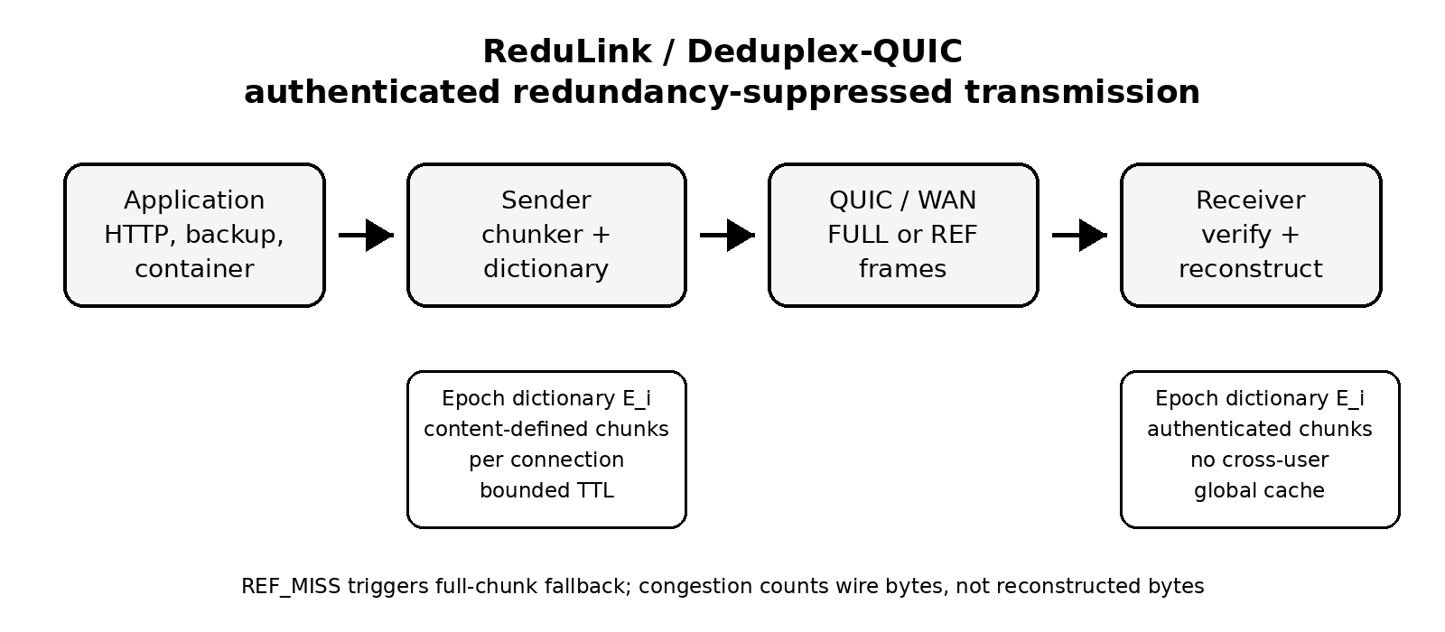
Figure 1. High-level ReduLink architecture.

4.1 Chunking
The sender divides outgoing payload into chunks. A practical deployment may use fixed-size chunks for CPU predictability, content-defined chunks for insertion resilience, or a hybrid strategy. The draft model assumes 8 KiB chunks and 48-byte references, but these values are parameters rather than constants.

4.2 Epoch dictionaries
An epoch dictionary is a temporary mapping from chunk identifiers to chunk bytes. A chunk identifier is derived from the chunk, the epoch, and the connection context. One possible construction is:
chunk_id = Truncate_128(HKDF(connection_secret, epoch_id || hash(chunk)))
This binding prevents references from one connection or epoch from being replayed into another context. The receiver stores only chunks received through authenticated FULL frames or otherwise confirmed through a secure dictionary establishment procedure.

4.3 Frame types
Frame or parameter | Purpose
redulink_parameters | Negotiates version, chunker, dictionary budget, expansion bound, scope, 0-RTT policy, and speculative-reference policy.
REDULINK_FULL | Carries original chunk bytes and metadata needed to validate and register the chunk in the receiver dictionary.
REDULINK_REF | Carries an authenticated reference to a chunk already present in the active receiver dictionary generation.
REDULINK_MISS | Indicates that the receiver cannot resolve a reference and requests semantic FULL repair for the same stream offset.
REDULINK_DICT_ACK | Optionally acknowledges receiver dictionary admission for conservative sender state.
epoch reset policy | Rotates dictionary state after key changes, memory pressure, excessive misses, or privacy policy changes.
Table 2. Proposed ReduLink frame types.

4.4 Core invariant
Invariant 1, authenticated reconstruction. A reference frame is deliverable if and only if the referenced chunk is present in the receiver dictionary, the epoch matches, the reference authentication succeeds, the reconstructed byte length remains within negotiated limits, and the reconstructed byte sequence occupies the committed stream position.
This invariant is the heart of the protocol. It distinguishes ReduLink from informal compression because it specifies exactly when reference substitution is safe.

5. Deduplex-QUIC instantiation
The most deployable public-WAN instantiation is Deduplex-QUIC. In this mode, redundancy suppression occurs inside the endpoint before QUIC packet protection or inside the QUIC stack before payload encryption. Middleboxes do not inspect or rewrite QUIC packets.

5.1 Negotiation
During connection setup, the endpoints exchange a transport parameter indicating ReduLink support. A conservative deployment would enable the feature only for selected origins, authenticated clients, enterprise VPNs, software-update channels, backup sessions, CDN transfers, or container registries.
redulink_transport_parameter = {
version: 1,
max_dictionary_bytes: 64 MiB,
max_chunk_bytes: 64 KiB,
target_chunk_bytes: 8 KiB,
max_reference_expansion: 256,
privacy_mode: per_connection | per_origin,
fallback_required: true
}

5.2 Sending algorithm
for chunk in chunk_stream(payload):
cid = chunk_id(chunk, epoch, dictionary_scope, stream_context)
if receiver_state_allows_ref(cid) and safe_to_reference(chunk):
send REDULINK_REF(epoch, stream_id, offset, cid, length, nonce, auth_tag)
else:
send REDULINK_FULL(epoch, stream_id, offset, cid, chunk, auth_tag)
mark_receiver_candidate(cid)

5.3 Receiving algorithm
on REDULINK_FULL(epoch, stream_id, offset, cid, chunk, tag):
verify tag, chunk id, length, epoch, and stream context
store dictionary[epoch][cid] = chunk
deliver chunk at offset
on REDULINK_REF(epoch, stream_id, offset, cid, length, nonce, tag):
verify tag, epoch, length, offset, nonce, expansion bound, and dictionary presence
if cid in dictionary[epoch] and length matches stored chunk:
deliver dictionary[epoch][cid] at offset
else:
send REDULINK_MISS(epoch, stream_id, offset, cid)

5.4 Loss recovery
Loss recovery must not assume that sender and receiver dictionaries are perfectly synchronized. Packet loss, out-of-order delivery, memory eviction, and connection migration can all create reference misses. ReduLink handles this by treating a reference miss as a normal recoverable event. The sender retransmits the full chunk and may reduce reference aggressiveness for that epoch.

5.5 Congestion semantics
ReduLink separates wire-byte accounting from reconstructed-byte accounting. Congestion control counts the bytes actually placed on the network. Application delivery counts the reconstructed bytes. This preserves fairness because a flow that sends 1 MiB of references consumes only 1 MiB of network capacity even if the receiver reconstructs 10 MiB of original payload.

6. Bandwidth model
Let R be the physical line rate, S the adjusted wire-byte saving, G the gross replaceable redundant share, q the reference-to-chunk size ratio, m the miss penalty, and o the control overhead. The model is:
G = raw_redundancy * replaceable_fraction
S = max(0, min(0.95, G * (1 - reference_bytes/chunk_bytes) - miss_rate * G - control_overhead))
T_effective = R / (1 - S)
The model is intentionally conservative. It does not assume that all repeated content is safely replaceable. It subtracts control overhead and reference misses. It also caps savings at 95 percent to prevent unrealistic infinite expansion.

6.1 Baseline 1 Gbit/s scenarios
Scenario | Raw redundancy | Replaceable share | Adjusted saving | Effective Gbit/s
Consumer HTTPS/media | 0.15 | 0.30 | 0.037 | 1.04
Mixed enterprise SaaS | 0.30 | 0.60 | 0.166 | 1.20
Corporate VPN/WAN | 0.45 | 0.70 | 0.287 | 1.40
Log shipping | 0.55 | 0.80 | 0.416 | 1.71
Software updates | 0.65 | 0.75 | 0.467 | 1.88
Container layers | 0.70 | 0.85 | 0.575 | 2.35
VM/backup replication | 0.80 | 0.85 | 0.671 | 3.04
Compressed video | 0.03 | 0.10 | 0.000 | 1.00
Encrypted random-like data | 0.02 | 0.05 | 0.000 | 1.00
Table 3. Conservative 1 Gbit/s ReduLink model results.
The model indicates that ReduLink is not a universal Internet accelerator. It is weak for media-heavy consumer traffic and strong for workloads with repeated artifacts. This negative result is important because it prevents overclaiming and improves the credibility of the proposal.
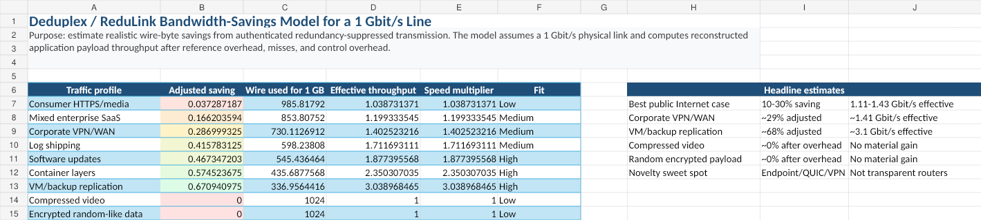
Figure 2. Draft dashboard from the ReduLink bandwidth model.

6.2 Interpretation
A 1 Gbit/s line with 30 percent adjusted saving can reconstruct about 1.43 Gbit/s of original payload. A 50 percent saving doubles effective reconstructed throughput to 2 Gbit/s. A 67 percent saving, plausible for carefully selected backup or VM replication workloads, reconstructs about 3 Gbit/s. These gains are workload-dependent and do not violate physical limits.

7. Security and privacy analysis

7.1 Threat model
The adversary may observe network traffic, drop packets, reorder packets, replay old packets, inject invalid frames, induce dictionary misses, and attempt to infer whether a receiver has seen particular content. The adversary is not assumed to break standard cryptographic primitives or compromise endpoint memory. In public-WAN mode, middleboxes are not trusted with plaintext.

7.2 Reference forgery
A forged reference must fail authentication because the reference tag is derived from connection secrets, epoch identifiers, stream position, chunk identity, and length. An attacker cannot make the receiver deliver arbitrary dictionary bytes at an arbitrary stream offset without passing this check.

7.3 Replay
Epoch binding and stream-offset binding limit replay. A reference from one epoch is invalid in another epoch. A reference for one stream offset is invalid at another offset unless explicitly allowed by the reconstruction commitment.

7.4 Dictionary poisoning
The receiver stores only authenticated full chunks. A malicious sender can still send useless chunks, but that is no worse than sending useless payload. Receivers enforce dictionary limits, eviction policy, and expansion caps.

7.5 Expansion abuse
Reference-based reconstruction can create amplification inside the receiver. ReduLink therefore negotiates a maximum reference expansion ratio, per-epoch reconstructed-byte limits, and per-reference length limits. A reference cannot expand unboundedly.

7.6 Privacy side channels
Deduplication can leak information if a sender can determine whether another user or origin already has a chunk. ReduLink avoids this by defaulting to per-connection dictionaries. A more efficient per-origin mode can be allowed only when the privacy policy accepts the risk, such as within one authenticated enterprise VPN, one software-update channel, or one administrative domain. Global cross-user deduplication is excluded from public-WAN mode.

7.7 Simulator security scope and residual risks
The Python artifact is a reconstruction and accounting model, not a production QUIC implementation. It now verifies byte-exact reconstruction, REF-miss failure, FULL/REF length mismatches, miss-rate fallback behavior, and wire-byte accounting. It does not implement cryptographic authentication tags, replay windows, QUIC packetization, 0-RTT policy, production dictionary manifests, or cross-tenant privacy controls.
Shared dictionaries must remain per-connection by default. Per-origin dictionaries are appropriate only for public artifacts, a single administrative trust domain, or an explicit tenant/user policy. Chosen-chunk probing, dictionary poisoning, replayed references, expansion abuse, and MISS storms are treated as protocol threats with fail-closed requirements and bounded fallback, not as solved by the simulator alone.

8. Deployment models

8.1 Public Internet endpoint mode
In the public Internet case, ReduLink should be implemented by endpoints. Examples include browsers and servers, CDN edges and clients, software-update agents, backup tools, and container registries. The protocol is negotiated and encrypted end to end. Routers and middleboxes see ordinary encrypted traffic.

8.2 Enterprise VPN and branch WAN mode
Enterprise VPNs are an ideal early deployment target because both endpoints are controlled by the same organization. Repeated SaaS assets, file synchronization, logs, backups, and software packages can generate meaningful savings. Privacy policy is also easier because the administrative domain is unified.

8.3 CDN and software-update mode
CDNs and update services repeatedly deliver related artifacts to many clients. ReduLink can help if dictionaries are scoped safely, for example per client or per signed update channel. A software-update agent may retain a local dictionary of previously authenticated vendor chunks, allowing future updates to reference unchanged content.

8.4 Data-center and SmartNIC mode
In a trusted data-center fabric, ReduLink can run in host software, DPDK, eBPF, or SmartNIC firmware. The main research challenge is line-rate chunk detection without excessive CPU or memory use. SmartNICs can offload fingerprinting, dictionary lookup, and reference generation, but this increases implementation complexity.

9. Evaluation methodology
A credible evaluation should combine trace-driven simulation, prototype implementation, and security analysis.

9.1 Datasets
- Synthetic workloads with controlled redundancy from 0 to 90 percent.
- Container image versions and layer updates.
- Backup streams and virtual-machine image versions.
- Software-update packages with repeated libraries.
- Enterprise log streams with repeated templates.
- Negative-control datasets such as compressed video and random encrypted payloads.
- Git pack snapshots from a medium-sized public repository.
- Linux kernel release tarballs for version-to-version delta behavior.
- Ubuntu or Debian package metadata and OCI image layers as reproducible public artifacts.

9.2 Metrics
- Adjusted wire-byte saving.
- Effective reconstructed throughput.
- CPU cycles per byte.
- Memory consumed per active dictionary.
- Reference miss rate.
- Added latency.
- Goodput under packet loss.
- Fairness against non-ReduLink flows.
- Privacy leakage under adversarial probing.

9.3 Hypotheses
- H1: ReduLink provides negligible gain for already compressed or random encrypted payloads.
- H2: ReduLink provides 10 to 30 percent wire-byte savings for mixed enterprise traffic when both endpoints cooperate.
- H3: ReduLink provides 40 to 80 percent savings for selected backup, VM, container, and software-update workloads.
- H4: Reference-miss fallback preserves correctness under loss and dictionary mismatch.
- H5: Congestion fairness is preserved when congestion control accounts for wire bytes rather than reconstructed bytes.

9.4 Reproducible offline simulator and first results
To strengthen the manuscript beyond an analytic bandwidth model, this revision treats the repository as part of the evidence. The v0.5 model remains an endpoint-controlled redundancy-suppressed representation layer with epoch dictionaries, chunk identifiers, reference frames, bounded dictionary capacity, reference-miss fallback, and explicit wire-byte accounting. The repository now adds tests, baseline comparison commands, public-artifact hooks, and CSV-driven figure generation. The simulator is still not presented as a population estimate for the entire Internet; it is a controlled proof-of-concept showing when the protocol mechanism can and cannot create effective throughput gain.
Two chunking modes are evaluated. Content-defined chunking is used as the conservative generic-WAN mode because it can resynchronize after insertions and edits. Fixed record/page chunking is used as a controlled-mode model for artifacts that are naturally block- or record-aligned, such as VM pages, backup pages, container layers, update objects, and structured log frames. This distinction prevents the paper from overstating the method as a universal acceleration mechanism.
Table 4. Simulator parameters used in the v0.3 proof-of-concept evaluation.
Parameter | Value | Purpose
Physical line rate | 1 Gbit/s | Used to convert wire-byte savings into reconstructed payload throughput.
Average chunk size | 4 KiB | Used for both CDC target size and fixed record/page mode.
Dictionary scope | session or warm origin dictionary | Cold mode learns only within a stream; warm mode models prior same-origin/stateful contexts.
Reference overhead | 32 bytes | v0.5 simulator REF metadata estimate; final QUIC wire encoding must recompute overhead from varints and tag policy.
Reference-miss rate | 0.2% | Models occasional dictionary mismatch or repair fallback.
Dictionary capacity | 64 MiB | LRU-bounded receiver dictionary.
Table 5. Selected ReduLink simulation results on a 1 Gbit/s physical line.
Workload | Mode | Saving | Effective payload | Interpretation
Consumer mixed | warm, cdc | 20.70% | 1.26 Gbit/s | Public Internet mixed traffic, endpoint dictionary
Enterprise SaaS | warm, cdc | 42.43% | 1.74 Gbit/s | Enterprise SaaS, content-defined chunks
Corporate VPN/WAN | warm, cdc | 41.68% | 1.72 Gbit/s | VPN/WAN generic stream
Log shipping | warm, fixed | 19.80% | 1.25 Gbit/s | Structured log frames, record-aligned mode
Software updates | warm, fixed | 55.35% | 2.24 Gbit/s | Versioned update object, origin dictionary
Container layers | cold, fixed | 33.43% | 1.50 Gbit/s | Container stream, repeated layers within session
Container layers | warm, fixed | 59.80% | 2.49 Gbit/s | Container stream, origin dictionary
VM backup replication | cold, fixed | 66.27% | 2.96 Gbit/s | Backup stream, repeated pages within session
VM backup replication | warm, fixed | 88.58% | 8.76 Gbit/s | Backup stream, prior snapshot dictionary
Compressed control | warm, cdc | 0.00% | 1.00 Gbit/s | Negative control
Encrypted random control | warm, cdc | 0.00% | 1.00 Gbit/s | Negative control
The selected results support three claims. First, the negative controls remain at the physical line rate, which is the expected behavior for compressed or random encrypted payloads. Second, generic endpoint-controlled WAN traffic benefits only when a safe same-origin or same-session dictionary is available. Third, controlled artifact flows can show substantial effective-throughput multiplication because the sender transmits compact authenticated references instead of repeated pages, layers, or update blocks.
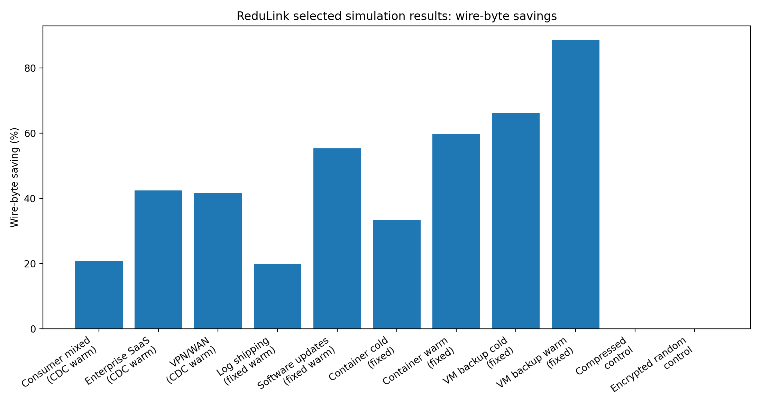
Figure 3. Selected ReduLink simulation results: wire-byte savings across workload families.
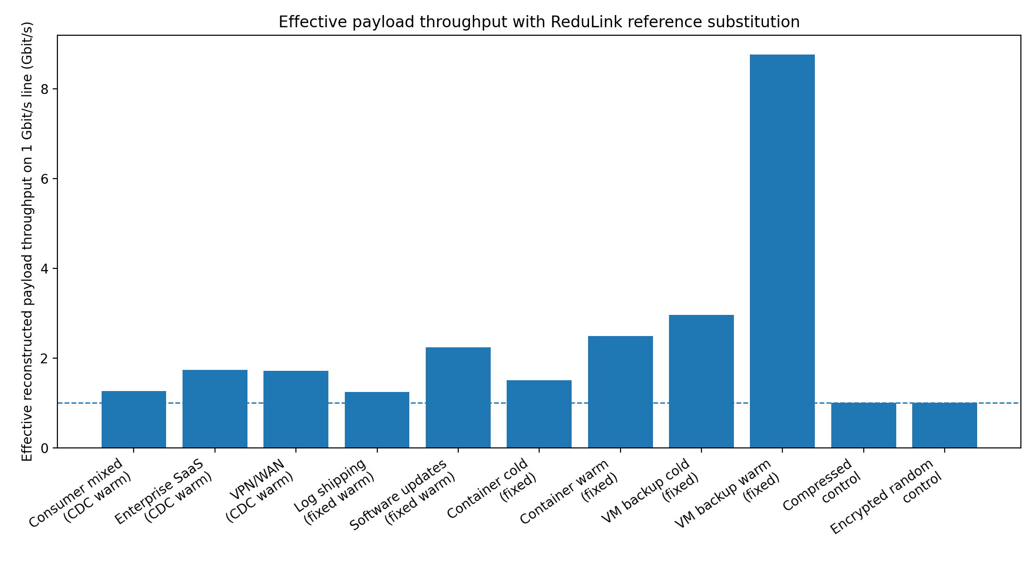
Figure 4. Effective reconstructed payload throughput on a 1 Gbit/s physical line.
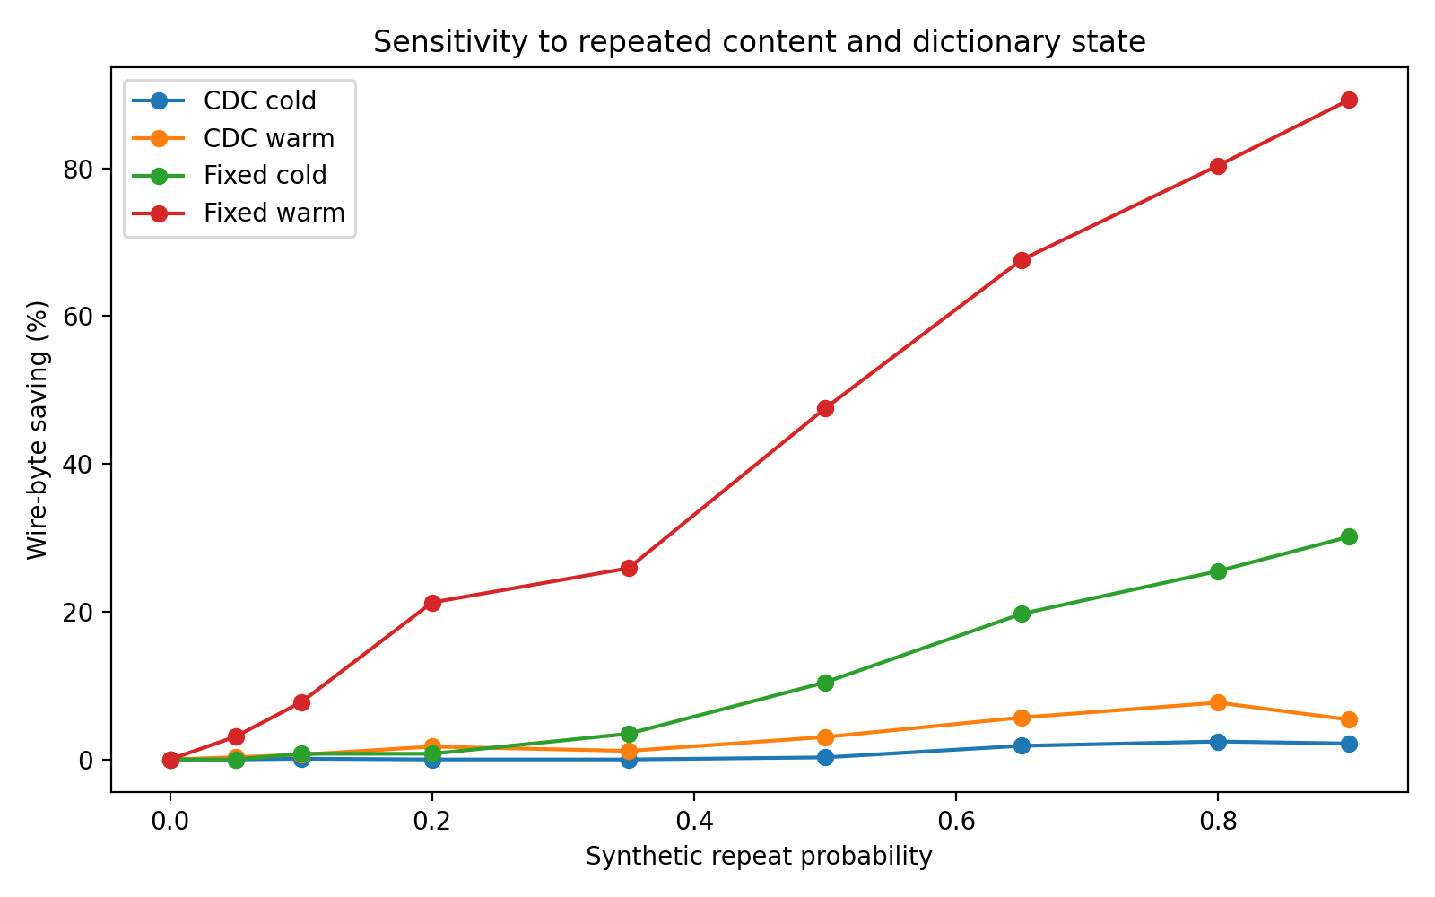
Figure 5. Sensitivity of wire-byte savings to repeated content and dictionary state.
These results also clarify the correct novelty claim. ReduLink is not a general replacement for caching, compression, or higher-rate Ethernet PHYs. Its strongest value is in cooperative endpoints that can safely maintain short-lived dictionaries before encryption or inside trusted endpoints. The most defensible deployment targets are VPNs, CDN-to-client delivery, software-update systems, container registries, VM replication, and backup streams.
The reproducibility package accompanying this draft now includes the Python model, unit tests, GitHub Actions workflow, selected real-artifact CSV, small fetched public-corpora fixture, rsync-style block reuse baseline, benchmark scripts, plot-generation script, generated figures, minimal socket prototype, and RFC-style protocol appendix. Larger validation should still run on frozen OCI layers, Linux kernel tarballs, git pack snapshots, and package metadata before any production-scale claim.

9.5 Public artifacts and baseline comparisons
The paper should no longer frame the evaluation as only a toy simulator. The repository provides a public-artifact benchmark hook that accepts reviewer-fetched files or directories, so the same command can be run on Ubuntu base container layers, Linux kernel release tarballs, git pack snapshots, package metadata, structured logs, or backup artifacts without embedding large downloads in the repository.
The baseline table compares raw bytes, gzip, zstd when available, rsync-style rolling block reuse, ReduLink with fixed chunking, ReduLink with content-defined chunking, and composition cases where compression is applied before or after ReduLink. The appropriate claim is that ReduLink is not a replacement for compression or rsync: compression primarily exploits redundancy inside the current object, rsync is a strong file-delta baseline, and ReduLink suppresses repeated chunks across endpoint-controlled dictionary history.

9.6 Automated tests, reproducible commands, and generated plots
The repository now includes tests for byte-exact FULL/REF reconstruction, random-data negative controls, warm-dictionary gains, safe REF-miss failure, and both fixed and content-defined chunkers. GitHub Actions runs the test suite and a benchmark smoke test on push and pull request. This gives reviewers a concrete correctness story rather than only a prose protocol description.
Benchmark reproduction is intentionally command-based: bash benchmarks/run_synthetic_suite.sh emits results/synthetic_suite.csv, and bash benchmarks/run_public_artifacts.sh label=/path/to/artifact emits results/public_artifact_suite.csv. Paper figures can be regenerated from those CSVs with python3 scripts/plot_results.py results/synthetic_suite.csv --output-dir figures.
Table 6. v0.7 evidence excerpt from generated CSV outputs, including rsync and public-corpora rows.
Dataset | Mode | Method | Multiplier | Saving
logs | warm update | rsync-block-reuse | 72.694x | 0.986
logs | warm update | ReduLink fixed | 63.631x | 0.984
updates | warm update | rsync-block-reuse | 63.300x | 0.984
updates | warm update | ReduLink fixed | 1.959x | 0.490
mixed | warm update | rsync-block-reuse | 4.942x | 0.798
mixed | warm update | ReduLink CDC | 4.775x | 0.791
cpython http.server | public version pair | rsync-block-reuse | 3.050x | 0.672
cpython http.server | public version pair | ReduLink CDC | 11.437x | 0.913
linux kernel parameters | public version pair | ReduLink CDC | 0.997x | 0.000
random control | cold artifact | ReduLink fixed | 0.997x | 0.000

Figure 6. Regenerated v0.7 synthetic-suite figure: effective reconstructed throughput multiplier by workload and method, including gzip, zstd, rsync-style block reuse, ReduLink fixed, and ReduLink CDC.
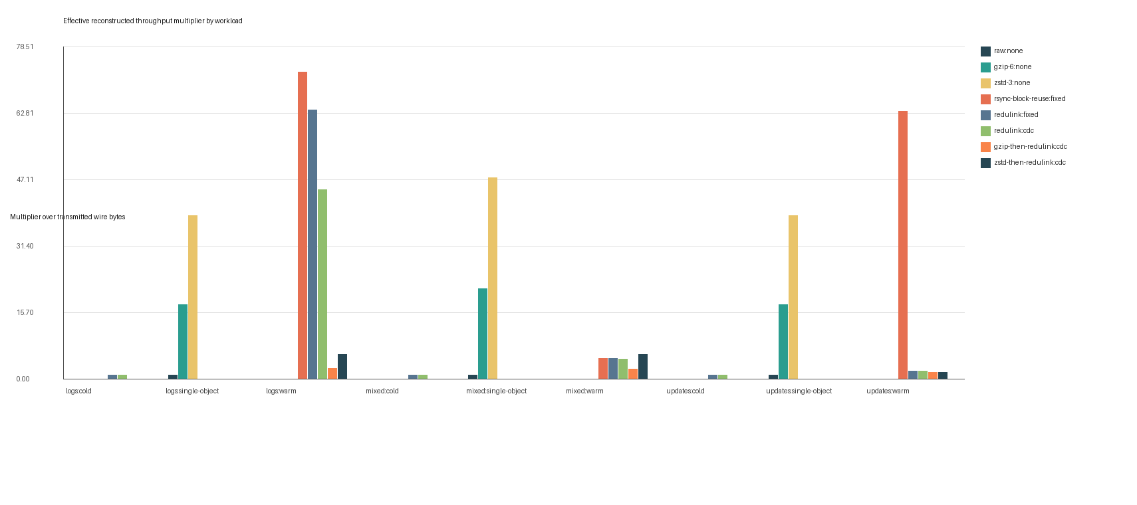

10. Prototype plan
A minimal prototype can be built in three stages.

10.1 Stage 1: offline simulator
The simulator reads byte streams, chunks them, calculates repeated chunks, replaces eligible repeats with references, and reports adjusted savings. The current toy model already implements the throughput equation. The next step is to replace synthetic redundancy assumptions with actual file and trace inputs.
The repository now also includes a minimal localhost socket prototype. In demo mode, a client sends modeled FULL/REF frames over TCP to a receiver, which reconstructs the update byte-exactly from the transmitted frames and warm dictionary. This is an endpoint reconstruction prototype, not a QUIC implementation.

10.2 Stage 2: user-space tunnel
A user-space tunnel can implement ReduLink over UDP between two controlled hosts. This avoids modifying QUIC initially while testing dictionary synchronization, reference-miss recovery, memory behavior, and wire-byte savings.

10.3 Stage 3: QUIC extension or plugin
After the tunnel validates the core mechanism, the method can be implemented inside a QUIC library or as a pre-encryption application mapping. This stage evaluates deployability in HTTP-like transfers, software updates, and container delivery.

10.4 Stage 4: SmartNIC feasibility
The final stage estimates whether chunking and lookup can be offloaded to a SmartNIC. This stage should be treated as optional or future work unless a real programmable NIC environment is available.

11. Discussion

11.1 Why not normal compression?
Compression exploits statistical redundancy inside a local encoding window. ReduLink exploits repeated chunks across time, streams, files, sessions, or related artifacts. The two methods can coexist, but the order matters. Deduplication must occur before encryption and usually before compression if compression would destroy repeated byte identity. Alternatively, ReduLink can operate on application-level objects before they are compressed.
The v0.5 benchmark suite therefore reports both standalone compression baselines and composition cases. This makes the distinction measurable: if zstd or gzip already removes all repeated byte identity, ReduLink should not claim additional gain; if update-like artifacts preserve repeated chunk identity across history, ReduLink can reduce transmitted bytes even though congestion control still accounts only for wire bytes.

11.2 Why not middlebox WAN optimization?
Middlebox WAN optimization works well in controlled environments but conflicts with encrypted end-to-end traffic unless endpoints or administrators deliberately expose plaintext. ReduLink moves the redundancy-suppression decision to endpoints or trusted administrative boundaries, preserving compatibility with encrypted transports.

11.3 Why this is not merely old redundancy elimination
The novelty is not the observation that redundancy exists. The novelty is the protocolization of redundancy suppression for modern encrypted WANs: explicit authenticated reference frames, epoch dictionaries, reference-miss fallback, bounded expansion, congestion semantics, and privacy-preserving deployment rules. These elements are necessary for a deployable Internet-era design.

11.4 Reviewer risks
The main reviewer objection will be that redundancy elimination and WAN optimization already exist. The paper should answer this directly in the introduction and related work. The second objection will be deployability on the public Internet. The answer is endpoint negotiation, not transparent middleboxes. The third objection will be weak gains for ordinary traffic. The answer is to include negative controls and position the protocol for workloads where redundancy is common.

12. Limitations
- The current evaluation combines analytic modeling and synthetic simulation; it still requires validation with public traces, real application corpora, and an implementation.
- The method provides little benefit for compressed media, random encrypted data, and unique one-time payloads.
- Endpoint integration is required for encrypted public-WAN traffic.
- Content-defined chunking may be CPU-intensive at high line rates without optimization or offload.
- Privacy-safe dictionary sharing limits the maximum savings compared with unsafe global deduplication.
- The design requires careful interaction with application compression, caching, and content encoding.

13. Conclusion
ReduLink reframes network acceleration from physical-speed escalation to semantic bandwidth multiplication. A 1 Gbit/s link cannot physically transmit more than its line rate, but a receiver can reconstruct more than 1 Gbit/s of original payload when repeated bytes are replaced by authenticated references. The proposed protocol makes this idea compatible with modern encrypted WANs by using endpoint negotiation, epoch-scoped dictionaries, authenticated references, bounded expansion, reference-miss fallback, and congestion accounting based on wire bytes. The expected gains are workload-dependent: small for ordinary consumer traffic, moderate for enterprise and VPN traffic, and large for backup, VM replication, container delivery, software updates, and log transport. The resulting research contribution is not a faster Ethernet PHY, but a secure transport-layer or link-adjacent primitive for effective bandwidth expansion under redundancy.

References
[1] N. T. Spring and D. Wetherall, “A protocol-independent technique for eliminating redundant network traffic,” ACM SIGCOMM, 2000.
[2] A. Anand, V. Sekar, and A. Akella, “SmartRE: An architecture for coordinated network-wide redundancy elimination,” ACM SIGCOMM, 2009.
[3] A. Anand et al., “Redundancy in network traffic: Findings and implications,” ACM SIGMETRICS, 2009.
[4] B. Aggarwal et al., “EndRE: An end-system redundancy elimination service for enterprises,” USENIX NSDI, 2010.
[5] A. Muthitacharoen, B. Chen, and D. Mazières, “A low-bandwidth network file system,” ACM SOSP, 2001.
[6] J. Iyengar and M. Thomson, “QUIC: A UDP-based multiplexed and secure transport,” RFC 9000, IETF, 2021. Available: https://datatracker.ietf.org/doc/rfc9000/
[7] M. Thomson and S. Turner, “Using TLS to secure QUIC,” RFC 9001, IETF, 2021.
[8] M. Kühlewind and B. Trammell, “Applicability of the QUIC transport protocol,” RFC 9308, IETF, 2022.
[9] B. Trammell et al., “Manageability of the QUIC transport protocol,” RFC 9312, IETF, 2022. Available: https://datatracker.ietf.org/doc/rfc9312/
[10] Y. Hu et al., “The design of fast content-defined chunking for data deduplication,” IEEE Transactions on Parallel and Distributed Systems, 2020.
[11] M. Gregoriadis, L. Balduf, B. Scheuermann, and J. Pouwelse, “A thorough investigation of content-defined chunking algorithms for data deduplication,” arXiv, 2024.
[12] B. Alexeev, C. Percival, and Y. X. Zhang, “Chunking attacks on file backup services using content-defined chunking,” arXiv, 2025.
[13] IEEE 802.3 Ethernet Working Group, “IEEE 802.3 Ethernet Working Group active projects,” accessed June 2026. Available: https://www.ieee802.org/3/
[14] M. Nguyen, "ReduLink / Deduplex-QUIC v0.5 repository and reproducibility package," GitHub repository, 2026. Available: https://github.com/pinkysworld/redulink-deduplex-quic

Appendix A: Reproducibility package contents
The v0.7 reproducibility package contains the runnable model, tests, GitHub Actions workflow, selected real-artifact CSV, synthetic CSV, public-corpora manifest and result CSV, rsync baseline, benchmark scripts, plot-generation script, regenerated figures, minimal socket prototype, threat model, and RFC-style protocol appendix. Core files include src/redulink_proto_v0_5.py, tests/, benchmarks/, prototypes/, scripts/plot_results.py, results/, figures/, docs/protocol_summary.md, and docs/threat_model.md. Representative commands are:
python3 -m unittest discover -s tests
bash benchmarks/run_synthetic_suite.sh
python3 prototypes/redulink_socket_prototype.py demo
python3 benchmarks/fetch_public_corpora.py
bash benchmarks/run_public_artifacts.sh ubuntu-base=/path/to/oci/layers linux-kernel=/path/to/tarballs git-pack=/path/to/git-pack-snapshots
python3 scripts/plot_results.py results/synthetic_suite.csv --output-dir figures
The CDC run represents conservative generic stream chunking, while the fixed run represents record/page-aligned controlled artifact flows. Public-artifact runs should report artifact source, version, retrieval date, chunker, chunk size, dictionary limit, miss-rate assumption, and whether the run is cold or warm/update-like.

Appendix B: Example frame format
The full repository appendix expands this sketch into negotiation parameters, frame types, sender and receiver state machines, DICT_ACK semantics, warm dictionary manifests, reference-miss repair, security requirements, congestion and flow-control accounting, and failure cases.
REDULINK_REF {
frame_type: extension-assigned varint,
epoch_id: uint64,
stream_id: varint,
stream_offset: varint,
original_length: varint,
chunk_id: 128 bits,
reference_nonce: 96 bits,
auth_tag_or_commitment: 128 bits
}

Appendix C: Conservative claim language
Recommended claim: ReduLink increases effective reconstructed payload throughput for redundant traffic without increasing physical line rate or weakening transport security.
Avoided claim: ReduLink makes Ethernet physically faster than its negotiated line rate.

