Assignment 1: Analysis of SVD for Fine-Tuning LLMs
315551078 蕭佳蘋
GitHub repository: https://github.com/pinkyyy333/NYCU_115Fall_Big-Data-Analytics-Techniques-and-Applications/tree/main/HW1
Experimental setup. The base model is Llama-3.2-1B. PiSSA-style SVD adaptation was applied to q_proj, k_proj, v_proj, o_proj, gate_proj, up_proj, and down_proj. Each run used one epoch, learning rate 2 × 10⁻⁵, FP16 model precision, maximum input length 512, and maximum generation length 256. The first 25,000 MetaMathQA rows were loaded; 24,975 remained after excluding examples without supervised tokens. Each accuracy uses 1,000 GSM8K and 1,000 MATH test examples. Runs used one RTX A6000, seed 42, and the same data and evaluation procedure.

Question 1 — Accuracy at different target ranks
(a) Report original Llama-3.2-1B accuracy on GSM8K and MATH.
(b) Fine-tune at target ranks 16, 64, and 256 using the default (top singular-value) component; report both accuracies.
Dataset | Original LLM | Rank 16 | Rank 64 | Rank 256
GSM8K accuracy | 3.3% | 15.6% | 20.5% | 27.3%
MATH accuracy | 0.1% | 3.7% | 5.1% | 4.8%

(c) Observe and explain the performance trends for both datasets.

Fine-tuning substantially improves accuracy on both datasets compared with the original Llama-3.2-1B model. On GSM8K, accuracy consistently increases from 3.3% to 15.6%, 20.5%, and 27.3% as the target rank increases from 16 to 256. A higher rank provides more trainable parameters and greater adaptation capacity, allowing the model to learn more task-specific mathematical patterns.

However, MATH shows a different trend. Accuracy improves from 0.1% to 5.1% at rank 64, but slightly decreases to 4.8% at rank 256. This suggests that increasing the target rank does not necessarily guarantee better generalization. Higher adaptation capacity may introduce additional optimization complexity, while the harder problems and more complex answer formats in MATH may also affect measured accuracy.

Overall, larger ranks are beneficial for GSM8K within the tested range, whereas MATH achieves its best result at rank 64. The small decline at rank 256 is insufficient to establish a general negative effect of higher ranks.

Question 2 — Training time
- Record training time in minutes for ranks 16, 64, and 256.
All three models were trained on a single NVIDIA RTX A6000 using the same 24,975 MetaMathQA examples and one training epoch. Training time was measured for the training loop only; SVD initialization, model merging, and evaluation were excluded.
Default-component target rank | 16 | 64 | 256
Training time (minutes) | 19.49 | 20.54 | 27.35

(b) Observe and explain the trend.
Training time increases with the target rank, from 19.49 minutes at rank 16 to 20.54 minutes at rank 64 and 27.35 minutes at rank 256. The increase is relatively small between ranks 16 and 64 (5.4%), but becomes more noticeable between ranks 64 and 256 (33.2%).
This trend can be explained by the increasing number of trainable parameters in higher-rank adapters. Larger ranks require more computations for forward propagation, gradient calculation, and optimizer updates. However, training time does not increase proportionally to rank because much of the computation, including operations in the frozen base model, remains unchanged.
These results illustrate a trade-off between adaptation capacity and computational cost. Rank 256 achieves the highest GSM8K accuracy but requires approximately 40.3% more training time than rank 16. Meanwhile, rank 64 achieves the highest MATH accuracy with considerably lower training cost than rank 256.

Question 3 — Which singular values are adapted?
- Fix target rank at 16. Compare the top 16 singular values, 16 starting at 25% position, 16 starting at 50% position, and the bottom 16; plot GSM8K and MATH accuracies as bars.

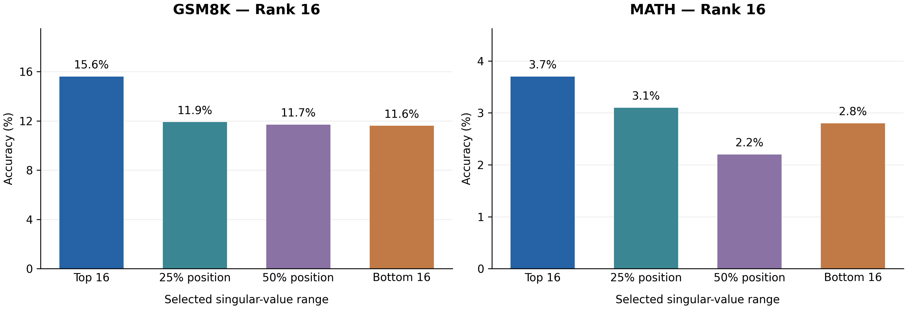
Figure 1. Rank-16 singular-value selections; 1,000 test examples per dataset.

(b) Observe and explain the performance trends for both datasets.
With the target rank fixed at 16, selecting the top 16 singular values achieves the highest accuracy on both datasets (15.6% on GSM8K and 3.7% on MATH). This suggests that the leading singular directions provide more useful components for adapting the model to mathematical reasoning tasks under the tested settings.
On GSM8K, accuracy decreases to 11.9%, 11.7%, and 11.6% when selecting singular values from the 25%, 50%, and bottom positions, respectively. The differences among these three settings are relatively small, indicating that their adaptation effectiveness is similar for GSM8K.
On MATH, however, the trend is not strictly decreasing. The bottom 16 singular values achieve 2.8% accuracy, outperforming the 50% selection (2.2%). This indicates that singular-value magnitude alone does not completely determine the usefulness of an adaptation direction. Smaller singular directions may still contain task-relevant information, and optimization effects may also influence performance.
Overall, the top singular values provide the strongest results in this experiment, but the relationship between singular-value position and downstream accuracy is not strictly monotonic.

Question 4 — Energy in original query projections
(a) Perform full SVD on original q_proj weights in layers 0, 7, and 15, without a target rank.
(b) Report the minimum rank retaining at least 50% cumulative energy.
For descending singular values sᵢ, cumulative energy at rank r is 100 × (Σᵢ≤ᵣ sᵢ²) / (Σᵢ sᵢ²). The denominator uses the entire spectrum although the figures display only the first 200 values.
Original q_proj layer | 0 | 7 | 15
Minimum rank for ≥50% energy | 62 | 120 | 84

(c) Show bar charts of singular-value magnitude and line charts of cumulative energy for the first 200 values in each layer (six charts total).
Singular-value magnitudes | Cumulative energy
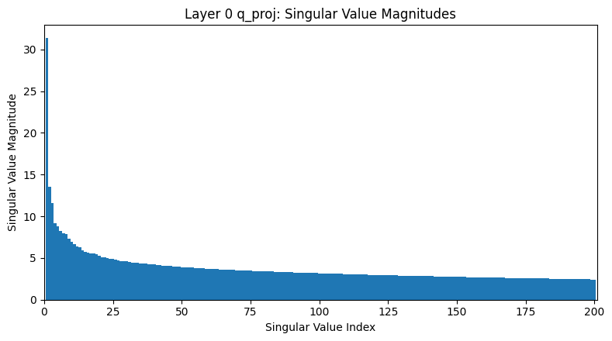 | 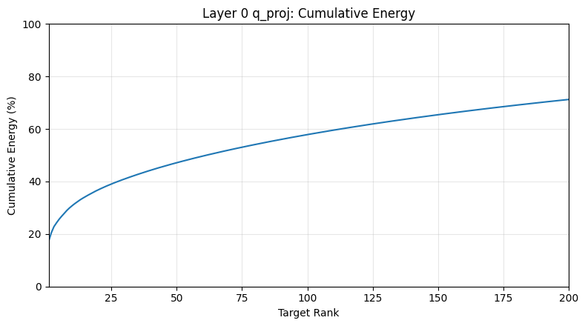
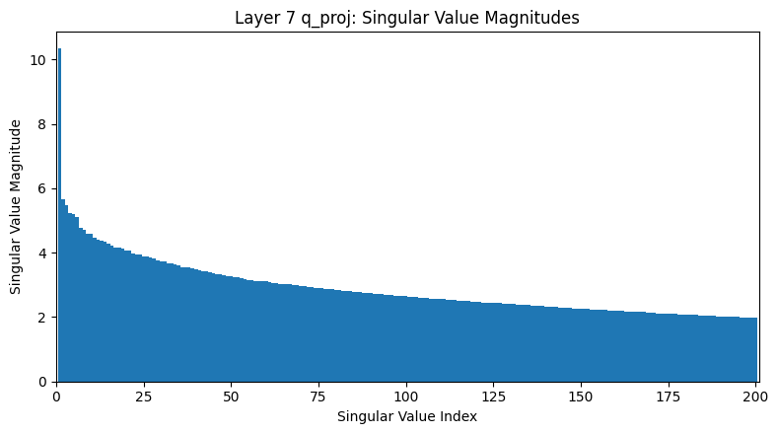 | 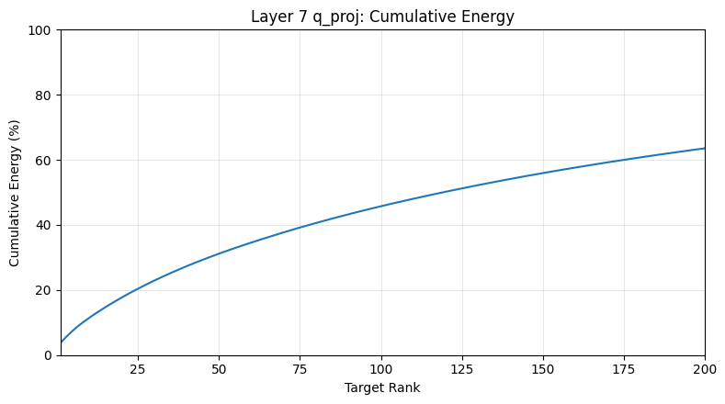
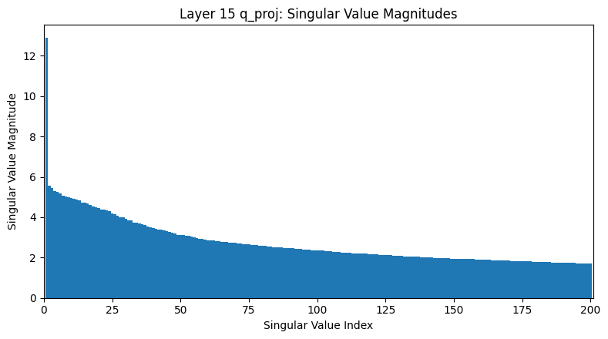 | 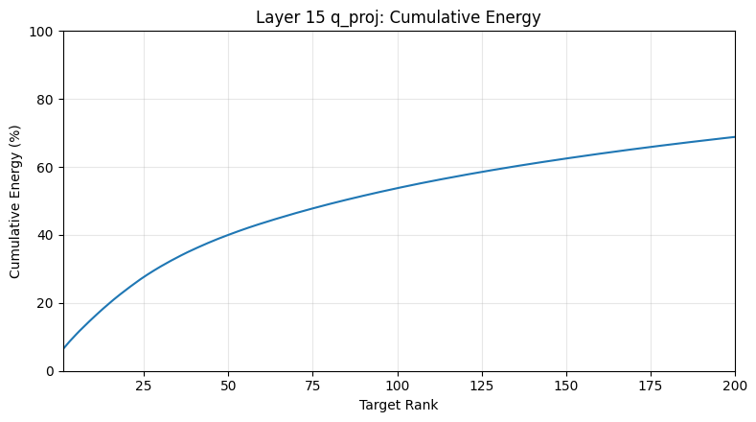
Figure 2. Original q_proj spectra: layer 0 (top), 7 (middle), and 15 (bottom). Energy uses the full spectrum.
(d) Observe the differences across the three layers.
The SVD results reveal different singular-value distributions across the three query projection layers. Layer 0 requires only 62 singular values to retain at least 50% cumulative energy, indicating that its energy is relatively concentrated in the leading singular directions. Layer 7 requires 120 singular values, suggesting a more distributed spectrum, while Layer 15 shows intermediate behavior with a minimum rank of 84.
The singular-value magnitude plots show that all three layers have relatively large leading singular values followed by gradually decreasing values. Their cumulative-energy curves increase at different rates: Layer 0 accumulates energy fastest, Layer 7 slowest, and Layer 15 lies between them. The curves do not necessarily reach 100% within the first 200 singular values because the cumulative energy is normalized using the complete singular-value spectrum.
These observations indicate that different transformer layers have distinct spectral characteristics and different degrees of energy concentration. Consequently, applying the same target rank to every layer may preserve different proportions of their original weight energy. This suggests that layer-specific rank allocation could be worth investigating, although the present SVD analysis alone does not establish its effect on downstream accuracy.

