

PROJECT ON

(NEXUS SERVICE MARKETING SYSTEM)

Developed by

Members:
No. | Student Name | Student ID
1 | Dang Hoang Hong(Leader) | Student1219180
2 | Hoang Nguyen Huu | Student1225625
3 | Thien Ha Si | Student1225576
4 | Duc Ngoc Ho | Student1219661
5 | Bao Le Hoang Phuc | Student1144200

- Class No.:C1908i3 + C1908i2
- Start Date:30/12/2021
- End Date:8/2/2022
- Name of the Coordinator: Phan Huu Tri
- Date of Submission:10/2/2022

SYSTEM ANALYSIS

System Summary:
- Creation, maintenance and updating database, which contains
  - Find products to buy
  - View product information
  - Details of the products
  - Product payment
  - Buy product
  - Open shop to sell

- Creation, maintenance and updating store, which contains
- Manage store invoices
- Store product management

- Creation, maintenance and updating super admin, which contains
- Manage all information

CLASS DIAGRAM

Class:
Category(Category_id, Name, Status, Image)

Contact(Contact_id, Messenger, User_id_send, User_id_get, Created)

Image(Image_id, Name, Created, Product_id)

Order(Order_id, User_id, Store_id, Shipper_id, Created, Order_of_start, Order_of_finish, Address, Payment, Status_id)

Order_detail(Order_detail_id, Product_id, Order_id, Discount_id, Quantity, Unit_price, Note, Status)

Product(Product_id, Name, Price, Brand, Made_in, Quantity, Unit_on_Order, Created, Content, Address, Status, Category_id, User_id, Discord_id)

Role(Role_id, Name, Status )

Store(User_id, Name, Address, Created, View, Status, Image)

Store_category(User_id, Category_id)

User(User_id, Username, Password, Fullname, Email, Phone, Address, Created, Status)

DATABASE DESIGN

Database Name: Nexus Service Marketing System
Number of tables:8
Tables Names:
- Category
- Contact
- Image
- Order
- Order_detail
- Product
- Role
- Store
- Store_category
- User
Schematic Diagram Of Database:
Schematic diagram of the database depicting the primary and foreign key
relationships.
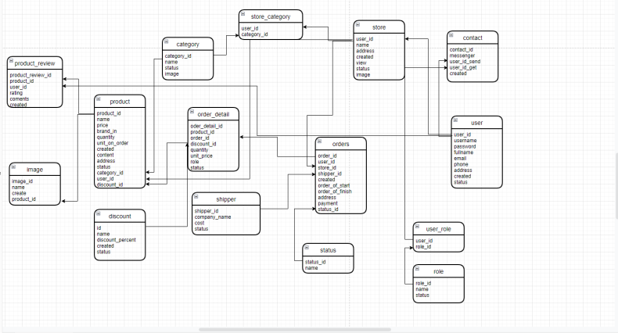

TABLE DESIGN

Database Name:
Category:
Field Name | Data type | Width | Description
category_id | int | 11 | Id of the category
name | varchar | 250 | Name of the category
status | tinyint | 1 | Status of the category
image | varchar | 250 | Image of the Product

Contact:
Field Name | Data type | Width | Description
contact_id | int | 11 | Id of the contact
messenger | varchar | 1000 | Messenger of the contact
user_id_send | Int | 11 | User id send of the contact
User_id_get | int | 11 | User id get of the contact
Create | date |  | Create of the contact

Image :
Field Name | Data type | Width | Description
Image_id | int | 11 | Id of the Image
name | varchar | 250 | Name of the Image
Create | date |  | Create of the Image
product_id | int | 11 | Id Product of the image

Order:
Field Name | Data type | Width | Description
order_id | Int | 11 | Id of the Order
user_id | int | 11 | Id User of the Order
store_id | int | 11 | Store of the Order
shipper_id | int | 11 | Id Shipper of the Order
order_of_start | date |  | Start of the Order
order_of_finish | date |  | Finish of the Order
address | varchar | 250 | Address of Order
Payment | varchar | 250 | Payment of Order
status_id | int | 11 | Id Status of Order

Order Detail:
Field Name | Data type | Width | Description
order_detail_id | int | 11 | Id of the Order detail
product_id | int | 11 | Id Product of the Order detail
order_id | int | 11 | Id of the Order detail
discord_id | int | 11 | Id Discord of the Order detail
quantity | int | 11 | Quantity of the Order detail
unit_price | double |  | Unit Price of the Order detail
note | varchar | 500 | Note of the Order detail
status | tinyint | 1 | Status of the Order detail

Product:
Field Name | Data type | Width | Description
product_id | Int | 11 | Id of the Product
name | varchar | 250 | Name of the Product
price | double |  | Price of the Product
brand | varchar | 250 | Brand of the Product
made_in | varchar | 250 | Made in of the Product
quantity | int | 11 | Quantity of the Product
unit_on_order | int | 11 | Unit on order of the Product
created | date |  | Create of the Product
content | varchar | 2000 | Content of the Product
address | varchar | 250 | Address of the Product
status | tinyint | 1 | Status of the Product
category_id | int | 11 | Id Category of the Product
user_id | int | 11 | Id User of the Product
discord_id | int | 11 | Id Discord of the Product

Role:
Field Name | Data type | Width | Description
role_id | Int | 11 | Id of the Role
name | varchar | 250 | Name of the Role
status | tinyint | 1 | Status of the Role

Store:
Field Name | Data type | Width | Description
user_id | int | 11 | Id of the Store
name | varchar | 250 | Name of the Store
address | varchar | 250 | Address of the Store
created | date |  | Created of the Store
view | int | 11 | View of the Store
status | tinyint | 1 | Status of the Store
image | varchar | 250 | Image of the Store

Store Category:
Field Name | Data type | Width | Description
user_id | int | 11 | Id user of the Store Category
category_id | int | 11 | Id Category of the Store Category

User:
Field Name | Data type | Width | Description
user_id | Int | 11 | Id of the User
username | varchar | 250 | Username of the User
password | varchar | 250 | Password of the User
fullname | varchar | 250 | Fullname of the User
email | varchar | 250 | Email of the User
phone | varchar | 12 | Phone of the User
address | varchar | 250 | Address of the User
created | date |  | Created of the User
status | tinyint | 1 | Status of the User

VALIDATIONS PERFORMED

Database Name:
Name Table 1:
Validation Required | Method Used For Validation

Name Table 2:
Validation Required | Method Used For Validation

DATA FLOW DIAGRAM

Data Flow Diagram representing the control flow of Project Case Study.

(WEB/WINDOWS) FORMS OUTLINE

Forms Name | Description
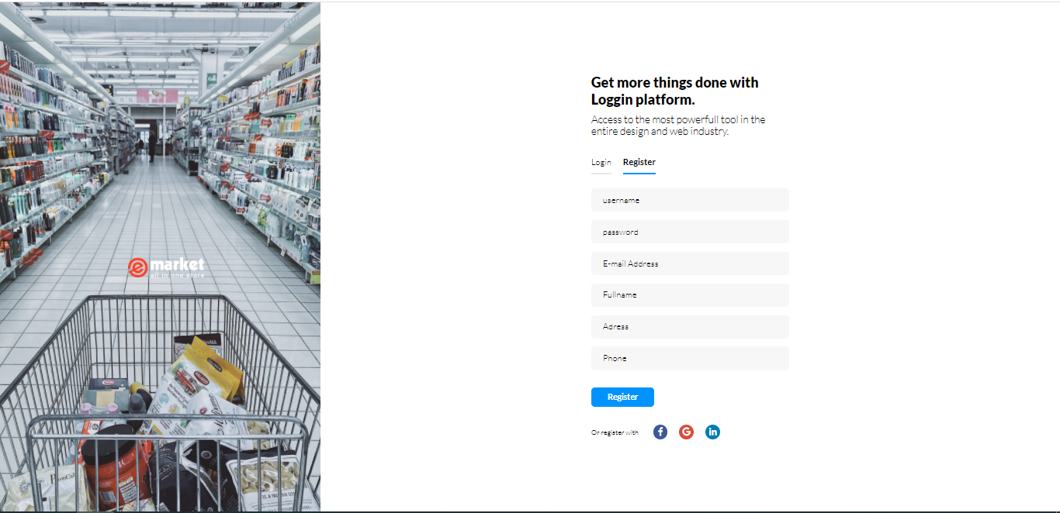 | Sign-up form is clear, with a basic background, so you can focus on the form fields that  Matter.
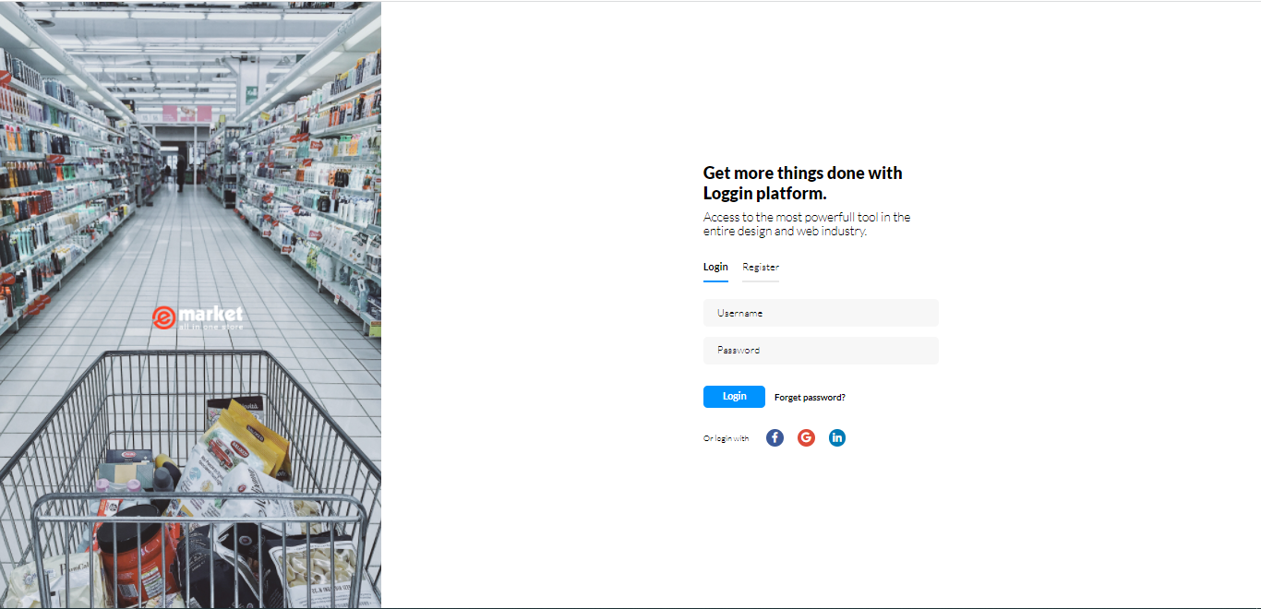 | Login form clear, with a basic background, so you can focus on the form fields that  Matter.  (Account admin: user: account1  Password: account321)  (Link:http://localhost:8085/superadmin/dashboard/index)
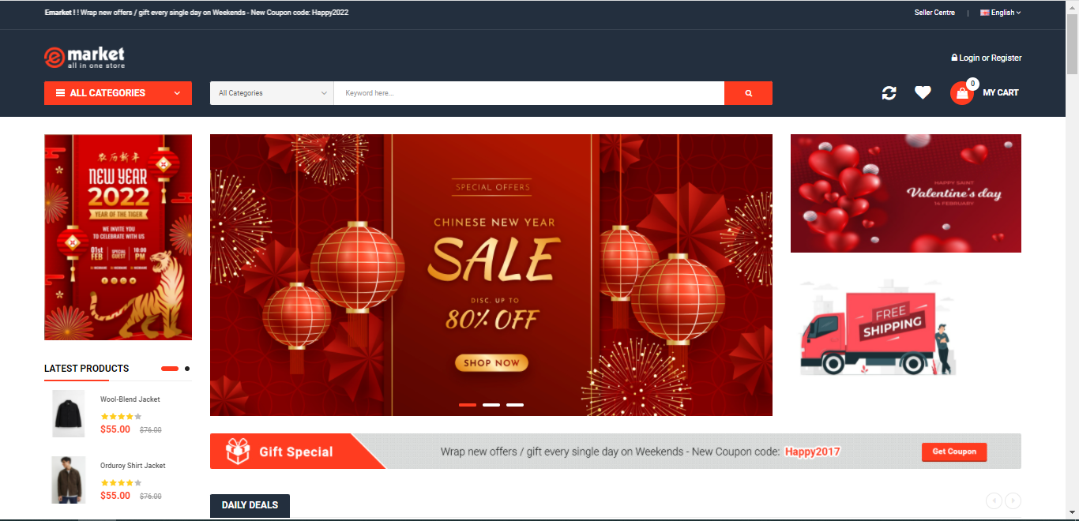 | The Home page will be display the product.
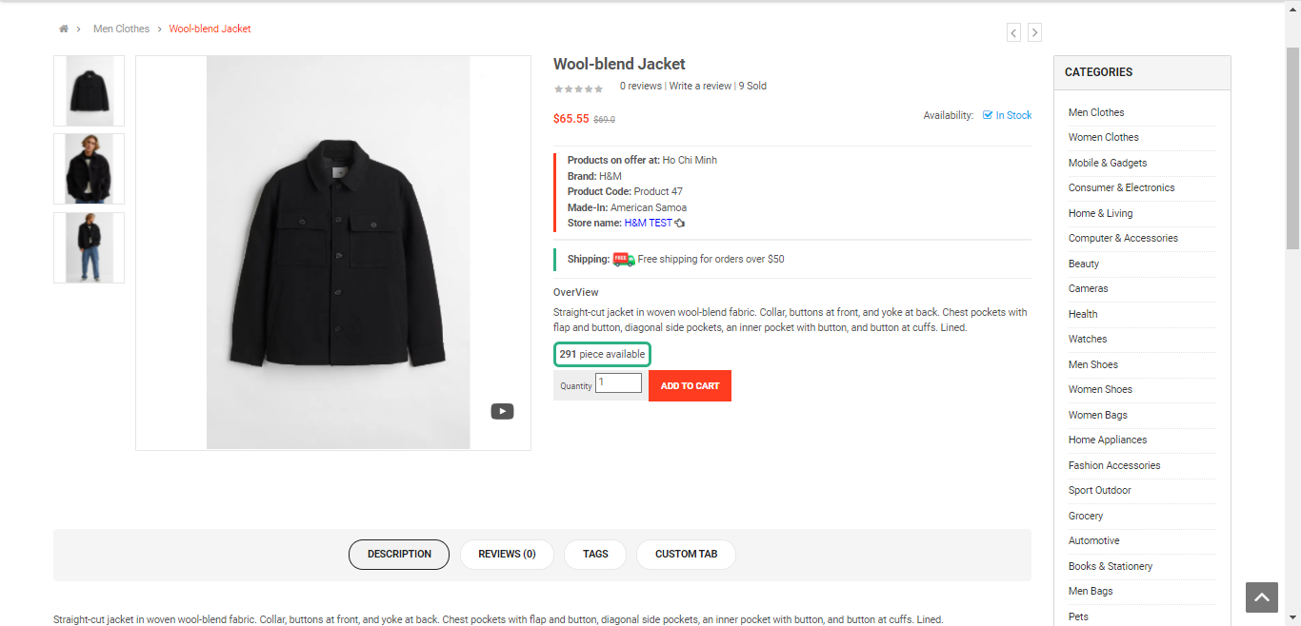 | When you choose one Product this page show information product, evaluate and some product in store or category.
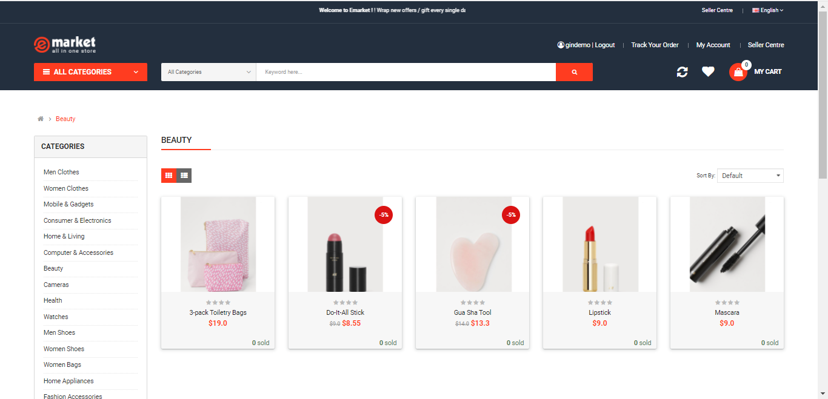 | When you choose one category this page show product in this category.
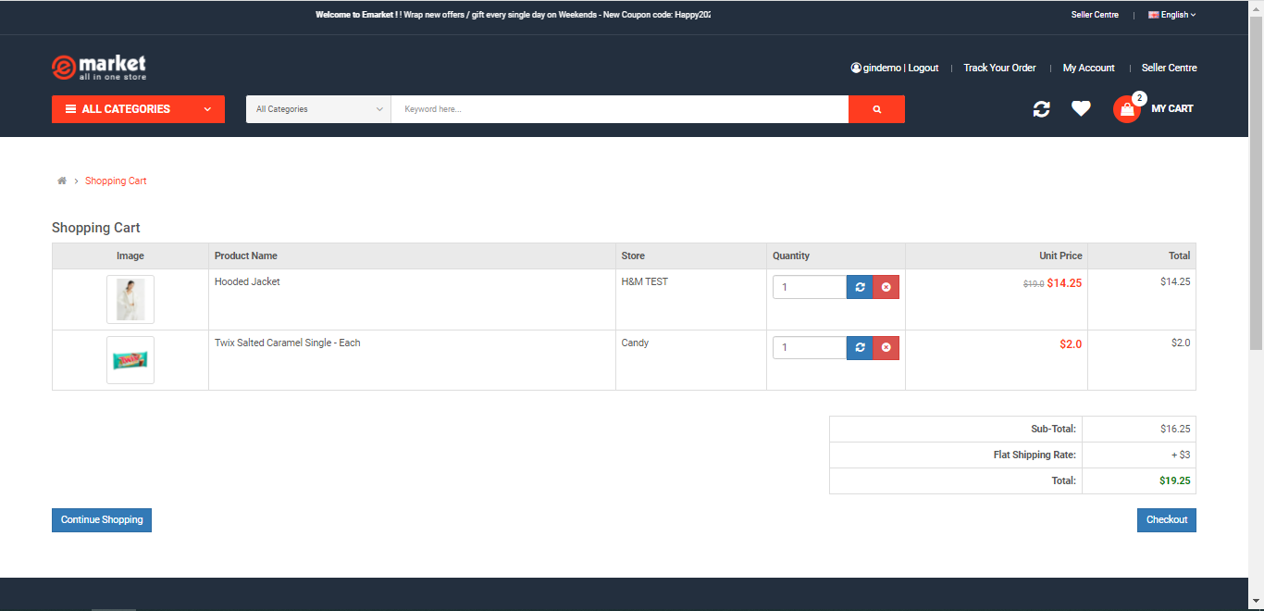 | When you click View Cart in My Cart this page show some product you choose to pay and you can increase or decrease the amount.
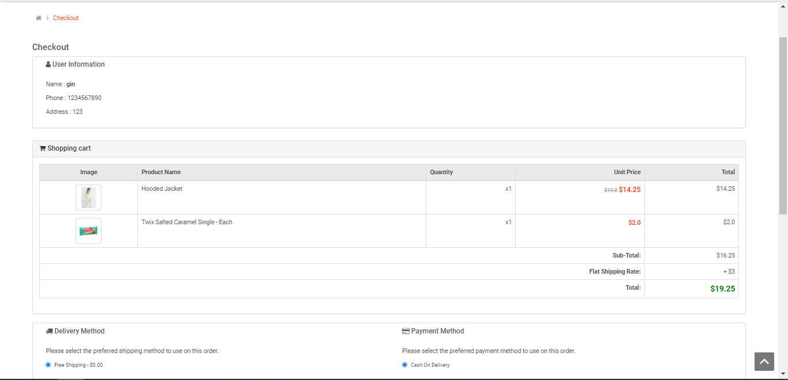 | When you click check out this page show the amount to pay.
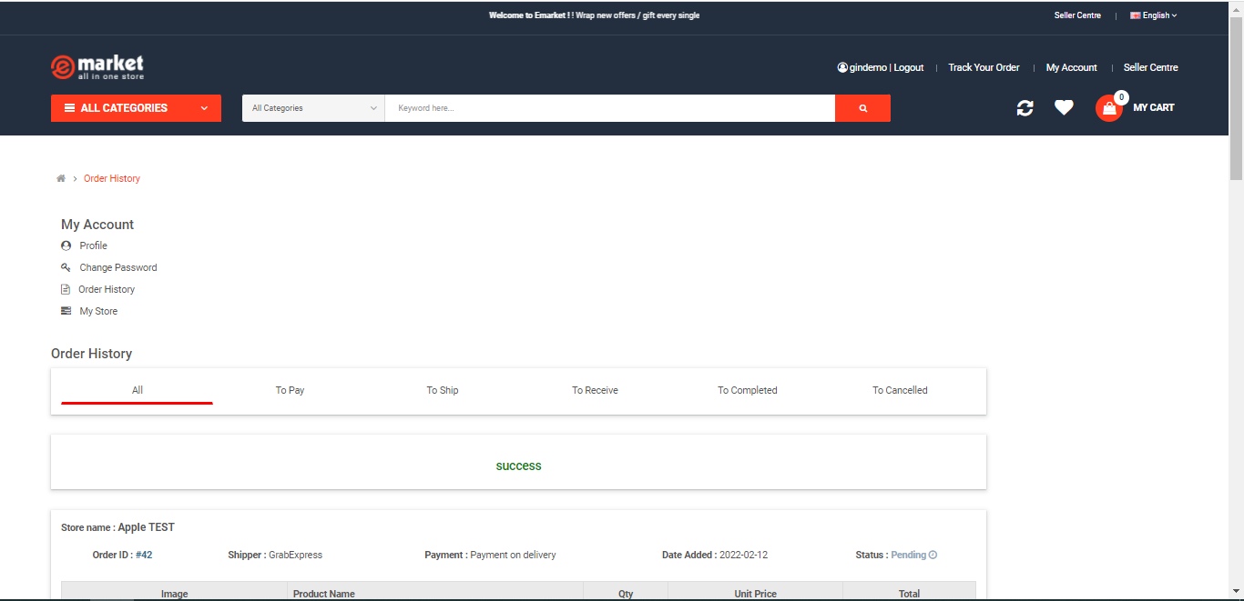 | When you click Confirm Order this page can show all your product to buy and waiting for processing.
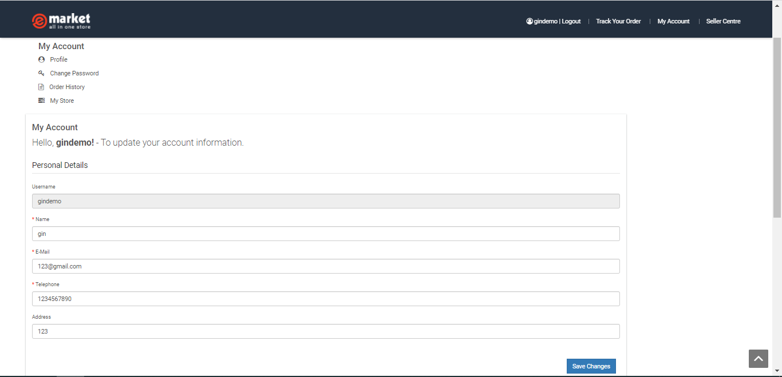 | When you click My Account this page can show your information and you can update your information.
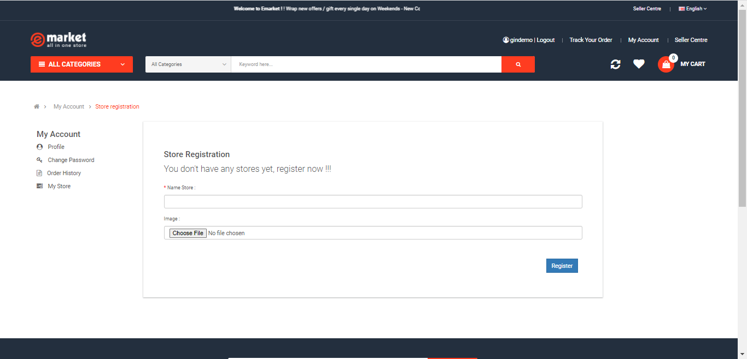 | When you click Seller Centre you can store registration in this web.
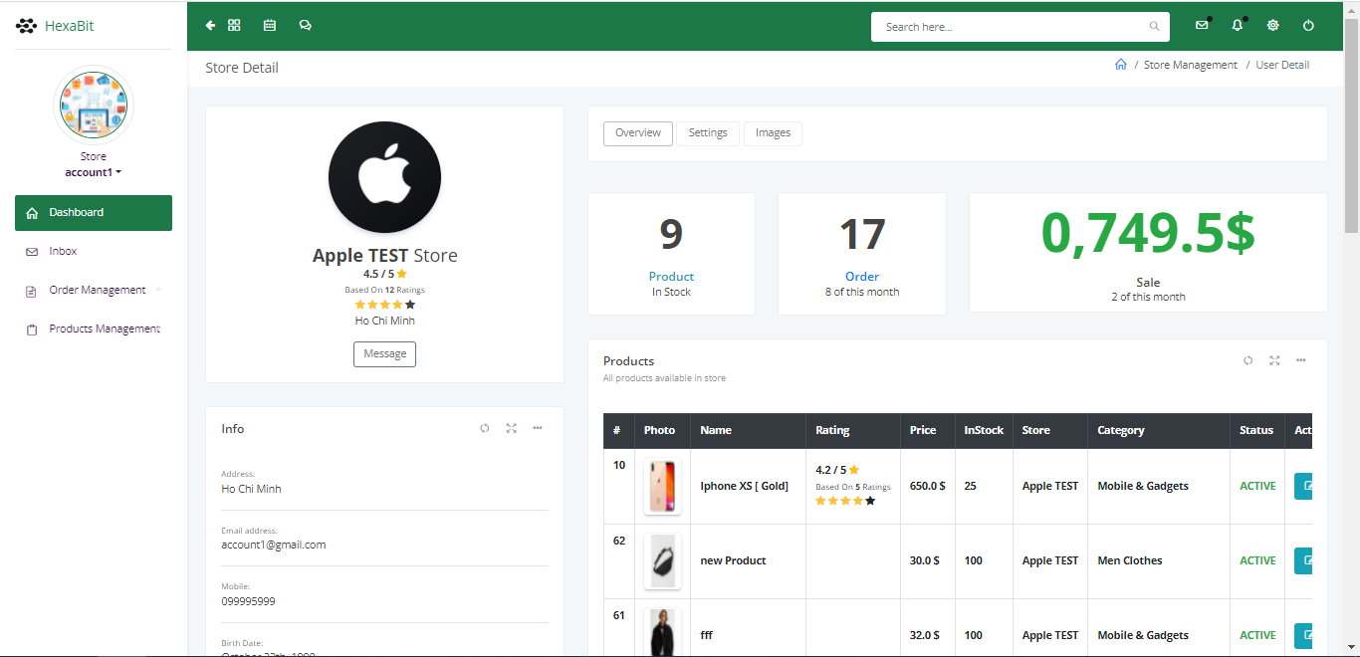 | If account have a store, you click Seller Centre you can go to this page. This page show all the product you up to sell.
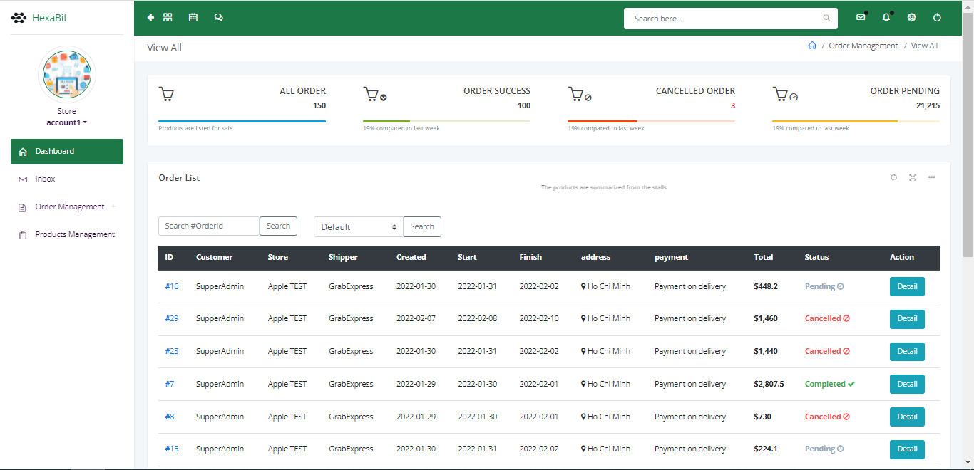 | When you click Order Management + Order Invoice this page can show the bill when the customer buy.
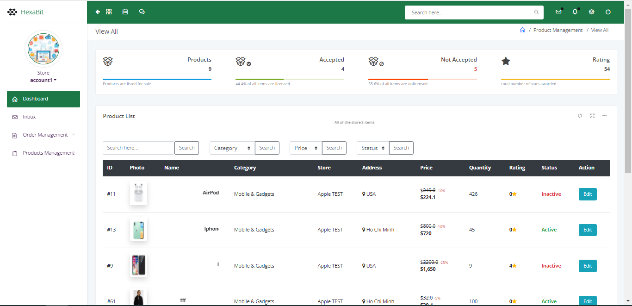 | When you click Products Management + View Products  This page can show all the product you sell.
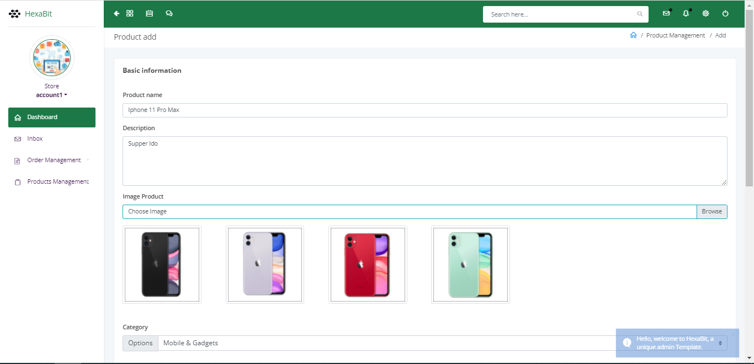 | When you click Edit one product you can update that product.
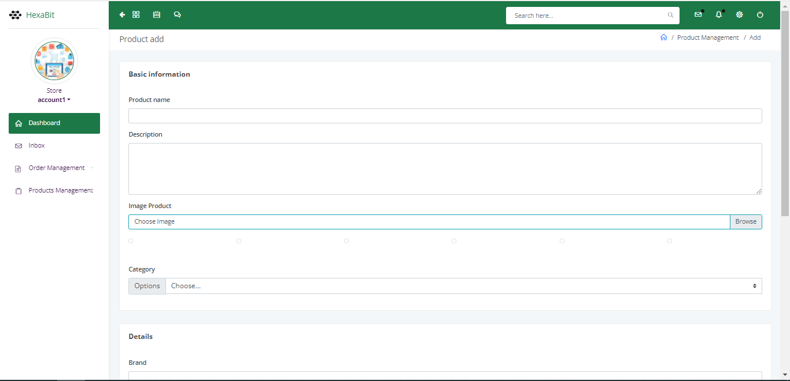 | When you click Products Management + New Product this page you can up product can sell.

CONFIGURATION

+ Software:
- Spring Tool 4
- MySql
+ Technology:
- Spring Mvc
- Springframework
- Jstl

PROJECT TIMELINES

S.No. | Task to be performed | Time
1
2

INDIVIDUAL PROJECT SCHEDULE

S.No. | Activity Description | Responsibility
1. | Full Stack | Dang Hoang Hong
2. | Full Stack | Duc Ngoc Ho
3. | Full Stack | Hoang Nguyen Huu
4. | Full Stack | Thien Ha Si
5. | Full Stack | Bao Le Hoang Phuc

