1)Load the rest countries data using your html and script.js file and run a for loop on the data and print all the

Ans: -

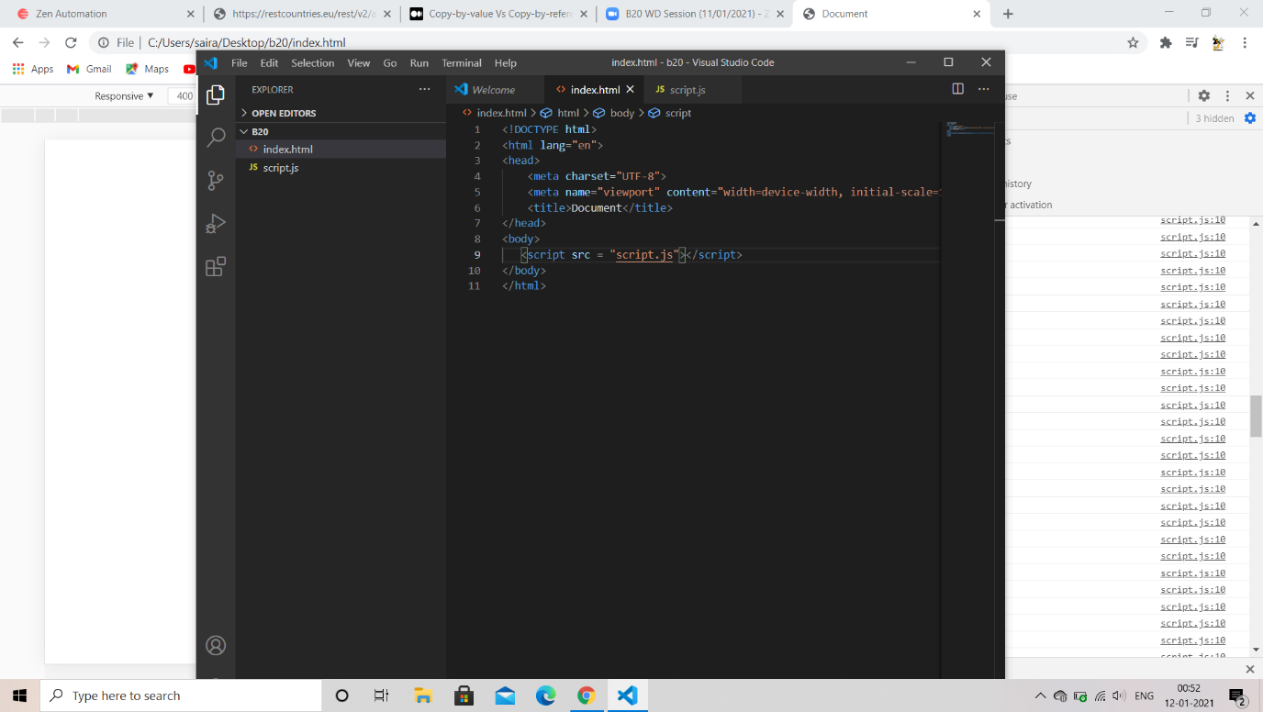country name in the console.

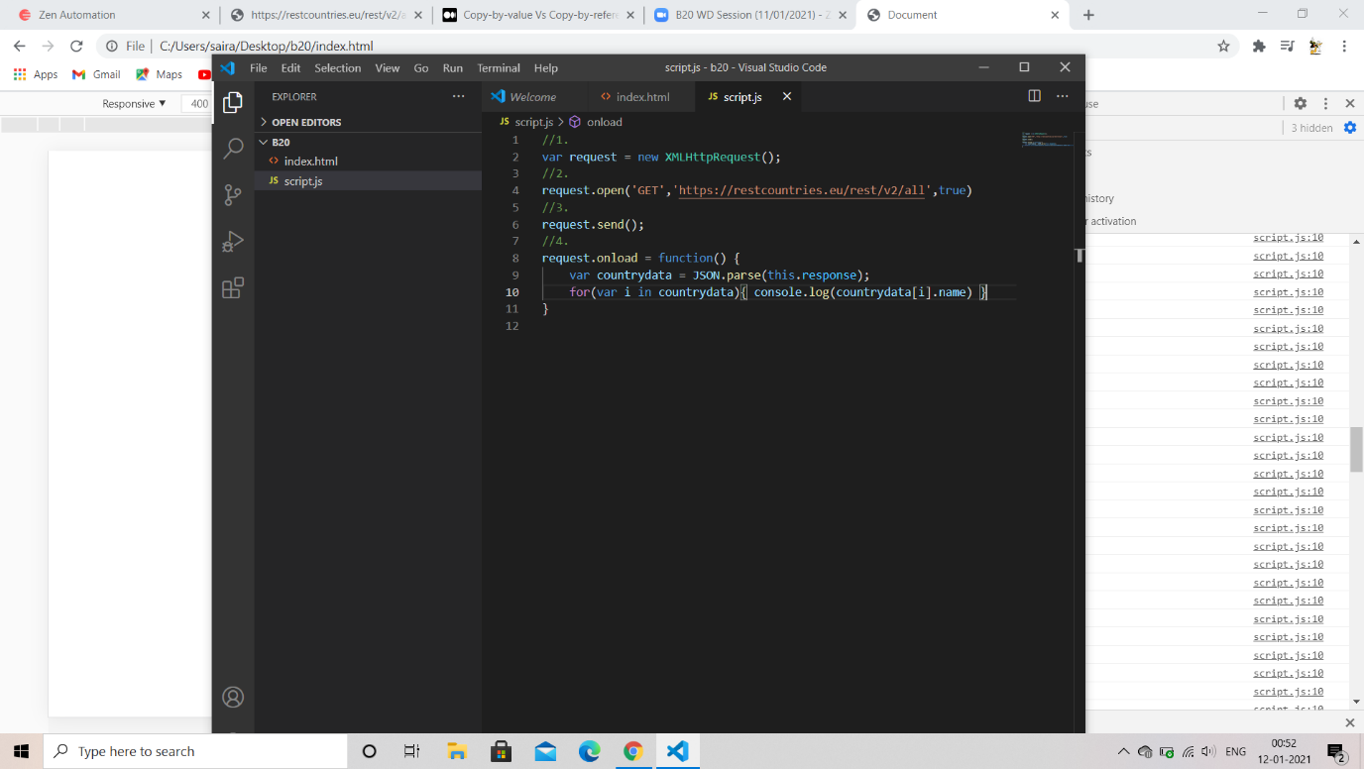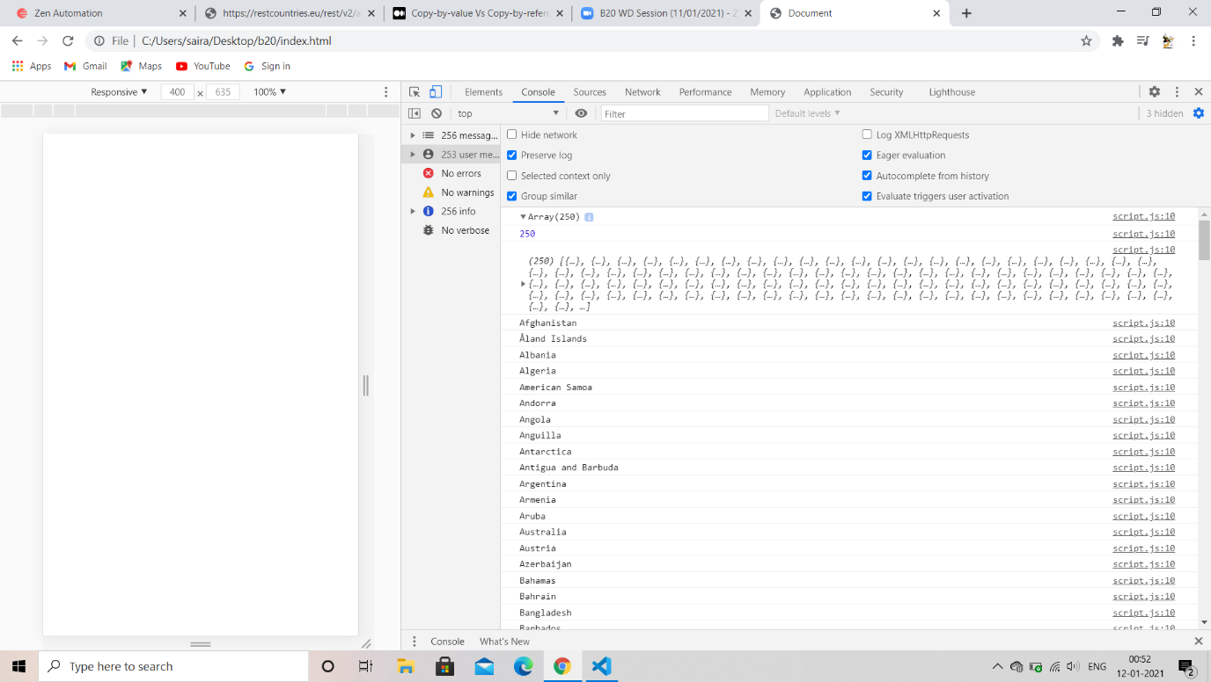

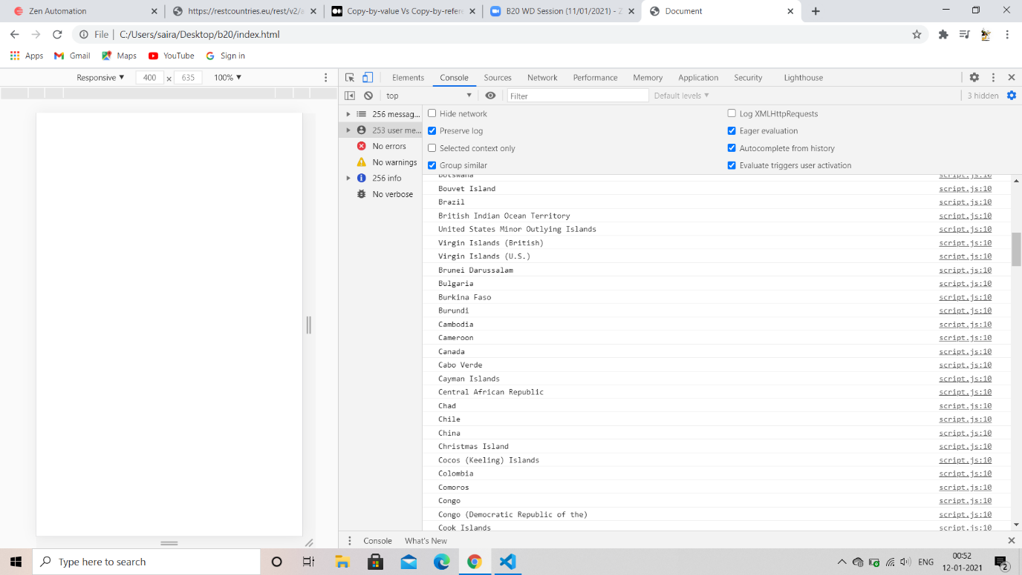

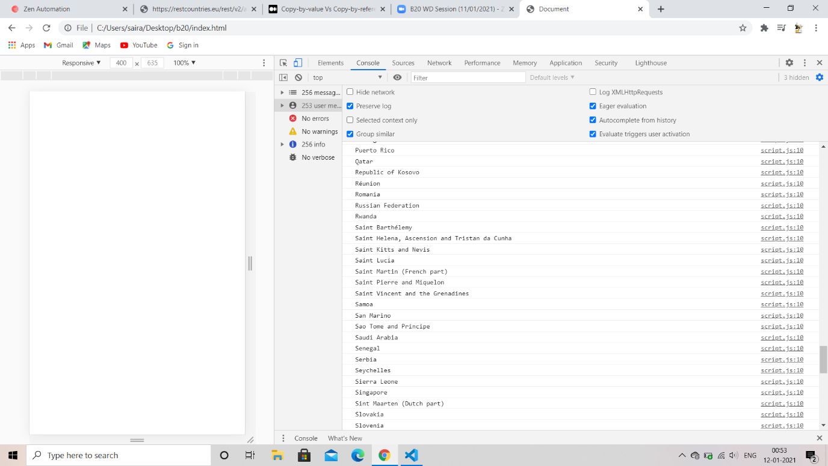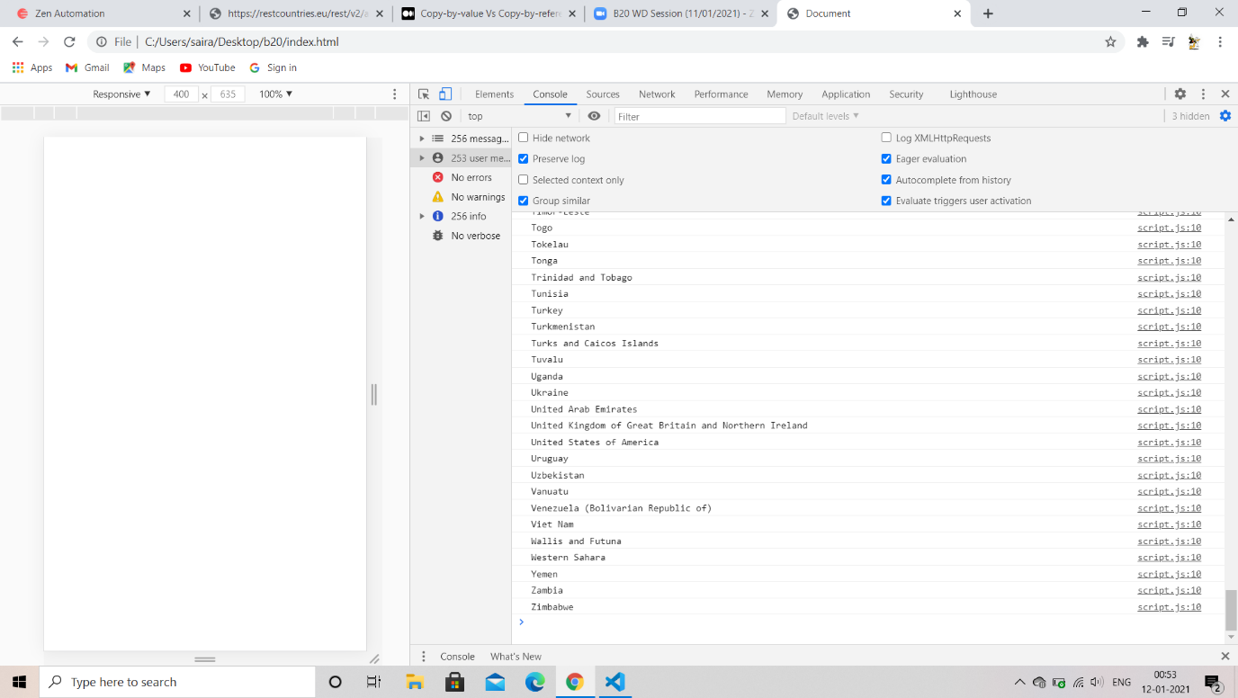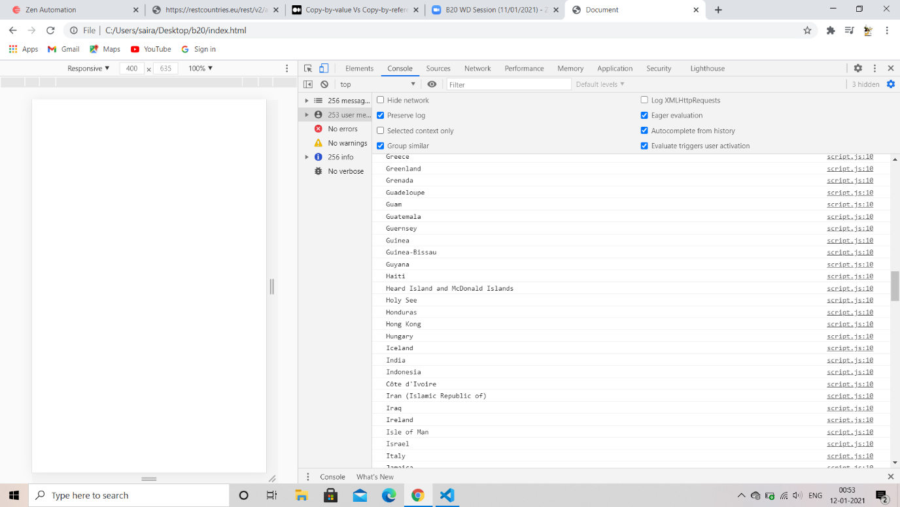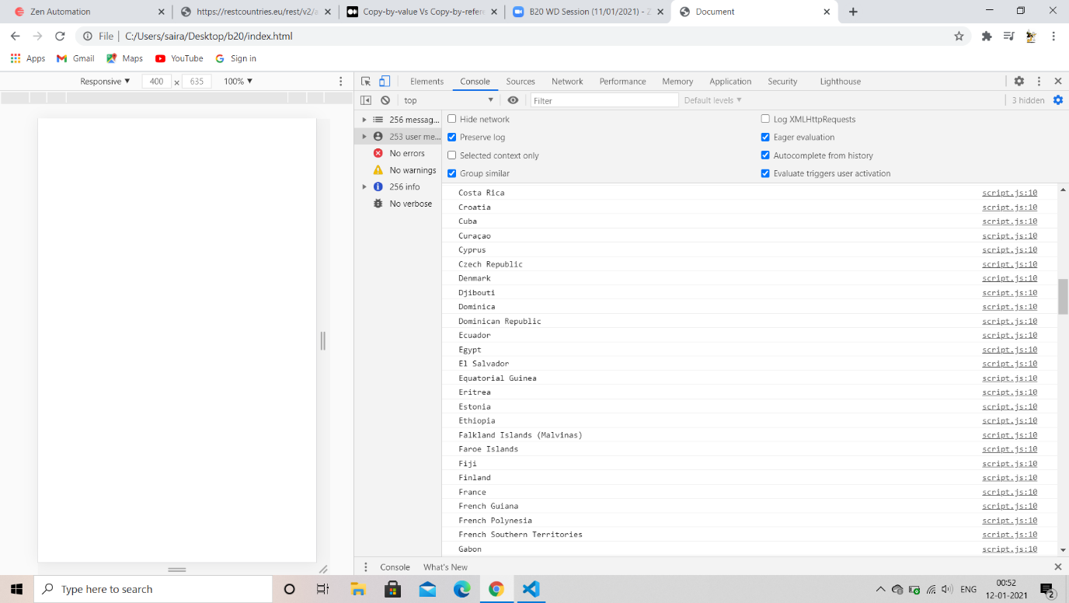

2) Write a write up on Difference between copy by value and copy by reference.

Ans: -

Call by reference: - In this which passes the address of the variable means a variable itself passed through the program

Call by value: - In this which passes the value of the variable means a copy variable itself passed through the program

Call by reference call by value

1)passes the address of the variable 1) passes the value it self

2)original value is modified 2) original value is not modified

3)supported by java language 3) supported by c, c#

4)pointers are required to store the address of 4) variables are passing through the

Variable straightforward method/normal method

5) a variable itself passes using this method 5) a copy of variable itself passes using this method

3) How to copy by value a composite datatype (array + objects).

Ans: -

Composite data types are passed by reference (so from the call by reference value itself passed) it is both the array and object

Array: -

An array is a series of data stored in a variable that is accessed using index numbers that indicate particular data.

Object: -

An object is a compound data type that consists of one or more pieces of data of any type grouped together in an object.

The best part of object is having the methods and functions, properties which are constants and variables