Course: Data Structures (CSE CS203A)
Assignment V: Tree
Student Worksheet Companion

Due date: 2025.12.30 23:59:59

Academic Integrity and AI Usage Statement
In this assignment, you must use AI tools (such as ChatGPT, Gemini, Claude, Grok, M365 Copilot, etc.) as learning assistants, but you must also take full responsibility for understanding and organizing your own work.

Permitted Use of AI Tools
You may use AI to:
- Review or clarify definitions and concepts.
- Compare different tree data structures.
- Get suggestions for report layout or examples.
- Ask for explanations of algorithms (e.g., BST insertion, AVL rotation, heapify process).
You should read, think about, and rewrite the content in your own words.

Not Permitted
- Do not copy/paste AI-generated content directly as your final answer.
- Do not ask AI to draw the final diagrams or directly produce the final tree screenshots.
- Do not ask AI to complete the whole assignment report for you.

Your Responsibility
- You are responsible for understanding the definitions and algorithms.
- You are responsible for verifying whether AI answers are correct or not.
- You must produce your own original explanations and diagrams.

AI Usage Log
- You must record all AI queries related to this assignment.
- At the end of your report, include an AI Usage Log table with: Index, Prompt, AI service name.
By submitting this assignment, you acknowledge that you have used AI tools only as study aids, and that the final content of this assignment represents your own understanding and work.

Section 1. Definitions of Tree Variants
Task: Write your own definitions for each tree type. You may use AI for learning, but rewrite in your own words.
- General Tree
Definition: 源頭是root，其他的節點叫做nodes，尾端沒有子節點的叫leaf與其他樹相較起來他的子節點沒有任何限制與規則。
- Binary Tree
Definition:每個節點只能有兩個子節點，為左子節點與右子節點。

- Complete Binary Tree
Definition: 在上面的binary tree額外加上條件：除了最後一層(leaf)以外都需要填滿，而且必須從左排到右。

- Binary Search Tree (BST)
Definition: 在上面的binary tree額外加上條件：對任意節點來說，左子樹的所有節點的直都小於該節點，右子樹反之。有排序過。

- AVL Tree
Definition: 在上面的binary tree額外加上條件：會自我平衡，任一節點的左子樹與右子樹高度差不超過一，若有更動導致失衡，會透過旋轉來恢復平衡。

- Red-Black Tree
Definition: 在上面的binary tree額外加上條件：會自我平衡，每個節點都有顏色，透過特定的顏色規則來確保樹的平衡，保證最長路徑不會超過最短路徑的兩倍。

- Max Heap
Definition: 在上面的complete binary tree額外加上條件：父節點的值永遠大於或等於其子節點的值。根節點永遠是整棵樹中最大的元素。

- Min Heap
Definition: 在上面的complete binary tree額外加上條件：父節點的值永遠小於或等於其子節點的值。根節點永遠是整棵樹中最小的元素。與max heap相反。

Section 2. Tree Family Hierarchy and Transformations
Task: Show how these structures are related (general → specialized). Use a simple diagram and explanations of what constraints are added at each step.
2.1 Tree Family Diagram
You may draw this by hand and paste a photo, or use drawing tools.
Suggested chain example (you may extend or adjust):
General Tree → Binary Tree → Complete Binary Tree
Binary Tree → Binary Search Tree → AVL / Red-Black
Binary Tree → Max Heap / Min Heap
Your Diagram:
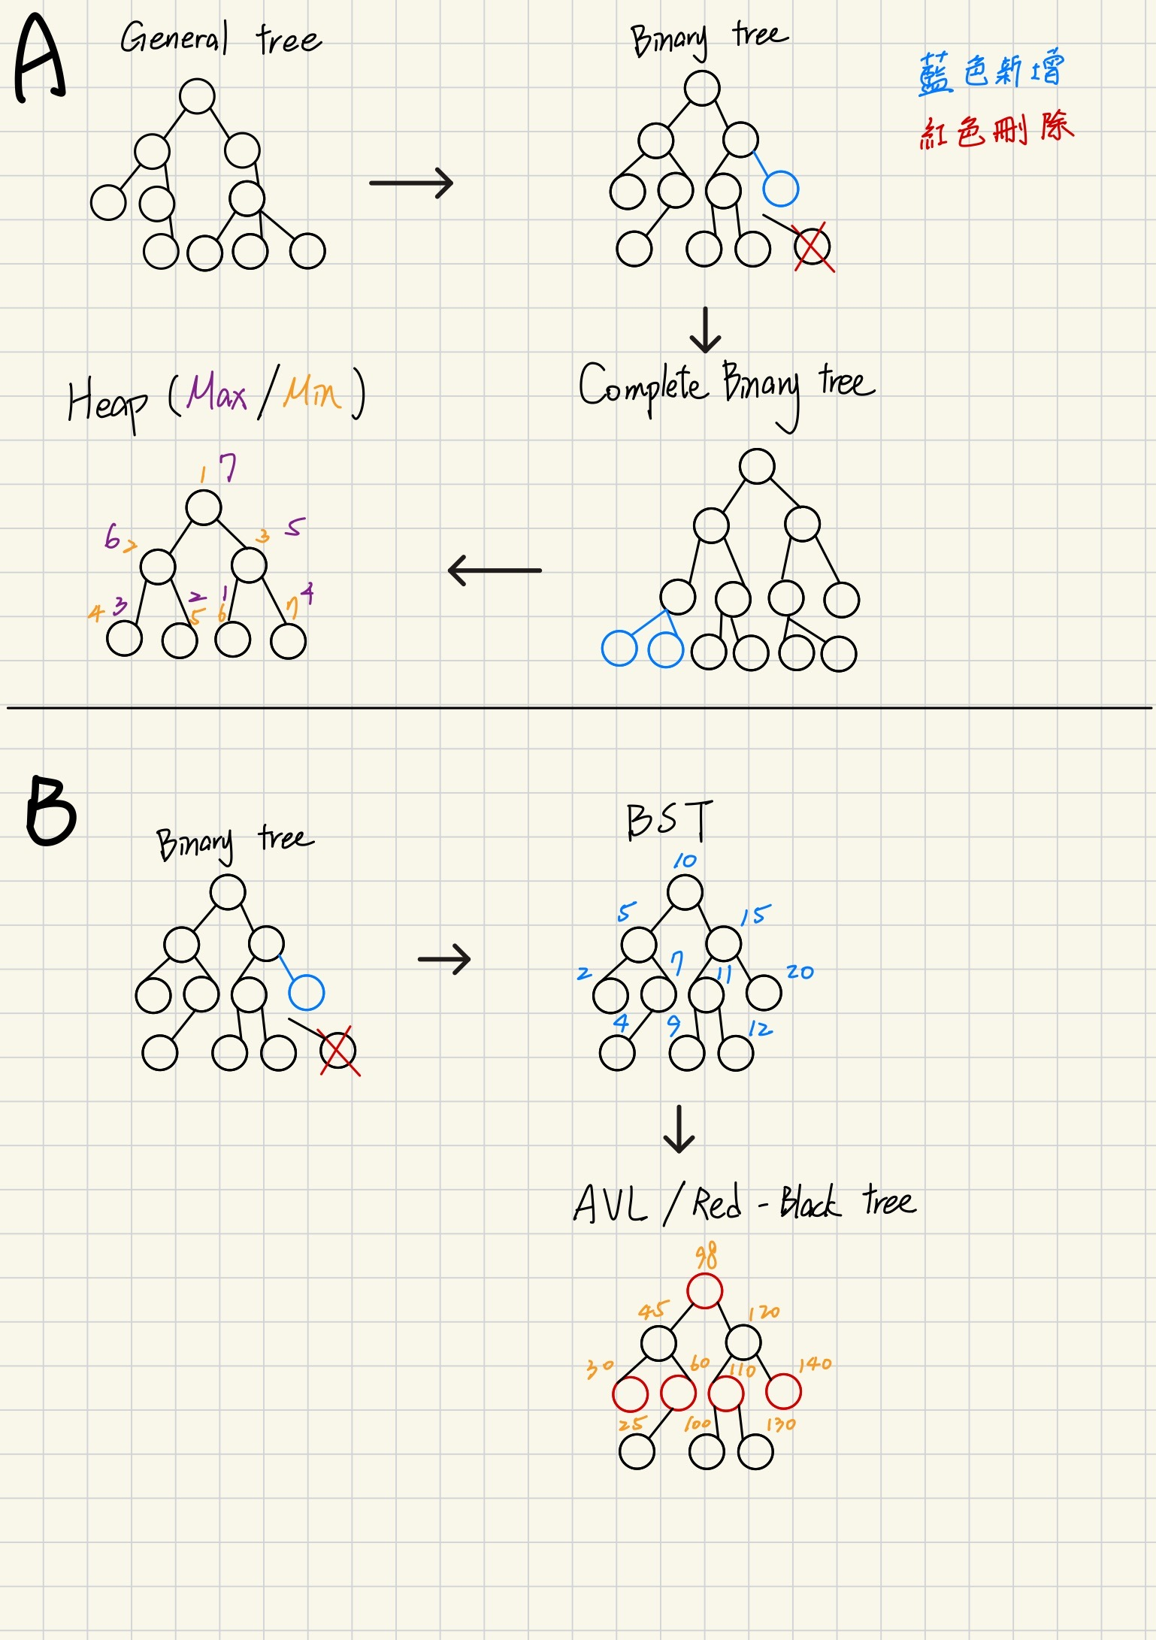

2.2 Explanation of Transformations
Fill in what new property or constraint is added at each step.
From | To | New property / constraint added
General Tree | Binary Tree | 數量限制：每個節點最多只能有兩個子節點
Binary Tree | Complete Binary Tree | 形狀限制：除了最後一層必須填滿，最後一層從左至右中間不能有空洞
Binary Tree | Binary Search Tree | 排序限制：左子節點root右子節點
BST | AVL Tree | 平衡限制：左右子樹高度差不能超過1
BST | Red-Black Tree | 顏色規則：透過顏色標記與規則，確保最短路徑長與最長路徑長不超過1
Binary Tree | Max Heap | 父子節點大小限制：父節點>=子節點
Binary Tree | Min Heap | 父子節點大小限制：父節點<=子節點

Section 3. Tree Constructions Using Given Integers
Given integers (fixed for all parts):
37, 142, 5, 89, 63, 117, 24, 176, 58, 133, 92, 11, 151, 72, 39, 184, 7, 101, 54, 160
Task: For each tree type below, construct the tree using these integers, take a screenshot of the tree from your chosen tool, record the tool name/URL, and describe the insertion / heap-building procedure.
3.1 Binary Tree
Tool name / URL:
Draw.io / https://www.drawio.com

Construction / insertion description:
普通樹可以隨意插入，不需要規律。

Screenshot of Binary Tree (paste below):
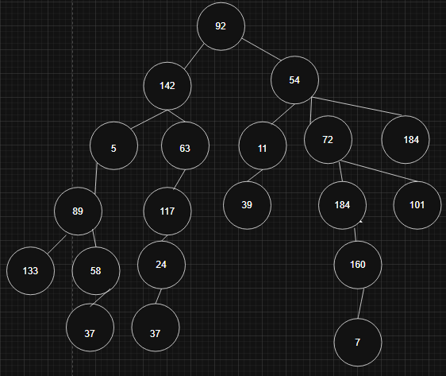
3.2 Complete Binary Tree
Tool name / URL:
Draw.io / https://www.drawio.com
Construction / insertion description:
結構有規定，除最後一層以外都須排滿，且由左到右中間不能空著。
Screenshot of Complete Binary Tree (paste below):
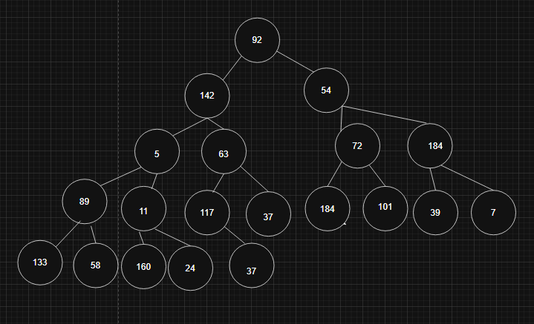
3.3 Binary Search Tree (BST)
Tool name / URL:
USF CA Visualization-Binary Search Tree/ https://www.cs.usfca.edu/~galles/visualization/Algorithms.html
Insertion rule (e.g., “insert in given order using BST rules”):
依序輸入，網站會自動排列。
Screenshot of BST (paste below):
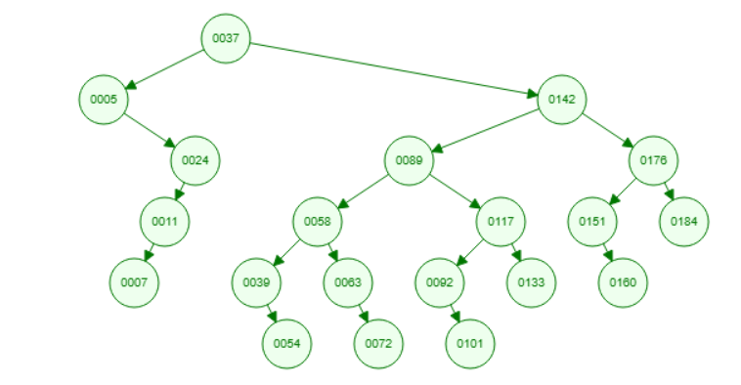
3.4 AVL Tree
Tool name / URL:
USF CA Visualization- AVL Trees (Balanced binary search trees) / https://www.cs.usfca.edu/~galles/visualization/Algorithms.html

Insertion & balancing description:
依序輸入，網站會自動旋轉成合適的樹。

Screenshot of AVL Tree (paste below):
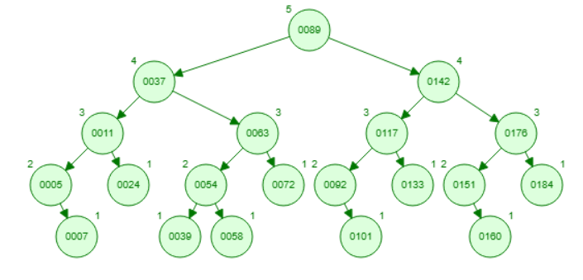

3.5 Red-Black Tree
Tool name / URL:
USF CA Visualization- Red-Black Trees / https://www.cs.usfca.edu/~galles/visualization/Algorithms.html

Insertion & balancing description:
依序輸入，網站會自動旋轉成合適的樹。

Screenshot of Red-Black Tree (paste below):
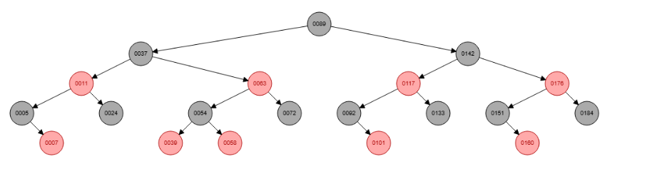

3.6 Max Heap
Tool name / URL:
Max Heap Simulator/ https://sercankulcu.github.io
Construction / heap-building description (e.g. heapify, insert-and-sift-up):
依序輸入，網站會自動旋轉成合適的樹。
Screenshot of Max Heap (paste below):
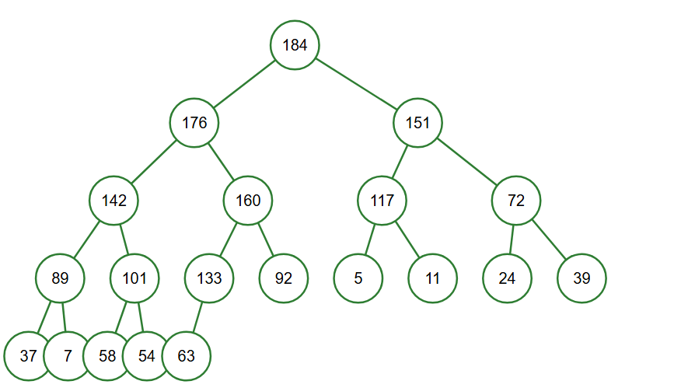

3.7 Min Heap
Tool name / URL:
USF CA Visualization-Skew Heap / https://www.cs.usfca.edu/~galles/visualization/Algorithms.html

Construction / heap-building description:
依序輸入，網站會自動旋轉成合適的樹。
Screenshot of Min Heap (paste below):
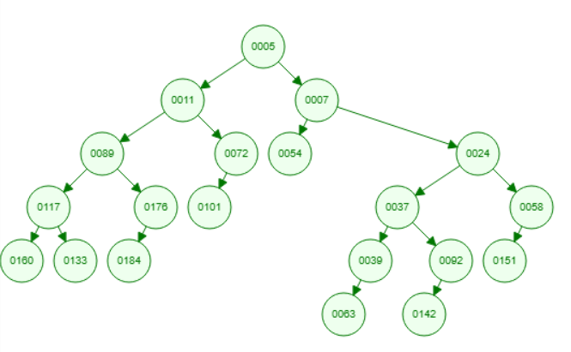
Section 4. Application Examples
Task: For each tree type, choose one application and explain why this tree is suitable.
Tree Type | Application Example (name / context) | Why this tree fits (properties that matter)
Binary Tree | Expressoion tree | 因為剛好對應二元運算子，可以解數學
Complete Binary Tree | Heap array | 沒有空洞可以直接映射到array上
Binary Search Tree | 動態字典 | 插入、刪除、搜尋都是O(log n)
AVL Tree | Read-heavy DB | 遵守平衡原則，所以搜尋速度快，適合讀多寫少的資料
Red-Black Tree | C++ STL Map / Java TreeMap | 插入予刪除的旋轉次數比AVL少，適合經常變動的資料儲存
Max Heap | 優先權的Queue | 最大值永遠在root，可以用O(1)時間找到
Min Heap | 霍夫曼編碼 | 資料壓縮須找出頻率最小的字元合併，可以用O(1)時間找到

Section 5. Reflection on Tree Family and Performance (Optional but recommended)
Among BST, AVL, and Red-Black trees, which one would you pick for:
Mostly search (few updates)? Why?
AVL tree，平衡條件最嚴格，所以高度最低，搜尋時要遍歷的節點較少。

Frequent insertions and deletions? Why?
Red-Black tree，平衡條件較寬鬆，插入刪除時需要的旋轉次數通常比 AVL 少，維護成本較低。

If you must store these 20 integers for static search only (no updates), which structure or representation would you prefer (sorted array + binary search, BST, AVL, etc.)? Why?
Sorted array + binary search，因為需要更新的話array占用的空間最少

Section 6. AI Usage Log (Required)
Task: Record every time you ask an AI assistant about this assignment.
Index | Date / Time | AI Service (ChatGPT, Gemini, etc.) | Your Full Prompt / Question
1 | 2025/12/29 | Gemini | Assignment_V.word
2 | 2025/12/29 | Gemini | 幫助我寫這份作業
3
4
You may extend this table as needed.

