DR. RVR NRI UNIVERSITY
B.TECH – COMPUTER SCIENCE AND ENGINEERING
(ARTIFICIAL INTELLIGENCE AND MACHINE LEARNING)

WEB DEVELOPMENT PROJECT REPORT

FITZONE GYM WEBSITE
AND
NRI COLLEGE WEBPAGE

Submitted by
PINNIKA VAMSI KRISHNA
First Year – B.Tech CSE (AI & ML)

Academic Project Submission

DECLARATION OF PROJECT SCOPE
This report documents two separate introductory web development projects supplied for this submission: the FITZONE Gym website and the NRI College webpage. The explanations and screenshots are based on the uploaded HTML and CSS files. The source listings are included as submitted, without changing their code.
Both pages were rendered in Chromium from the supplied HTML markup with the exact linked local CSS rules applied. The screenshots represent the browser output at a 1280-pixel viewport width. Neither project references external images or external libraries.

STUDENT DETAILS
Student Name | PINNIKA VAMSI KRISHNA
University | DR. RVR NRI UNIVERSITY
Course | B.Tech – CSE (AI & ML)
Year | First Year

CONTENTS
- 1. Project One – FITZONE Gym Website
- 2. FITZONE – Actual Webpage Output and Explanation
- 3. FITZONE – Complete Source Code
- 4. Project Two – NRI College Webpage
- 5. NRI College – Actual Webpage Output and Explanation
- 6. NRI College – Complete Source Code
- 7. Overall Conclusion

1. PROJECT ONE – FITZONE GYM WEBSITE

1.1 Project Title
FITZONE – Gym and Fitness Website

1.2 Introduction
FITZONE is a simple gym and fitness website designed to present a gym’s workout programs, trainer categories, membership plans, facilities, class schedule and registration form. Its purpose is to give visitors a clear overview of the services offered and guide interested users towards the registration section.

1.3 Technologies Used
- HTML5: Provides the webpage structure through elements such as header, navigation, main, sections, headings, links, buttons, form controls and footer.
- CSS3: Controls the page layout, colors, typography, spacing, card design, button appearance, hover effects and responsive behavior.
No JavaScript framework, database, external image library or backend service is referenced in the supplied files.

1.4 Webpage Description
The page begins with a dark cyan header. The FITZONE name is displayed with a flexed-arm emoji, and a navigation menu provides links to Home, Programs, Trainers, Pricing and Register. The navigation is placed inside the header and uses white text.
The Home section is a dark slate-colored hero area with the main heading “BUILD YOUR BEST BODY”, a short fitness slogan and an orange “Join Now” button. The button is styled as a call-to-action; in the supplied HTML it is a button element and is not connected to a form or navigation action.
The Workout Programs section presents three cards: Strength Training, Cardio Fitness, and Yoga & Flexibility. The Trainers section presents three trainer roles: Strength Coach, Cardio Coach, and Yoga Instructor. Both sections use a three-column CSS grid on wider screens.
The Membership Plans section shows Basic, Standard and Premium plans with monthly prices of 999/-, 1,499/- and 2,499/- respectively. Each plan includes a “Choose Plan” link that points to the registration section.
Two additional sections list facilities and class schedule details. Facilities include Modern Equipment, Locker Rooms and Personal Training. The schedule lists Mon – Yoga, Wed – Cardio and Fri – Strength.
The Registration Form contains fields for full name, email address, phone number, a text field with the placeholder “select text”, and a membership dropdown. The fields are marked required. The supplied code does not specify a form-processing endpoint or backend, so successful data storage cannot be inferred.
A dark footer displays “© 2026 FITZONE GYM | All Rights Reserved”. The CSS uses Arial/sans-serif for the body, a white page background, dark slate blue text, dark cyan header, dark hero and footer backgrounds, and orange accent buttons. Cards have rounded corners and soft shadows. Hover styling lifts cards and enlarges buttons slightly. A media query adjusts header and navigation alignment for narrower screens.

1.5 Actual Webpage Output
The following screenshots were captured by rendering the submitted vamsi.html markup with the exact rules from vamsi.css in Chromium. No external images are referenced by this page.
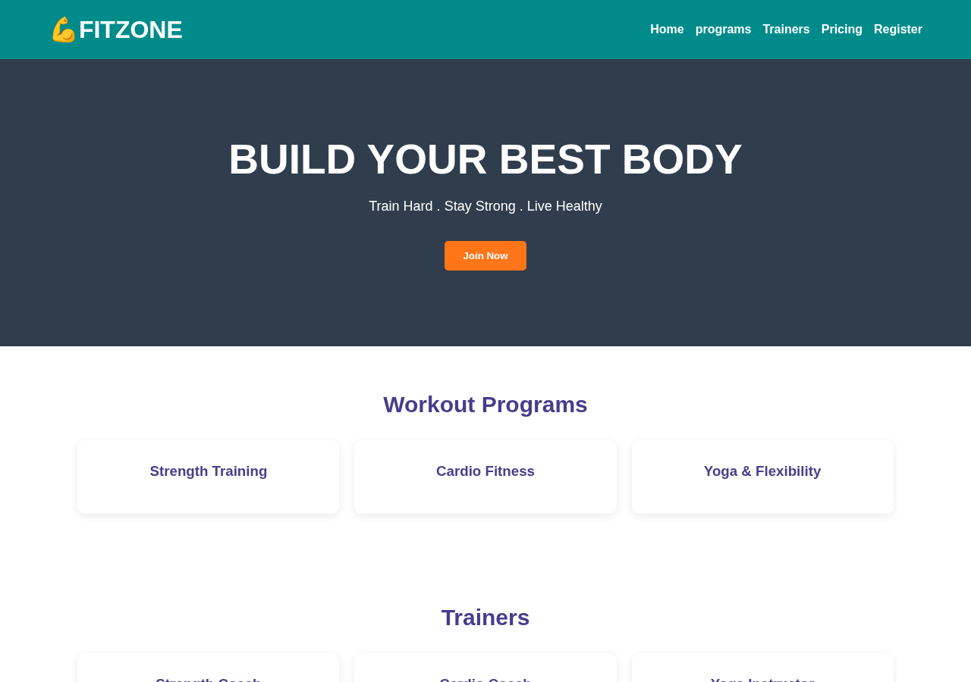
FITZONE Gym Website – Screenshot 1 of 3
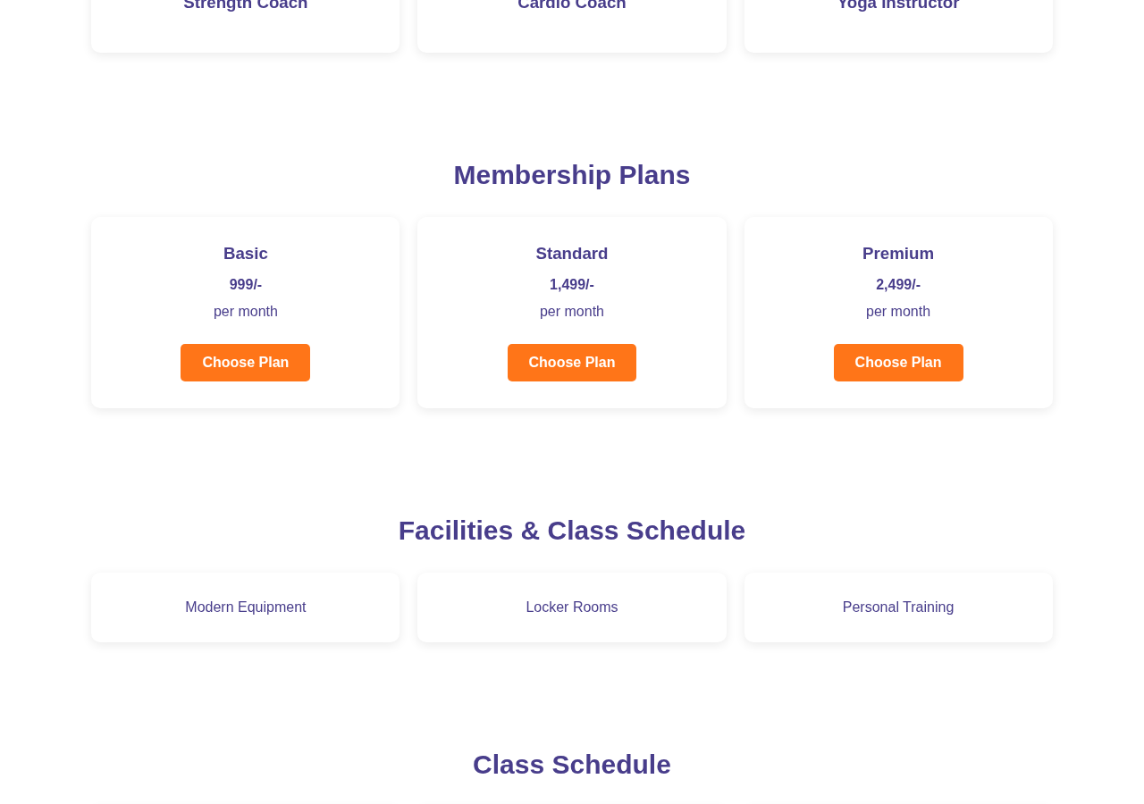
FITZONE Gym Website – Screenshot 2 of 3
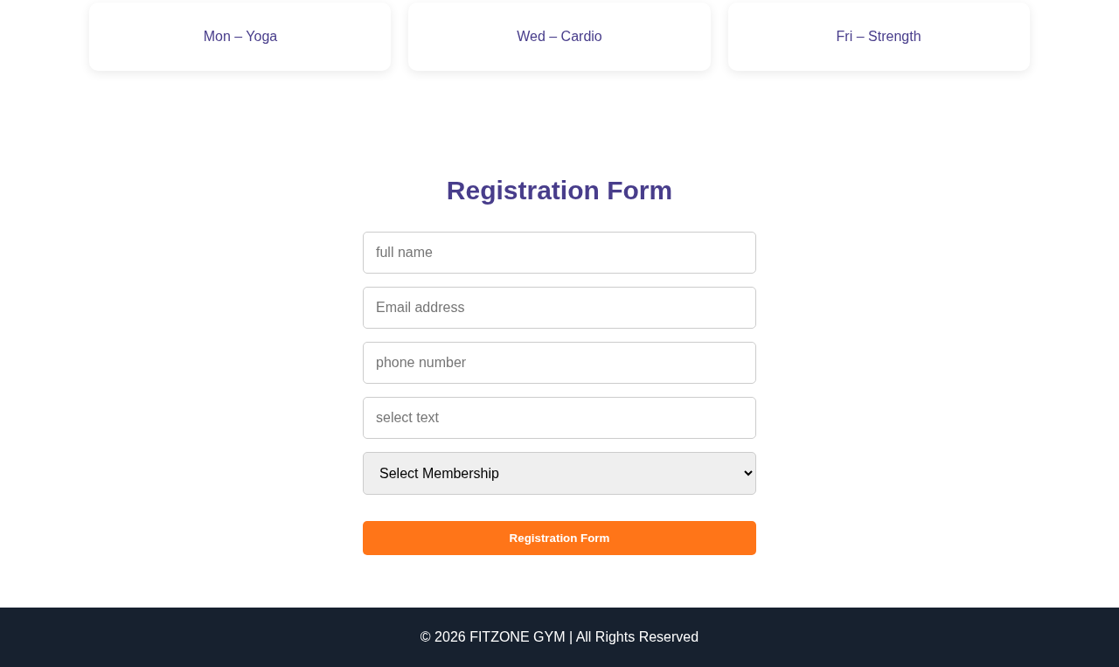
FITZONE Gym Website – Screenshot 3 of 3

1.6 Output Explanation
The rendered output shows the FITZONE branding and navigation at the top, followed by a prominent dark hero banner with a centered fitness message and orange call-to-action. Below it, the workout, trainer and membership information is arranged in card layouts. The facilities and weekly class schedule are displayed in additional card groups. The registration area appears near the bottom with vertically arranged input fields and a membership selector, followed by the dark footer. The page uses a consistent dark-blue, cyan, white and orange color scheme.

1.7 Complete Source Code

HTML5 – vamsi.html
<!DOCTYPE html>
<html lang="en">
<head>
<title>fitzone</title>
<meta charset="UTF-8">
<link rel="stylesheet" href="vamsi.css">
</head>
<body>
<header>
<h1>💪FITZONE</h1>
<nav>
<a href="#home">Home</a>
<a href="#programs">programs</a>
<a href="#trainers">Trainers</a>
<a href="#pricing">Pricing</a>
<a href="#register">Register</a>
</nav>
</header>
<main>
<section id="home" class="hero">
<h1>BUILD YOUR BEST BODY</h1>
<p>Train Hard . Stay Strong . Live Healthy</p>
<button id="#register" class="btn">Join Now</button>
</section>

<section id="programs">

<h2>Workout Programs</h2>
<div class="cards">

<div class="card">
<h3>Strength Training</h3>
</div>
<div class="card">

<h3>Cardio Fitness</h3>
</div>
<div class="card">
<h3>Yoga & Flexibility</h3>
</div>
</div>
</section>

<section id="trainers">
<h2>Trainers</h2>
<div class="cards">
<div class="card">
<h3>Strength Coach</h3>
</div>
<div class="card">
<h3>Cardio Coach</h3>
</div>
<div class="card">
<h3>Yoga Instructor</h3>
</div>
</div>
</section>

<section id="pricing">
<h2>Membership Plans</h2>
<div class="cards">
<div class="card">
<h3>Basic</h3>
<h4>999/-</h4>
<p>per month</p>
<a href="#register" class="btn">Choose Plan</a>
</div>

<div class="card">

<h3>Standard</h3>
<h4>1,499/-</h4>
<p>per month</p>
<a href="#register" class="btn">Choose Plan</a>
</div>

<div class="card">
<h3>Premium</h3>
<h4>2,499/-</h4>
<p>per month</p>
<a href="#register" class="btn">Choose Plan</a>
</div>
</div>
</section>

<section>
<h2>Facilities & Class Schedule</h2>
<div class="cards">

<p class="card">Modern Equipment</p>
<p class="card">Locker Rooms</p>
<p class="card">Personal Training</p>
</div>
</section>
<section>

<h2>Class Schedule</h2>
<div class="cards">
<p class="card">Mon – Yoga</p>
<p class="card">Wed – Cardio</p>
<p class="card">Fri – Strength</p>
</div>
</section>

<section id="register">
<h2>Registration Form</h2>

<form>
<input type="text" placeholder="full name" required>
<input type="email" placeholder="Email address" required>
<input type="tel" placeholder="phone number" required>
<input type="text" placeholder="select text" required>

<select required>
<option value="">Select Membership</option>
<option>Basic</option>
<option>Standard</option>
<option>Premium</option>
</select>

<button type="submit" class="btn">Registration Form</button>
</form>
</section>
</main>
<footer>
<p>© 2026 FITZONE GYM | All Rights Reserved</p>
</footer>
</body>

</html>

CSS3 – vamsi.css
* {
margin: 0;
padding: 0;
box-sizing: border-box;
}
header
{
background-color: darkcyan;
color: white;
padding: 20px 5%;
display: flex;
justify-content: space-between;
align-items: center;
flex-wrap: wrap;
gap: 20px;
}

html {
scroll-behavior: smooth;
}
body {
font-family: Arial, sans-serif;
background: white;
color: darkslateblue;
}
header span {
color: #ff7518;
}
nav {
display: flex;
gap: 15px;
flex-wrap: wrap;
}
nav a {
color: white;
text-decoration: none;
font-weight: bold;
transition: color 0.3s;
}
nav a:hover {
color: #ff7518;
}
.hero {
background: #303d4c;
color: white;
text-align: center;
padding: 100px 20px;
}
.hero h1 {
font-size: clamp(32px, 5vw, 55px);
font-weight: 900;
}
.hero p {
margin: 20px 0;
font-size: 18px;
}
.btn {
display: inline-block;
background: #ff7518;
color: white;
border: none;
padding: 12px 24px;
margin-top: 15px;
border-radius: 5px;
text-decoration: none;
font-weight: bold;
cursor: pointer;
transition: 0.3s;
}
.btn:hover {
background: #d95400;
transform: scale(1.05);
}
section {
padding: 60px 8%;
text-align: center;
}
section h2 {
font-size: 30px;
margin-bottom: 30px;
}
.cards {
display: grid;
}
.cards {
display: grid;
grid-template-columns: repeat(3, 1fr);
gap: 20px;
}
.card {
background: white;
padding: 30px 20px;
border-radius: 10px;
box-shadow: 0 3px 12px #00000015;
transition: 0.3s;
}
.card h3 {
margin-bottom: 15px;
}
.card p {
margin: 12px 0;
}
.card:hover {
transform: translateY(-8px);
box-shadow: 0 8px 20px #00000025;
}
form {
max-width: 450px;
margin: auto;
display: flex;
flex-direction: column;
gap: 15px;
}
input, select {
width: 100%;
padding: 14px;
border: 1px solid #ccc;
border-radius: 5px;
font-size: 16px;
}
input:focus, select:focus {
outline: 2px solid #ff7518;
}
footer {
background: #17212f;
color: white;
text-align: center;
padding: 25px;
}
@media (max-width: 768px) {
header {
justify-content: center;
text-align: center;
}}
nav {
justify-content: center;
}

2. PROJECT TWO – NRI COLLEGE WEBPAGE

2.1 Project Title
NRI College – Welcome Webpage

2.2 Introduction
The NRI College webpage is a basic introductory college webpage. Its purpose is to display the college name and a welcome message, along with a simple navigation bar containing links labelled Home, About, Courses and Contact. It demonstrates the use of semantic HTML elements and basic CSS styling.

2.3 Technologies Used
- HTML5: Builds the page structure using the document head, title, body, header, heading, paragraph, navigation and anchor elements.
- CSS3: Applies background colors, text alignment and padding to the header and navigation area.
The supplied code does not reference JavaScript, external images, frameworks or backend technologies.

2.4 Webpage Description
The browser tab title is “my web page”. In the body, a header contains the heading “NRI college” and the welcome message “welcome to NRI college”. The CSS gives this header a brown background, centered text alignment and 20 pixels of padding.
Below the header is a navigation bar containing four anchor links: HOME, About, Courses and contact. The navigation bar has a white background, centered text alignment and 25 pixels of padding. The stylesheet also includes a rule for an element selector named “anav”, which sets padding; however, the HTML uses ordinary anchor elements and does not contain an anav element, so that rule does not style the navigation links.
The webpage is intentionally minimal. It does not include separate content sections, images, buttons, a form or a footer. The navigation anchors use placeholder or empty destinations in the submitted HTML, so they do not lead to implemented content sections.

2.5 Actual Webpage Output
The following screenshot was captured by rendering the submitted semantic.html markup with the exact rules from se.css in Chromium. No external images or other external resources are referenced.
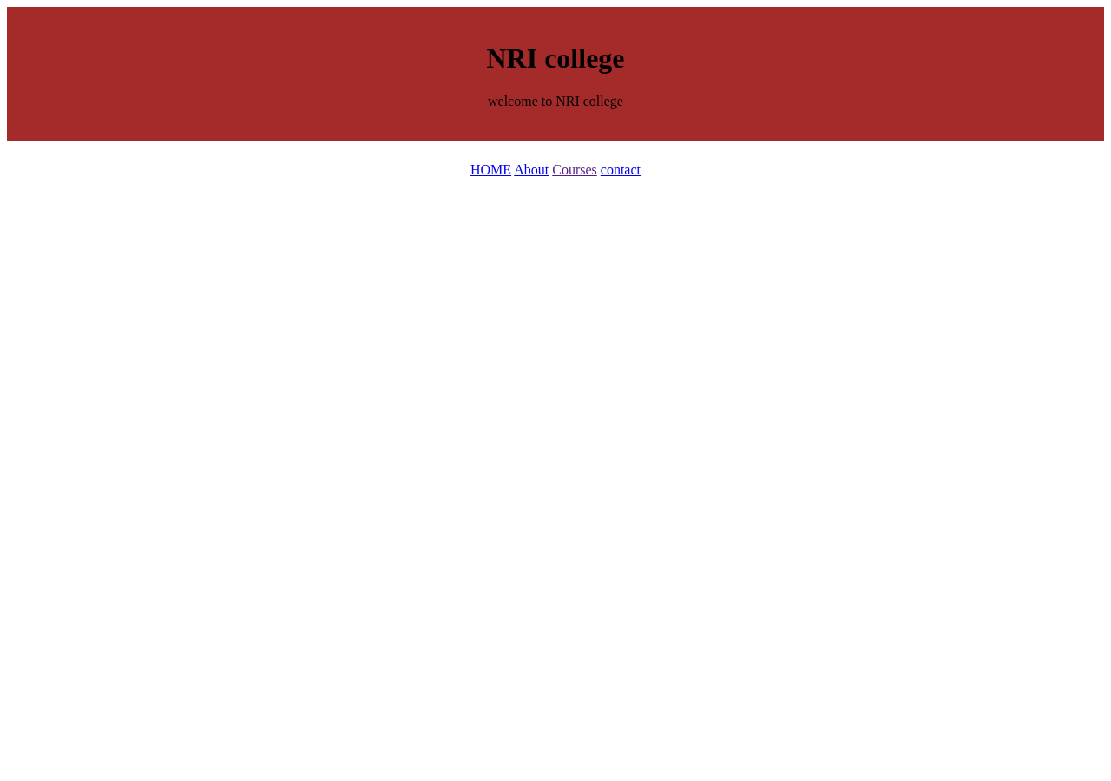
NRI College Webpage – Screenshot 1 of 1

2.6 Output Explanation
The rendered page displays a brown header area with the college name and welcome message centered inside it. A white navigation strip appears directly below the header, with the four navigation labels centered horizontally. The rest of the page is empty because the supplied HTML does not define any additional content sections. The simple output demonstrates how HTML elements are styled through CSS rules.

2.7 Complete Source Code

HTML5 – semantic.html
<!DOCTYPE html>
<html lang="en">
<head>
<title>my web page </title>
<meta charset="UTF-8">
<link rel="stylesheet" href="se.css" >
</head>
<body>
<!--HEADER-->
<header>
<h1>NRI college</h1>
<p>welcome to NRI college</p>
</header>
<nav>
<a href="#">HOME</a>
<a href="#">About</a>
<a href="">Courses</a>
<a href="#">contact</a>
</nav>
</body>
</html>

CSS3 – se.css
header{
background-color: brown;
text-align: center;
padding: 20px;
}

nav{
text-align: center;
background-color:white;
padding: 25px;
}

anav{
padding: 10px;
}

3. OVERALL CONCLUSION
Through these two projects, I learned how HTML5 and CSS3 work together to create webpages. The FITZONE project helped me understand how to organize a larger webpage into sections, create navigation links, display information using cards, style buttons and forms, and apply responsive layout rules. The NRI College project helped me practise basic semantic page structure and simple styling of a header and navigation bar.
I also learned that HTML defines the content and structure of a webpage, while CSS controls its visual presentation. These projects improved my understanding of webpage layout, colors, spacing, typography, navigation and the importance of checking the actual browser output. They provide a useful foundation for learning more advanced web development concepts.

NOTE ON IMPLEMENTATION
This report describes only the behavior supported by the submitted source files. The FITZONE registration form has no visible server-side processing code, and the NRI College navigation links do not have corresponding content sections in this version. These points are recorded as limitations rather than being represented as completed functionality.

