WEB DEVELOPMENT
PROJECT REPORT
EXPLORE VIJAYAWADA
A Static Informational Webpage

Submitted by
PINNIKA VAMSI KRISHNA
University
DR. RVR NRI UNIVERSITY
Course
B.Tech – CSE (AI & ML)
Academic Year
First Year
Submitted in partial fulfilment of the academic requirements
for the First Year B.Tech programme

1. Project Title
The title of this project is “Explore Vijayawada”. It is a static informational webpage that introduces Vijayawada, a city in Andhra Pradesh, and presents selected places to visit, activities to enjoy, and local food items.

2. Introduction
Explore Vijayawada is a simple and informative website designed to give visitors a brief introduction to Vijayawada. The webpage highlights the city’s cultural and tourist attractions and provides a quick overview of experiences that visitors may consider during a trip.
The main purpose of the website is to present useful introductory information in a clear, organised, and visually appealing format. It uses a prominent heading, a photograph of Prakasam Barrage, and separate content sections to make the information easy to read.
The webpage includes a welcome section, a list of places to visit, a list of activities, a list of food items to try, and a closing footer message. The supplied implementation is static and does not include interactive navigation or form-based features.

3. Technologies Used

3.1 HTML5
HTML is used to create the structure and content of the webpage. The code uses elements such as <html>, <head>, <title>, <body>, <header>, <section>, <h1>, <h2>, <p>, <img>, <ul>, <li>, and <footer>. The sections group related information into meaningful parts.

3.2 CSS3
CSS is used to control the visual appearance of the webpage. The supplied stylesheet defines the background colour, font family, text alignment, header and footer colours, section spacing, borders, rounded corners, image dimensions, and list formatting.

3.3 Additional Technologies
No JavaScript, backend framework, database, or external library is referenced in the supplied HTML and CSS files. The page uses a local image file named barrage.jpg.

4. Webpage Description

4.1 Overall Layout and Design
The webpage uses a centred layout with a light blue background (#eaf7ff). The main content is arranged vertically, with each major topic placed inside a white section. The sections have a light cyan border (#90e0ef), rounded corners, and consistent margins and padding. The page uses Arial, sans-serif as its browser font family.

4.2 Header
At the top of the page, a header displays the main title “Explore Vijayawada” and the subtitle “Discover the beauty of Andhra Pradesh”. The header has a blue background (#0077b6), white text, and 25 pixels of padding. The main heading is centred and styled with a font size of 36 pixels.

4.3 Welcome and Destination Section
The first content section is titled “Welcome to Vijayawada”. It contains the supplied photograph of Prakasam Barrage and a short paragraph describing Vijayawada as a city in Andhra Pradesh known for its temples, historical places, the Krishna River, and traditional food. The CSS sets the image to 80% width, limits it to 600 pixels, gives it a height of 300 pixels, and uses object-fit: cover. A blue border and rounded corners are also applied.

4.4 Places to Visit Section
The “Places to Visit” section contains an unordered list of five locations: Kanaka Durga Temple, Prakasam Barrage, Undavalli Caves, Bhavani Island, and Gandhi Hill.

4.5 Things to Do Section
The “Things to Do” section lists four suggested activities: visiting famous temples, enjoying a boat ride, exploring historical monuments, and enjoying beautiful river views.

4.6 Food to Try Section
The “Food to Try” section lists Andhra Chicken Curry, Gongura Pachadi, Punugulu, and Andhra Meals.

4.7 Footer
At the bottom of the webpage, a footer displays the message “Thank you for visiting! Plan your next trip to Vijayawada.” It uses a dark blue background (#023e8a), white text, and 15 pixels of padding.

4.8 Elements Not Present
The supplied code does not contain a navigation bar, buttons, hyperlinks, forms, or a separate contact section. These elements have therefore not been added to this report as existing webpage features.

5. Actual Webpage Output
The following screenshot was rendered from the supplied vamsi.html and vamsi.css files using the accompanying barrage.jpg image. It shows the complete page from the header through the footer. The local stylesheet and image were available during rendering.
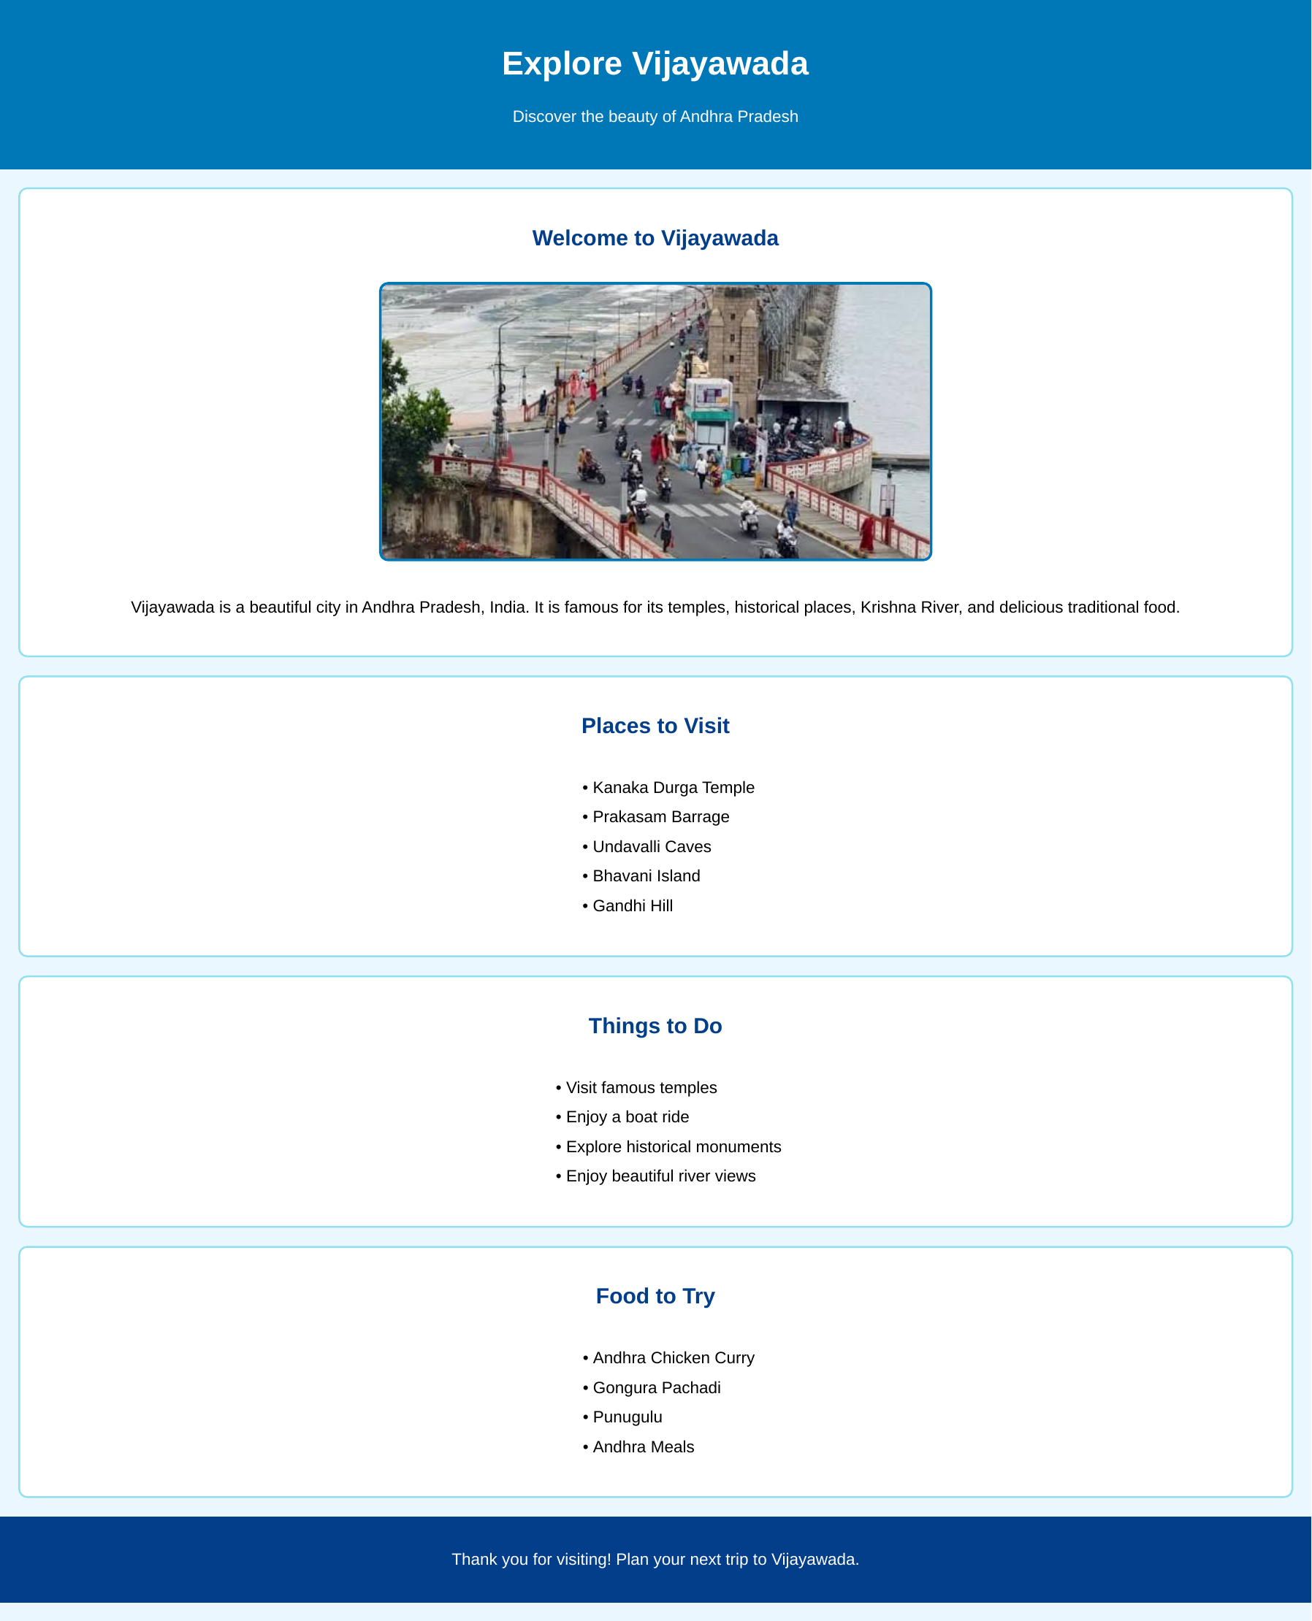
Figure 1: Rendered output of the Explore Vijayawada webpage

6. Output Explanation
When the webpage is opened, the visitor first sees a blue header containing the website title and subtitle. Below it, the light blue page background frames a series of white content panels. The welcome panel displays the Prakasam Barrage photograph with a short description of the city.
The next three panels present the places to visit, activities, and food items as easy-to-read bullet lists. The section headings are centred and use a dark blue colour. The lists are left-aligned within their centred content area. Finally, a dark blue footer with a white closing message appears at the bottom. The screenshot demonstrates the page’s simple vertical structure, consistent spacing, blue colour theme, and use of a local destination photograph.

7. Conclusion
Through this project, I learned how to build a basic webpage using HTML and style it using CSS. I practised using semantic page elements, headings, paragraphs, images, unordered lists, colours, spacing, borders, and layout properties. This project helped me understand how HTML provides webpage structure and how CSS improves its presentation. It also gave me practical experience in organising information into clear sections.

8. Source Code
The complete source code supplied for this project is reproduced below. The original HTML and CSS content has been retained without functional changes.

8.1 HTML Source Code (vamsi.html)
<!DOCTYPE html>
<html>
<head>
<title>Explore Vijayawada</title>
<link rel="stylesheet" href="vamsi.css">
</head>
<body>

<header>
<h1>Explore Vijayawada</h1>
<p>Discover the beauty of Andhra Pradesh</p>
</header>

<section class="destination">
<h2>Welcome to Vijayawada</h2>

<img src="barrage.jpg" height="500" width="1000">

<p>
Vijayawada is a beautiful city in Andhra Pradesh, India.
It is famous for its temples, historical places, Krishna River,
and delicious traditional food.
</p>
</section>

<section class="places">
<h2>Places to Visit</h2>
<ul>
<li>Kanaka Durga Temple</li>
<li>Prakasam Barrage</li>
<li>Undavalli Caves</li>
<li>Bhavani Island</li>
<li>Gandhi Hill</li>
</ul>
</section>

<section class="activities">
<h2>Things to Do</h2>
<ul>
<li>Visit famous temples</li>
<li>Enjoy a boat ride</li>
<li>Explore historical monuments</li>
<li>Enjoy beautiful river views</li>
</ul>
</section>

<section class="food">
<h2>Food to Try</h2>
<ul>
<li>Andhra Chicken Curry</li>
<li>Gongura Pachadi</li>
<li>Punugulu</li>
<li>Andhra Meals</li>
</ul>
</section>

<footer>
<p>Thank you for visiting! Plan your next trip to Vijayawada.</p>
</footer>

</body>
</html>

8.2 CSS Source Code (vamsi.css)
body {
background-color: #eaf7ff;
font-family: Arial, sans-serif;
margin: 0;
padding: 0;
text-align: center;
}

header {
background-color: #0077b6;
color: white;
padding: 25px;
margin-bottom: 20px;
}

h1 {
font-size: 36px;
text-align: center;
}

h2 {
color: #023e8a;
text-align: center;
}

section {
background-color: white;
margin: 20px;
padding: 20px;
border: 2px solid #90e0ef;
border-radius: 10px;
}

.destination img {
width: 80%;
max-width: 600px;
height: 300px;
object-fit: cover;
border: 3px solid #0077b6;
border-radius: 10px;
margin: 15px;
}

p {
font-size: 18px;
line-height: 1.6;
}

ul {
display: inline-block;
text-align: left;
font-size: 18px;
line-height: 1.8;
}

footer {
background-color: #023e8a;
color: white;
padding: 15px;
margin-top: 20px;
}

