1.C1 Extends C2
Explanation of the Program – Points
- This program demonstrates inheritance in Java.
- It specifically demonstrates Hierarchical Inheritance.
- Animal is the parent class (superclass).
- Dog and Cat are the child classes (subclasses).
- The Animal class contains a display() method for displaying common animal information.
- The Dog class inherits the properties and methods of Animal.
- The Dog class also has its own method to display dog-specific information.
- The Cat class also inherits the properties and methods of Animal.
- The Cat class has its own method to display cat-specific information.
- The extends keyword is used to create inheritance between the parent and child classes.
- Objects are created for both Dog and Cat in the main() method.
- The Dog object calls the inherited display() method and its own dog-details method.
- The Cat object calls the inherited display() method and its own cat-details method.
- The output displays common animal information followed by specific information about the dog and cat.
Ouput:
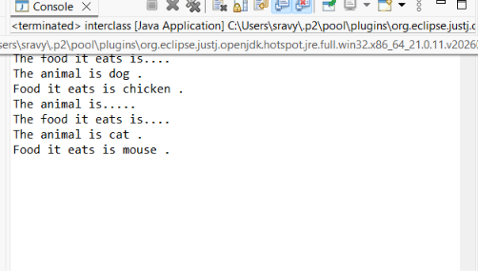
2.C1 implements I1 and C1 implements I1,I2
Explanation of the Program – Points
- This program demonstrates interfaces in Java.
- Three interfaces are created: I1, I2, and I3.
- Each interface contains one abstract method.
- The X class implements I1.
- Since X implements I1, it must provide the implementation for the method declared in I1.
- The Y class implements two interfaces: I2 and I3.
- This demonstrates that Java supports multiple inheritance through interfaces.
- Since Y implements I2 and I3, it provides implementations for the methods declared in both interfaces.
- The public access modifier is required when implementing interface methods because interface methods are public by default.
- The @Override annotation indicates that a method is implementing a method declared in an interface.
- In the main() method, objects of classes X and Y are created.
- The object of X is used to call the method from I1.
- The object of Y is used to call the methods from both I2 and I3.
- Therefore, class X implements one interface, while class Y implements two interfaces simultaneously.
- Main concept: Java does not support multiple inheritance using classes, but it supports multiple inheritance using interfaces.
OUPUT:

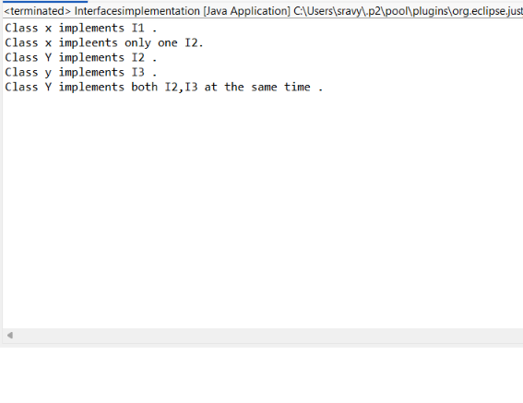
3.C1 extends C2 Implements I1
Explanation of the Program – Points
- This program demonstrates how a class can inherit another class and implement an interface at the same time.
- The interface I contains an abstract method for addition.
- The class D contains a method for multiplication.
- The class Z extends class D, so it inherits the multiplication method from D.
- The class Z also implements interface I.
- Since Z implements I, it provides the implementation of the addition method.
- The @Override annotation indicates that the addition method is implementing the method declared in the interface.
- The Z class also contains its own subtraction method.
- Therefore, class Z gets functionality from three sources:
  - Addition → from the interface I
  - Multiplication → inherited from class D
  - Subtraction → its own method
- In the main() method, an object of class Z is created.
- The object is used to perform addition, multiplication, and subtraction.
- The program demonstrates hybrid use of class inheritance and interface implementation.
Structure
Interface I → Addition
Class D → Multiplication
Class Z
- Extends D
- Implements I
- Has subtraction
Main Concept
A Java class can extend only one class but can implement one or more interfaces. Here, Z extends D and implements I simultaneously.

OUTPUT:
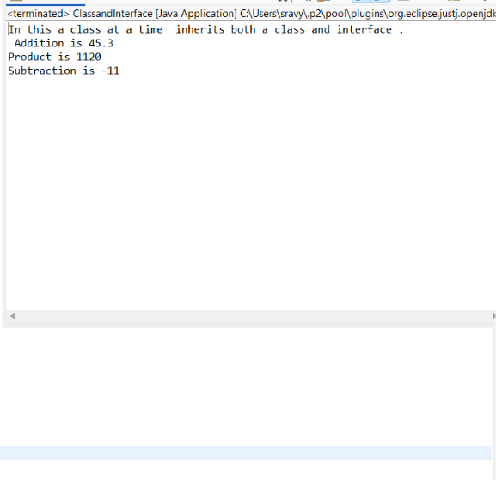
4.I1 implements I2 and I implements I2,I3
Explanation of the Program – Points
- This program demonstrates inheritance between interfaces in Java.
- There are four interfaces: I9, I8, I6, and I.
- Interface I9 contains the add() method.
- Interface I8 extends I9, so it inherits the add() method and also contains the sub() method.
- Interface I6 contains the rem() method.
- Interface I extends both I6 and I8.
- Therefore, interface I inherits all the methods from its parent interfaces:
  - add() from I9
  - sub() from I8
  - rem() from I6
- Interface I also has its own mul() method.
- The Dsa class implements interface I.
- Since Dsa implements I, it must provide implementations for all four methods.
- The Dsa class performs:
- Addition
- Remainder
- Subtraction
- Multiplication
- The @Override annotation indicates that these methods are implementing methods declared in the interfaces.
- In the main() method, an object of Dsa is created.
- The object is used to call all four operations.
- This program demonstrates that an interface can extend multiple interfaces.
Structure
I9
↓
I8 ─────┐
↓
I6 ───→ I
↓
Dsa
OUTPUT:
