CSE474/574 Introduction to Machine Learning

**Programming Assignment 2**

*Classification and Regression*

**Problem 1: Gaussian Discriminators**

The reason why there are difference between LDA and QDA is because LDA is linear and is only learning and testing a single d*d covariance matrix while QDA is quadratic and is learning a list od d*d covariance matrixes.

QDA: 96%

LDA: 97%

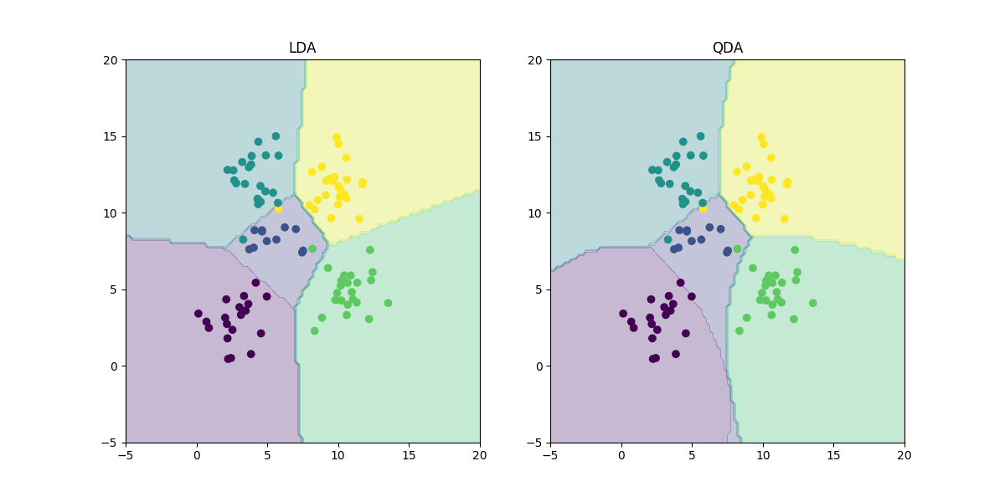

**Problem 2: Linear Regression**

MSE without intercept training data : [[ 19099.44684457]]

MSE with intercept training data : [[ 2187.16029493]]

MSE without intercept test data: [[ 106775.36155512]]

MSE with intercept test data: [[ 3707.84018132]]

MSE with intercept is better since lesser Mean Square Error is better. MSE with intercept in both test data and training data has a lower value than MSE without intercept. Therefore, we choose MSE with intercept is better.

**Problem 3: Ridge Regression Learning**

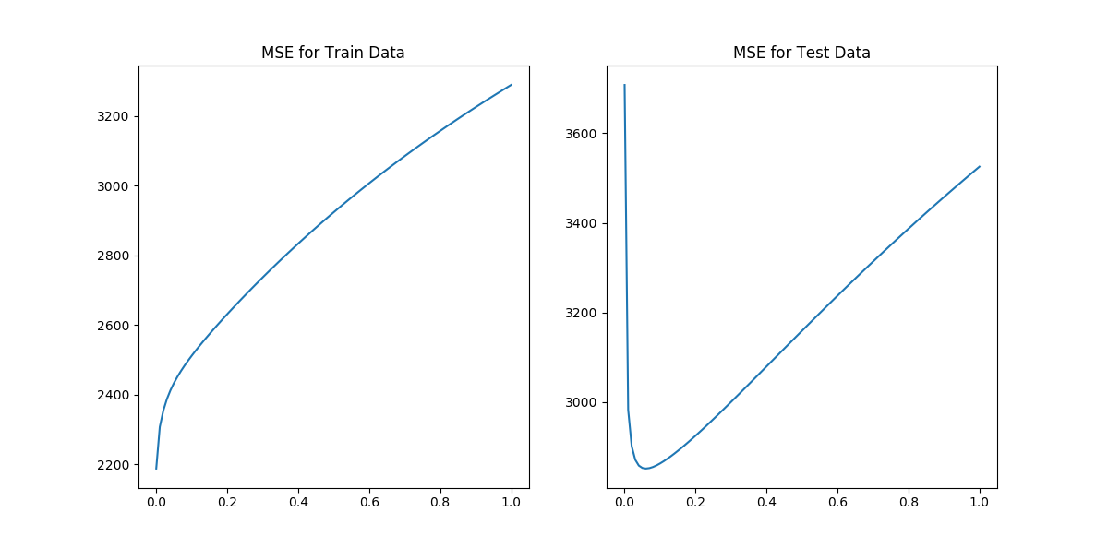

**Problem 4: Using Gradient Descent**

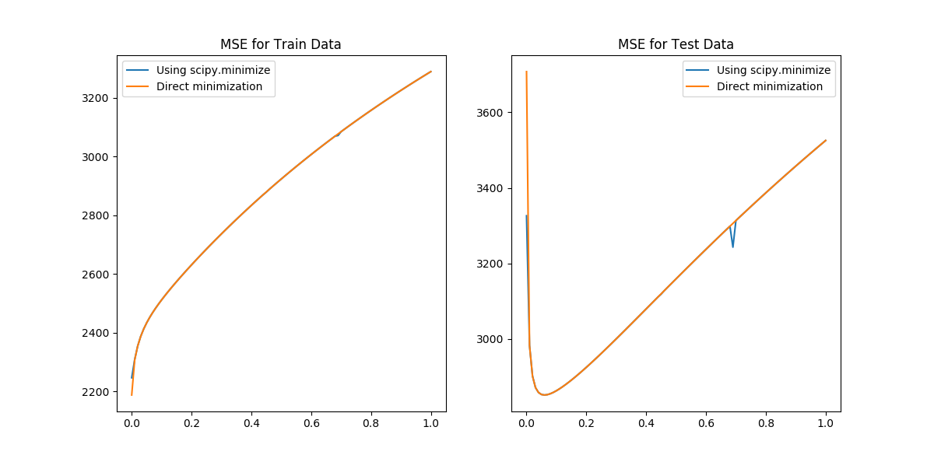

**Problem 5: Non-linear Regression**

