|  |  |
| --- | --- |
|  |  |
| Report Arduino Project |  |
|  |  |
|  | 10/01/2020NGUYEN Martin *MBOUP Mbayang* |
|  | CAFFIAUX MatisZINSOU Françoise |

I**ntroduction**

Our project is a system of security for a private user. Private because the person who knows the code is able to change the code. Imagine a system like that in an entry of a building, it wouldn’t be safe because everybody in the building could be able to change the code. So the user types a sequel of five numbers on a digital code to unlock a servomotor which represents the fictive latch of a door or a chest. We have also added a 16*2 led screen to print instructions and error messages if needed. Moreover we have added an extra functionality which blocks the entry for 3 missfilled entries in a row.

**Proceeding**

*Initiation*

Firstly, the led screen keeps printing endlessly, every 3 seconds “Enter A to unlock” then “Enter B to change the code". If the user uses the system for the first time, by typing ‘A’, the program asks him to create a new code.

*loop*

If the user types ‘A’ or ‘B’ in the digital code, the program makes a pause and the entry of the code begins. When the user types ‘A’, he has to enter the code, if it is right the servomotor goes on his unlocked position and wait for the user to type ‘A’ to bring him back. If it is not right, a message is printed on the screen for 3 seconds, after that the screen goes back to his repetitive printing mode. Other case, if the user types ‘B’, he has to enter the code, if it is right, a new message is printed “Enter the new code” and the user has to enter the new code, if not it is same as previously, the screen prints an error message for 3 seconds before moving back on repetitive mode.

**Electrical diagrams**

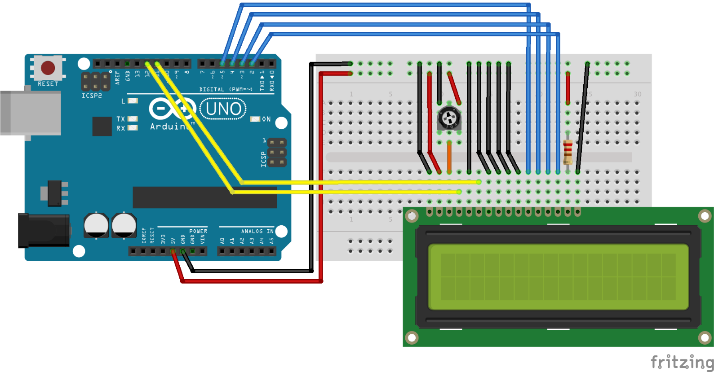

Led screen connections

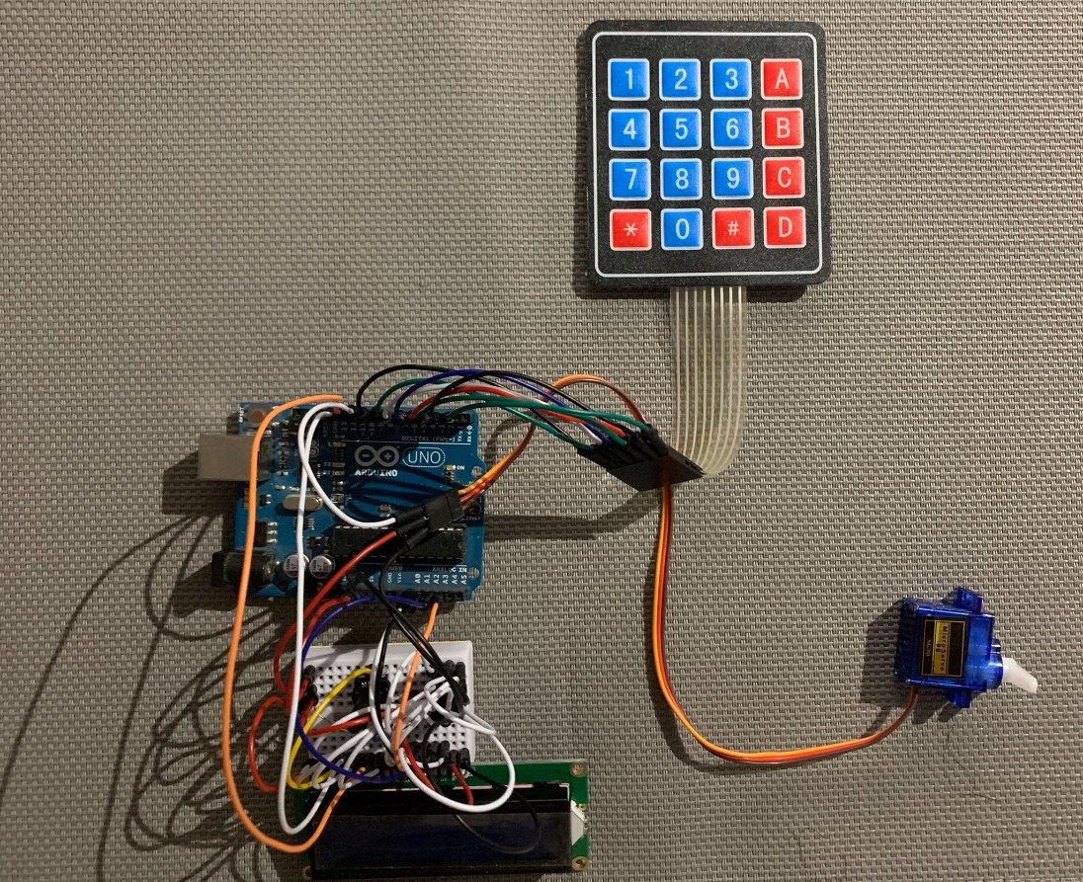

The final montage

**Conclusion**

**This project pushed us to dig for knowledges we didn’t have. We have learned to use servomotor, lcd screen, digital code. We have encountered many difficulties like the connections with too many wires, the way to stop the loop of the screen while it is priting, the bugs management. Despite all the difficulties we have produced something working and it is the main thing.**

**Thank you.**