***Question 1***

The dynamic programming problem is: $$\max_{i_{t}} \sum_{t=0}^{∞}{β^{t}π(a_{t}, i_{t}, ϵ_{0t},ϵ_{1t})}$$

Where:

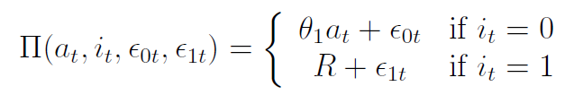

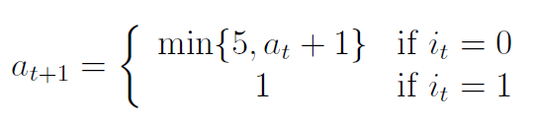

The above problem is equivalent to finding the following value function

$$V\left(a_{t};ε_{t};θ\right)=\max_{i_{t}}[u\left(a_{t},i_{t};θ\right)+ϵ_{it}+βE[V(a_{t+1},ϵ_{t+1};θ)|a_{t},i_{t};θ]]$$

Where:

$$u\left(a_{t},i_{t};θ\right)= \left\{\begin{aligned}θ_{1}a_{t} if i_{t}=0 \\ R if i_{t}=1\end{aligned}\right.$$

$$θ=(θ_{1},R)$$

***Question 2***

*Refer to code*

***Question 3***

|  |  |  |
| --- | --- | --- |
| V0 | V1 | Pr1 |
| -10.1317 | -11.3652 | 0.2256 |
| -11.4797 | -11.3652 | 0.5286 |
| -12.6201 | -11.3652 | 0.7781 |
| -13.6731 | -11.3652 | 0.9095 |
| -14.6731 | -11.3652 | 0.9647 |

For the value that the firm is indifferent between replacing its machine or not for the following value of $ϵ_{0t}-ϵ_{1t}={\overline{V}}_{1}\left(2\right)-\overline{V_{0}}(2)$:

11.3652 -11.4797 = -0.1145

The probability that the firm will replace the machine if $a_{t}=2$:

52.86%

The PDV of future profits is:



1 - 13.6731 = -12.6731

-1.5 – 11.3652 = -12.8652

PDV = **-12.6731**

The firm is not going to replace the machine

***Question 4***

Theta1 = -1.1484 R = -4.4464

|  |  |  |
| --- | --- | --- |
| V0 | V1 | Pr1 |
| -16.9575 | -19.0834 | 0.1066 |
| -18.6448 | -19.0834 | 0.3921 |
| -19.9958 | -19.0834 | 0.7135 |
| -21.2121 | -19.0834 | 0.8937 |
| -22.3605 | -19.0834 | 0.9636 |

***Question 5***

We don’t compute standard errors

***Question 6***

a)

The new dynamic programming problem is that the firm solves:

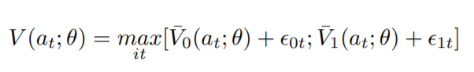





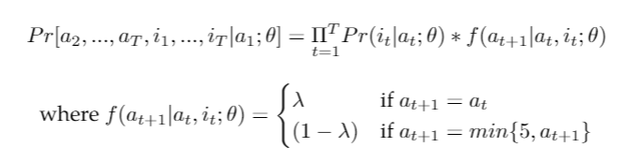We cannot empirical identify $λ$ from the data that we have at hand because it is a random sample of machines. We would need multiple time observations for each bus to indentify $λ$. In this case we have a probabilitstic state vector $a_{t}$, and we would need panel data to maximize the joint likelihood of $i_{t}$ and $a_{t}$. That is for any given bus, the likelihood is:

When we try to estimate $λ$ we got -0.0363 and $λ$ cannot have a negative value. So clearly this data is inadequate to identify $λ.$

b) Firm A solves:

$$V\left(a_{t};ε_{t};θ\right)=\max_{i_{t}}[u\left(a_{t},i_{t};θ\right)+ϵ_{it}+βE[V(a_{t+1},ϵ_{t+1};θ)|a_{t},i_{t};θ]]$$

$$u\left(a_{t},i_{t};θ\right)= \left\{\begin{aligned}θ_{1A}a_{t} if i_{t}=0 \\ R if i_{t}=1\end{aligned}\right.$$

$$θ=(θ_{1A},R)$$

Firm B solves:

$$V\left(a_{t};ε_{t};θ\right)=\max_{i_{t}}[u\left(a_{t},i_{t};θ\right)+ϵ_{it}+βE[V(a_{t+1},ϵ_{t+1};θ)|a_{t},i_{t};θ]]$$

$$u\left(a_{t},i_{t};θ\right)= \left\{\begin{aligned}θ_{1B}a_{t} if i_{t}=0 \\ R if i_{t}=1\end{aligned}\right.$$

$$θ=(θ_{1B},R)$$

The probability of not replacing implied by the solution to the problem solved by firm A & firm B are:

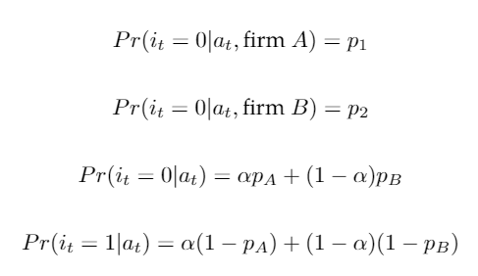

The overall probability of not replacement and replacement are these:



This is the log likelihood function:

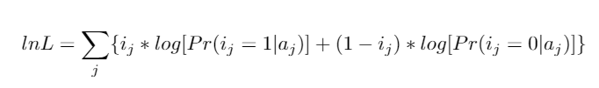

c) With panel data, this would be the likelihood function:

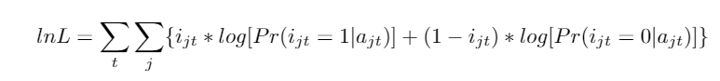

d) The firm now solves this problem:



Where:



