**Recommendation:** Based on the provided data we recommend that future investments in coffee production are made in Viet Nam.

**Influencing Factors:** The four factors below are the key indicators that our analysis was based on.

1. **Coffee Production:** A countries existing coffee production offers an indicator of the suitability of that countries climate, and infrastructure for a new coffee production site.Countries with minimal existing production are unlikely to be suitable for an investment due to lacking either a favorable climate, necessary infrastructure, or necessary expertise.
2. **Coffee export:** An established ability to export coffee is a positive indicator for future investment as most producer countries don’t have the domestic demand to match production so the ability to export is a must to generate a profit.
3. **Change in Coffee Export:** Change in yearly coffee production is another important indicator as it captures whether the export industry in each country is improving or in decline. We considered both the year over year change and 3 year average.
4. **Domestic Consumption:** While most of the coffee is exported a nonzero domestic consumption is a positive indicator as it represents an additional market opportunity for a potential producer.

**Honduras Performance:**

The thesis for investing in production capacity in Viet Nam is one rooted in in growth and stability of production capacity and exports.

First, we can establish Viet Nam as a major coffee powerhouse by looking at total production, export, and domestic consumption. On these metric we can see that Viet Nam ranks number 2 for both total production and total exports from 1990 – 2020.

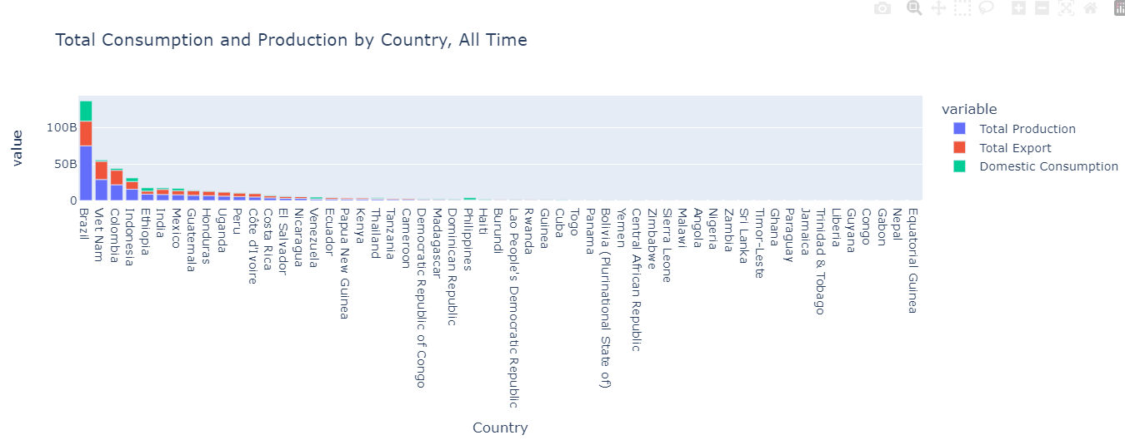

Next, we want to examine how these metric have changed over time. While Brazil is clearly the leader in both production and exports we can see that there exports have had significant volatility in the last couple years as judged by a 3 year moving average. Viet Nam on the other hand has shown steady growth over the last 6 years and has been insulated from the volatility impacting the Brazilian export market.

The one area where Viet Nam doesn’t score as well is in domestic consumption where it ranks fourth. However, for producing countries besides Brazil domestic consumption is a small fraction of export and as a result we believe in prioritizing the stable export market of Viet Nam over the high domestic consumption in Brazil.

