**BootStrap**

* It is a library for web applications.
* Library comprises of pre-defined functions, which you can implement and customize according to your requirements.
* Bootstrap provides HTML, CSS and JavaScript templates.
* Like bootstrap there are so many 3rd party libraries used in web development.

bootstrap

telerik

devexpress

jquery-ui

mui

material-angular etc…

* Bootstrap provides templates for free and premium.
* Bootstrap provides

1. HTML layouts
2. CSS classes
3. jQuery Attributes

* HTML layout is for presentation.
* CSS classes to make presentation more responsive, effective.
* jQuery attributes to handle interactions, like click, mouse over, timing etc..

Setup Bootstrap for projects

* npm install bootstrap-icons –save
* npm install bootstrap –save
* npm install jquery –save

Link the following files to webpage

----------------------------------------------

Bootstrap.css ] <link href=”” rel=”stylesheet”>

Bootstrap-icons.css ]

Jquery.js ] <script href=”” type=”text/javascript”>

Bootstrap.bundle.js

Note: As per recommendations from bootstrap keep all script file in <body> section.

Bootstrap Versions

-------------------------

* commonly used bootstrap version in projects is 4.
* Latest bootstrap version is 5.

FAQ: What is default font used in Bootstrap [3rd party]

Ans: Roboto.

Bootstrap Classes

1. **Containers**

* Containers are designed for different viewports.
* Viewports is to target your content for various devices
* Container classes

.container small screen devices

.container-lg large screen [laptop]

.container-sm mobile

.container-xl more wider screen

.container-fluid fits according to screen

EX:

<!DOCTYPE html>

<html lang="en">

<head>

    <meta charset="UTF-8">

    <meta name="viewport" content="width=device-width, initial-scale=1.0">

    <title>Document</title>

    <link rel="stylesheet" href="../node_modules/bootstrap/dist/css/bootstrap.css">

    <link rel="stylesheet" href="../node_modules/bootstrap-icons/font/bootstrap-icons.css">

    <style>

        .container-fluid{

            border: 2px solid black;

            margin: 20px;

        }

    </style>

</head>

<body class="container-fluid">

    <h1>Welcome To Bootstrap</h1>

    <dl>

        <dt>Components</dt>

        <dd>Buttons, Forms, Navbars</dd>

        <dt>Interactions</dt>

        <dd>Alerts, Models, Cards</dd>

    </dl>

    <script src="../node_modules/jquery/dist/jquery.js"></script>

    <script src="../node_modules/bootstrap/dist/js/bootstrap.bundle.js"></script>

</body>

</html>

1. **Box Model Classes**

**Margin and Padding**

.m margin

.p padding

t top

b bottom

s left[start]

e right[end]

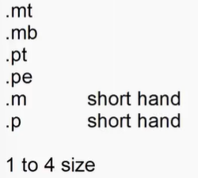

.mt-{size}

.pt-{size}

**Border and Radius**

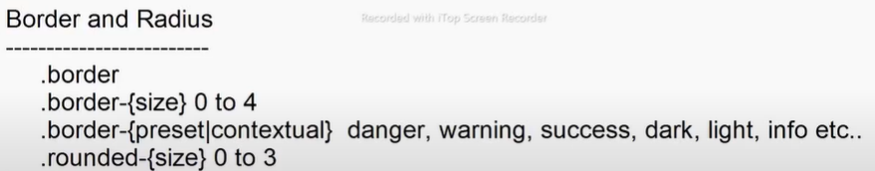

.rounded-pill

.rounded-circle

**Width And Height**

