CSS

* Styles are additional attributes used to make HTML more interactive and responsive.
* Styles provides c CSSOM to make elements effective .

[Cascade Style Sheet Object Model]

* Styles can be defined in 3 ways

1. Inline styles
2. Embedded styles
3. External style sheet

Inline styles :

* Styles are defined for every element individually by using “style ” attribute.
* It is faster in rendering
* It difficult to re-use.

Syntax:

<h2 style = “attribute:value”></h2>

Embedded Styles :

* Styles are defined in head or body section by using <style> tag.
* You can re-use the styles but slow in rendering .

Syntax:

<style>

h2{

}

</style>

**Session - 23**

FAQ: What is difference between styles in <head> or <body> ?

Ans: Styles in head section are intended to load into browser memory first , from there you can apply to elements .

* Styles in body section are intended to load and apply to elements directly.

FAQ: Can we defines styles in both sections ?

Ans: Yes.

Note: You can keep styles outside HTML .

FAQ: What is the MIME type for styles ?

Ans: text/css

Syntax:

<style type=”text/css”></style>

FAQ: What is the media types for styles ?

Ans: screen , print, speech

EX:

<!DOCTYPE html>

<html>

    <head>

        <title>Styles</title>

        <style type="text/css" media="screen">

            h1{

                background-color: green;

                color: white;

                text-align: center;

            }

            aside{

                width:100px;

                height: 50px;

                border: 2px dotted red;

                padding: 5px;

            }

        </style>

        <style type="text/css" media="print">

            h1{

                background-color: red;

                color: white;

                text-align: center;

            }

            aside{

                display: none;

            }

        </style>

    </head>

    <body>

        <aside>

            Ads..

        </aside>

        <h1>HTML</h1>

        <h1>CSS</h1>

        <h1>JavaScript</h1>

    </body>

</html>

* You can not access embedded styles from another page.

3.External Style Sheets

[Cascading Style Sheets]

* styles are maintained in a separate stylesheet.
* Clean separation of markup and styles.
* Reusability across page.
* Using an external style sheet will increase the number of requests for page.
* If number of requests for page increases then page load time will increase.

EX:

1. Create a new style sheet .

effects.css

h1{

    background-color: tomato;

    color: white;

    text-align:center;

}

1. Link the stylesheet to any page

        <link rel="stylesheet" href="../src/styles/effects.css" type="text/css">

FAQ: What is Minification ?

Ans: it is a technique used to reduce the file size.

it is not ZIP or RAR file.

effects.css development

effects.min.css production

EX:

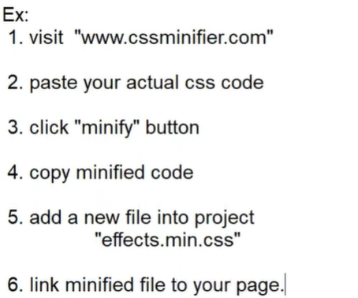

FAQ: Can we edit minified files directly ?

Ans: Yes . but you should not disturb the minified logic.